**CS 591 P1 Assignment 6 Bank ATM README**

**Xueyan Xia (U82450191)**

**Available account:**

Manager ID:

Username: Happy Admin Password: money

Customer ID:

Username: Rich man Password: 123456

Username: Poor man Password: 123456

Username: Customer Password: 123456

**The entrance:**

ATM.java

**Customer:**

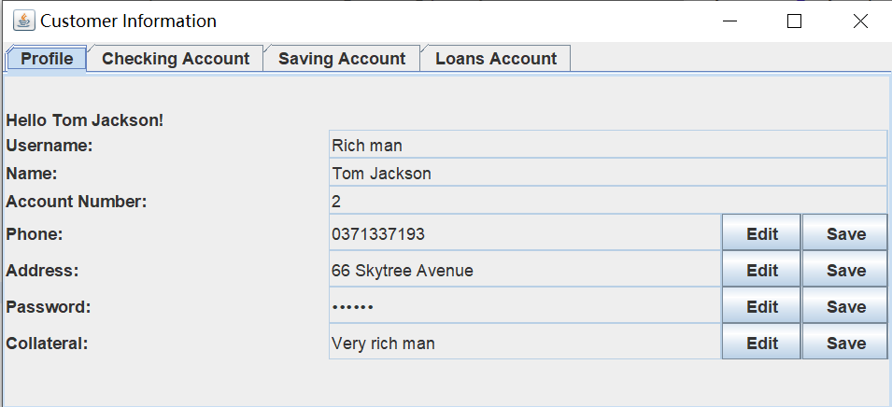

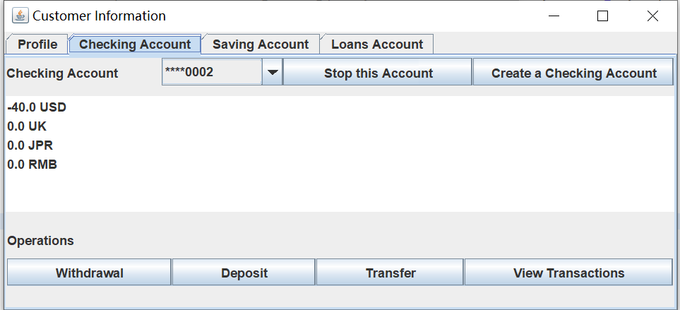

You can click “Withdrawal” or “Deposit” to move on next window.

Also, you can modify your decision there.

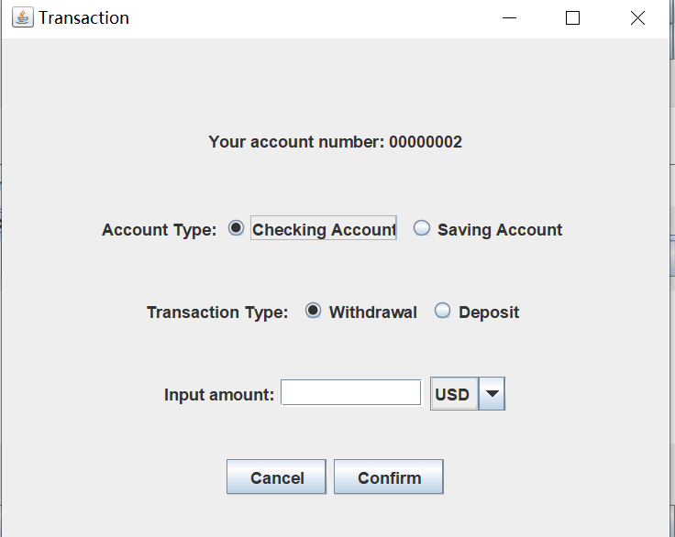

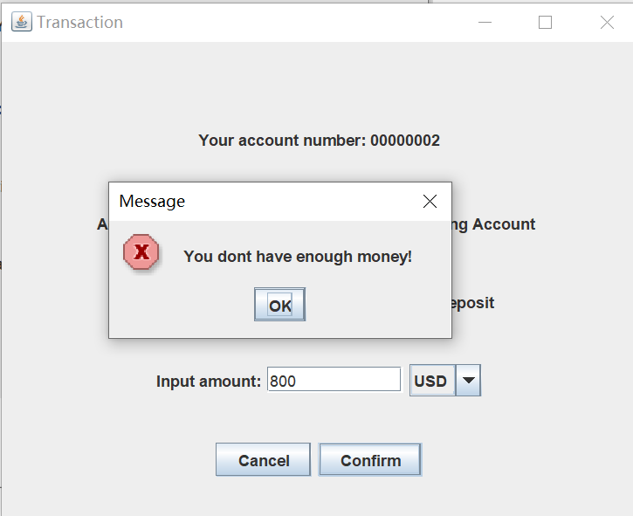

Since we don’t have money right now, we should deposit first.

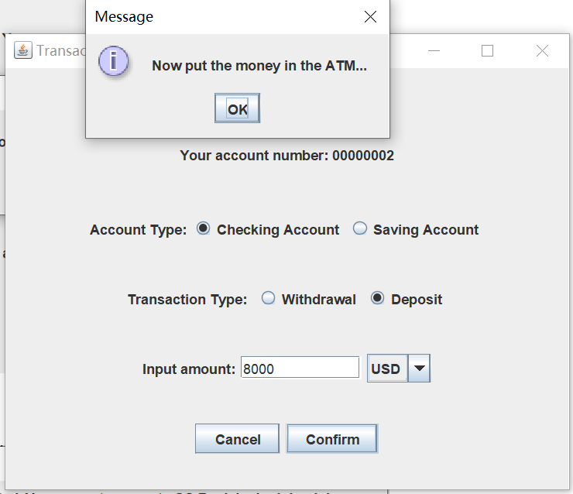

Then it will return the last window after you clink ‘ok’.

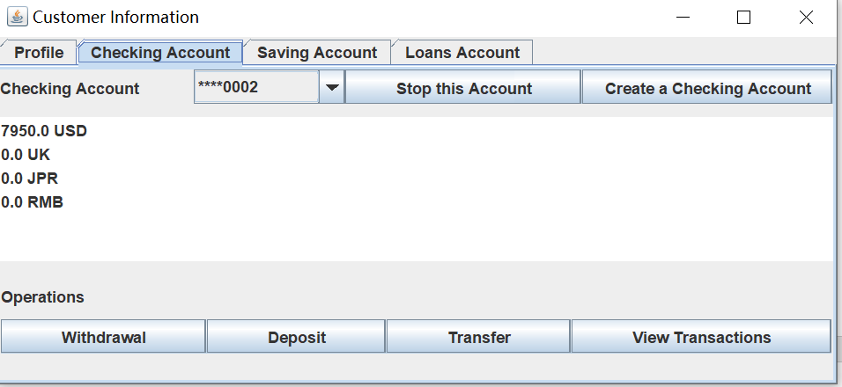

In saving account, the withdrawal and deposit operations are the same with that in checking account.

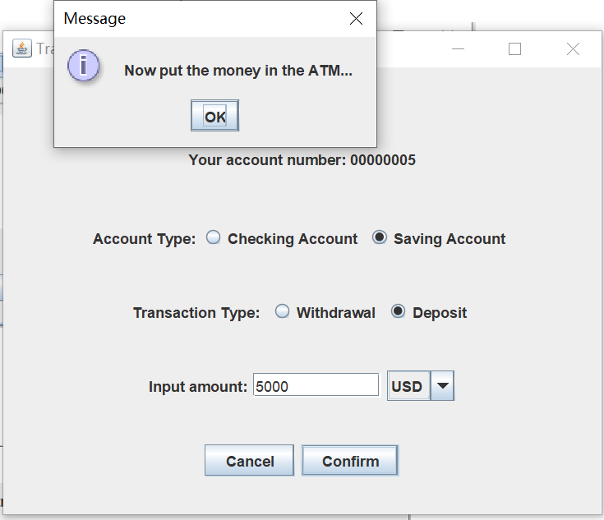

Clink ‘Get interests’ to get the interests of all your saving accounts.

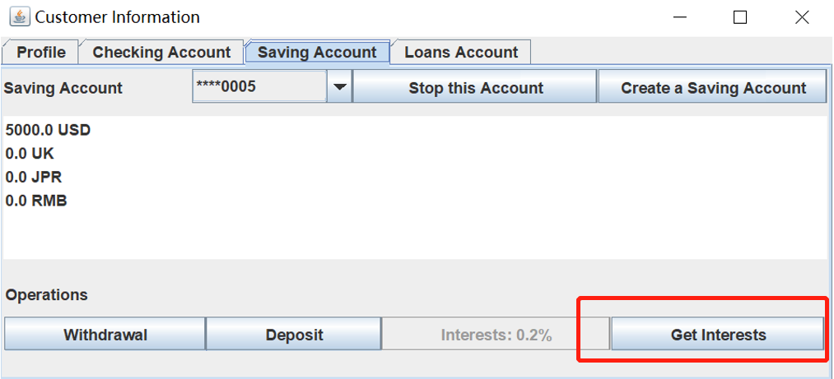

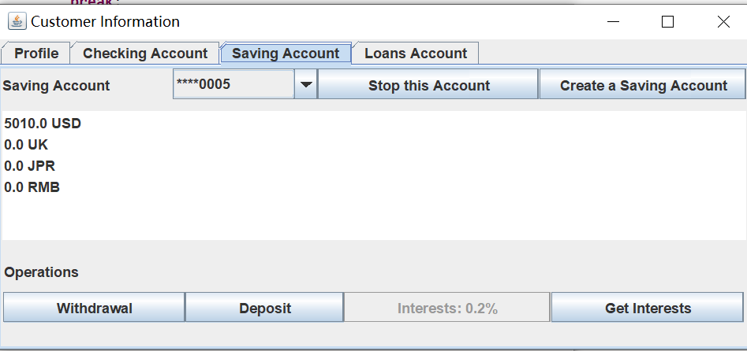

If you don’t have a collateral, you could not create a loans account.

After creating a loans account, you could make loans or return loans.

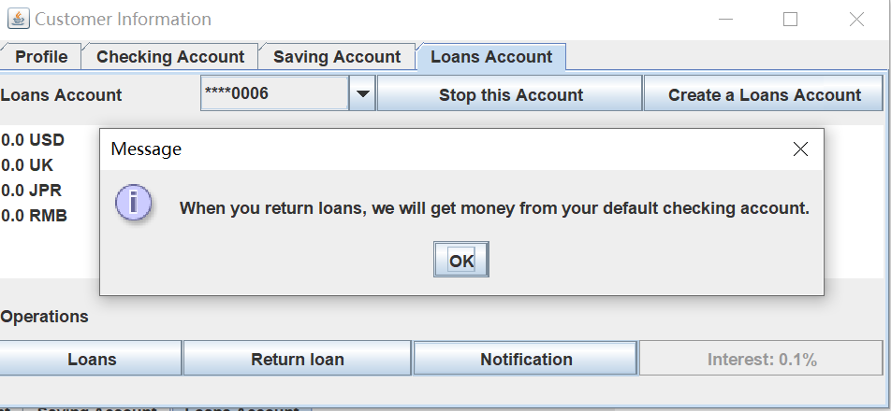

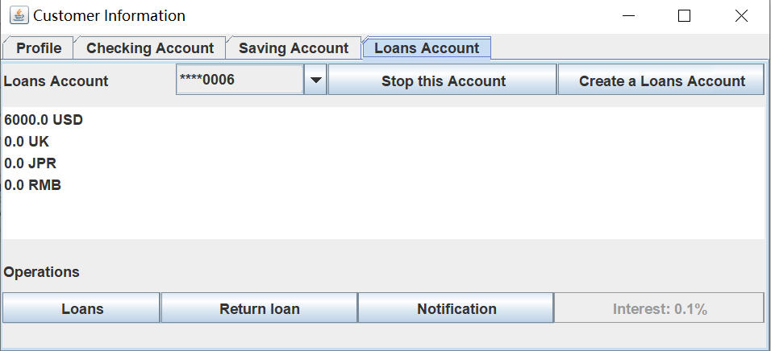

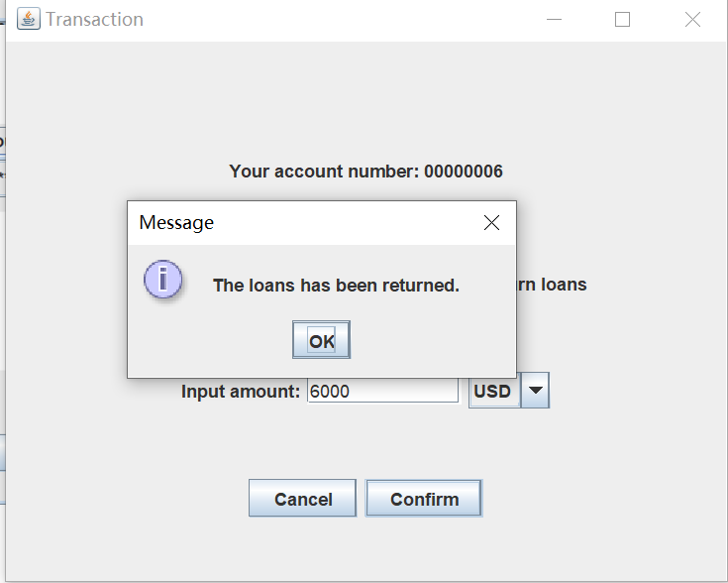

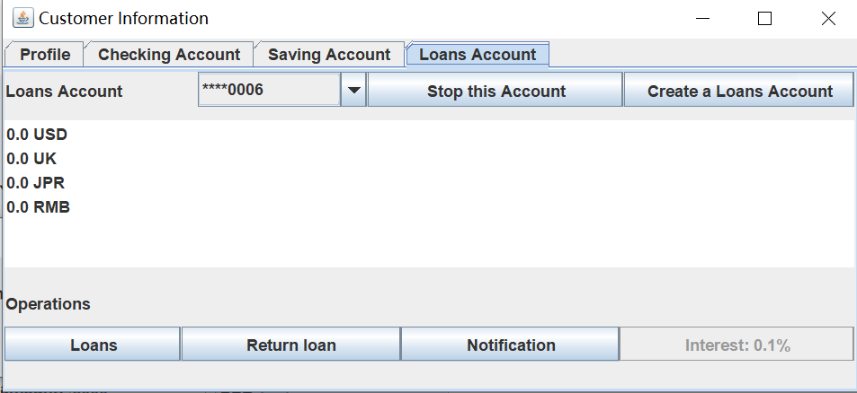

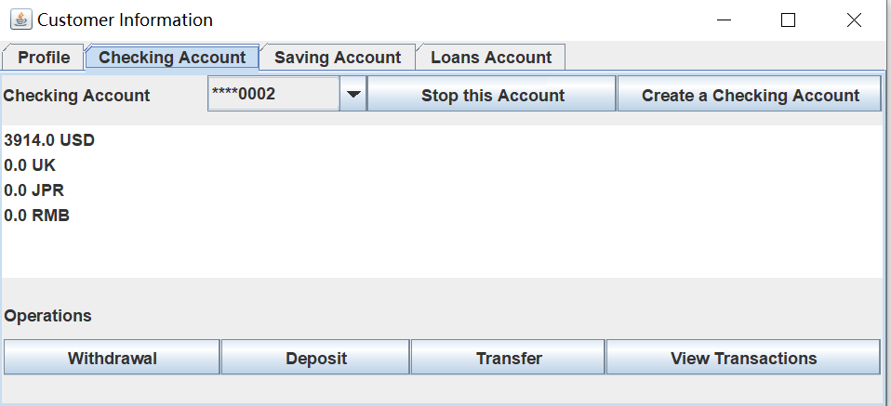

You can transfer from an account to another account. These two accounts may belong to different banks and different customers. Now we transfer money from checking account to our saving account.

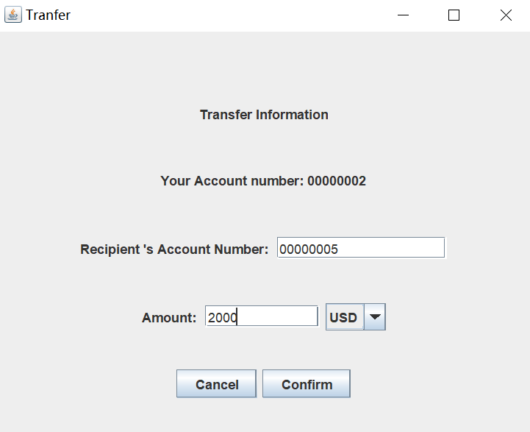

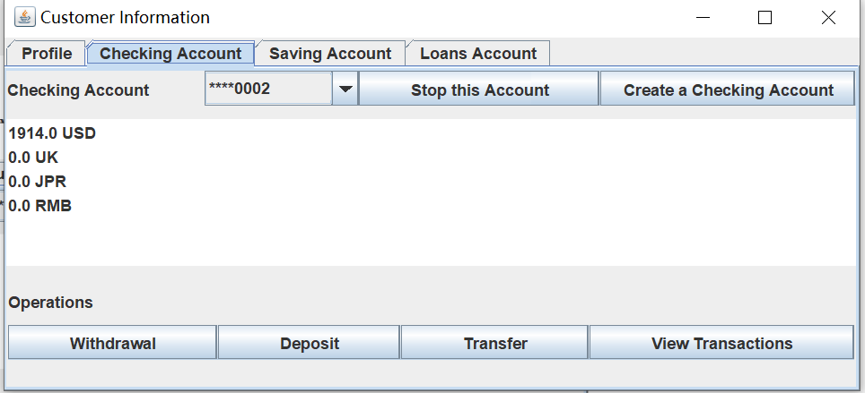

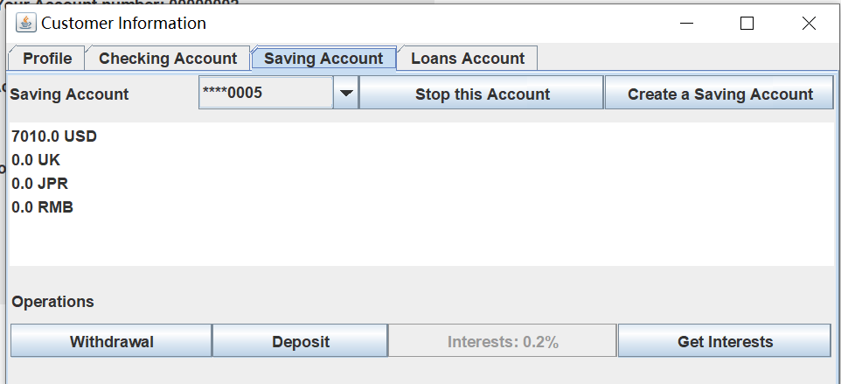

In the page of checking account, clicking ‘view transaction’, you can view your transaction history.

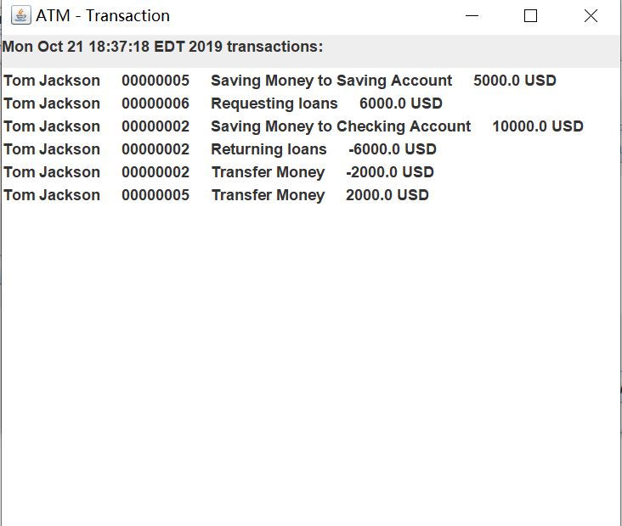

**Manager:**

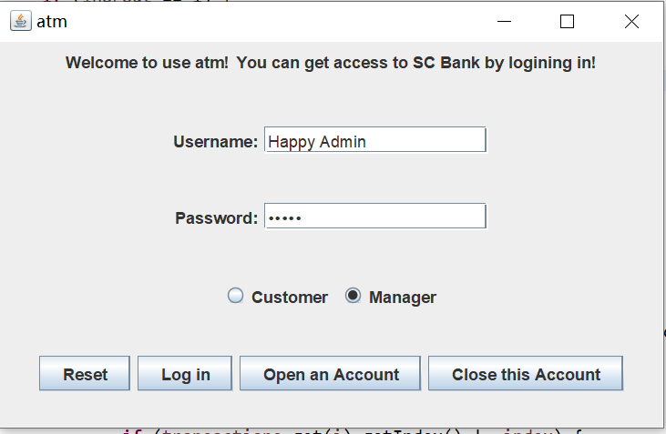

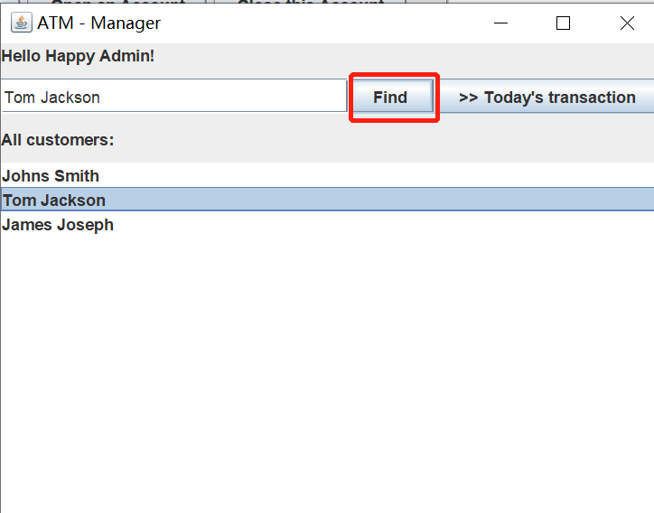

By clicking the list item and the button ”find”, the manager could view the customer ‘s information. However, he cannot do any operation.

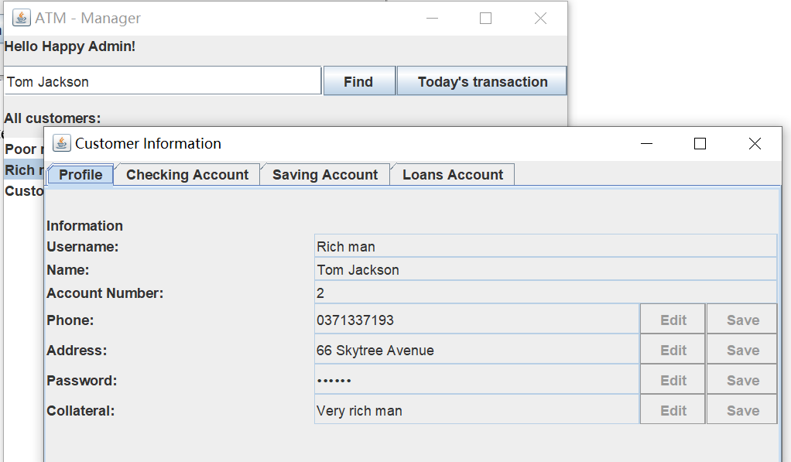

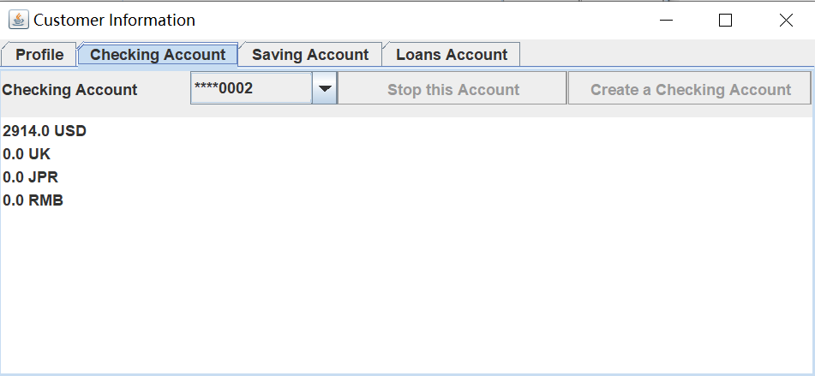

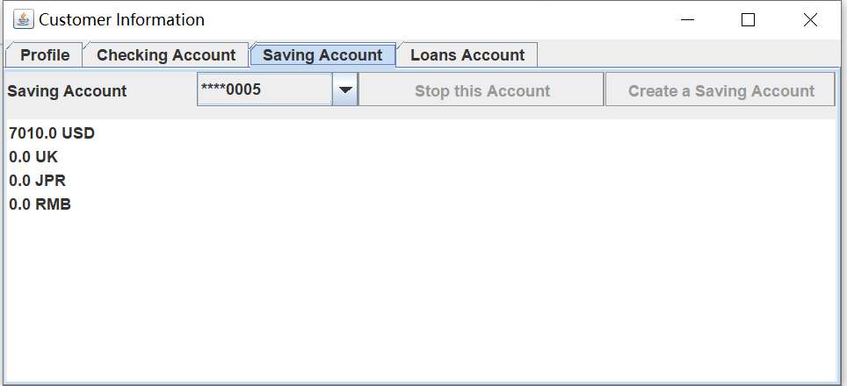

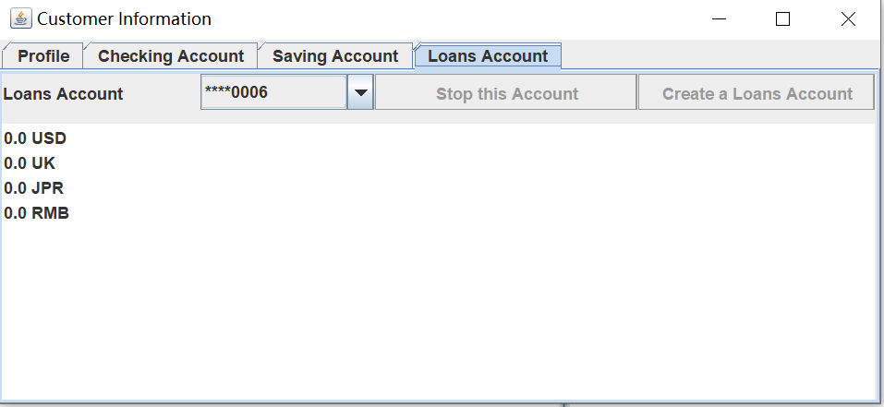

The manager could get today ‘s transaction report by clicking the following button.

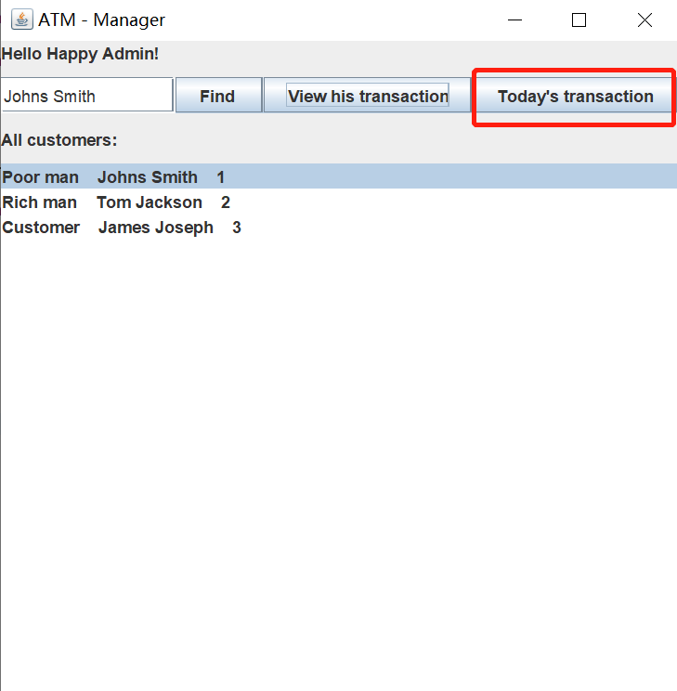

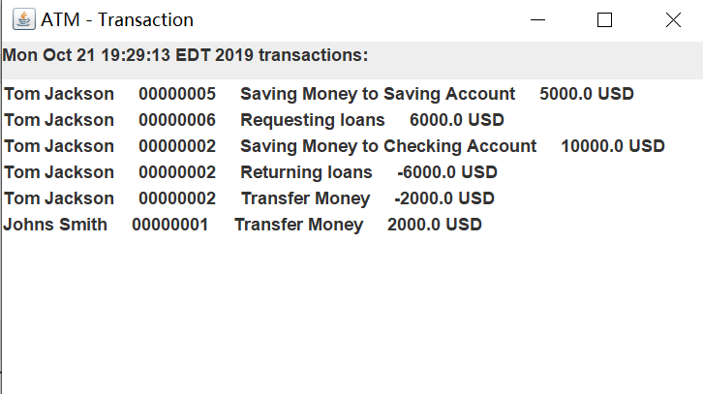

The manager could also click ‘view his transaction’ to view a customer’s transaction.

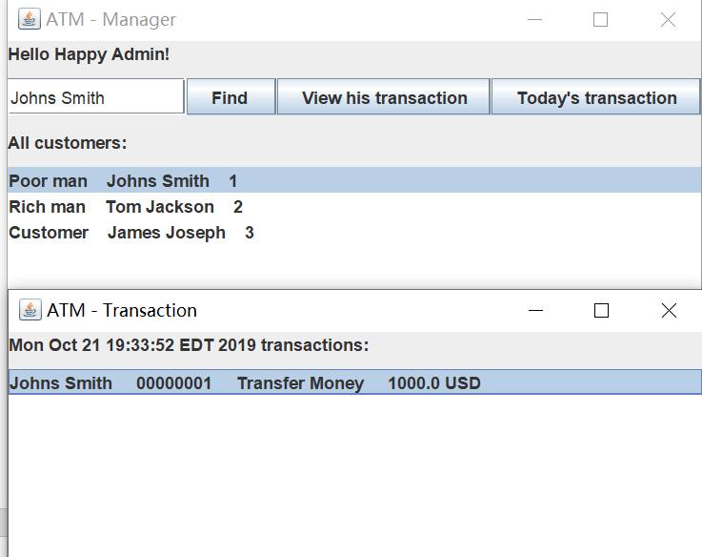

**Open Account:**

The user should input all * information to create an account.

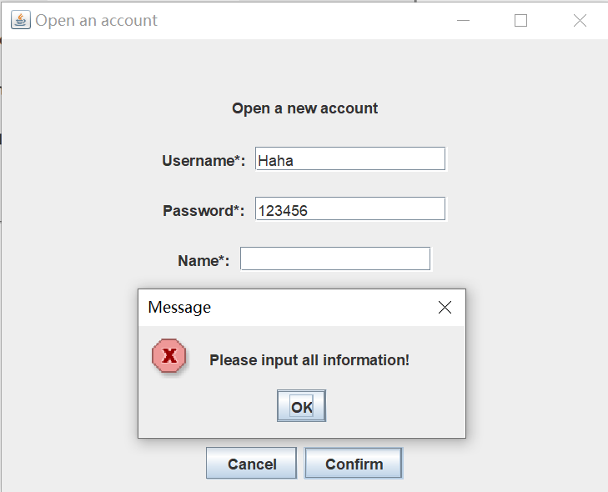

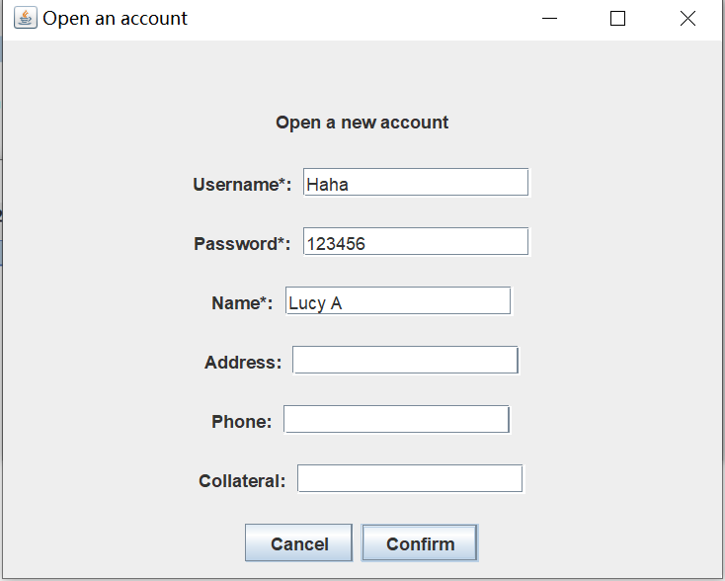

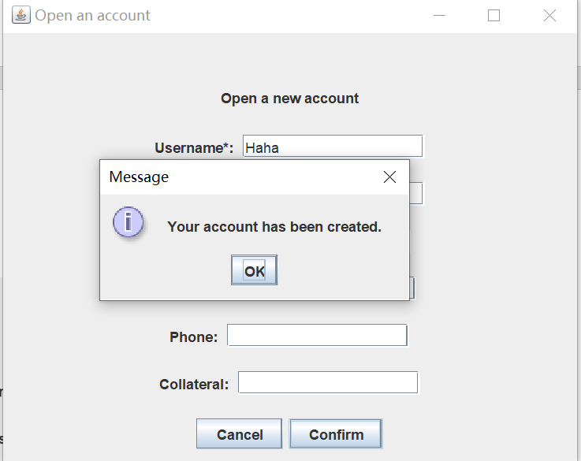

**Close Account:**

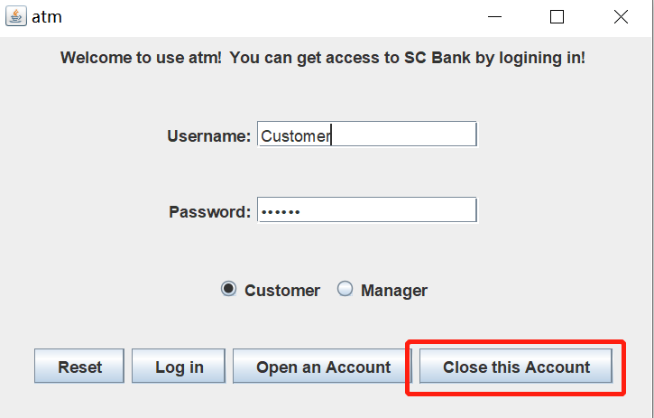

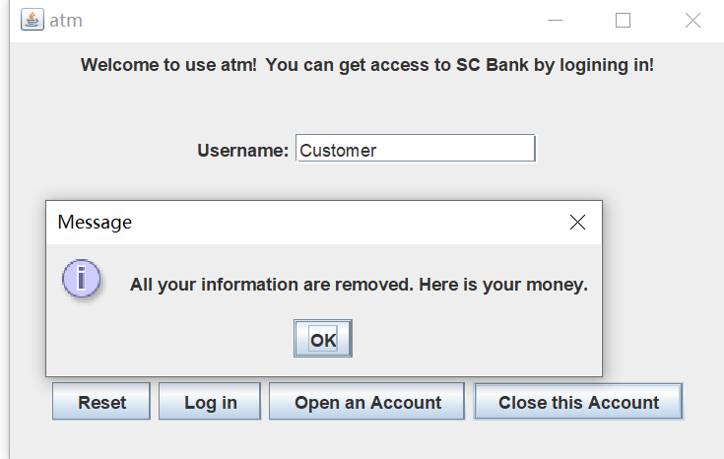

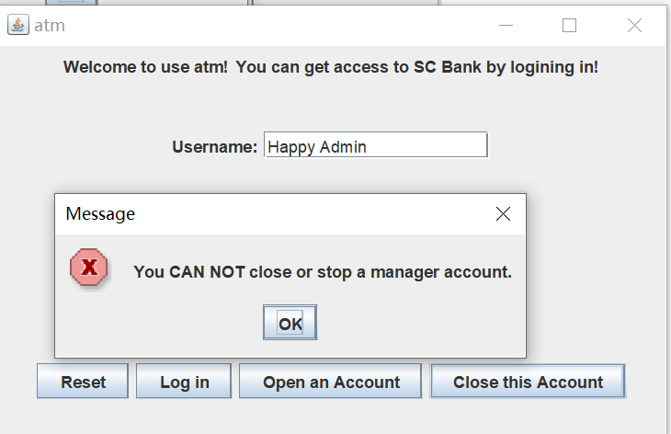

And these information would be updated in the manager window.

