<Jingyin Chen (Seline)>

<2021-Aug-08>

<Foundations of Programming (Python)>

<Assignment 05>

### Step 6 - Document your knowledge

### Introduction

The codes I created for this week’s assignment only work in limited conditions. It’s really not user-friendly. Actually, what I mean is, I totally did not write the 100% right codes, but I did my best.

### Topic 1: Loading File Data

My first struggle is that I did not understand the concept of ‘load Inventory from file’. I realized that if I load data twice when running the program, the data will be doubled. I then dived into the rabbit hole of solving it and failed. Then realized probably the premise is only loading the file data once per time. Or, at least I can ask the user to load file data only once per time.

So I added parentheses in the menu as:

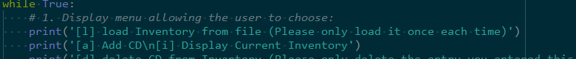

Figure 1 - First struggle

At that time, I did not realize another rabbit hole had been waiting for me.

Topic 2: Deleting Entry

My second struggle was how to ‘Add functionality of deleting an entry’. At first, I did it with the .pop():

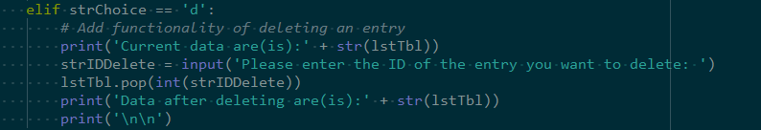

Figure 2 – Using .pop().

Then realized it doesn’t work because the ‘ID’ the user enters does not equal the indexing number in the list.

So I dived into the second rabbit hole and kept researching online. Almost all the examples I found did not involve user input. One of them uses for-loop and the ‘del’ function. But seems like the ‘del’ function still requires indexing number equals to ‘ID’.

Meanwhile, it’s almost the deadline.

Therefore I just used the most straightforward .remove() and asked the user to input ‘ID’, ‘Title’, and ‘Artist’. At that time, the codes were like:

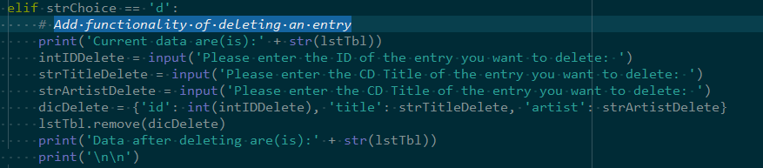

Figure 3 – User enters all

I also decided to print the current data to the user to help the user enter the correct ‘ID’, ‘Title’, and ‘Artist’ to match the dictionary-meant-to-be-deleted in the 2D list.

While testing, the deletion sometimes worked sometimes failed.

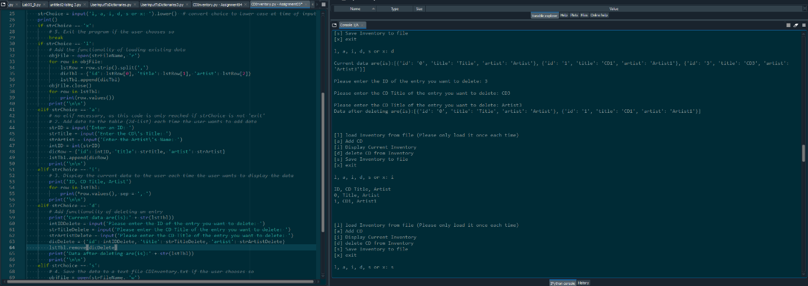

Figure 4 – deletion worked

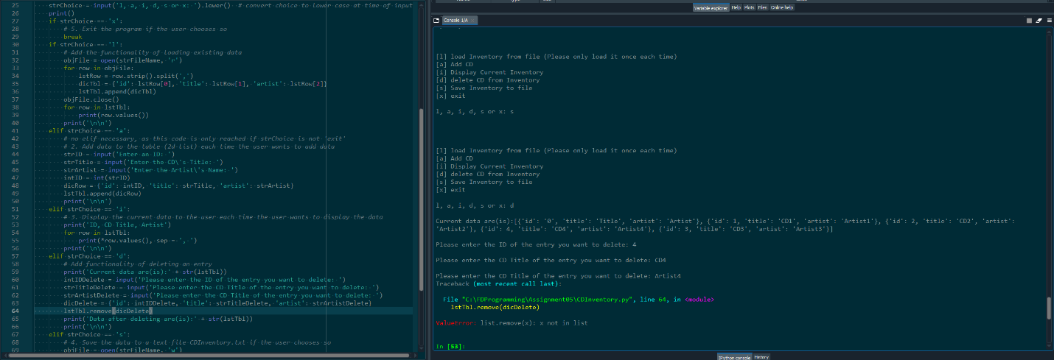

Figure 5 – Deletion failed

After matching the datatypes in related variables, I realized that if the user wants to delete an entry loaded from the txt file (existed before running the program), the codes don't work because the ‘ID’ loaded from the file is a string than an integer. While the ‘ID’ from user input during program running, is an integer.

In this case, I decided to give our user another pair of parentheses, with the menu modified like this:



Topic 3: In the ideal situation…

In the ideal situation with our super-cooperative user, the codes work like this:

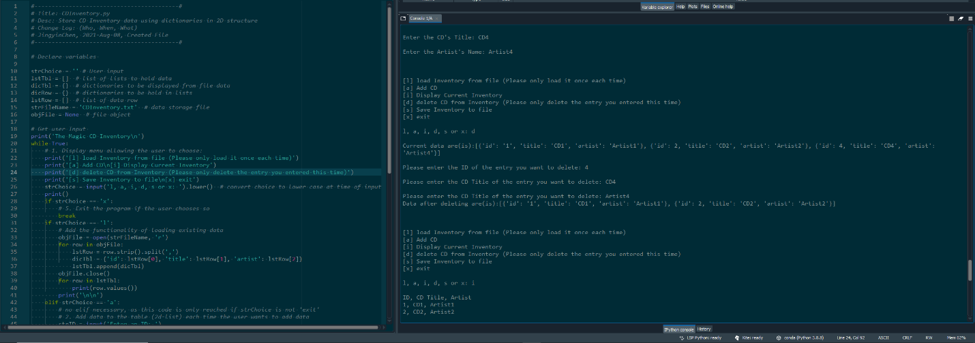

Figure - working in spyder

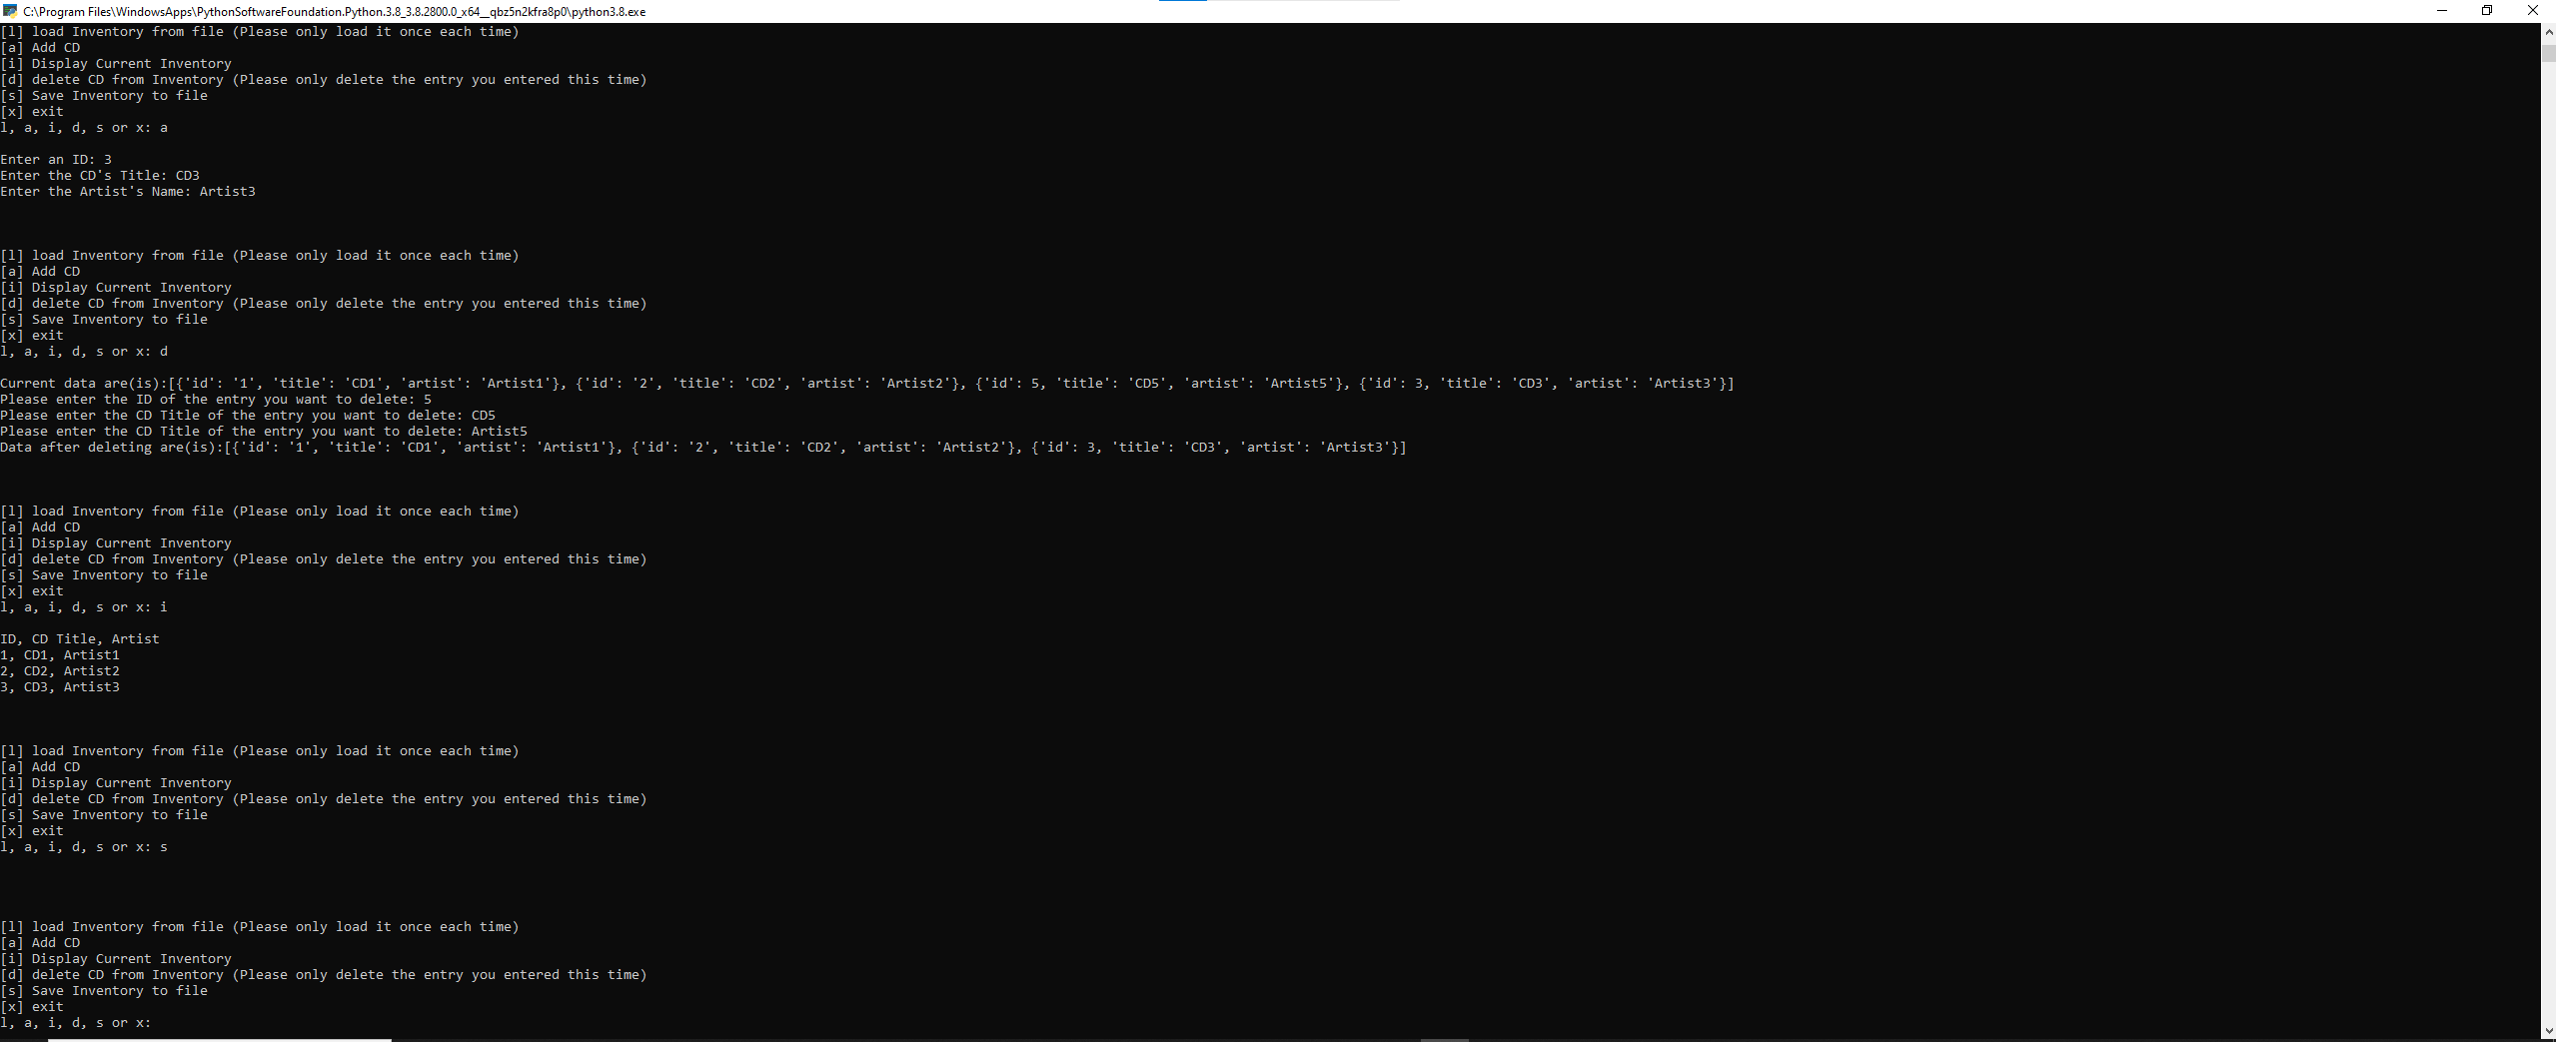

Figure - working in terminal

Topic 4: Doubts

My first doubt is that is there a way to make the data of all user inputs strings? Like, making the ‘ID’ user enters a string rather than an integer from the very beginning? I searched and found the raw_input(). But it seems like it only exists in python 2, and it works exactly as the input() in python 3 that I have used. I might get it wrong or I might miss something. I didn’t actually test the raw_input() cause the deadline is approaching…

My second doubt is how to understand ‘load Inventory from file’. Does that mean loading the data only one time per running the codes? If it does, should I introduce an Error Handling to prevent the user from loading data twice? (Probably yes to this question…) But what if the premise of this assignment is that the user can load data from the file as many times as they want, then how to solve it?

### Summary

I thought for this assignment modifying the 2D data structure to use dictionaries was the key point, didn’t expect loading data from file and deleting an entry would be the rabbit holes. My only thought right now is that coding is so hard with user inputs, and all the solutions that I found online, turned out not suitable because they don’t include user inputs. I thought about the apps we are so used to and sincerely realized how hard it is to create them. Respect to all programmers.