<Jingyin Chen (Seline)>

<2021-Aug-15>

<Foundations of Programming (Python)>

<Assignment 06>

### Step 6 - Document your knowledge

### GitHub link to this week’s assignment:

<https://github.com/SelineCCC/Assignment_06>

### Introduction

This week’s knowledge and assignment both seem comprehensible at first glance. I mean, when I read the codes and copied the codes, I thought I understood what Dirk explained and strengthened. But when I actually worked on the assignment, I realize I did not fully understand many of the concepts, like argument and variables, global variables and local variables, when using variables as arguments, and when using return values.

### Topic 1: Loading File Data

The first issue I encountered is this error:

----‘’’----

File "C:\FDProgramming\Mod_06\Assignment06_Testing.py", line 221, in <module>

DataProcessor.add_table(dicRow, lstTbl)

File "C:\FDProgramming\Mod_06\Assignment06_Testing.py", line 38, in add_table

intID = int(strID)

NameError: name 'strID' is not defined

----‘’’----

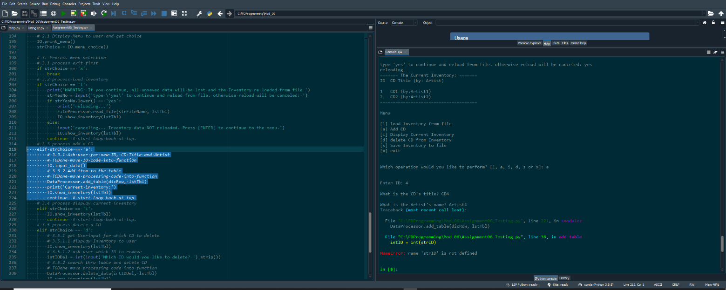

Figure 1 - First struggle

I dived into this rabbit hole, trying to find the problem in lines 38 and 221. Can’t figure out anything.

Then I went through the course material again, thinking: are there any knowledge points I did not include in the assignments?

So I tested global and local variables:

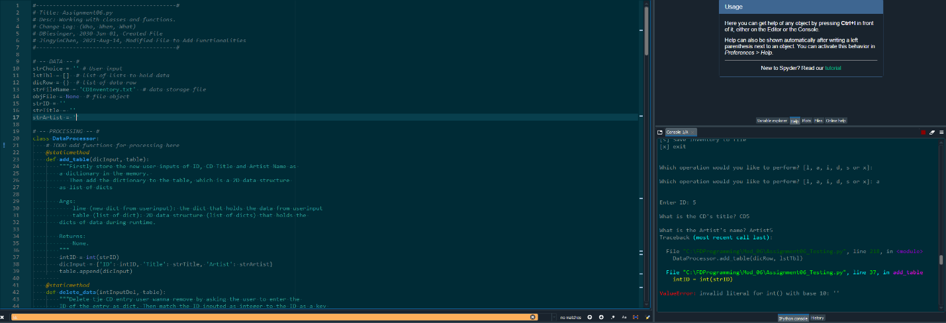

Figure 2 – Testing Global Variable

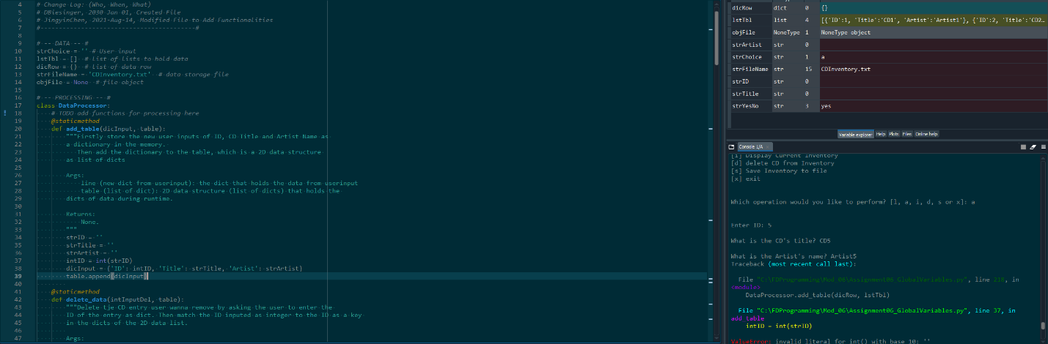

Figure 3 – Testing Local Variable

Neither works and surprise-surprise a new type of error.

Then it’s 3am again, so I went to bed with a head full of codes and doubts. Luckily, I dreamt about it again.

Then I tested unpacking tuple, with codes like this:

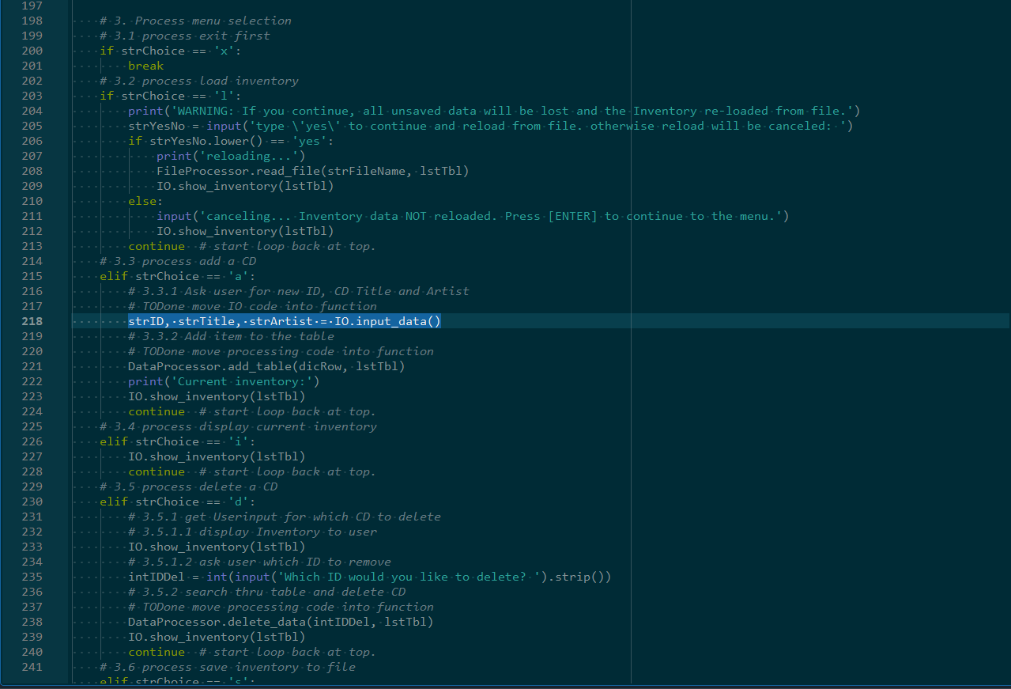

Figure 4 – Testing Tuple Unpacking

Viola, it works. But I sincerely don’t know why the tuple unpacking is needed here. Like I understand what unpacking of tuples is when I read the codes line by line, closely follow the objects/data and variables, I know how the flow/logic makes sense. But I doubt I can think of using it when it is needed, or especially say why I use unpacking of tuples here, rather than a list or a dict.

Topic 2: ID Datatype from User-Input

My next rabbit hole was about the two ID-datatypes from user input – one is the ID from deleting CD, and another is the ID from adding CD. I noticed sometimes the strID is integer.

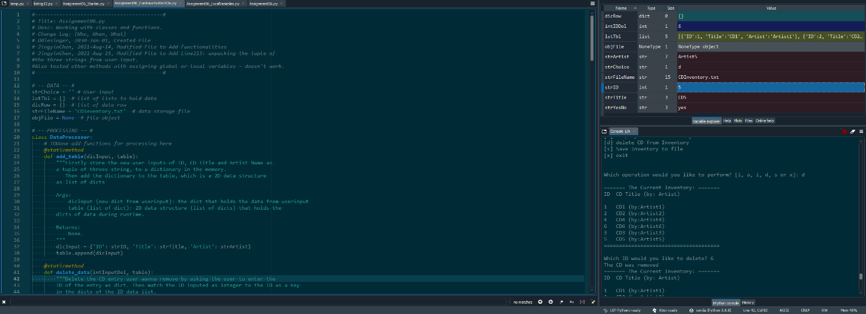

Figure 5 – strID as Integer

Then why do we need to cast the strID to intID?

So I read the codes line by line again, marking down the datatype of variables. Then realized when unpacking the tuples, I turned (should I say ‘casted’ here?) strID from integer to string. Rabbit hole solved…I guess.

Topic 3: Final Result

Below are how the final codes work in Spyder and the terminal:

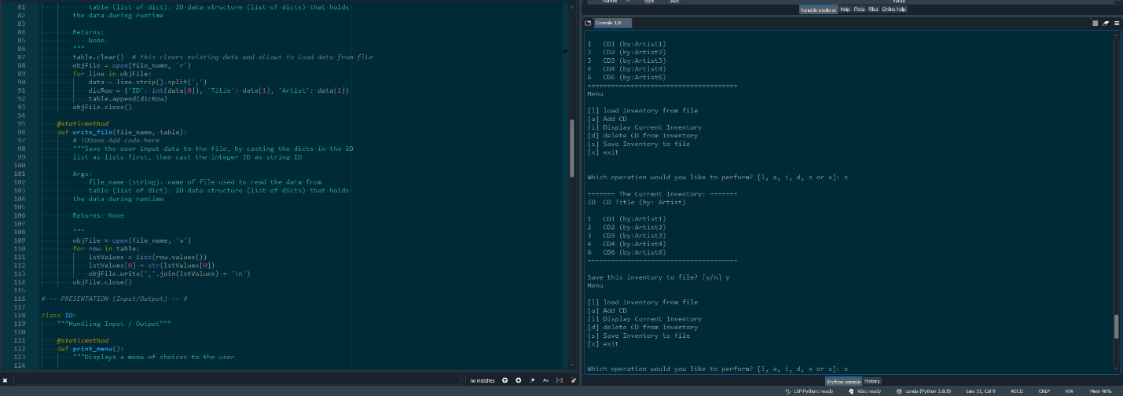

Figure - working in spyder

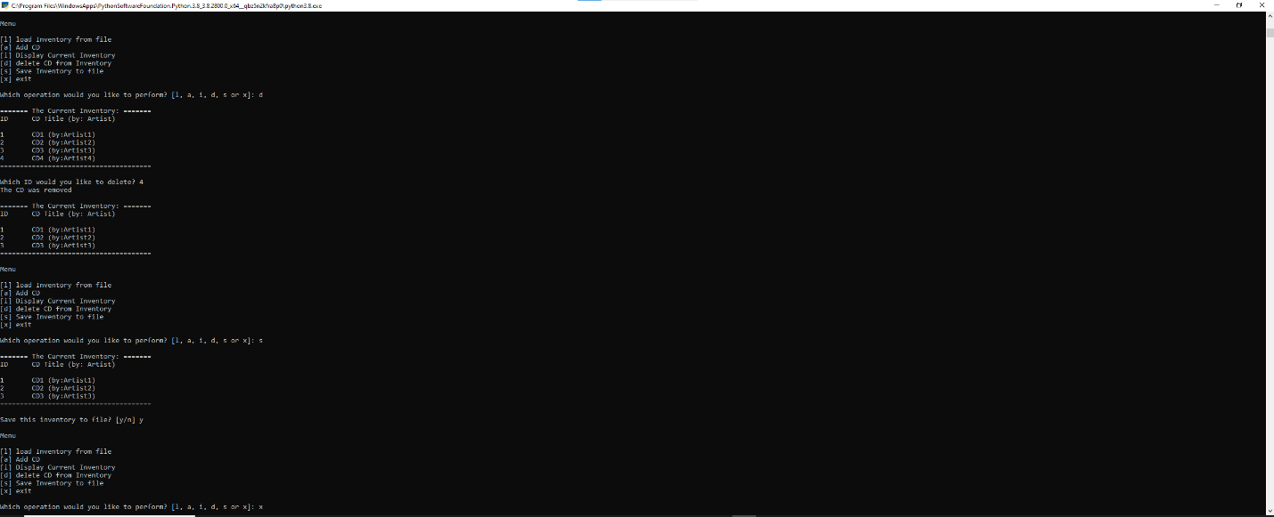

Figure - working in the terminal

Topic 4: Doubt

My doubt is why use unpacking of tuples between the function of adding CD from user input, and the function of turning the user input data to a dictionary and save this dictionary in a 2Dlist. Specifically the “IO.input_data() “ function and the “DataProcessor.add_table(dicRow, lstTbl)” function in my final codes. Does it relate to using variables as arguments and using return values? Like I need to have something to catch the ‘return values’ from the function of adding CD from user input? I also need to have something to pass on to the function of making the user input data to be saved in a 2Dlist? Or, it relates to “Multiple Return Values”? (P6)

### Summary

This week could be summarized as: I feel that I have learned a lot, but not sure precisely what it is and how to use them. But, the moment I found my final codes work, I was very excited and proud. That feeling is very rewarding.