<Jingyin Chen (Seline)>

<2021-Aug-29>

<Foundations of Programming (Python)>

<Assignment 08>

### Step 6 - Document your knowledge

### GitHub link to this week’s assignment:

<https://github.com/SelineCCC/Assignment_08>

### Introduction

This week’s concepts are hard, but the assignment is relatively easier, which means, I really don’t think everything in the script is in its right place or right form. For example, I did not use any Field strings. And I did not run into problems asked about by one of us (Matthew Penny) in the Friday class. I am having scratchy feelings but, whatever, it’s a learning process.

Topic 1: Concepts

I understand that I need to be patient before fully knowing what objects are and all the concepts of this module. However, I still did not understand any of the them after reading the materials and watching the video for the first time. Only after second-time reviewing everything plus the textbook that I have some ideas. I even watched some online python videos in Chinese (my first language) to cross-learning the concepts.

So far, I used metaphors to help myself understanding the concepts. I pictured a program as a story, and classes are elements of the story such as characters and plots. In this case, each characters have the ‘Fields’ like character-settings that exist throughout the story and constructors, decorators, methods to make this character real. And every element could be seen as an ‘object’. However later I still got lost and … just paused here to do the assignment first.

Topic 2: __str__(self): …? Properties …?

As I finished the codes, I realize I did not use the ‘__str__(self):’. I checked the variable explorer and it seems like the datatype of ‘cd_id’ from the input is already a string. In this case, I am not sure where to use the __str__() method.

Also, I am not sure how the ‘Properties’ of class CD work with the whole script.

I did use these properties:

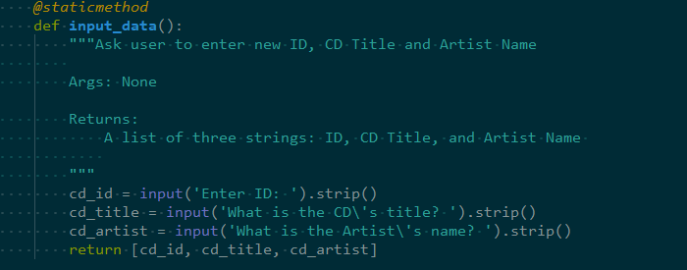

Figure 1 – Properties doubt

But, not seeing how they are functioning. Is it like the error handling should be placed in the ‘setter’ codes?

Topic 3: Final Result

Below are how the final codes work in Spyder and the terminal:

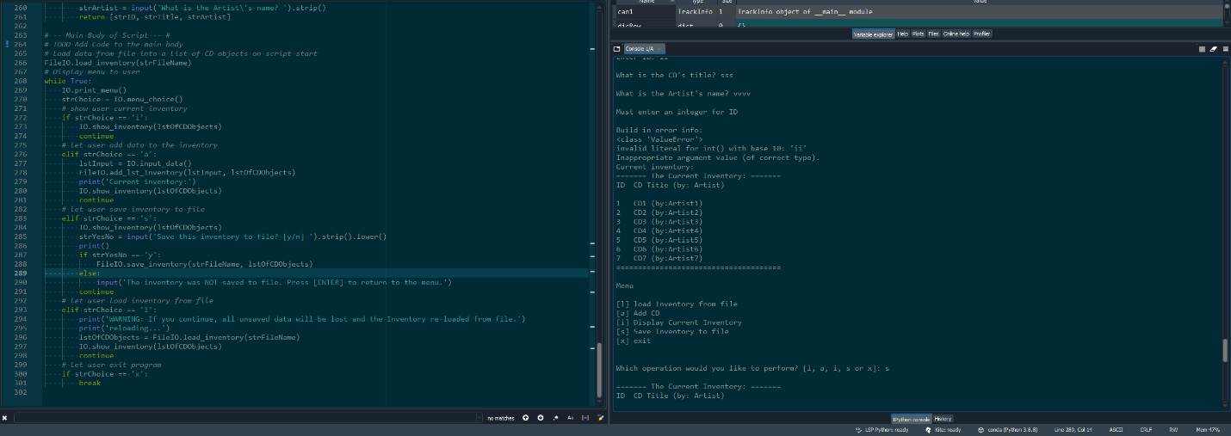

Figure - working in Spyder

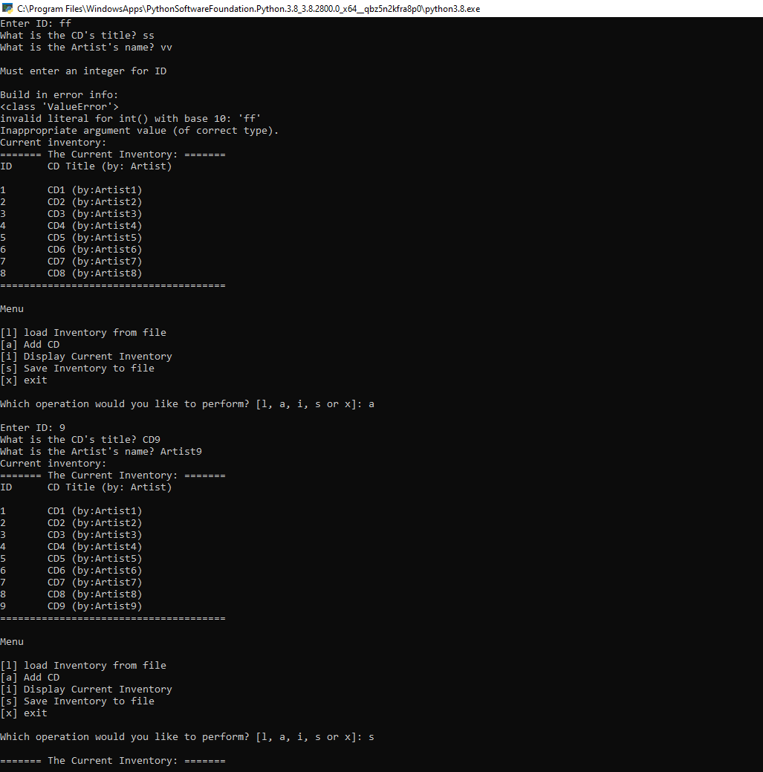

Figure - working in the terminal

Topic 4: Doubt

First Doubt:

In the script main body, do we still need to put the ‘else: print(‘General Error)’ since we already have the error handling in the menu_choice()?



Figure - else in the main body



Figure - error handing in the menu_choice()

Second Doubt:

I think I missed some part from our class. I’m not sure what should fill in after the ‘->’ in the docstring. I am guessing it is the ‘product’ or ‘result’ of the that specific class? Will ask in our next class.

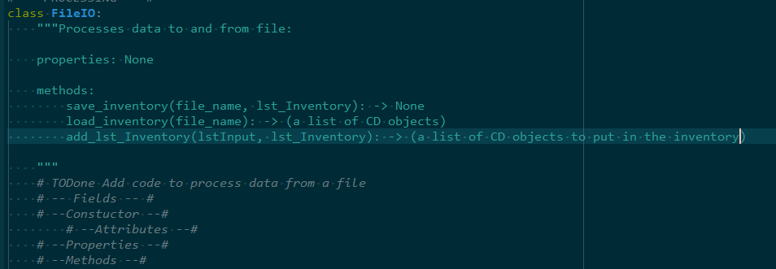

Figure - docstring doubt

### Summary

This week’s concepts are so hard but very rewarding. So far I have a feeling that all these new concepts is to enhance our control to the codes? Like having them to better control the datatypes, transformations of the variables especially what they are in the memories? I just have many doubts but not sure how to put them in specific questions. Hope things will be clear for me like for your later in the certificate class…