SELINE BOWENS

CST-150  4/5/2024

Activity 5 part 1

Seline Bowens

CST-150

Activity 5 part 1

4/5/2024

**Flowchart of application.**

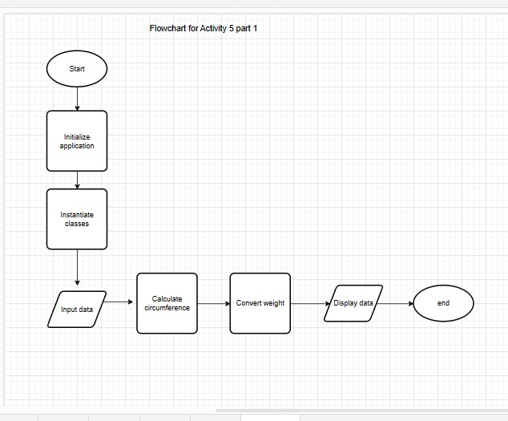

Start the program, initialize application by setting up the main form then create instances of the dog class. Data input for dog attributes follows. Then circumference of the neck is calculated using circumference method and converted into centimeters. The weight is then converted to kilograms. The data is then displayed on a DataGridViewto show the dog’s attributes. End the program.

Seline Bowens

CST-150

Activity 5 part 1

4/5/2024

**UML of the class.**

The dog class has the following field type: Name, NeckRad, Color, Weight, and Sit. The method type include; +Dog() and +Dog (name: string, which is a string representing the dog’s name, neckRad: double and weight: double which are doubles representing the radius of the dog’s neck and the dog’s weight respectively. color: string which is a string representing the color of the dog and sit: bool which is a Boolean) representing whether the dog can sit or not.

**Screenshot of the solution explorer with N-Layer expanded showing the form and class.**

**Screenshot of the form before populated.**

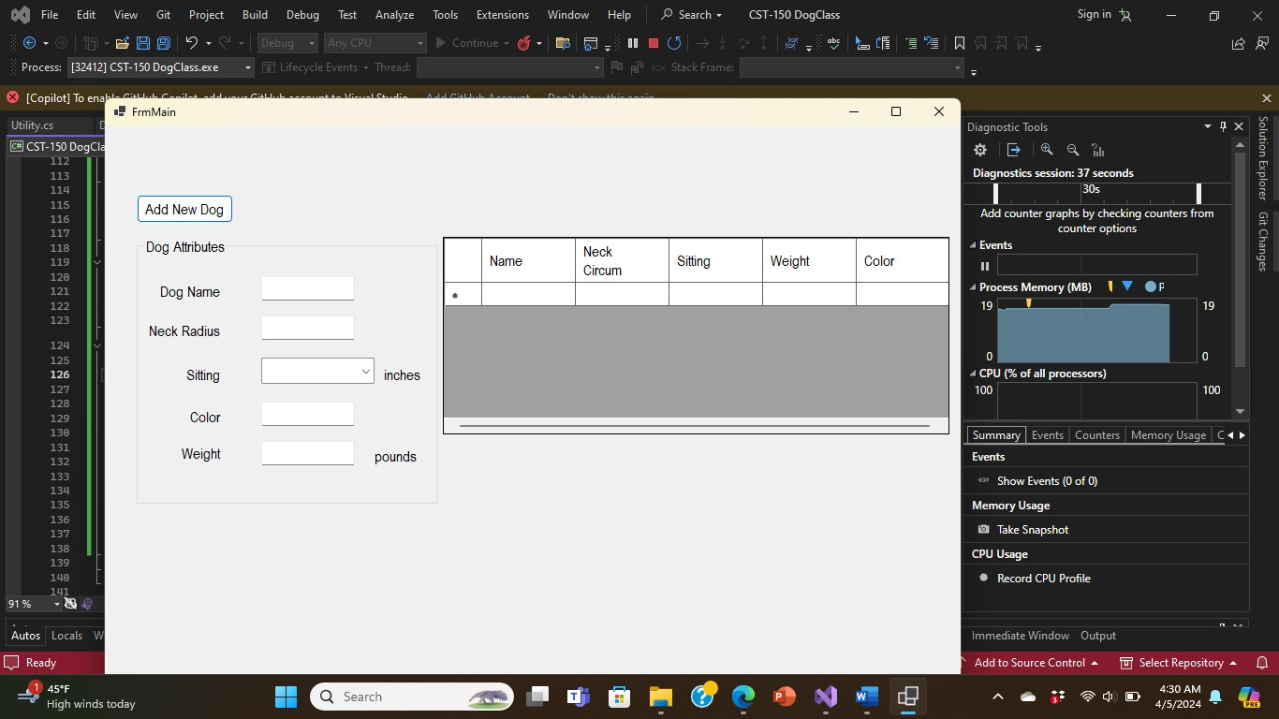

**Screenshots of the form after populated.**

Seline Bowens

CST-150

Activity 5 part 1

4/5/2024

**Screenshot(s) of the code behind FrmMain.**

The code contains a constructor that initializes the form by calling InitializeComponent(). It also sets the visibility of a label named lblErrorMessage to false. Form Load Event Handler (FrmMainLoadEventHandler) is executed when the form loads. The Event Handler (BtnAddNewDog_ClickEvent) is triggered when the user clicks a button.

Seline Bowens

CST-150

Activity 5 part 1

4/5/2024

**Screenshot(s) of the code for dog class.**

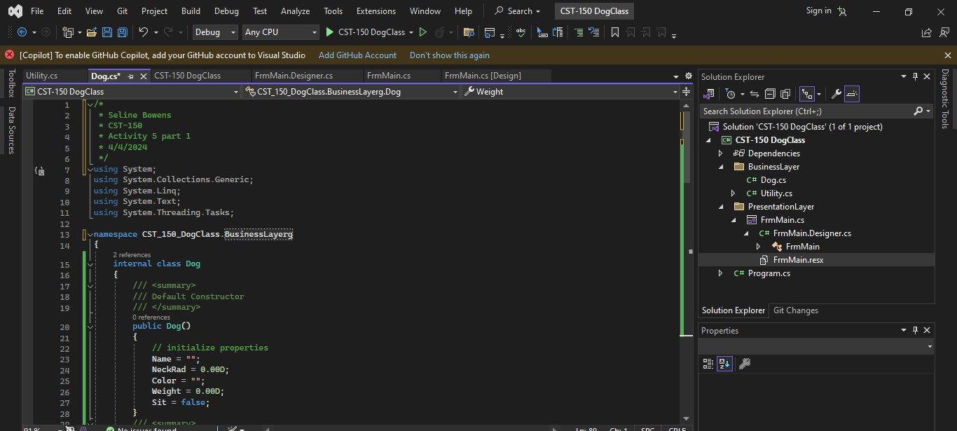

This code defines a Dog class with properties for dog attributes (name, neck radius, color, weight, and sitting status), constructors for initialization, and methods to calculate circumference and weight.

The Dog class contains a default constructor which has no parameters and initializes default values for the properties, and a Parameterized constructor which initializes the properties with the provided values. This constructor allows custom initialization of the Name, Neckrad, Color, Weight, and Sit properties. The code has two methods which are CalCircumference() and CalWeight() which calculates the neck circumference and weight of the dog.