## Instruction for programming: Competitive Sampling Game with a diverse option quantity:

## ­

1. **Settings:**
2. 6 players enter the lab and each player is sited individually in front of a computer.
3. The players are randomly assigned to two groups of 3 players each. The competition is within these groups, meaning the players compete against the other members of the group they are assigned to. The players remain in the group they are assigned to throughout the whole game.
4. Note that the players are competing against each other blindly, thus they do not know which are the players they are competing against (also they do not communicate with each other verbally throughout the whole experiment).
5. **First Screen- subject’s details:** 
   1. The detail collection screen is the first screen seen by players.
   2. There are three fields to fill:
6. Subject number ((מספר נבדק- it should be a three digits number. Each of the subjects in the experiment gets a different number that the experimenter gives them.
7. Subject age (גיל נבדק) - two digits number
8. Gender (זכר/נקבה)- radio button for either choice.­­
   1. All fields should be filled before it is made possible to continue to the next screen.
9. **Second Screen- Instruction Screen:**
   1. Before the game begins each player sees the following instructions.

**הוראות:**

ברוכים הבאים למשחק הכפתורים רב המשתתפים,

במשחק זה הולכים להיות 90 סבבים. בכל סבב, מתוך ארבעה כפתורים מטרתכם היא לבחור את הכפתור שלדעתכם תרוויחו ממנו את הסכום הכספי הגבוה ביותר. לפני שתבחרו בכפתור, תוכלו ללחוץ על הכפתורים ולראות את הסכומים השונים שהם מניבים. שלב זה מכונה שלב הדגימה. כאשר אתם מרגישים שהחלטתם איזה כפתור אתם מעדיפים תעברו לשלב הבחירה בפועל. לאחר שכל המשתתפים בחרו בכפתור תוצג תוחלת הכפתור שבחרתם, המהווה עבורכם את תוצאת הסיבוב.

אבל שימו לב, עוד שני שחקנים מתחרים איתכם על הכפתורים. בחירה של שחקן אחר בכפתור, תמנע משאר השחקנים את הבחירה בו. כלומר, אם משתתף אחר בחר בכפתור מסויים לפני שהגעתם לשלב הבחירה – לא תוכלו לבחור בכפתור זה. בנוסף, לא בכל הסבבים כל הכפתורים יהיו זמינים לכם. בחלק מהסבבים רק 2 כפתורים (מתוך ה-4) יהיו זמינים לכם ובחלק מהסבבים כל ארבעת הכפתורים יהיו זמינים.

התגמול על ההשתתפות במחקר יהיה סכום התוצאה שקיבלתם בשני סבבים שיבחרו רנדומלית בסוף המשחק ויוכפלו ביחס המרה של 0.6.

לפני שהמשחק יתחיל תתנסו בשלושה סבבי ניסיון שאינם משוחקים על כסף אמיתי.

לחץ המשך להתחלת סבבי הניסיון.

* 1. After reading the instructions and pressing continue the players need to wait for all the other players in their group to press continue and are moved to the three practice rounds. The values for the three practice rounds are in different sheet in the same excel file named- “practice values”. In each one of the practice round a different player gets to play the full choice role.
  2. After the practice rounds, the players see a screen with the following message:

תמו סבבי הניסיון, לחץ המשך כדי להתחיל במשחק האמיתי (ממנו יידגמו תשלומייך על ההשתתפות במחקר).

1. **A Round:**
2. In a round each player sees four buttons.
3. Each round has two phases
   * 1. Sampling Phase: in this part each player can sample with replacement from the available buttons. By pressing the buttons, a player sees an outcome either a high or a low outcome drawn from the selected button’s distribution (detailed in the excel file) and displayed for Showtime seconds (initial value Showtime=1.5 seconds). Before sampling another button (or making a final choice) the player has to wait for all the other player to sample (or choose). Every time a player samples it counts as a turn.
     2. Choice Phase: Each player must choose the button which he believes (based on the sampling he has done in the sampling phase) has the highest Expected Value. Every time a player makes a final choice it also counts as a turn. After choosing the player see the EV of the button chosen (this is his current round’s payoff) and the button immediately becomes unavailable to the other players regardless if they are in the choice phase or the sampling phase. The chosen button EV (which is the outcome of a round) is presented for ShowTimeEV (initial ShowTimeEV= 2 seconds). In the case that two players chose the same button at the same turn, there should be a random toll. The player that wins get its payoff (its EV), and the player that loses gets a message –

"שחקן אחר בחר באפשרות זו לפניך, תוכל להמשיך לדגום לפני שתבצע בחירה נוספת".

And is moved back to the sampling phase.

In the case a player has only two options and one of them was chosen by another player the player gets the other option outcome (it is showed on the button), with a message as the ppt.

* 1. These values define each of the options in a round and presented by four buttons (again see excel file):

1. **Expected Value** (EV1, EV2, EV3, EV4) - The average value which is expected to be yielded when pressing a button infinitely. In the choice phase this is the payoff that a player sees when choosing a button.
2. **High outcome** (High1, High2, High3, High4)- and **Low outcome** (Low1, Low2, Low3, Low4)- When pressing a button only two outcomes can be sampled- a high outcome or a low outcome.
3. **Phigh** (Phigh1, Phigh2, Phigh3, Phigh4): Probability High outcome- The probability of the high outcome to be sampled when sampling from a button.
4. **Plow** (Plow1, Plow2, Plow3, Plow4): Probability Low outcome- The complementary probability to the Phigh (Plow=1-Phigh)

*The option placement should also be completely randomized! Meaning for example Option 1 **shouldn’t** always be presented by the first button from the left.

1. **The Game Structure:**
2. The game has Nrounds rounds (initial value of the parameter Nrounds should be 90. (see excel file attached):
3. There are 3 different environments- Nrounds/3 rounds each:

No rare events *Nrounds/3

Only rare events *Nrounds/3

Mixed *Nrounds/3

1. There are also two types of outcome values- high and low values. For each environment there are Nrounds/6 rounds of each outcome (low/high)
2. All Nrounds rounds should be **completely randomized** regardless of the outcomes type or the environments.
3. In each round a player sees 4 unmarked buttons each with a different hidden distribution (defined by its Expected Value, High, Low, Phigh and Plow).
4. Before each round each player is randomly assigned a different role. A role means the buttons from which the player can sample. Specifically, only one player can sample from all four buttons the other players are restricted. In every round, there are 3 roles:
5. FullChoice (FC): A choice between 4 buttons
6. LimitedChoice A (LCA): a choice between random two buttons. (Random 2 buttons)
7. LimitedChoice B (LCB): the two buttons that are not available to Partial Choice A. (FC-PCA=PCB).

A randomization can be done at any way as long as it follows the rules bellow (figure 1).

1. Each of the player role should be played 5 times in the following settings- No rare events with low values, no rare events with high values, only rare events with low values, only rare events with high values, mixed with low values, mixed with high values.
2. The following tables summarizes this section (given Nrounds=90):

|  |  |  |  |
| --- | --- | --- | --- |
|  | Environment | EV Type | Player roles |
| Rounds  X  90 | No rare events  X30 | Low Values X 15 | FC X 5 |
| LCA X 5 |
| LCB X 5 |
| High Values X15 | FC X 5 |
| LCA X 5 |
| LCB X 5 |
| Only rare events  X30 | Low Values X 15 | FC X 5 |
| LCA X 5 |
| LCB X 5 |
| High Values X15 | FC X 5 |
| LCA X 5 |
| LCB X 5 |
| Mixed  X30 | Low Values X 15 | FC X 5 |
| LCA X 5 |
| LCB X 5 |
| High Values X15 | FC X 5 |
| LCA X 5 |
| LCB X 5 |

1. **Final Round-**
2. Each player final payment is the sum of two randomly selected payoffs from the game, multiplied by ExchangeRate (initial value=0.6).
3. One of the final outcomes should be randomly selected from LowValues environment, and the other should be randomly selected from HighValues environment.
4. The final payment should be rounded two digits after point.
5. A hidden button should e placed for the experimenter to exit the game.
6. **Recording the data**
7. The variables: all variables should appear in each row in the output file. The output file name should include the subject number (figure 2).

* ID- Subject Number
* Age
* Gender- **Male= 1; Female=0**
* R: Round number from 1-90.
* T-Turn: מספר התור בתוך כול סבב #every time the player does an action- samples or chooses.
* RT (Round Time)- the count starts at the beginning of a round and ends when the player makes his choice, it is updated in the document every time a player makes and action (either choses or samples).
* E- Environment**: No Rare=1; Rare=2; Mixed=3**
* EVtype- Expected Value type: **Low=0 High=1**
* EV1: Expected Value of option 1.
* EV2: Expected Value of option 2.
* EV3: Expected Value of option 3.
* EV4: Expected Value of option 4.
* Nchoice: (FullChoice=1; LimitedChoice =0)
* O1: Option availability of button A: **yes=1; no=0.**
* O2: Option availability of button B: **yes=1; no=0.**
* O3: Option availability of button C: **yes=1; no=0.**
* O4: Option availability of button D: **yes=1; no=0.**
* OC: Option Choice: **Option 1=1, Option 2=2, Option 3=3, Option 4=4.**
* OU: Outcome of Option Choice (OC)-
* M- Mode: **Sample mode= 0, Choice mode=1**
* Fopt- final option choice (O1=1, O2=2, O3=3, O4=4; when not in final turn=0)
* לניסוי אינטרנטי- Browser: אופצינלי נדבר על זה..
* רזולוצית מסך של הנבדק: אופציונלי נדבר על זה

1. Extensions:

We would like to have few extension options, for follow-up experiments-

1. Forgone- in each round after the making a choice all the EV’s are presented to the player not just the EV he got.
2. An online version. Do you recommend any platforms? Mturk? Something more fit?

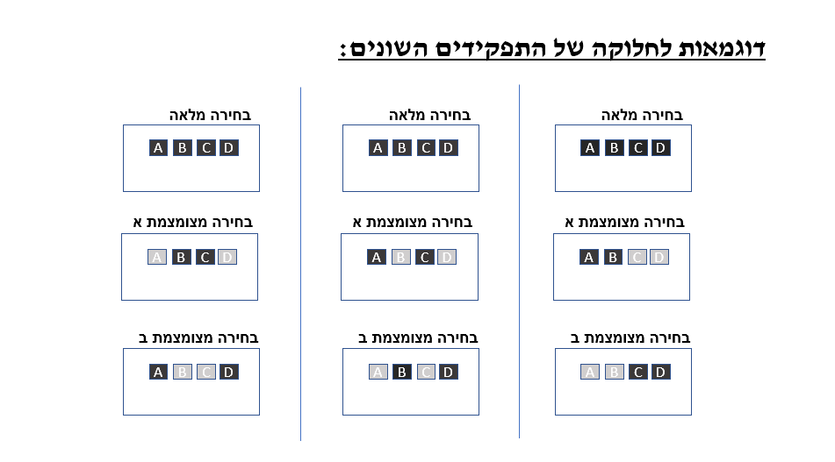Fig 1.

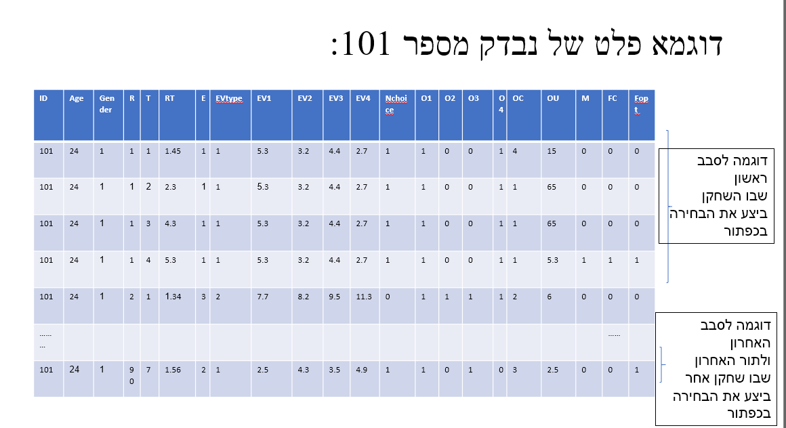Fig 2