OpenPaas Database API Client

User Guide

Table of content
Introduction 2
Installation 2
Execution 2
Linux 2
Windows 2
General Usage 2
Add a Database 3
Create an EntitySet 3
View an Entity 4
NoSQL Databases 4
Relational Databases 4
Create and Update an Entity 5
Delete an Entity 5
Technical Details 5

Introduction
The ODBAPI Client module is part of the larger ODBAPI project which aims to provide an easy way for developers to deploy and manage database solutions into the cloud.
The Client module provides an easy way to interact with the ODBAPI Core module: the REST webservice in charge of accessing the databases. Basically, it is just a front end GUI for the CRUD REST operations.

Installation
This is a web client written in pure JavaScript, there is no installation required, any modern browser on any platform will suffice.

Execution
However, ODBAPI doesn't support CORS specifications. So in order to work with this client using AJAX, you must use Google Chrome (or Chromium) with the flag "--disable-web-security".
This is due to the RESTlet framework (server side) which doesn't support CORS. It is planned in the next release, so this situation is temporary. You can see their detailed roadmap for more information about RESTlet next release.

Linux
In a terminal run:
$ chromium-browser --disable-web-security

Windows
An easy way to launch Google Chrome or Chromium with flags on Windows is to create a new shortcut and add the flag needed after the executable in the “Target” field (see below).

General Usage
The Client permits various interactions, listed below. Before making any action, you must specify a server address and port where an ODBAPI Core instance must be listening.

Add a Database
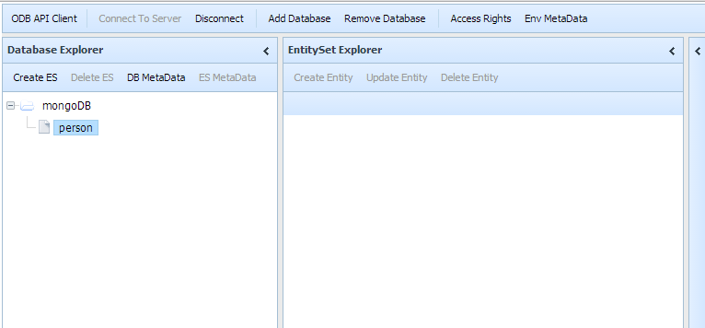

Create an EntitySet
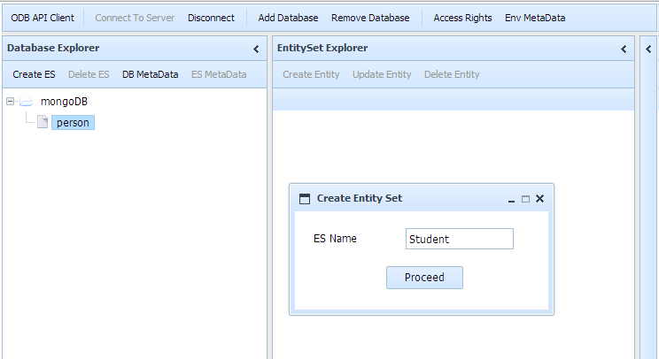

View an Entity

NoSQL Databases
NoSQL databases, with their special way of handling data, are displayed with a table of id paired with an Entity Viewer in “raw” JSON format.
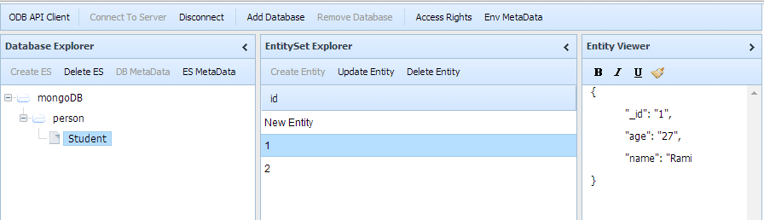

Relational Databases
Relational databases are displayed with a complete table, traditionally used for these.
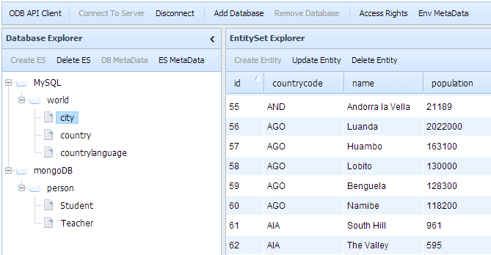

Create and Update an Entity
To add or update, you simply edit the JSON in the entity viewer and click update/create. These actions are not implemented yet for relational databases.
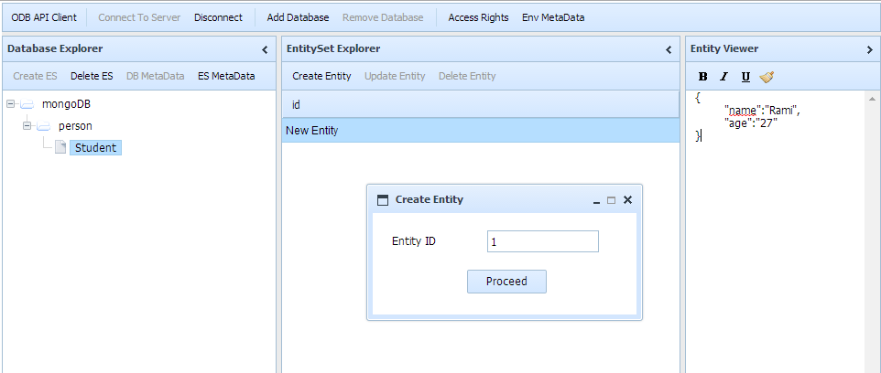

Delete an Entity
To delete an entity, select its id in the table and hit the “Delete Entity” button.

Technical Details
Source code is available at https://github.com/mvedrine/odbapi under the GPLv2 license.

