OpenPaas Database API Negotiation module

User Guide

Table of content
Introduction 2
Installation 2
Execution 2
General Usage 2
Technical Details 3

Introduction
The ODBAPI Negotiation module is part of the larger ODBAPI project which aims to provide an easy way for developers to deploy and manage database solutions into the cloud.
The negotiation module can be seen as the front end of ODBAPI. It is in charge of processing the user requirements regarding his database needs and proposing the best deployment solution through an XML manifest. The negotiation module's output will be then processed by the deployment module.

Installation
The Negotiation module is divided into two sub modules: the core, written in Java with Maven, and the GUI web client, written in HTML5/CSS/Javascript.
There is no specific installation procedure currently needed.

Execution
- For the web client, any modern browser on any system will do.
- For the core application, a JVM is of course needed. Currently, this module is not wrapped into a REST server, it is a classic program, the REST part is planned in the next iteration.

General Usage
The module is meant to be used through a small web client where you need to upload the user manifest (XML format).
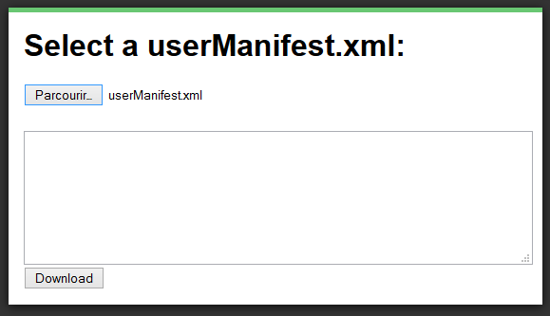
When uploaded, the negotiation will happen and the result will be displayed into the text area (XML format). It can be downloaded on your local hard drive for further processing.
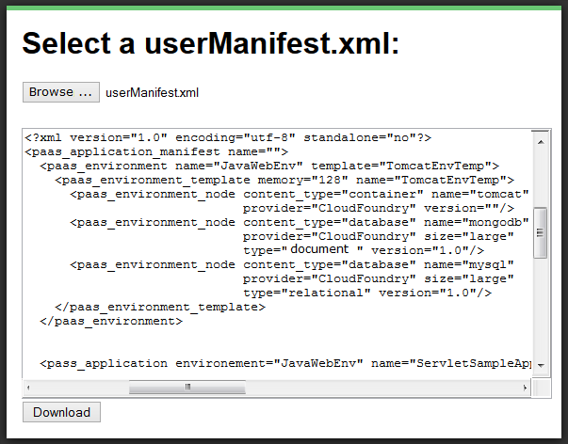

Technical Details
Source code is available at https://github.com/mvedrine/odbapi under the GPLv2 license.

