1.
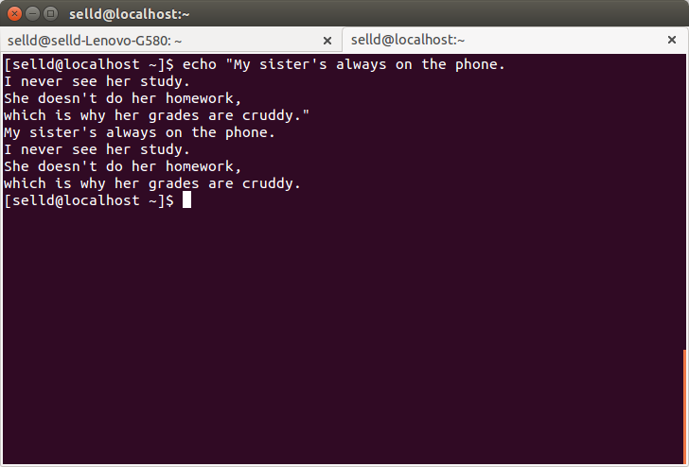
2.
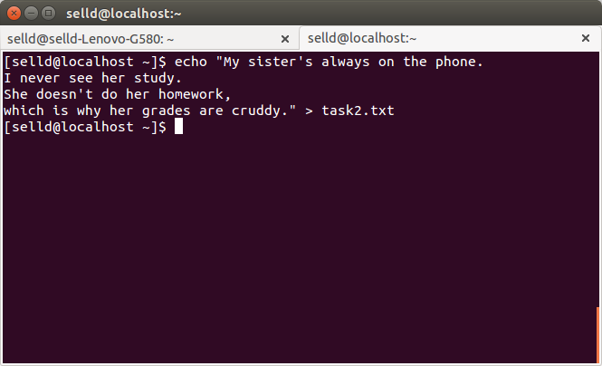
3.
[selld@localhost ~]$ cat task2.txt > task3.txt

4.
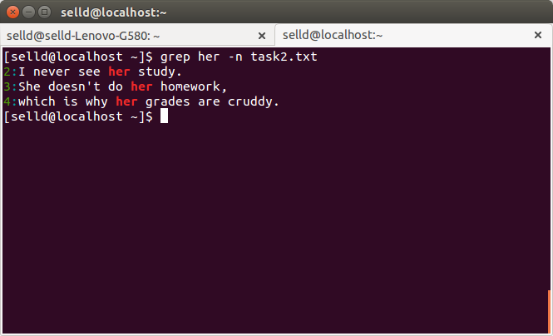
5.
[selld@localhost ~]$ ls /lib /lib64 -R | grep -E ".*dbus.*" | grep -E "\.so($|\.)" -v
6.
[selld@localhost ~]$ find /var/cache/yum -mindepth 1 -name "mirror*" -exec cat {} >> xxx.txt \;
7.
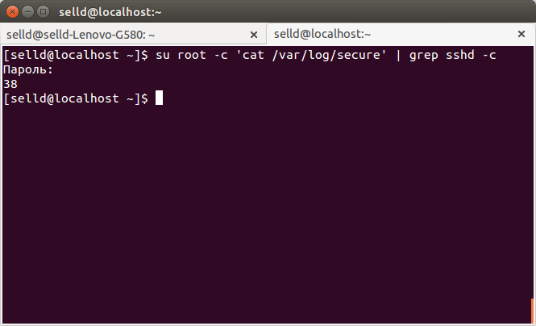

8.
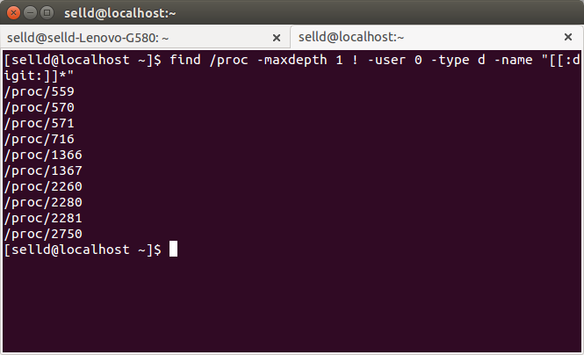

10.
[selld@localhost ~]$ cat xxx.txt | sed 's/http/ftp/g' > xxx2.txt
11.
[selld@localhost ~]$ awk 'NR%3' xxx2.txt > xxx3.txt
12.
[selld@localhost ~]$ diff xxx2.txt xxx3.txt > patch_xxx.txt
13.
[selld@localhost ~]$ patch xxx2.txt patch_xxx.txt
14.
[root@localhost home]# cp --preserve=mode,ownership /home/selld /home/tmp/ -R
15.
[selld@localhost ~]$ mkdir task && cp xxx.txt xxx2.txt xxx3.txt ~/task
16.
[root@localhost selld]# find /var/log -mindepth 1 -type f -name *.log -exec tail -n 5 {} \;
17.
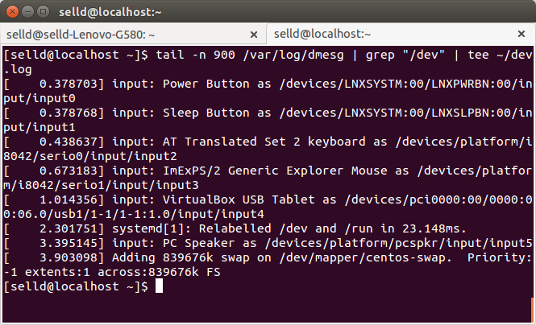
18.
[selld@localhost ~]$ touch fools_day_prank.txt -t 2004010000
19.
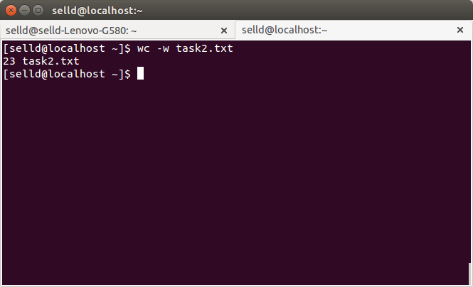

20.
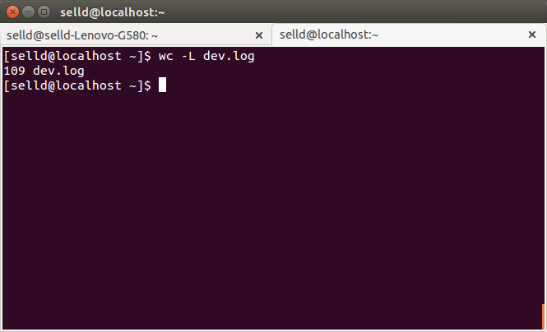
21.
[root@localhost selld]# cat /var/log/messages | cut -d' ' --complement -f1-3 > msg.log
22.
[root@localhost selld]# cat msg.log | sort | uniq -cd
23.
[root@localhost selld]# dmesg | grep -E '.*e1000.*[[:xdigit:]{2}:]{6}$' | cut -d' ' -f10 > hwadd
24.
selld@selld-Lenovo-G580:~$ sudo useradd t-user
selld@selld-Lenovo-G580:~$ sudo passwd t-user
selld@selld-Lenovo-G580:~$ su t-user
25.
t-user ALL=(root) NOPASSWD: /bin/ifconfig /bin/useradd
26.
[selld@localhost ~]$ chmod +x *.txt
27.
[selld@localhost ~]$ su root -c 'chown nobody:selld *log'
28.
[selld@localhost ~]$ ls /etc -Rhs

