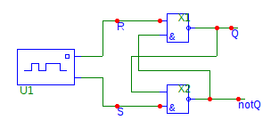

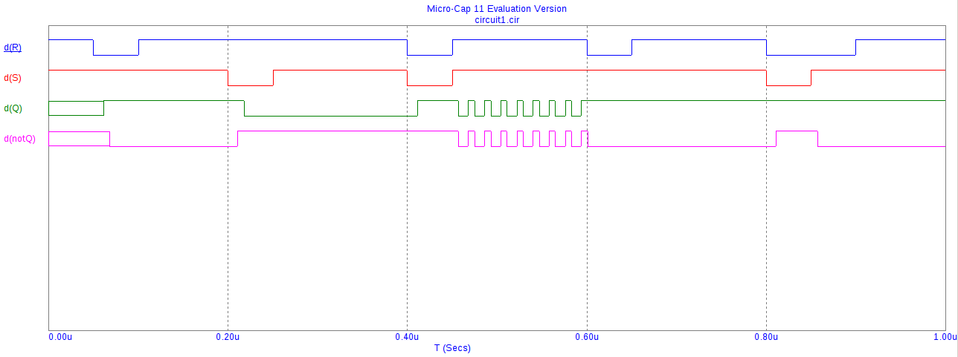
Digital Warning
Minimum clock width low violation at t=2.5e-008
Device X1.U1
Required minimum clock low width is 3.7e-008
Measured minimum clock low width is 2.5e-008

Digital Warning
Minimum clock width high violation at t=5e-008
Device X1.U1
Required minimum clock high width is 3e-008
Measured minimum clock high width is 2.5e-008

Digital Warning
D input setup time violation at t=1.5e-007
Device X1.U1
D input changed at 1.45e-007
Required D input setup time is 2e-008
Measured D input setup time is 5e-009

Digital Warning
Setup time violation at t=1.5e-007
Device X1.U4CON
Minimum setup time is 9e-009
Node 1D, measured setup time was 5e-009

Digital Warning
D input hold violation at t=1.51e-007
Device X1.U1
Clock changed at 1.5e-007
D input changed at 1.51e-007
Required D input hold time is 5e-009
Measured D input hold time is 1e-009

Digital Warning
*Hold time violation at t=1.51e-007
Device X1.U4CON
Minimum hold time is 5e-009
Node 1D, measured hold time was 1

