Preprocessing & EDA Report
Bayesian Hierarchical Model — Diabetes 130-US Hospitals Readmission Data

1. Dataset Overview
Source: Diabetes 130-US Hospitals dataset (1999–2008), loaded from the raw CSV file diabetic_data.csv.
- Raw shape: 101,766 rows × 50 columns
- Final cleaned shape: 96,436 rows × 48 columns
- Target: readmitted_30d (binary — 1 = readmitted within 30 days, 0 = otherwise)
- Grouping variable for the hierarchical model: medical_specialty (73 distinct categories; hospital ID is not present in this dataset)

2. Data Preprocessing
2.1 Missing Value Handling
The dataset encodes missing values as the string '?' rather than a true NaN. After replacing these with NaN, missingness was assessed and handled per column:
Column | % Missing | Action Taken
weight | 96.9% | Dropped
max_glu_serum | 94.7% | Dropped
A1Cresult | 83.3% | Filled as 'Not tested' category
medical_specialty | 49.1% | Filled as 'Unknown' category (grouping variable)
payer_code | 39.6% | Dropped
race | 2.2% | Rows dropped
diag_1 / diag_2 / diag_3 | ≤1.4% | Rows dropped

A1Cresult was kept rather than dropped despite 83.3% missingness, since whether HbA1c was tested at all is itself informative for readmission risk in this population. medical_specialty — the planned grouping variable — was kept with missing values folded into an 'Unknown' category rather than dropping ~49% of the dataset, preserving sample size for the hierarchical model.
2.2 Target Construction
The raw readmitted field had three classes: NO (53.4%), >30 (35.3%), and <30 (11.3%). This was binarized into readmitted_30d (1 = <30, 0 = otherwise), producing an 88.7% / 11.3% split — confirming a meaningfully imbalanced target that will need care during model evaluation.
2.3 Expired / Hospice Encounters
Discharge disposition codes corresponding to patient death or hospice transfer (codes 11, 19, 20, 21) were identified and removed, since these encounters cannot be readmitted by definition. This removed 1,616 rows (1.6% of the data); the target distribution shifted only marginally (88.7% → 88.5% / 11.3% → 11.5%), confirming the fix was necessary on principle even though its numerical impact was small.
2.4 Patient-Level Duplication
98,053 rows corresponded to only 68,630 unique patients (patient_nbr) — 29,423 rows (30%) were repeat encounters from returning patients. Repeat encounters from the same patient are not statistically independent, which can inflate model confidence and bias specialty-level estimates.
Decision: all encounters were retained rather than reduced to one per patient, to preserve sample size for the smaller medical_specialty groups (41 of 73 specialties have fewer than 50 encounters). This is documented explicitly as a limitation of the analysis rather than silently ignored.
2.5 Other Cleaning
- gender: one row with 'Unknown/Invalid' value was dropped (negligible, <0.001% of data)
- Checked for fully duplicate rows: none found
2.6 Final Cleaned Dataset
96,436 rows × 48 columns, zero missing values, saved to data/diabetic_data_cleaned.csv for use in all downstream modeling notebooks.

3. Exploratory Data Analysis
3.1 Readmission Rate by Medical Specialty
This is the central plot motivating the hierarchical modeling approach. It shows each specialty's 30-day readmission rate against its sample size (log scale).
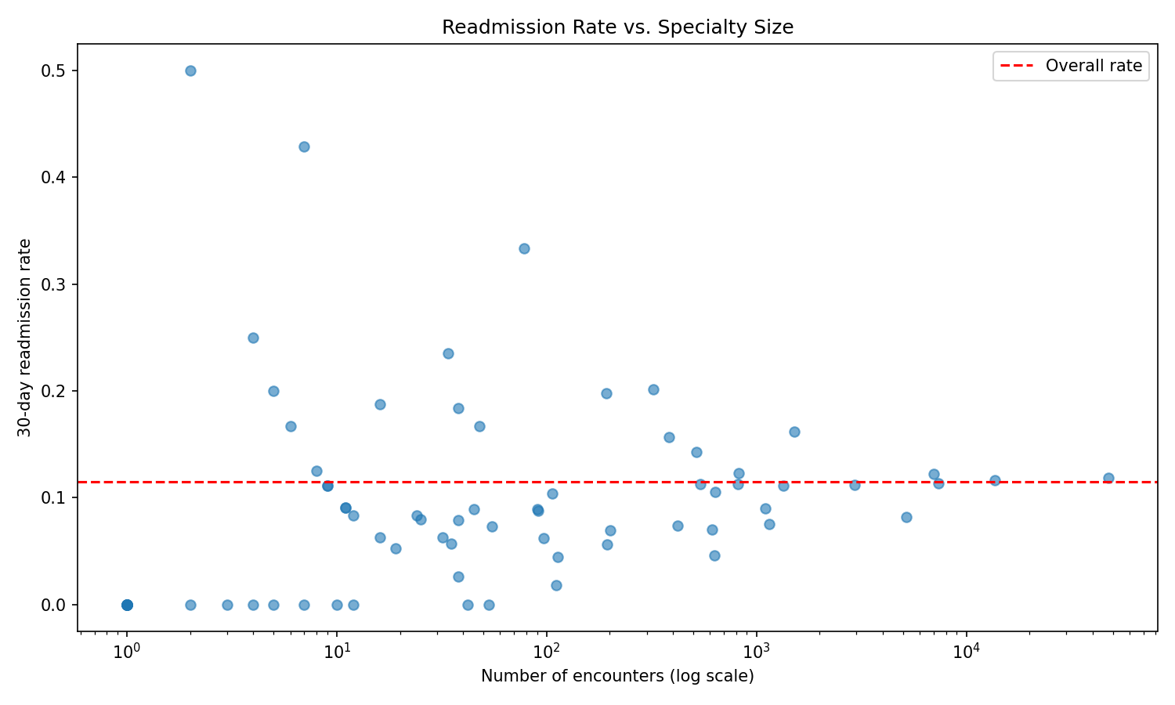
Figure 1. Readmission rate vs. specialty sample size. Small specialties show extreme, noisy rates; large specialties cluster tightly around the overall average (dashed line).
Small specialties (n < 20) show wildly variable rates — from 0% to 50% — reflecting noise rather than genuine risk differences. Large specialties (n > 1,000) cluster tightly in a 7–16% band around the overall average. This funnel pattern is the direct empirical justification for partial pooling: a no-pooling model would take small-specialty extremes at face value, while complete pooling would ignore real specialty-level variation entirely.
Selected specialty-level readmission rates:
Specialty | n Encounters | Readmit Rate
Unknown | 47,523 | 11.9%
InternalMedicine | 13,665 | 11.6%
Emergency/Trauma | 7,357 | 11.4%
Family/GeneralPractice | 7,004 | 12.2%
Cardiology | 5,163 | 8.2%
Surgery-General | 2,939 | 11.2%
Nephrology | 1,512 | 16.2%
Oncology | 323 | 20.1%

Two specialties stand out with enough volume to be a real signal rather than noise: Oncology (n=323, 20.1%) and Nephrology (n=1,512, 16.2%) — both clinically plausible as higher-risk populations, and worth watching once the hierarchical model produces proper credible intervals.
3.2 Candidate Predictor Distributions
Age, time in hospital, number of diagnoses, and number of medications were examined against readmission status.
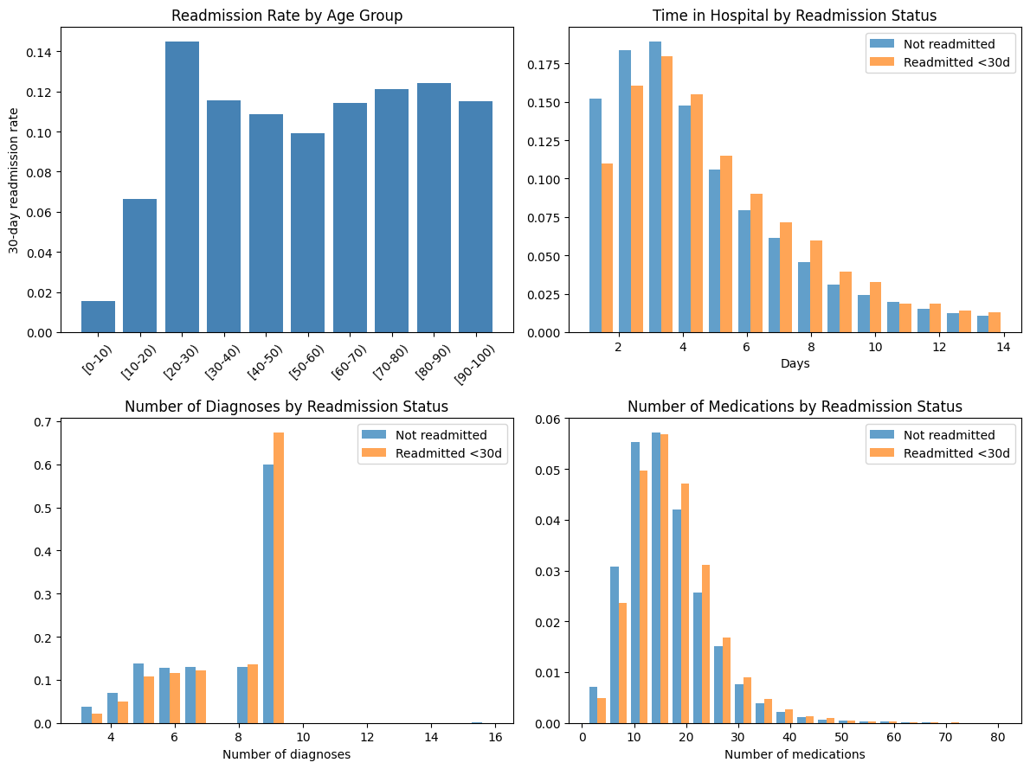
Figure 2. Readmission patterns across age groups and three continuous predictors, split by readmission status.
Age shows a non-monotonic pattern: lowest readmission risk for children ([0-10), 1.6%), a genuine elevated rate for [20-30) (14.5%, n=1,471 — large enough to be a real effect, not noise), then a relatively flat 10–12.5% band from [30-40) onward. The [20-30) elevation is plausibly linked to a higher share of Type 1 diabetes or less consistent follow-up care in that age band.
Mean values for the three continuous predictors, split by readmission status:
Predictor | Not Readmitted (mean) | Readmitted <30d (mean)
time_in_hospital (days) | 4.37 | 4.79
number_diagnoses | 7.47 | 7.75
num_medications | 15.96 | 16.98

- time_in_hospital: modest but consistent difference (4.79 vs. 4.37 days)
- number_diagnoses: clearest signal of the three — readmitted patients are disproportionately concentrated at the maximum diagnosis count (67% vs. 60% at 9 diagnoses)
- num_medications: subtle rightward shift for readmitted patients (16.98 vs. 15.96)
number_diagnoses and age (including the [20-30) elevation) look like the strongest candidate fixed effects; time_in_hospital and num_medications are weaker but still worth including.
3.3 Correlation Between Continuous Predictors
Checked for multicollinearity among the five continuous predictors under consideration before finalizing the fixed-effects specification.
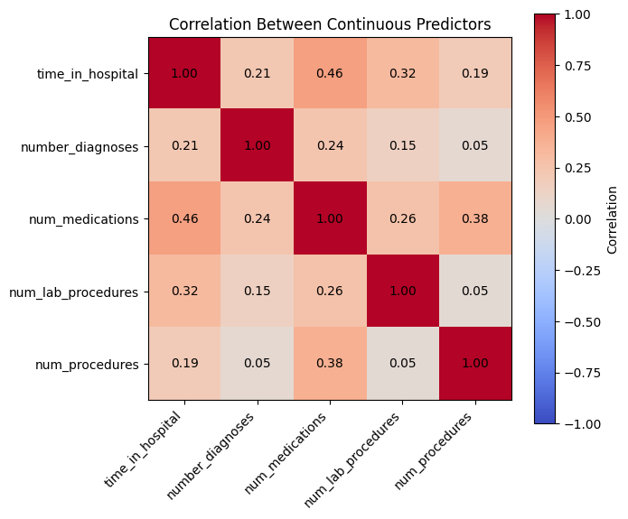
Figure 3. Correlation matrix across the five continuous predictors.
No serious multicollinearity: the highest correlation is time_in_hospital with num_medications at 0.46 (moderate, expected — longer stays involve more medications), well below the range that would threaten stable coefficient estimates. All five continuous predictors can be safely included together in the model.

4. Key Takeaways
- Final dataset: 96,436 rows × 48 columns, fully cleaned, zero missing values.
- Grouping variable (medical_specialty, 73 categories) shows exactly the small-n noise / large-n stability pattern that motivates a hierarchical model over no-pooling or complete-pooling alternatives.
- Target is imbalanced (11.5% positive class) — model evaluation will need to look beyond raw accuracy.
- Strongest candidate fixed effects: age, number_diagnoses; weaker but retained: time_in_hospital, num_medications, num_lab_procedures, num_procedures.
- Documented limitation: 30% of rows are repeat encounters from returning patients, introducing some non-independence between rows — retained for sample size, noted for the final write-up's limitations section.

