UNITED STATES INTERNATIONAL UNIVERSITY–AFRICA
School of Science and Technology
DSA 4050-XA: Deep Learning
Recognising Kenyan Sign Language from Smartphone Photographs: Deep Learning versus Classic Machine Learning
Term Paper
Student: Selmah Tzindori
Student ID: 669602
Lecturer: Dr. Alex Wambua
Date: November 2026
Word count (main text, excluding tables, captions and references): 1,795

Abstract
Kenyan Sign Language (KSL) is the language of Kenya’s Deaf community, yet few hearing Kenyans understand it. This paper tests whether deep learning can recognise nine everyday KSL signs from ordinary smartphone photographs, and compares it with classic machine learning on identical data. Using 6,238 cleaned images from the Zindi KSL Classification Challenge, eight classic models (raw-pixel and HOG features with four classifiers) and four convolutional neural networks (CNNs) were trained on the same stratified, group-aware split. The best classic model, HOG with a support vector machine, reached 60.0% test accuracy. The best deep model, EfficientNetB0 fine-tuned in three stages, reached 85–86% (95% CI 82.7–87.2%) and 94.7% top-2 accuracy. Grad-CAM shows the network attends to the hands, and robustness tests show it tolerates darkness and rotation far better than the classic model but is sensitive to heavy blur. An interactive dashboard makes the models and findings explorable.

1. Introduction: why deep learning for KSL
The Constitution of Kenya (2010, Art. 7(3)(b)) commits the State to promoting the development and use of Kenyan Sign Language. In practice, communication between Deaf and hearing Kenyans in clinics, schools and offices still depends on scarce interpreters. Tools that recognise signs automatically could support learning apps for hearing people and assistive services; recognising isolated signs from photographs is a realistic first step.
This is a problem where deep learning is justified rather than fashionable, for three reasons:
- High variation, subtle differences. Photos differ completely in signer, skin tone, clothing, background, lighting and camera angle, while two signs may differ only in open versus closed hands or finger positions. Hand-crafted features such as HOG respond to every edge, including patterned clothing; CNNs learn which visual patterns matter directly from labelled examples.
- Transfer learning makes small data viable. Networks pretrained on ImageNet (Deng et al., 2009) already detect edges, textures, skin and finger-like shapes, so roughly 4,400 training images are enough to adapt them.
- Decisions can be inspected. Grad-CAM (Selvaraju et al., 2017) shows where a CNN looks, so we can check that it reads the hands rather than shortcuts such as background or image shape.
The hypothesis is therefore that deep learning substantially outperforms classic machine learning on the same data, and the paper tests it with a controlled comparison.

2. Dataset
The images come from the Kenyan Sign Language Classification Challenge hosted on Zindi (Zindi Africa, n.d.). Zindi no longer allows downloads, so the data were mined from a public Kaggle re-upload (awsaf49, n.d.), downloaded with the Kaggle API into Google Colab and backed up to Google Drive. The re-upload states no licence, so both sources are credited.
The download contained 8,931 files: 6,249 labelled images and 2,679 unlabelled competition test images, which were excluded because their labels were never released. Every image was opened and checked: none were missing or corrupt. The nine signs (Church, Enough/Satisfied, Friend, Love, Me, Mosque, Seat, Temple, You) are perfectly balanced at 694–695 images each, so random guessing scores 11.1%. Images are torso-framed phone photos taken at home, 720×1280 portrait (79%) or 1280×720 landscape (21%), with faces mostly out of frame (Figure 1).
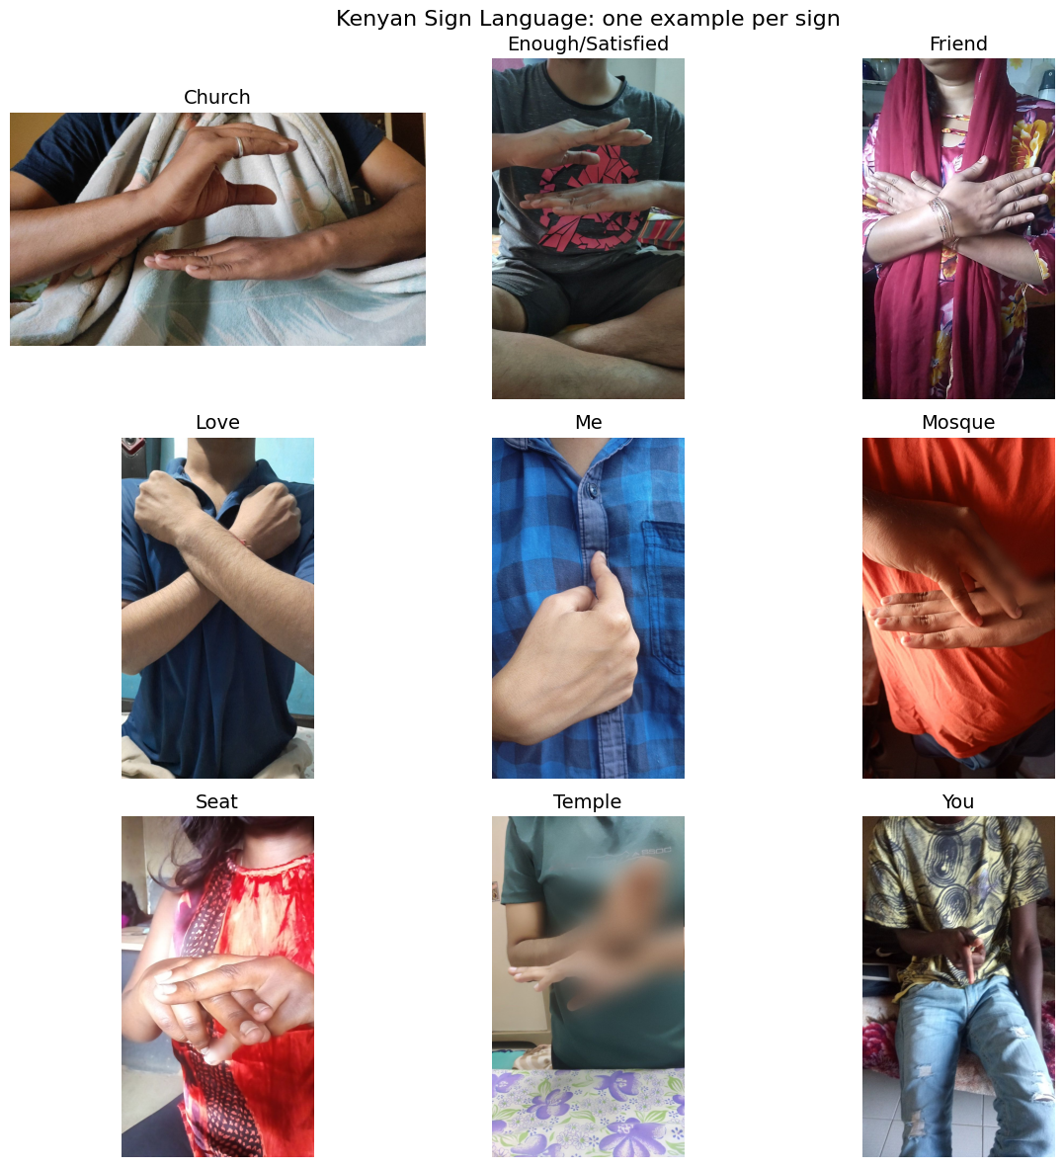
Figure 1. One example of each of the nine KSL signs.
Exploratory analysis produced four findings that shaped the method:
- Orientation shortcut. The share of landscape photos varied by sign (15.3% for Church to 28.4% for Love), so a model could partly guess the sign from the image shape.
- No quality shortcut. Median brightness (105–109), contrast (51–55) and sharpness were almost identical across signs.
- Same signers across signs. No exact duplicates existed and only 25 images (0.4%) had near-duplicates (perceptual hashing), but these revealed the same person photographed performing several signs.
- Look-alike signs. Average images per sign differ only faintly; Friend and Love both cross the arms, and Church, Enough/Satisfied and Mosque all use flat stacked hands.
Finally, a skin-colour screen ranked suspicious images for manual review, and 11 images showing no sign (blank surfaces, floors, fabric, a street scene) were removed, leaving 6,238. The screen itself under-detected the hands of darker-skinned signers, a known weakness of fixed colour rules, so every removal was decided by eye.
Table 1. Dataset summary after cleaning.
Property | Value
Source | Zindi KSL Classification Challenge (via Kaggle)
Signs (classes) | 9, balanced (691–695 each after cleaning)
Images used | 6,238 (11 invalid removed)
Split (train / validation / test) | 4,362 / 935 / 941
Input to models | Centre square crop, 224 × 224 RGB

3. Methods

3.1 Preprocessing and split
Every image was centre-cropped to a square and resized to 224×224 pixels. The square crop removes the orientation cue, and the hands sit in the centre of almost every photo. The data were split 70/15/15, stratified by sign and group-aware: near-duplicate groups were kept within a single set to prevent leakage. All model choices used the validation set; each model was scored on the test set exactly once.

3.2 Classic machine learning
Two feature sets were built from greyscale images: raw 32×32 pixels (1,024 values) and HOG (Dalal & Triggs, 2005) on 64×64 images (9 orientations, 8×8-pixel cells; 1,764 values). Each was standardised and reduced with PCA to 150 components, then classified by Logistic Regression, an RBF-kernel SVM, a Random Forest (300 trees) and k-Nearest Neighbours, with key settings tuned on the validation set.

3.3 Deep learning
Three architectures were trained in Keras/TensorFlow on a Colab T4 GPU:
- Custom CNN from scratch: four double-convolution blocks (32–256 filters) with batch normalisation, global average pooling and dropout; 1.18M weights; up to 60 epochs.
- MobileNetV2 (Sandler et al., 2018), pretrained on ImageNet: a frozen base with a new 9-class head, then fine-tuning of the top 40 layers at a learning rate of 10⁻⁵.
- EfficientNetB0 (Tan & Le, 2019): the same two stages, plus a third stage that unfroze the top 100 layers because the curves were still rising.
All networks used random flips, rotation (±10°), zoom (±15%), translation (±10%) and brightness/contrast changes (±20%) during training, plus early stopping and learning-rate reduction based on validation performance.

3.4 Evaluation
Models were compared on test accuracy and macro-F1. For the two best models we added 95% bootstrap confidence intervals (2,000 resamples; Efron & Tibshirani, 1993), top-2 accuracy, confusion matrices, Grad-CAM heatmaps, and accuracy on test images altered by blur, darkness, rotation and noise.

4. Results

4.1 Deep learning versus classic machine learning
Every deep model outperformed every classic model (Table 2). The best, EfficientNetB0 with extended fine-tuning, reached 86.0% test accuracy (macro-F1 0.859) against 60.0% for HOG + SVM, a gain of 25.9 percentage points. The bootstrap intervals (82.7–87.2% versus 57.1–63.2%) do not overlap, so the gap is not an artefact of the test split.
Table 2. Test performance of all twelve models (sorted by test accuracy).
Model | Type | Train acc. | Test acc. | Macro-F1 | Training time
EfficientNetB0 (extended fine-tuning) | Deep | 95.8% | 86.0% | 0.859 | 10 min*
EfficientNetB0 | Deep | 90.4% | 84.9% | 0.849 | 10 min
CNN from scratch | Deep | 93.3% | 84.3% | 0.843 | 42 min
MobileNetV2 | Deep | 93.4% | 81.6% | 0.817 | 7 min
HOG + SVM (RBF) | Classic | 100% | 60.0% | 0.603 | 20 s
HOG + k-NN | Classic | 64.3% | 55.8% | 0.558 | 1 s
HOG + Logistic Regression | Classic | 62.4% | 52.3% | 0.524 | 3 s
HOG + Random Forest | Classic | 100% | 51.8% | 0.516 | 19 s
Raw pixels + SVM (RBF) | Classic | 99.7% | 35.0% | 0.352 | 26 s
Raw pixels + k-NN | Classic | 38.9% | 27.5% | 0.271 | 1 s
Raw pixels + Random Forest | Classic | 100% | 26.8% | 0.262 | 26 s
Raw pixels + Logistic Regression | Classic | 28.0% | 20.6% | 0.203 | 2 s

* Extra stage only, after the 10-minute EfficientNetB0 run. Random-guess baseline: 11.1%.
Three further patterns stand out. First, features matter more than the classifier: HOG beats raw pixels by 20–32 points with every algorithm. Second, classic models memorise: SVM and Random Forest reach 100% training accuracy but only 52–60% on unseen photos, whereas augmentation kept the deep models’ train–test gap near 9–10 points. Third, pretraining needs fine-tuning: with frozen ImageNet features validation accuracy plateaued around 68–74%, and unfreezing the top layers added 12–16 points. The scratch CNN came close (84.3%) with the fewest weights, but needed four times longer to train and had not fully converged after 60 epochs.

4.2 Which signs improved
Deep learning improved every sign, by 0.15–0.31 F1, most for Temple, Enough/Satisfied, Seat and You, whose finger configurations HOG could not capture. The remaining errors are the look-alike pairs (Figure 2): Friend → Love still occurs in 23.8% of Friend images (28.6% for the classic model), while Church → Enough/Satisfied fell from 21.2% to 9.6% and Temple → Church from 19.0% to 6.7%. Church (F1 0.77), Friend (0.78) and Love (0.78) remain hardest.
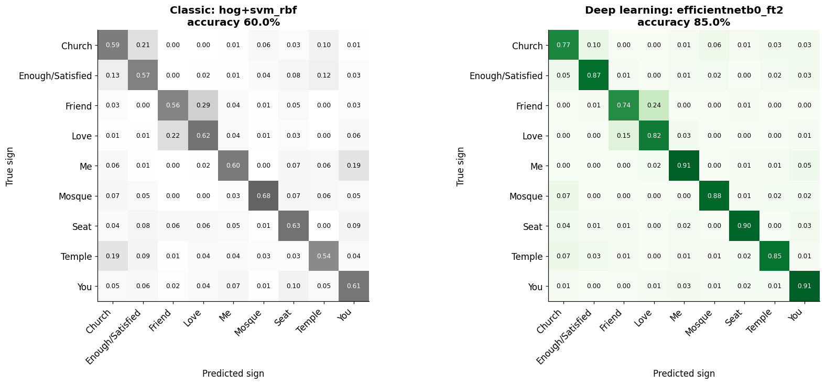
Figure 2. Normalised confusion matrices on the test set: HOG + SVM (left) and EfficientNetB0 (right).

4.3 What the model looks at, and how sure it is
Grad-CAM heatmaps concentrate on the hands and fingers (stacked palms for Church, interlocked fingers for Seat, the raised thumb for You) while backgrounds and clothing are largely ignored (Figure 3). On errors the model still looks at the hands but reads them as a similar sign. Several of its most confident “mistakes” appear to be mislabelled images (e.g. photos labelled Church that show the Mosque hand shape), so the reported accuracy is probably conservative.
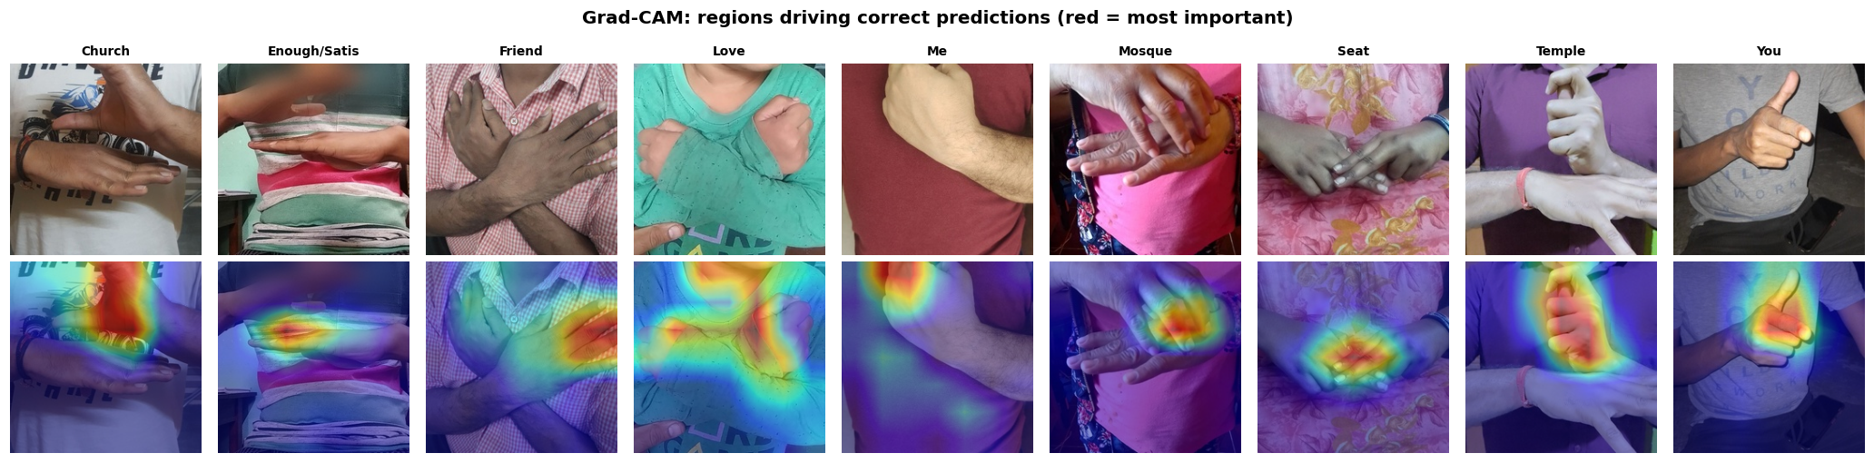
Figure 3. Grad-CAM for one correctly classified test image per sign (red = most influential regions).
Confidence is informative: the median top probability is 0.99 for correct predictions but 0.62 for wrong ones. Answering only when confidence is at least 0.80 covers 78.6% of test images at 95.9% accuracy, and the correct sign is among the top two guesses 94.7% of the time. The dashboard uses this threshold to say “not sure” instead of guessing.

4.4 Robustness
With no photos from new signers available, robustness was tested by altering the test images (Figure 4). Darkening barely mattered (≤1.4 points). Rotation exposed the classic model: at 30° it collapsed to 17.0%, near random, while the deep model kept 74.2%. The deep model’s weakness is heavy blur, which removed 17.6 points (to 67.4%), and strong noise (−8.2), because it relies on fine finger detail that the coarse HOG features never used.
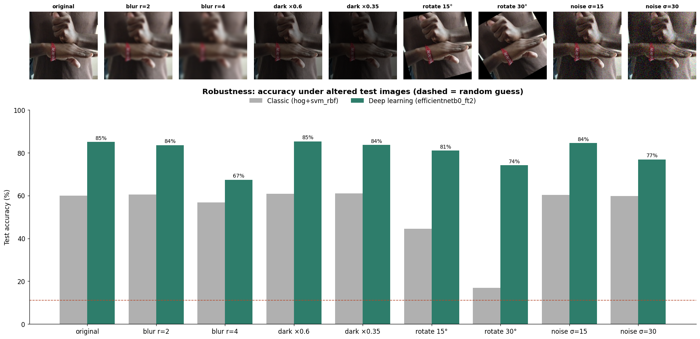
Figure 4. Test accuracy of both models when images are blurred, darkened, rotated or noisy (dashed line = random guess).
Note: re-evaluating the best model with the image decoder used by the dashboard gave 85.0% instead of 86.0% (9 of 941 images), a difference within the confidence interval.

5. Interactive dashboard
A Streamlit dashboard presents the work in five pages: an Overview of the problem and results; a Dataset explorer (example photos, average images, balance, quality and cleaning funnel); a Model showdown with an interactive leaderboard, overfitting and size–speed charts, per-sign F1, confusions and training curves (Figure 5); Try it live, which classifies an example, uploaded or webcam photo, shows the probabilities, applies the 0.80 confidence threshold and overlays Grad-CAM; and a Stress test, where sliders blur, darken, rotate or add noise to a photo while both models re-predict live. It is publicly available online:
Live dashboard: https://ksl-recognition.streamlit.app
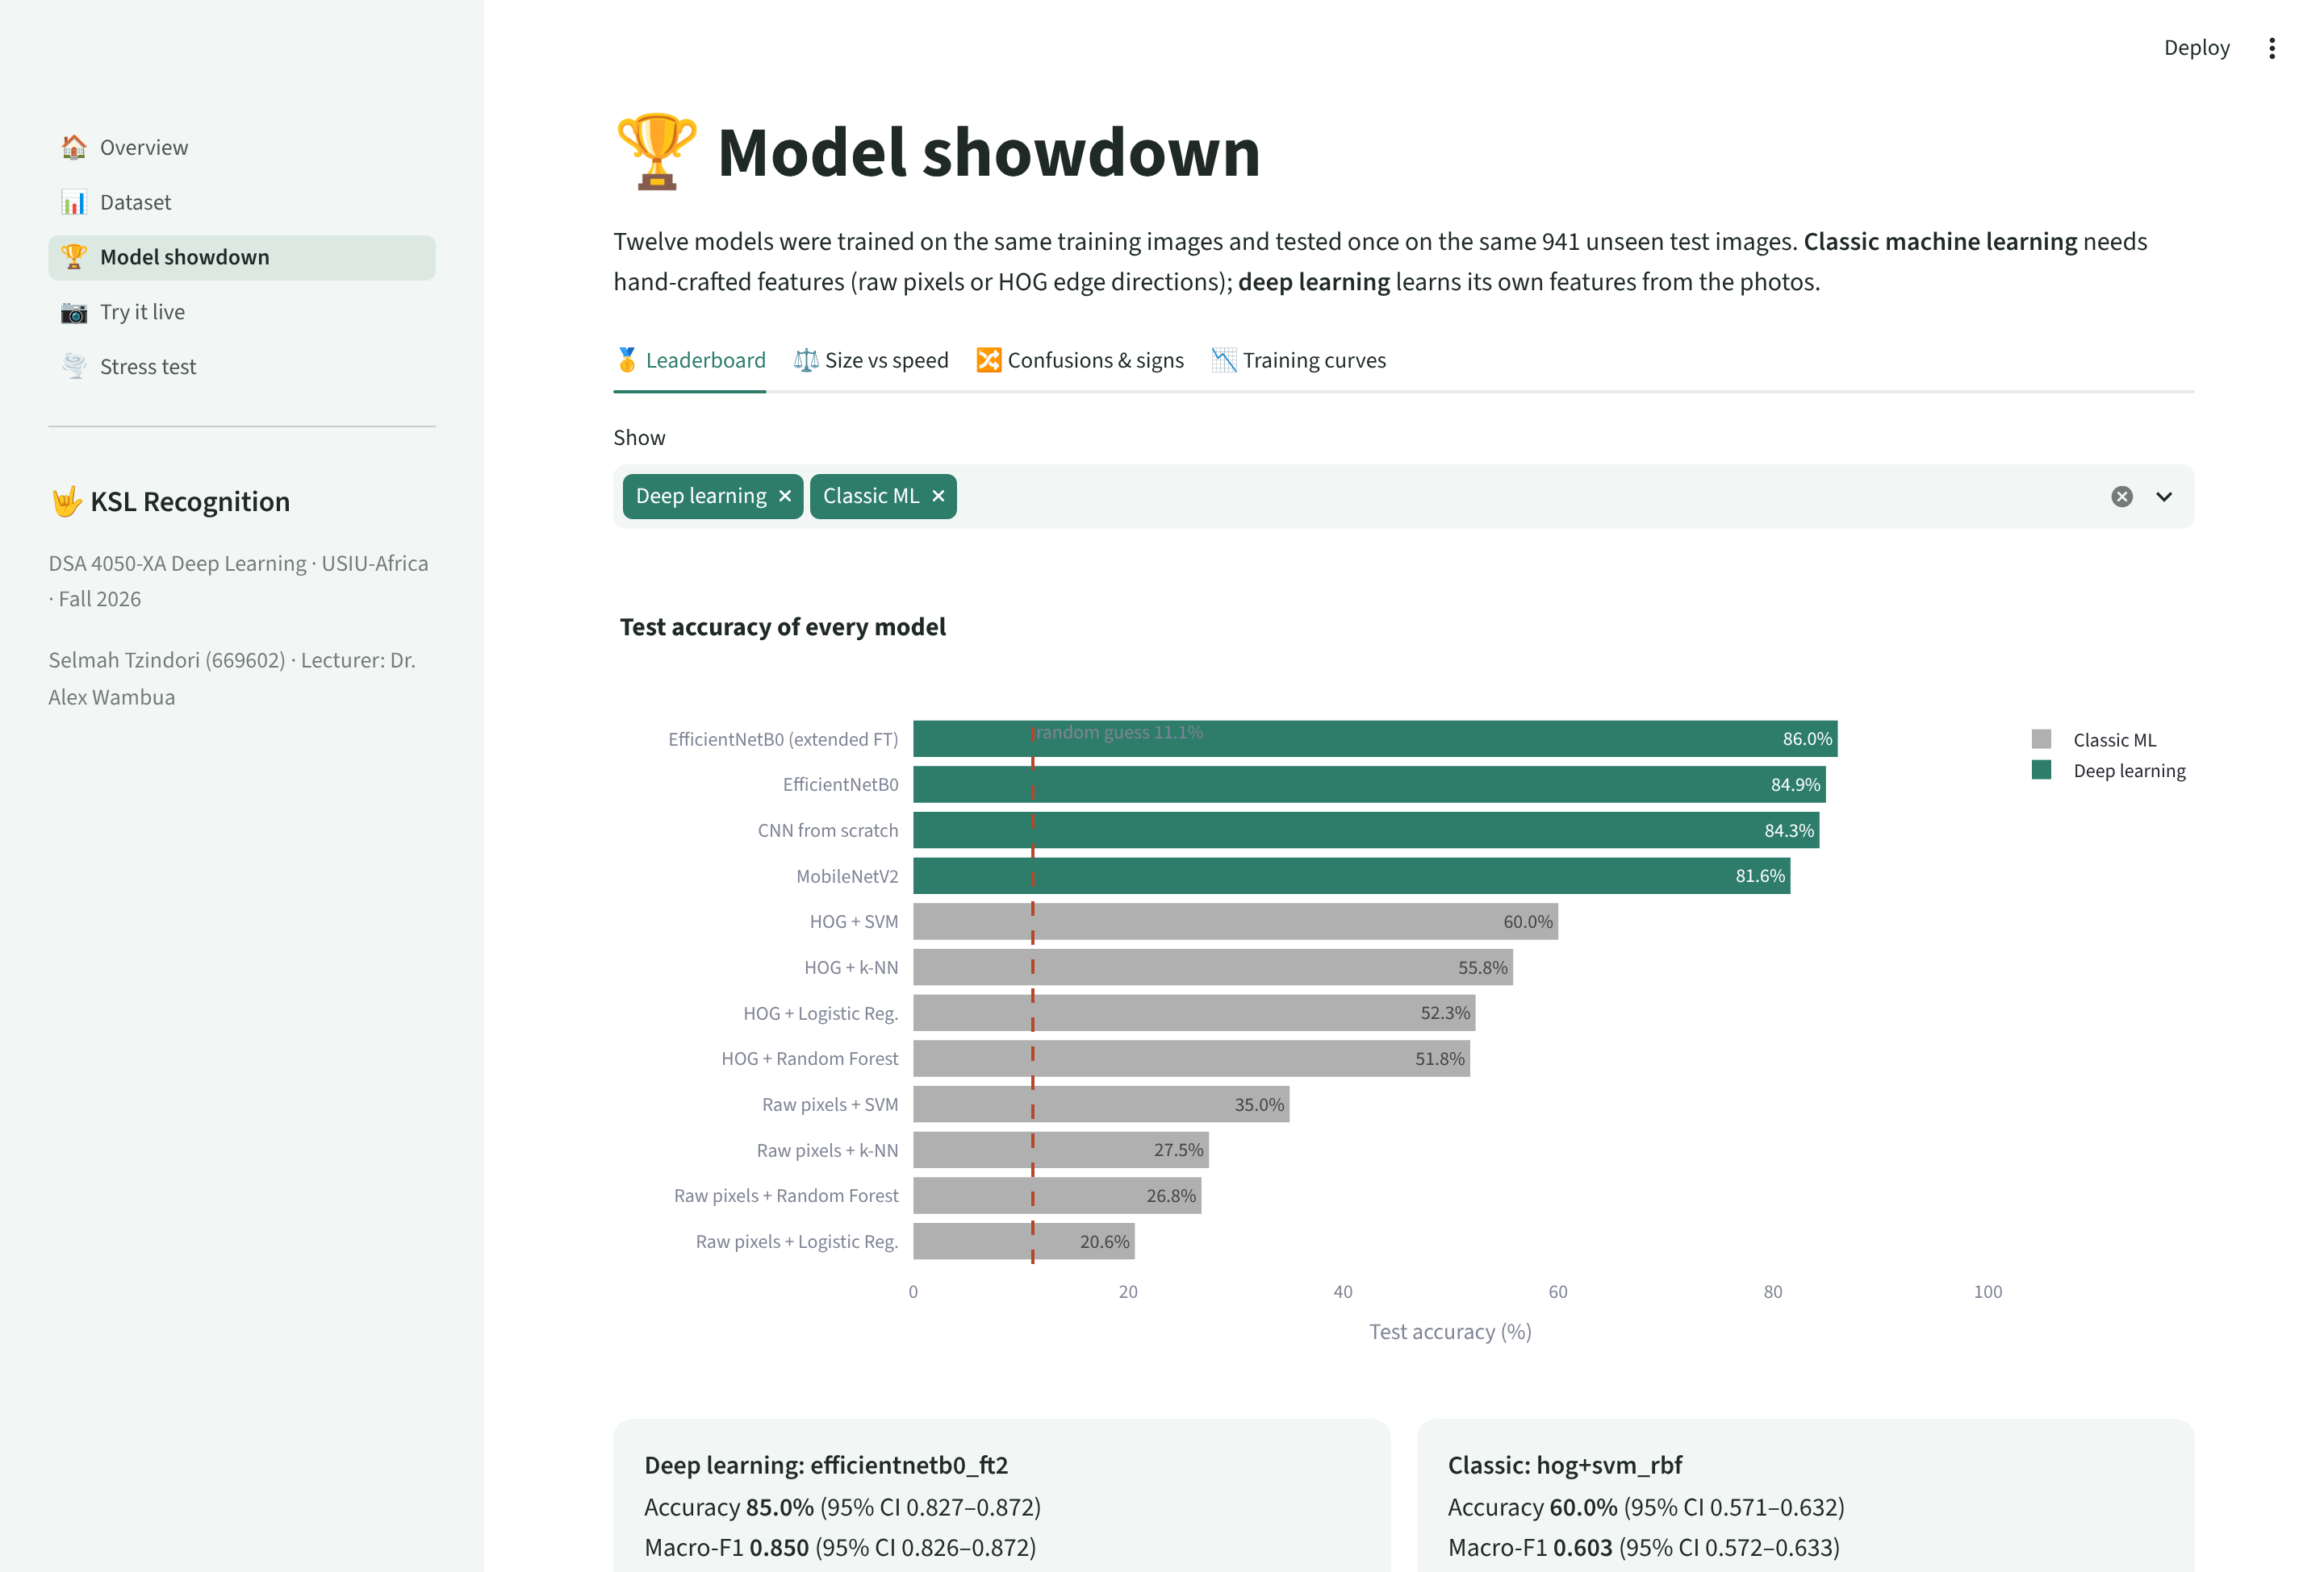
Figure 5. The dashboard’s Model showdown page, comparing all twelve models.

6. Limitations and future work
- Scope: nine isolated, static signs; real KSL is continuous and includes movement and facial expression. Video or pose-based models (e.g. hand landmarks over time) are the natural next step.
- Signer overlap: the dataset has no signer IDs, so the same people may appear in training and test sets, which can inflate accuracy. A signer-independent test set, ideally collected with the Deaf community, would give a more honest estimate.
- Labels: some labels appear wrong, and none were verified by Deaf signers.
- Robustness: heavy blur hurts; stronger blur and noise augmentation should be added before real use.
- Preprocessing: the square crop occasionally cut part of a hand in landscape photos.

7. Conclusion
On identical data, deep learning recognised nine KSL signs from everyday phone photographs with 85–86% accuracy, against 60% for the best classic approach, a statistically clear gain of about 26 points. Transfer learning with fine-tuning gave the best results in a fraction of the training time, the network’s attention falls on the hands, and its confidence can flag uncertain cases. The main obstacles to real-world use are now data rather than models: more signs, signer-independent evaluation, motion, and labels verified by Deaf signers.

Code and reproducibility
All code (Colab notebooks 00–06 with documented outputs, a shared helper module and the dashboard) is available on GitHub, with random seeds, the data split and every figure, table and metric saved so the full pipeline can be re-run end to end:
Code repository: https://github.com/SelmahT/ksl-recognition

References
awsaf49. (n.d.). KSLC Dataset [Data set]. Kaggle. https://www.kaggle.com/datasets/awsaf49/kslc-dataset
Constitution of Kenya. (2010). Article 7(3)(b). National Council for Law Reporting.
Dalal, N., & Triggs, B. (2005). Histograms of oriented gradients for human detection. In Proceedings of the IEEE Conference on Computer Vision and Pattern Recognition (CVPR) (pp. 886–893).
Deng, J., Dong, W., Socher, R., Li, L.-J., Li, K., & Fei-Fei, L. (2009). ImageNet: A large-scale hierarchical image database. In Proceedings of the IEEE Conference on Computer Vision and Pattern Recognition (CVPR) (pp. 248–255).
Efron, B., & Tibshirani, R. J. (1993). An introduction to the bootstrap. Chapman & Hall.
Sandler, M., Howard, A., Zhu, M., Zhmoginov, A., & Chen, L.-C. (2018). MobileNetV2: Inverted residuals and linear bottlenecks. In Proceedings of the IEEE Conference on Computer Vision and Pattern Recognition (CVPR) (pp. 4510–4520).
Selvaraju, R. R., Cogswell, M., Das, A., Vedantam, R., Parikh, D., & Batra, D. (2017). Grad-CAM: Visual explanations from deep networks via gradient-based localization. In Proceedings of the IEEE International Conference on Computer Vision (ICCV) (pp. 618–626).
Tan, M., & Le, Q. V. (2019). EfficientNet: Rethinking model scaling for convolutional neural networks. In Proceedings of the 36th International Conference on Machine Learning (ICML) (pp. 6105–6114).
Zindi Africa. (n.d.). Kenyan Sign Language Classification Challenge. https://zindi.africa/competitions/kenyan-sign-language-classification-challenge

