**TASK 4**

**Ansible**

Git url : [SelmiNazeeb/ansible-exam-repo](https://github.com/SelmiNazeeb/ansible-exam-repo)

Git clone

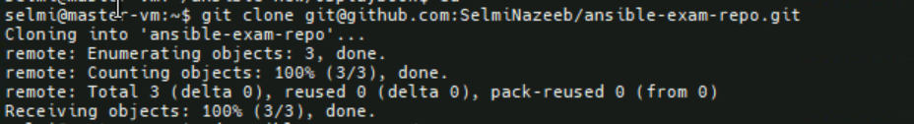

Tree structure

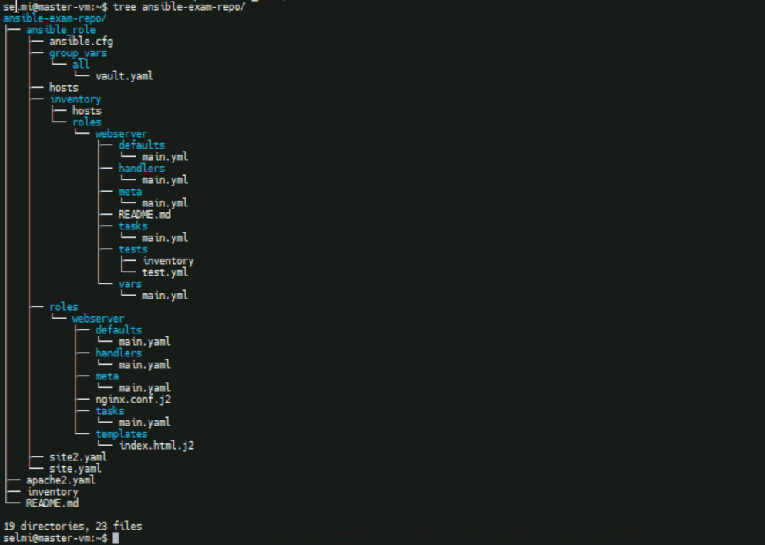

Inventory file

Output

