# LINUX 1.

# Swap Space

* **Definition**: Swap space is a part of your hard disk used as **virtual memory** when the physical RAM is full. It helps the system manage large workloads that don’t fit entirely in memory.
* **How It Works**: If your system runs out of RAM, inactive data from RAM is moved to the swap space, freeing up RAM for active processes.
* **Example**: When you have too many apps open and your RAM is maxed out, the system starts using swap space to manage the load.

# Booting

* **Definition**: Booting is the process of starting up a computer and loading the operating system (OS).
* **Steps**:
  1. **Power-on**: You turn on the machine.
  2. **BIOS/UEFI**: The BIOS (or UEFI on newer systems) is responsible for performing hardware checks and initializing system components (like CPU, RAM, and drives).
  3. **Bootloader**: Once BIOS/UEFI completes, the bootloader takes over to load the operating system from the storage.

# BIOS (Basic Input/Output System)

* **Definition**: BIOS is firmware built into the motherboard that helps the computer **initialize hardware** and locate the operating system during bootup.
* **Function**: BIOS checks system components (keyboard, display, etc.), and it’s responsible for locating the OS (via MBR or GPT).

# Hardware Components of the Machine

* These include the **physical parts** of the computer: CPU, RAM, storage (HDD/SSD), motherboard, input/output devices, etc.
* The operating system interacts with these hardware components through device drivers, allowing software to run on the hardware.

# Management of the OS

* **Definition**: OS management involves controlling and allocating system resources (like CPU, memory, storage) to processes and tasks.
* **Key Roles**:
  + **Process Management**: Controls the execution of processes (programs).
  + **Memory Management**: Allocates and manages RAM.
  + **Storage Management**: Manages files, folders, and access to disk storage.

# Network Edition vs. Desktop Edition

* **Network Edition**: Typically designed for servers or network devices. It focuses on connectivity, networking services, and managing many simultaneous connections.
* **Desktop Edition**: Designed for personal computers with a graphical user interface (GUI), offering tools for everyday tasks like browsing, file management, and media.

**General Need**: Network editions are for handling large-scale network tasks, while desktop editions are user-friendly for regular computer use.

# MBR (Master Boot Record)

* **Definition**: The MBR is a small section of a storage device (like a hard drive) that contains information about the partitions on the disk and tells the computer which OS to load.
* **How It Works**: The BIOS loads the MBR, which points to the bootloader, and the bootloader then loads the OS.

# Bootloader

* **Definition**: A program that loads the operating system when the computer starts.
* **How It Works**: After BIOS loads the MBR, the bootloader takes over, selects the OS (in case there are multiple), and starts the OS loading process.
* **Example**: Grub (for Linux) or Windows Boot Manager.

# Kernel

* **Definition**: The kernel is the **core** of the operating system that interacts directly with hardware and manages system resources.
* **Role**: It acts as a bridge between applications and the physical hardware of the machine (like CPU, RAM, storage devices).
* **Example**: The Linux kernel, Windows kernel, etc.

# INIT (Initialization)

* **Definition**: init is the first process to run when the operating system starts. It’s responsible for launching other system processes and services.
* **Role**: It initializes the system, like setting up the system clock, loading necessary drivers, and starting background processes (networking, etc.).

# Startup Scripts

* **Definition**: These are scripts executed by the operating system during the boot process to configure the system and start services.
* **Example**: On Linux, the /etc/init.d/ directory contains startup scripts that set things like the system time or networking.
* **Clock Setup**: As part of the startup process, the system clock is usually set by a startup script (e.g., syncing time with an NTP server).

# Processes

* **Definition**: A **process** is a program in execution. Each time a program is run, a new process is created.
* **Management**: The operating system manages processes by allocating resources (like CPU time and memory) and scheduling them for execution.
* **States**: A process can be in various states (running, waiting, etc.).

**Summary:**

* **Swap Space**: Virtual memory that allows the system to handle more data when RAM is full.
* **Booting**: The process of starting the computer and loading the OS.
* **BIOS**: Initializes the hardware and loads the bootloader.
* **MBR**: Tells the system which OS to load.
* **Bootloader**: Loads the OS after the BIOS.
* **Kernel**: Manages hardware and system resources.
* **INIT**: The first process that initializes the system and launches other processes.
* **Startup Scripts**: Automatically run during boot to configure system settings.
* **Processes**: Programs in execution managed by the OS.

This is a high-level overview of how an operating system and machine work together during startup and how they manage tasks and resources.

**salient features of Linux**

1. **Process Management:** 
   * Efficient process scheduling and multitasking.
   * Manages process states (running, sleeping, waiting, etc.).
   * Supports creation, execution, and termination of processes.
2. **File Management:** 
   * Hierarchical file system structure (root / directory).
   * Supports various file systems (ext4, XFS, NTFS, etc.).
   * File permissions (read, write, execute) for security.
3. **Device Management:** 
   * Device drivers allow communication with hardware.
   * Devices are represented as files in /dev directory.
   * Automatic detection and configuration of devices (Plug & Play).
4. **I/O System Management:** 
   * Efficient buffering and caching for I/O performance.
   * I/O scheduling to prioritize disk operations.
   * System calls for managing I/O operations (read, write).
5. **Security:** 
   * User authentication and strong access control mechanisms.
   * File and directory permissions for limiting access.
   * Security modules like SELinux and AppArmor for enhanced security.
   * Disk encryption and secure network protocols.
6. **Command Interpretation:** 
   * Command-line interface (CLI) for executing commands.
   * Shells (e.g., Bash) interpret commands and scripts.
   * Shell scripting for task automation.
7. **Networking:** 
   * Supports TCP/IP, UDP, ICMP, and other networking protocols.
   * Tools like ping, ifconfig, netstat for network management.
   * Firewall tools (iptables, firewalld) for network security.
   * Network services such as SSH, HTTP, DNS.
8. **Job Accounting:** 
   * Tracks resource usage by processes (CPU time, memory).
   * Job scheduling tools like cron for automating tasks.
   * Process monitoring tools like top, htop, ps for system health.

Here’s a more **short and simple** version of the key concepts:

1. **Supervisor Mode (Kernel Mode):** 
   * **Definition**: A privileged mode where the OS runs and has full control over hardware and system resources.
   * **Key Point**: Only the OS can run in this mode and perform critical tasks (like memory management, controlling hardware).
2. **Hypervisor:** 
   * **Definition**: Software that allows multiple operating systems (OS) to run on one machine at the same time.
   * **Types**:
     + **Type 1 (Bare-Metal)**: Runs directly on hardware.
     + **Type 2 (Hosted)**: Runs on top of another OS.
   * **Example**: VMware, VirtualBox.
3. **User Mode vs Supervisor Mode:** 
   * **User Mode**: Where regular applications (like browsers, games) run with limited access to system resources.
   * **Supervisor Mode**: Where the OS runs with full access to all system resources and hardware.
   * **Key Difference**: **User mode** has restricted access, while **supervisor mode** can do anything.
4. **Mode Transitions:** 
   * When an app in **user mode** needs system resources (like memory or files), it asks the OS in **supervisor mode** using **system calls**.
   * After the OS finishes the task, it switches back to **user mode**.
5. **Use Cases of Protected/Supervised Modes:** 
   * **Memory Protection**: Ensures apps can’t change or crash the OS.
   * **Hardware Control**: Only the OS in supervisor mode can directly control hardware (like disks or networks).
   * **Security**: Supervisor mode prevents unauthorized access by user applications.
   * **Virtualization**: Hypervisors (running in supervisor mode) allow multiple virtual machines to share hardware.

**In Short:**

* + **Supervisor Mode**: OS has full control, used for critical tasks.
  + **User Mode**: Regular apps run with restricted access.
  + **Hypervisor**: Manages multiple OSs on one machine.
  + **Transition**: Apps ask the OS for help via system calls (mode switching).
  + **Use Cases**: Protect memory, control hardware, run virtual machines.

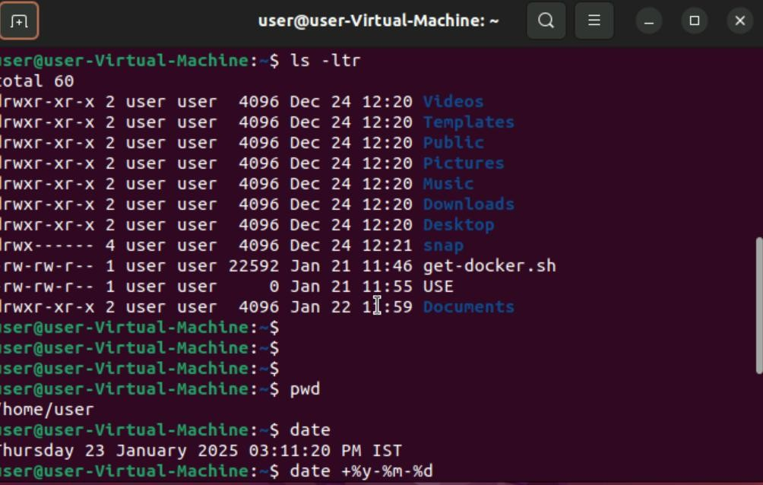

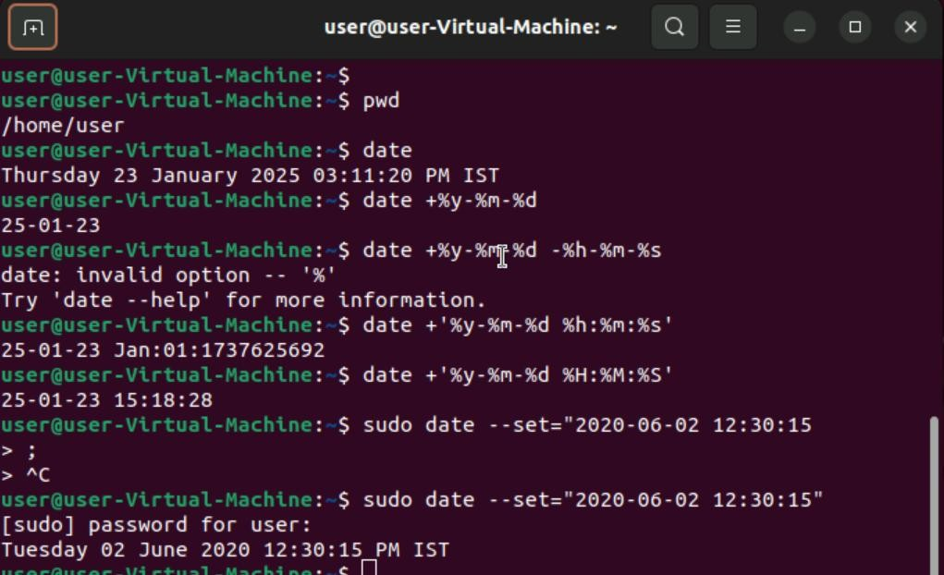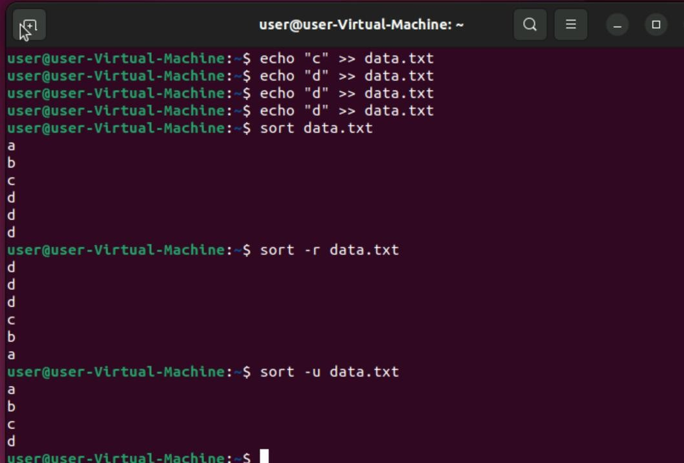

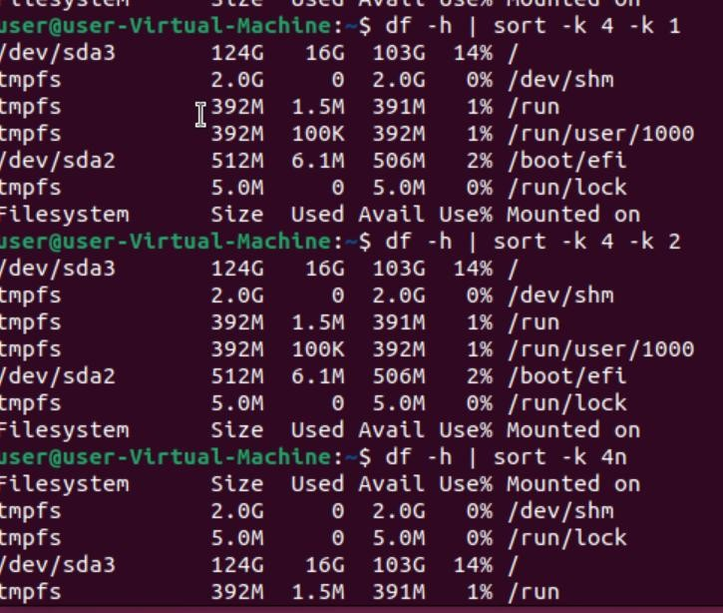

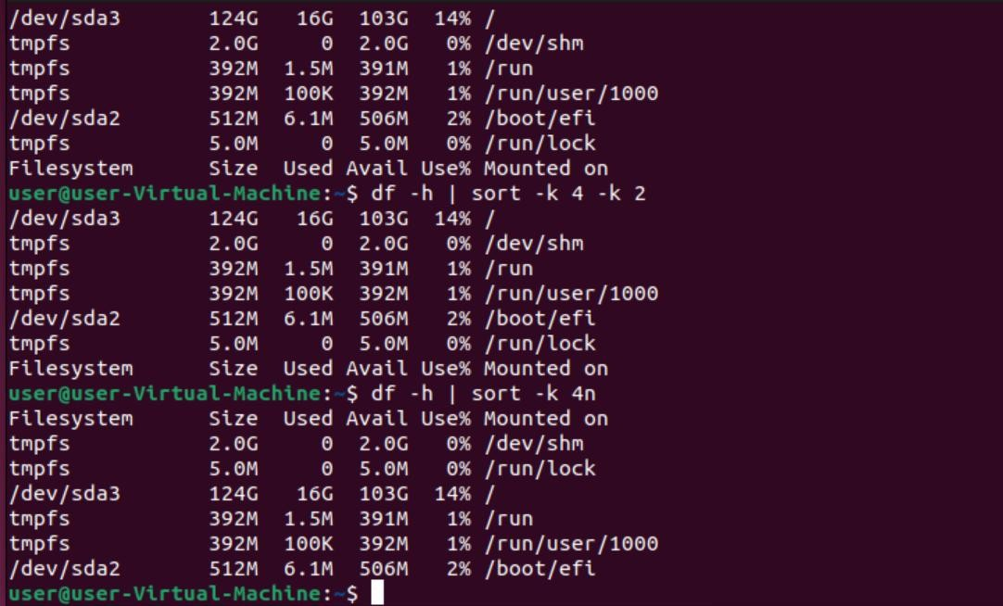

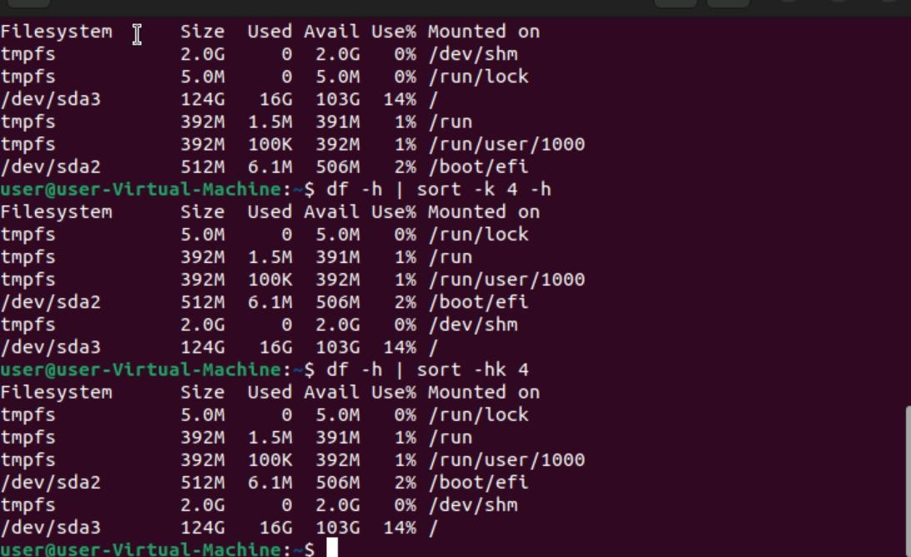

# Introduction to Linux

who:

Displays a list of users currently logged into the system.

Shows information such as the username, terminal, date and time of login, and the IP address or hostname of the remote host.

whoami:

Displays the current logged-in user's username.

Useful for confirming the identity of the user executing commands, especially when using `sudo` or switching users.

pwd:

Prints the current working directory.

Useful for determining the full path of the directory you are currently in.

date:

Displays the current date and time.

Useful for checking the system's date and time settings, and can be formatted in various ways using options.

Example:

To display the current date and time in the default format: date

To display the date in a custom format (e.g., YYYY-MM-DD):

date +"%Y-%m-%d"

ls:

Lists the contents of a directory.

Useful for viewing files and directories within the current directory or a specified path.

Example:

To list all files and directories in the current directory: ls

To list all files and directories, including hidden ones: ls -a

To list files and directories with detailed information (permissions, owner, size, etc.): ls -l

To list files and directories with detailed information, including hidden ones: ls -la

To list files that match a specific pattern (e.g., files starting with 'A' followed by a lowercase letter or digit and ending with '.txt'):

ls A[a-z0-9].txt

ps:

Displays information about active processes.

Useful for monitoring and managing running processes on the system.

Example:

To display all running processes in a full-format listing: ps -ef

To display processes related to a specific command (e.g., bash):

ps -ef | grep bash

grep:

Searches for patterns within files.

Useful for finding specific text within files or output from other commands.

Example:

To search for a specific string (e.g., 'example') within a file (e.g., file.txt):

grep 'example' file.txt

To search for a pattern recursively within a directory:

grep -r 'pattern' /path/to/directory

To search for a pattern and display line numbers:

grep -n 'pattern' file.txt

To search for a pattern ignoring case sensitivity:

grep -i 'pattern' file.txt

To search for a pattern and display only the matching part of the line:

grep -o 'pattern' file.txt

cat:

Concatenates and displays the content of files.

Useful for viewing the content of files, combining multiple files, and creating new files.

Example:

To display the content of a file (e.g., file.txt):

cat file.txt

To concatenate multiple files and display the output: cat file1.txt file2.txt

To create a new file and write content to it: cat > newfile.txt

(Type the content and press Ctrl+D to save)

To append content to an existing file:

cat >> existingfile.txt

(Type the content and press Ctrl+D to save)

ip a:

Displays information about all network interfaces.

Useful for checking IP addresses, network interfaces, and their statuses.

Example:

To display detailed information about all network interfaces: ip a

To display information about a specific interface (e.g., eth0):

ip a show eth0

cp:

Copies files and directories.

Useful for duplicating files and directories to a new location.

Example:

To copy a file (e.g., file.txt) to a new location (e.g., /path/to/destination/):

cp file.txt /path/to/destination/

To copy a file and rename it:

cp file.txt /path/to/destination/newfile.txt

To copy a directory and its contents recursively:

cp -r /path/to/source_directory /path/to/destination_directory

To copy files interactively, prompting before overwrite:

cp -i file.txt /path/to/destination/

To copy files and preserve attributes (e.g., timestamps, ownership):

cp -p file.txt /path/to/destination/

To copy files verbosely, displaying the files being copied:

cp -v file.txt /path/to/destination/

To forcefully copy files, overwriting existing files without prompting:

cp -f file.txt /path/to/destination/

ls -ltr:

Lists the contents of a directory in long format, sorted by modification time in reverse order (oldest first).

Useful for viewing detailed information about files and directories, with the most recently modified files at the bottom.

Example:

To list all files and directories in the current directory, sorted by modification time in reverse order:

ls -ltr

rm:

Removes files or directories.

Useful for deleting unwanted files or directories.

Example:

To remove a file (e.g., file.txt):

rm file.txt

To remove multiple files:

rm file1.txt file2.txt

To remove a directory and its contents recursively:

rm -r /path/to/directory

To remove files interactively, prompting before each removal: rm -i file.txt

To forcefully remove files, ignoring nonexistent files and never prompting: rm -f file.txt

To remove directories and their contents forcefully:

rm -rf /path/to/directory

To remove an empty directory (e.g., emptydir):

rm -d emptydir

find . -name:

Searches for files and directories by name within the current directory and its subdirectories.

Useful for locating files and directories based on their names.

Example:

To find a file named 'example.txt' within the current directory and its subdirectories:

find . -name 'example.txt'

find . -iname:

Searches for files and directories by name within the current directory and its subdirectories, ignoring case sensitivity.

Useful for locating files and directories based on their names without considering case.

Example:

To find a file named 'example.txt' (case insensitive) within the current directory and its subdirectories:

find . -iname 'example.txt'

find . -iname Downloads -mtime -7:

Searches for files and directories named 'Downloads' within the current directory and its subdirectories that have been modified in the last 7 days.

Useful for locating recently modified files and directories with a specific name.

Example:

To find a directory named 'Downloads' that has been modified in the last 7 days:

find . -iname 'Downloads' -mtime -7

find . -iname Downloads -mtime +7

Searches for files and directories named 'Downloads' within the current directory and its subdirectories that have been modified more than 7 days ago.

Useful for locating files and directories with a specific name that have not been modified recently.

Example:

To find a directory named 'Downloads' that has been modified more than 7 days ago:

find . -iname 'Downloads' -mtime +7

find . -name "*.*" -exec grep "added" {} \;

Searches for files with any extension within the current directory and its subdirectories, and executes the `grep` command to search for the string "added" within those files.

Useful for finding files containing a specific string.

Example:

To find files with any extension and search for the string "added" within those files:

find . -name "*.*" -exec grep "added" {} \;

sort:

Sorts the lines of a file or input.

Useful for organizing data in a specific order.

Example:

To sort the lines of a file (e.g., a.txt) in ascending order: sort a.txt

To sort the lines of a file in descending order: sort -r a.txt

To sort the lines of a file numerically:

sort -n a.txt

To sort the lines of a file and remove duplicates: sort -u a.txt

To sort the lines of a file based on a specific field (e.g., the second field):

sort -k 2 a.txt

df:

Displays disk space usage of file systems.

Useful for checking available and used disk space on mounted file systems.

Example:

To display disk space usage in a human-readable format: df -h

To display disk space usage of a specific file system (e.g., /dev/sda1):

df -h /dev/sda1

To display disk space usage including file system type: df -T

To display disk space usage in inodes: df -i

cut:

Removes sections from each line of files.

Useful for extracting specific columns or fields from text files or command output.

Example:

To extract the first 10 characters of each line in a file (e.g., file.txt):

cut -c 1-10 file.txt

To extract the second and fourth fields from a file (e.g., file.txt) using a space as the delimiter:

cut -d ' ' -f 2,4 file.txt

To extract the first and third fields from a file (e.g., file.txt) using a comma as the delimiter: cut -d ',' -f 1,3 file.txt

less:

Displays the content of files one screen at a time.

Useful for viewing large files without loading the entire file into memory.

Example:

To view the content of a file (e.g., file.txt):

less file.txt

head:

Displays the first few lines of a file.

Useful for quickly viewing the beginning of a file without opening the entire file.

Example:

To display the first 10 lines of a file (e.g., file.txt): head file.txt

To display the first 20 lines of a file: head -n 20 file.txt

tail:

Displays the last few lines of a file.

Useful for quickly viewing the end of a file, especially log files.

Example:

To display the last 10 lines of a file (e.g., file.txt):

tail file.txt

To display the last 20 lines of a file:

tail -n 20 file.txt

top:

Displays real-time information about system processes.

Useful for monitoring system performance, resource usage, and managing processes.

kill:

Sends a signal to a process, usually to terminate it.

Useful for stopping processes that are running in the background or are unresponsive.

tar:

Archives and compresses files and directories.

Useful for creating backups, transferring files, and reducing storage space.

Example:

To create an archive (e.g., archive.tar) from a directory (e.g., /path/to/directory):

tar -cvf archive.tar /path/to/directory

To extract an archive (e.g., archive.tar):

tar -xvf archive.tar

To create a compressed archive using gzip (e.g., archive.tar.gz):

tar -czvf archive.tar.gz /path/to/directory

To extract a compressed archive using gzip (e.g., archive.tar.gz):

tar -xzvf archive.tar.gz

du:

Displays disk usage of files and directories.

Useful for checking the amount of disk space used by files and directories.

Example:

To display disk usage of the current directory: du

To display disk usage in a human-readable format: du -h

To display disk usage of all files and directories, including subdirectories: du -a

To display only the total disk usage of a directory: du -s

ifconfig:

Configures and displays network interface parameters.

Useful for viewing and modifying network interface settings, such as IP addresses and netmasks.

netstat:

Displays network connections, routing tables, interface statistics, masquerade connections, and multicast memberships.

Useful for monitoring and troubleshooting network connections and performance.

wget:

Downloads files from the web.

Useful for retrieving files from HTTP, HTTPS, and FTP servers.

curl:

Transfers data from or to a server using various protocols (HTTP, HTTPS, FTP, etc.).

Useful for downloading or uploading files, interacting with APIs, and testing endpoints.

alias:

Creates shortcuts for commands.

Useful for simplifying and customizing command-line usage.

To remove an alias: unalias myalias

To list all currently defined aliases: alias

systemctl:

Manages systemd services.

Useful for starting, stopping, restarting, enabling, and disabling services on a systemd-based system.

Example:

To start a service (e.g., httpd):

systemctl start httpd

To stop a service: systemctl stop httpd

To restart a service: systemctl restart httpd

To enable a service to start at boot:

systemctl enable httpd

To disable a service from starting at boot:

systemctl disable httpd

To check the status of a service:

systemctl status httpd

To list all services:

systemctl list-units --type=service

crontab:

Schedules and manages recurring tasks.

Useful for automating repetitive tasks by running commands or scripts at specified times and intervals.

Example:

To edit the crontab file for the current user:

crontab -e

To view the current user's crontab file:

crontab -l

To remove the current user's crontab file: crontab -r

tr:

Translates or deletes characters from the input.

Useful for transforming text by replacing or removing specific characters.

Example:

To translate all lowercase letters to uppercase:

echo "hello world" | tr 'a-z' 'A-Z'

To delete all digits from the input:

echo "hello123" | tr -d '0-9'

To replace spaces with underscores: echo "hello world" | tr ' ' '_'

To compress consecutive repeated characters into a single character:

echo "aaabbbccc" | tr -s 'a-z'

sed:

Stream editor for filtering and transforming text.

Useful for performing basic text transformations on an input stream (a file or input from a pipeline).

scp:

Securely copies files between hosts over a network.

Useful for transferring files to and from remote servers securely.

Example:

To copy a file (e.g., file.txt) from the local system to a remote system:

scp file.txt user@remote_host:/path/to/destination/

To copy a file from a remote system to the local system:

scp user@remote_host:/path/to/file.txt /path/to/destination/

To copy a directory and its contents recursively from the local system to a remote system:

scp -r /path/to/source_directory user@remote_host:/path/to/destination_directory

To copy a file from a remote system to another remote system:

scp user1@remote_host1:/path/to/file.txt user2@remote_host2:/path/to/destination/

awk:

A powerful text processing and pattern scanning language.

Useful for extracting and manipulating data from text files or command output.

Example:

To print the second column of a file (e.g., file.txt):

awk '{print $2}' file.txt

To print lines where the third column is greater than 100:

awk '$3 > 100' file.txt

To print the sum of the values in the first column:

awk '{sum += $1} END {print sum}' file.txt

To print lines matching a specific pattern (e.g., 'error'):

awk '/error/' file.txt

To use a custom field delimiter (e.g., comma): awk -F ',' '{print $1}' file.csv