**Task 1**

**Docker and container internals**

Fork the repo

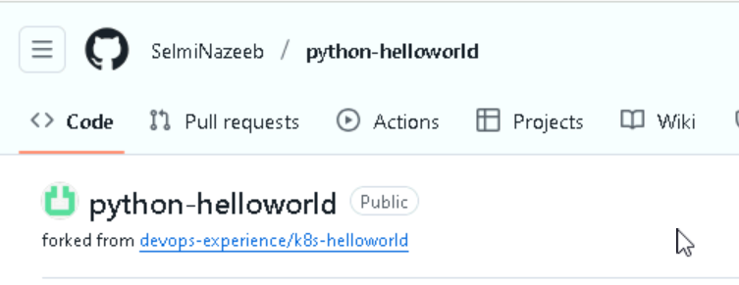

Clone the repo

Build image using dockerfile

Run the container and check the container ID

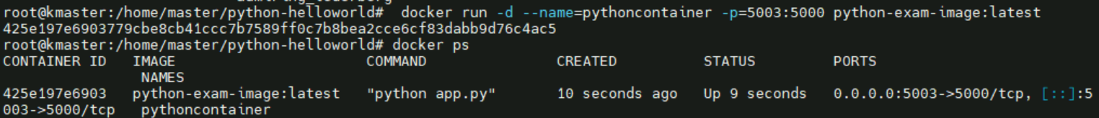

Get inside the container and check Working directory inside the container



Note: the working directory is /app

Read write layer directory on host

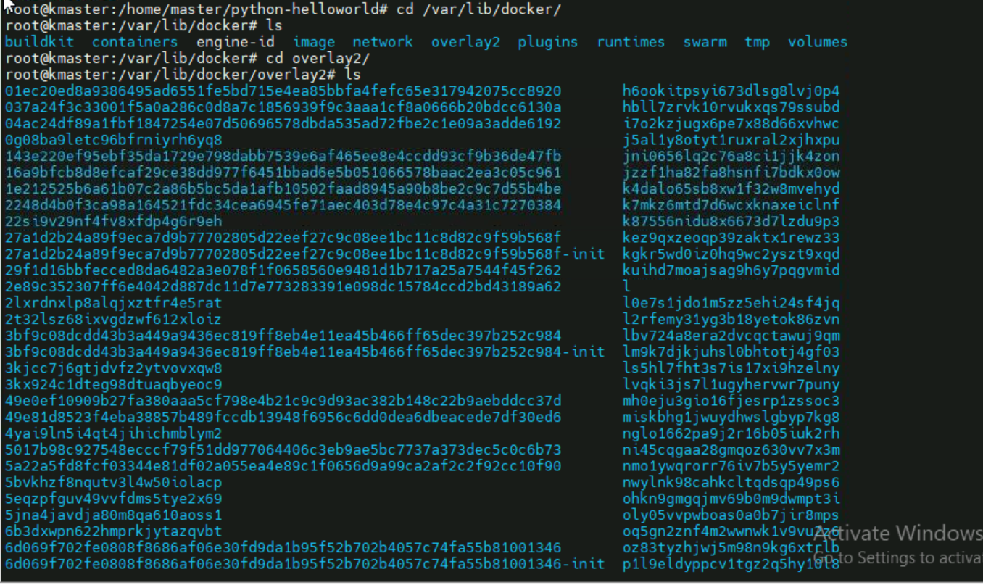

**History of commands**

 git clone git@github.com:SelmiNazeeb/python-helloworld.git

 cd python-helloworld/

 nano Dockerfile

docker build -t python-exam-image:latest .

docker run -d --name=pythoncontainer -p=5003:5000 python-exam-image:latest

docker exec -it 425e197e6903 /bin/bash

pwd

exit

cd /var/lib/docker/

ls

cd overlay2/

ls

git add .

git commit -m "exam things"

git push