**AWS EXAM 2**

**TERRAFORM**

**TASK 1 & 2:**

**INITIALIZE TERRAFORM AND PROVIDER & STORE ALL FILES IN CODE COMMIT REPOSITORY**

**CREATE SECURITY CREDENTIAL IN IAM USER FOR USE OF CODE COMMIT**

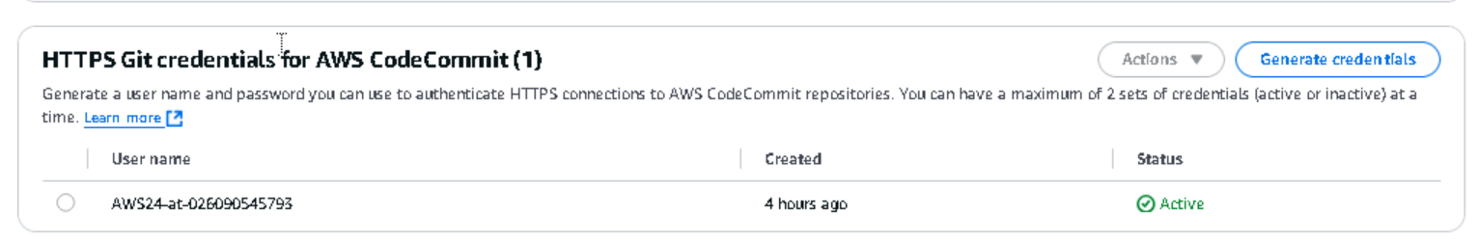

**CREATE A CODE COMMIT REPOSITORY FOR TERRAFORM**

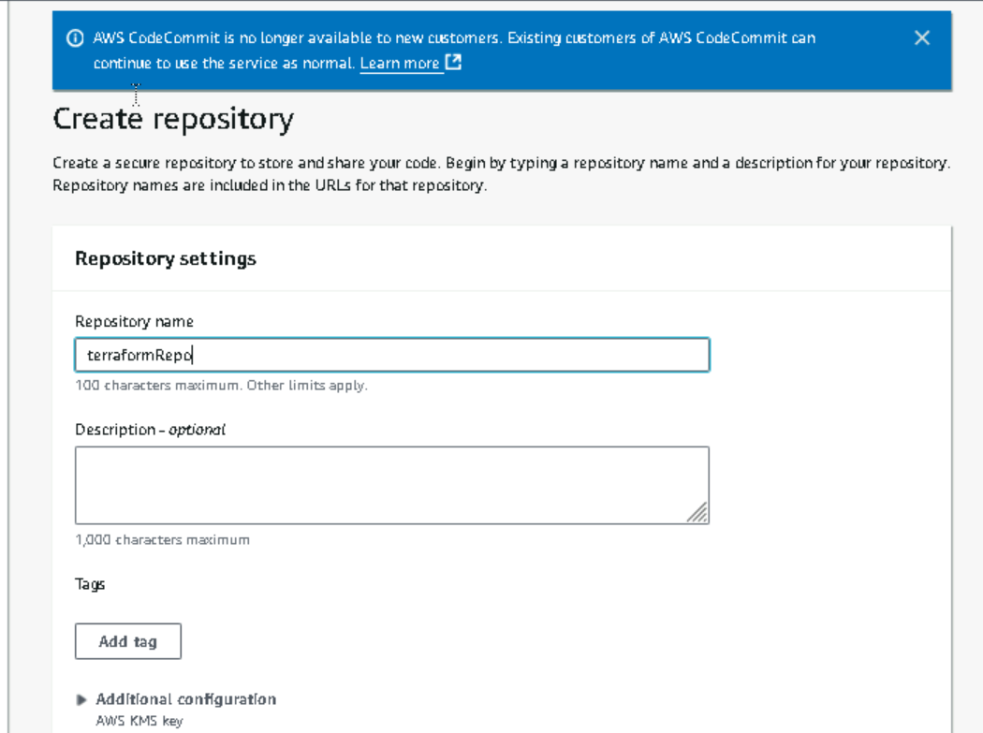

**CODE COMMIT REPOSITORY CREATED**

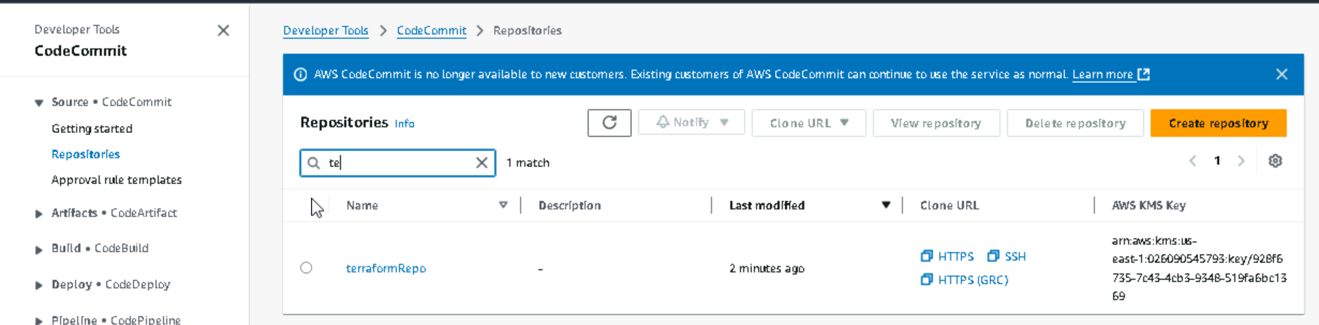

**CLONE THE REPOSITORY AND ADD FILES AND PUSH**

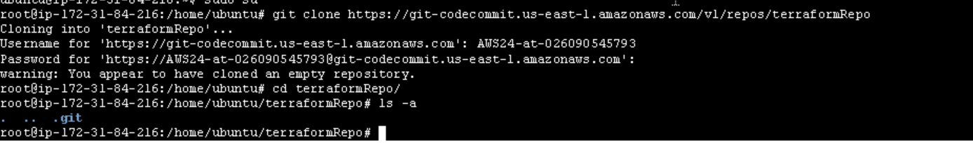

**TERRAFORM code main.tf**

* Give appropriate terraform providers and region
* This will create a s3 bucket

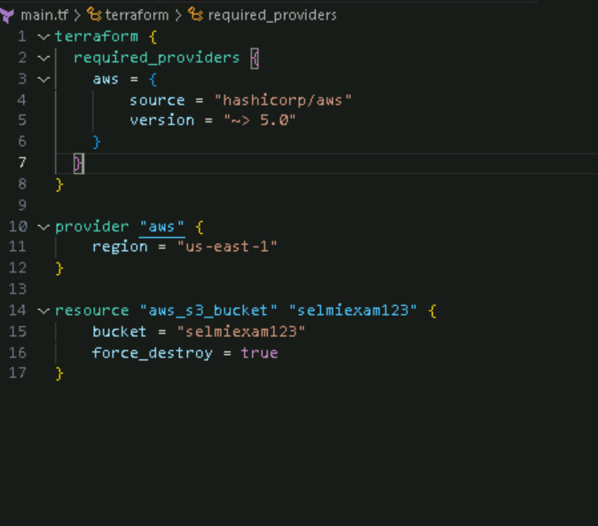

**Buildspec.yaml for apply terraform using code build**

* **Installing terraform**
* **Terraform init (TO INITIALIZE TERRAFORM AND PROVIDER (TASK1)**
* **Terraform plan**
* **Terraform apply**

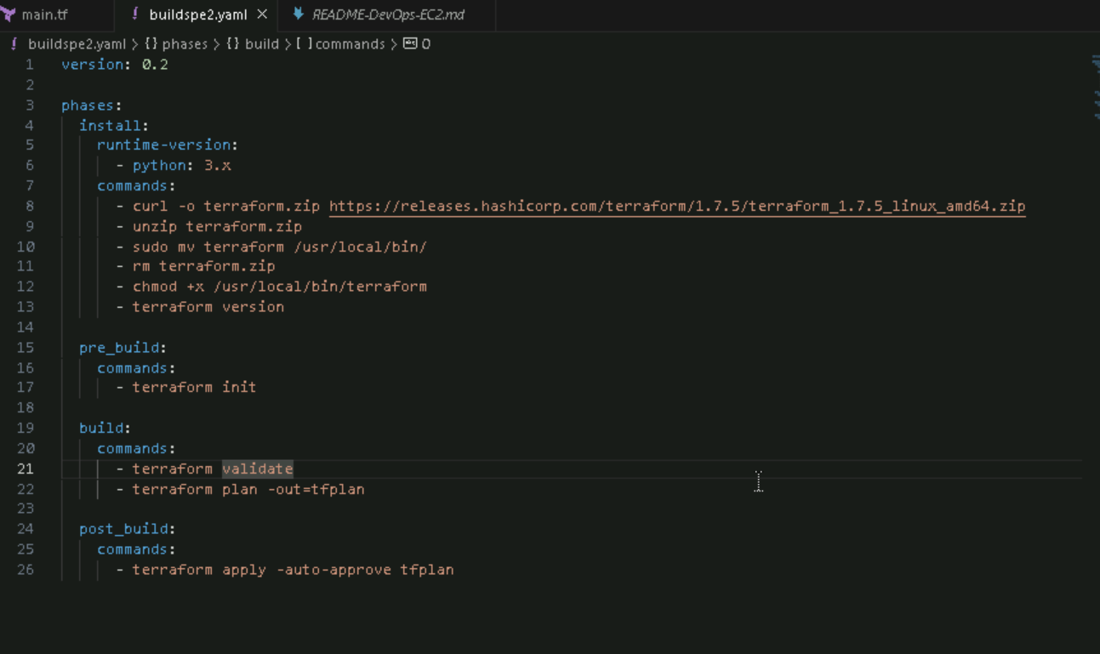

**Add a backend.tf to store the tfstate file of terraform**

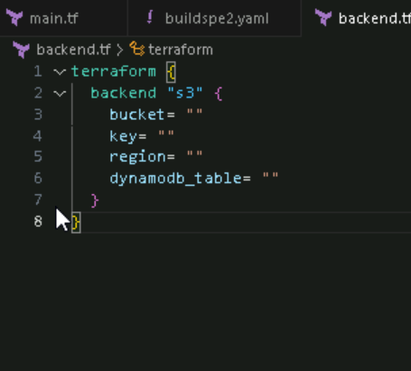

**Push all the files to code commit**

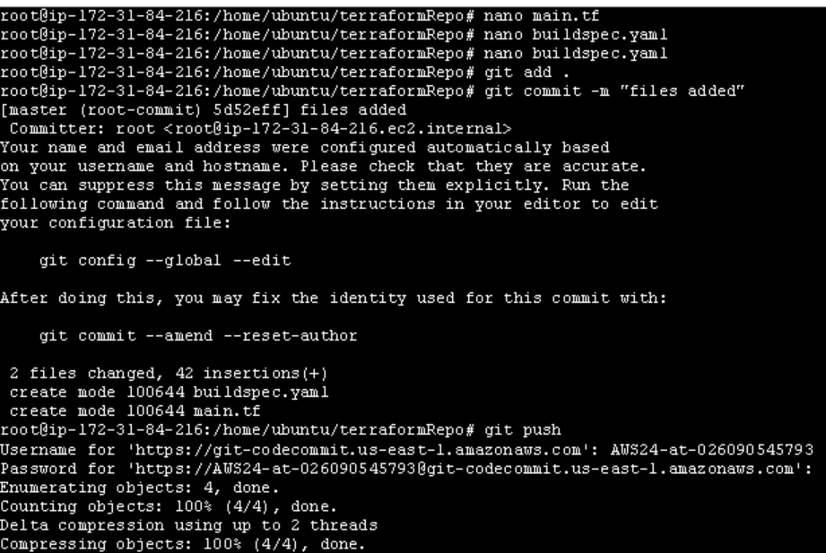

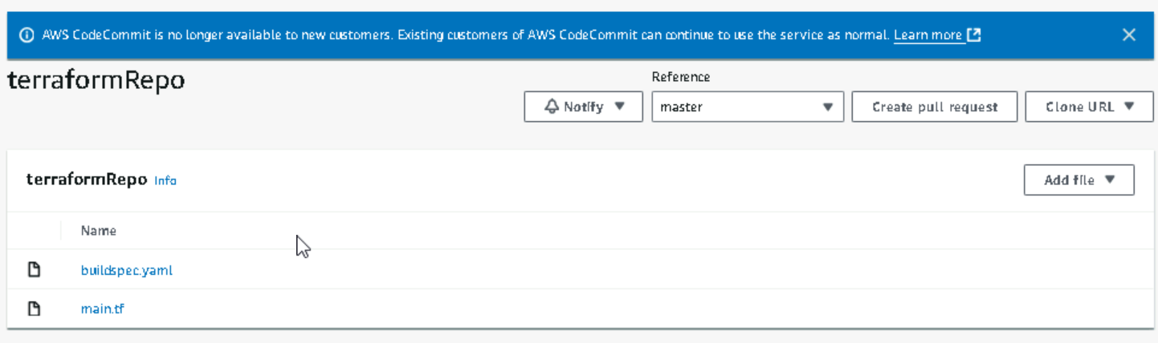

**TASK3 AND 4 :**

**AWS CODE PIPELINE FOR RUN TERRAFORM SCRIPT & CREATE S3 BUCKET**

**CREATE CODE BUILD FOR BUILD STAGE IN CODE PIPELINE**

* **Add code commit as source**

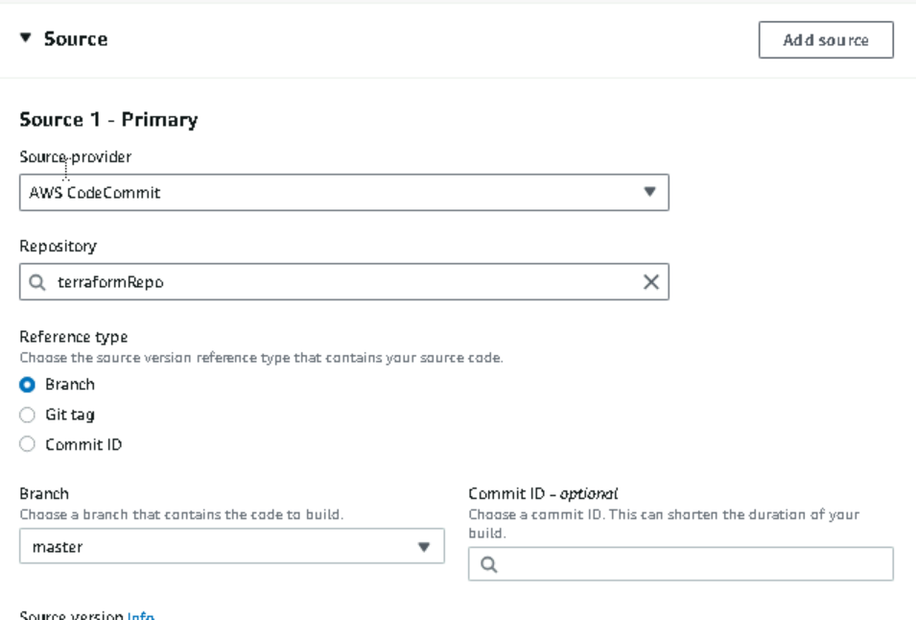

**Add builspec.yaml to code build**

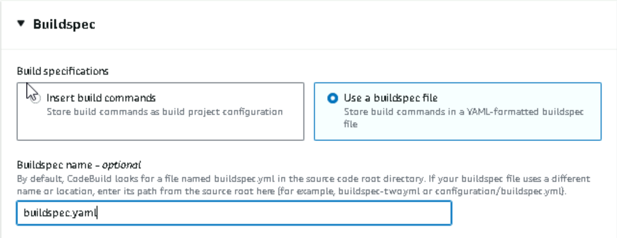

**Give permission for code build**

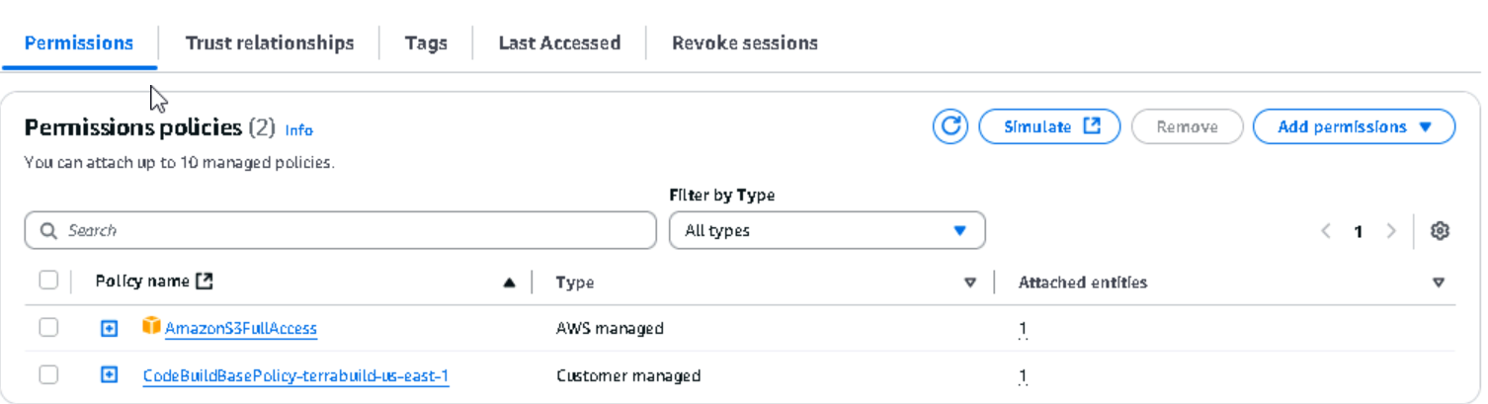

**CREATE CODE PIPELINE**

* **MENTION SOURCE : CODE COMMIT REPO**

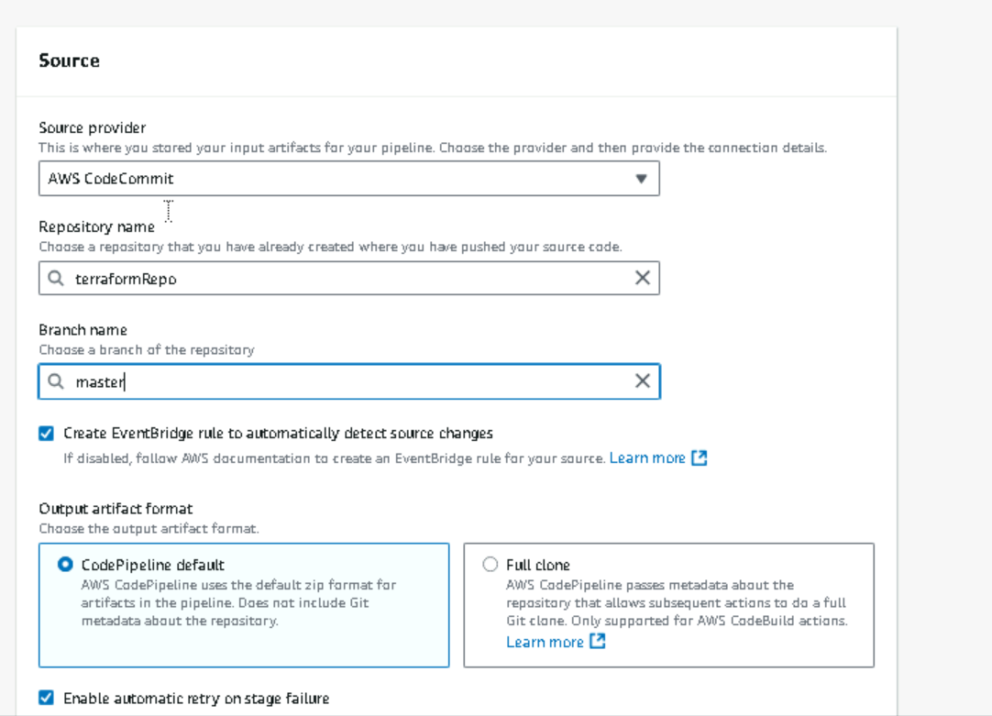

* **MENTION BUILD PROVIDER: CODE BUILD**

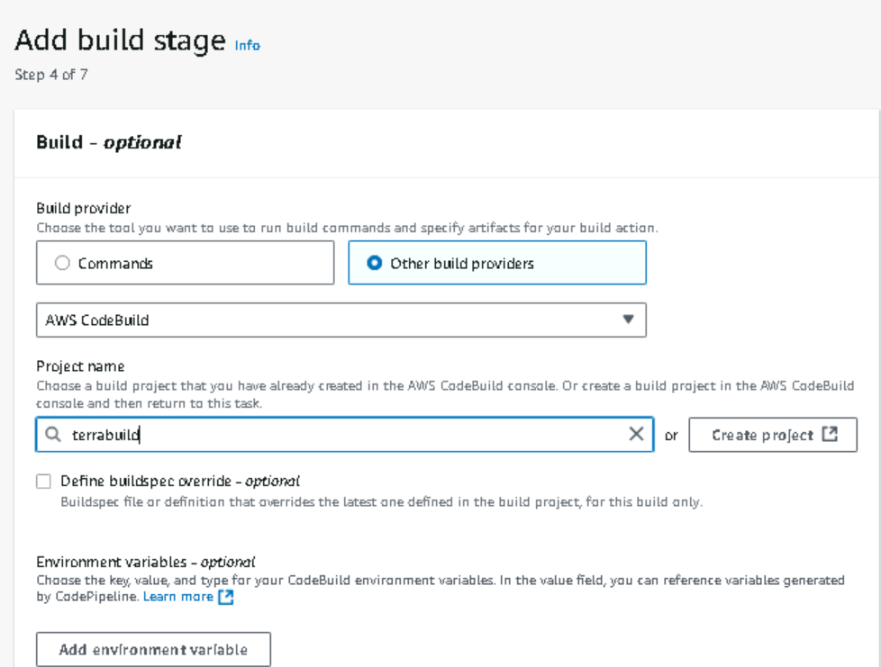

**RUN THE PIPELINE**

**PIPELINE IS SUCCESS AND S3 BUCKET IS CREATED**

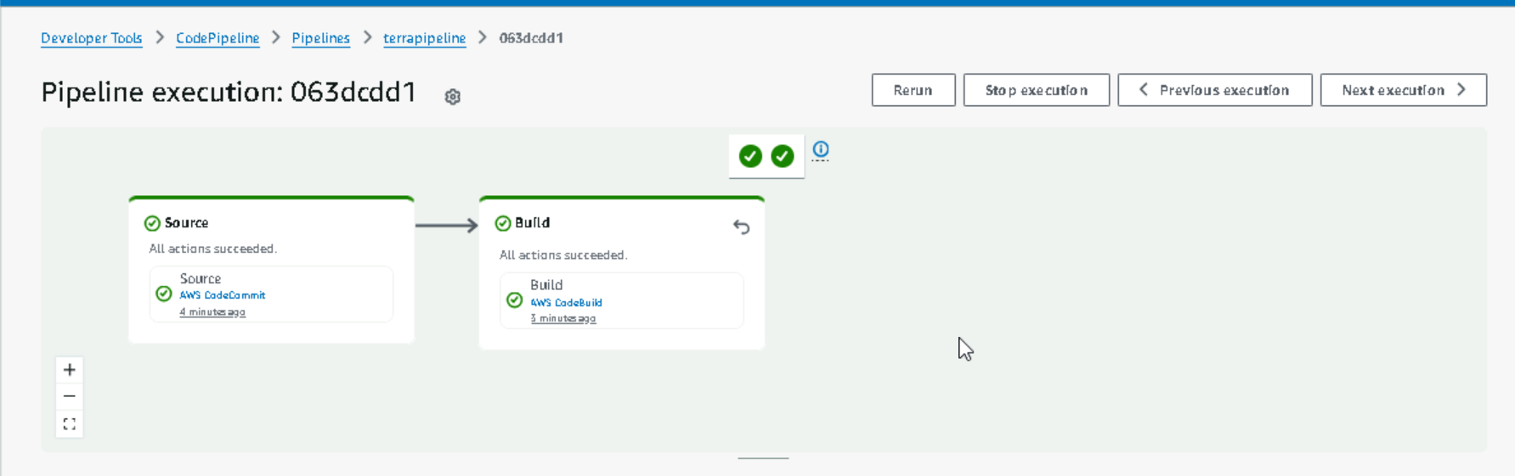

**BUILD PHASE OUTPUT - SUCCESS**

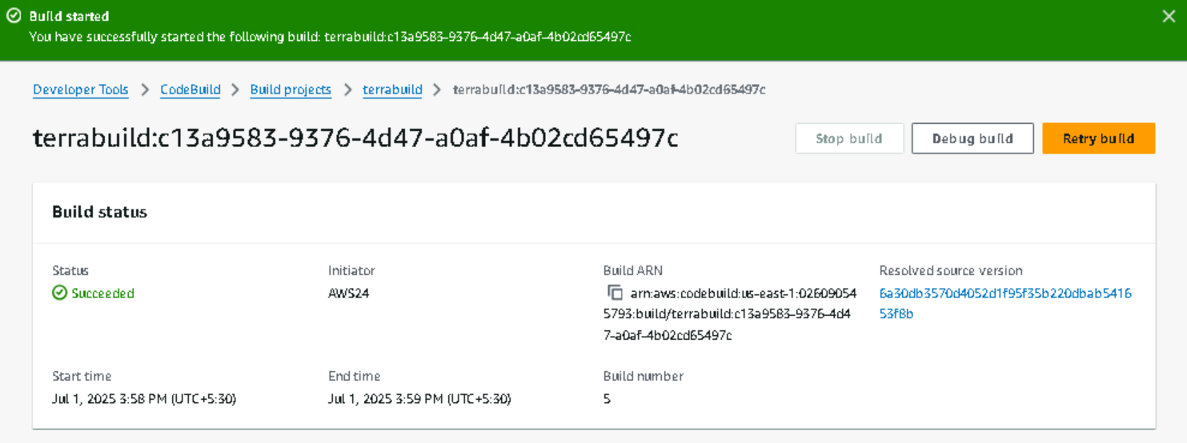

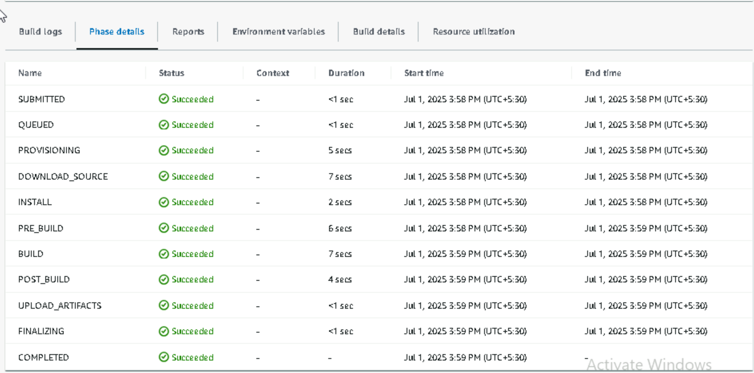

**OUTPUT LOG OF PIPELINE**

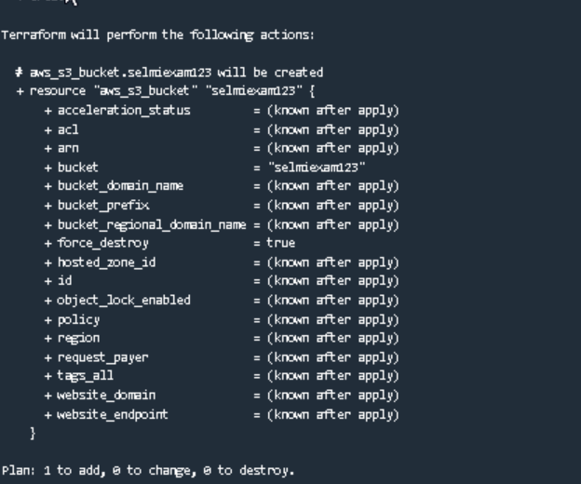

**S3 BUCKET CREATED THROUGH TERRAFORM**

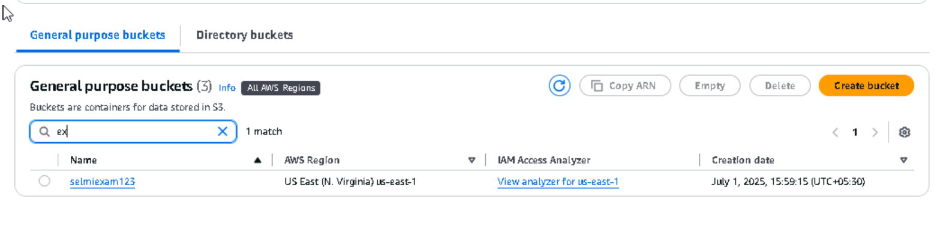

S3 bucket endpoint

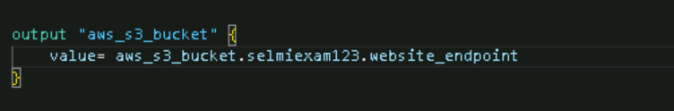

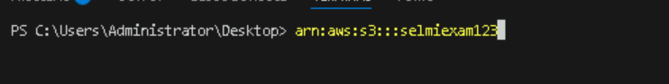

**TASK 5 & 6:**

**UPLOAD SAMPLE FILE & VERIFY**

I added one file named file.txt to code commit repository and upload that to s3 bucket created through pipeline

**UPLOADING A FILE TO S3 BUCKET - SUCCESS**

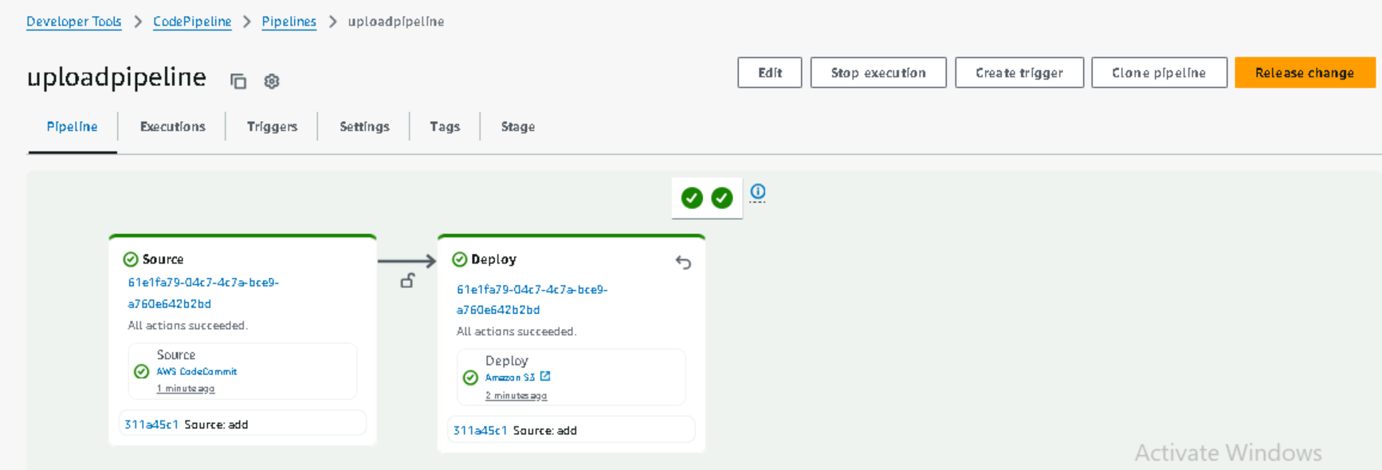

**FILE UPLOADED BY TERRAFORM AND PIPELINE**

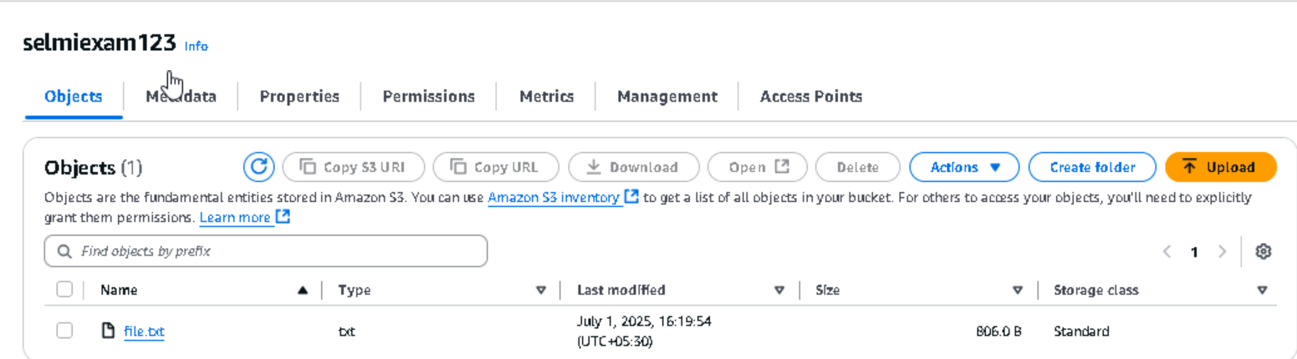

**TASK 7 & 8**

**ENABLE NETWORK RULES & VERIFY**

**TERRAFORM UPDATED FOR NETWORK RULES**

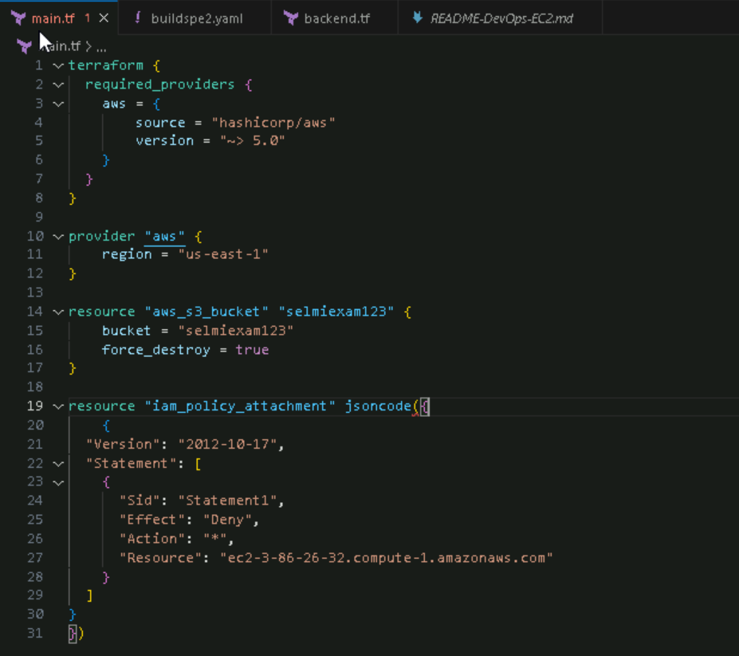

**VERIFY**

