Ansible1

Ansible code for creating multiple user and ssh key

Ssh key generation

>> ssh-keygen (this will create a ssh key)

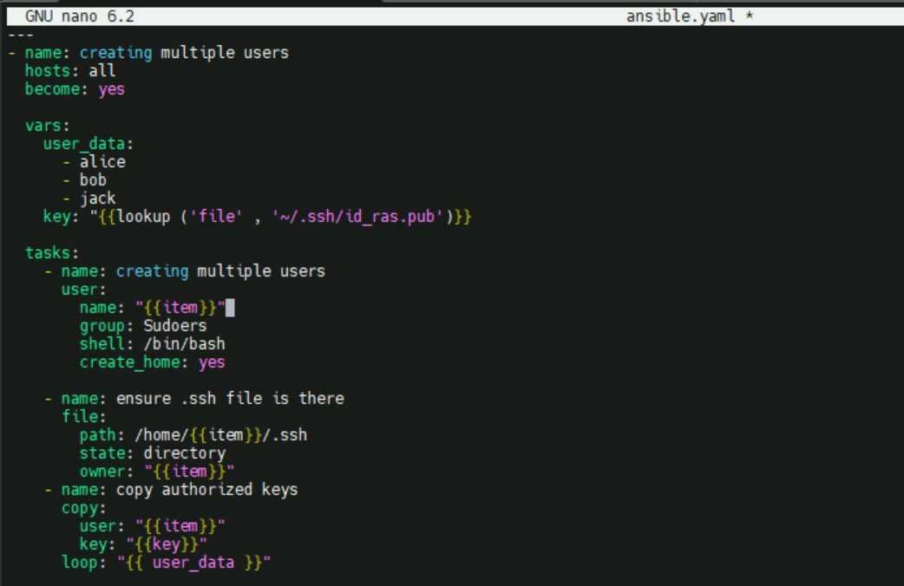

How to run:

**Ansible-playbook -i inventory ansible1.yaml**

