ANSIBLE2

Ansible role created

Ansible-galaxy init role-1



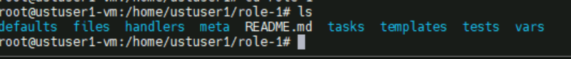

Tree role-1 🡪 will show ansible role structure

Here tree is not installed so I can’t do

Tasks/ main.yaml

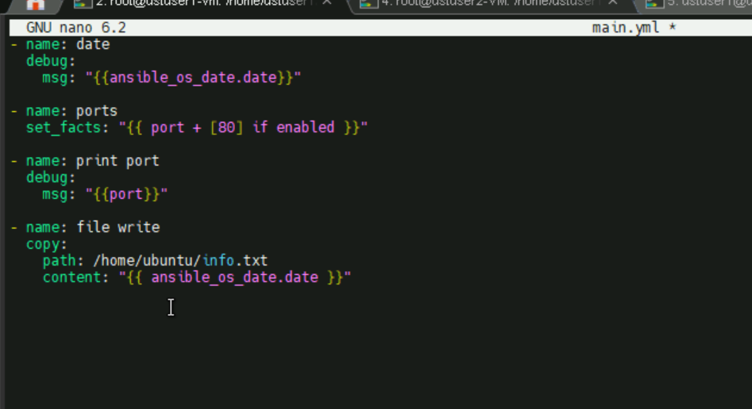

* Printing system info – date
* Check port 80 is enabled or not
* Printing the ports
* Store the system info to a file named info.txt
* For disk usage df -h

Default/main.yaml

This file contains the variables

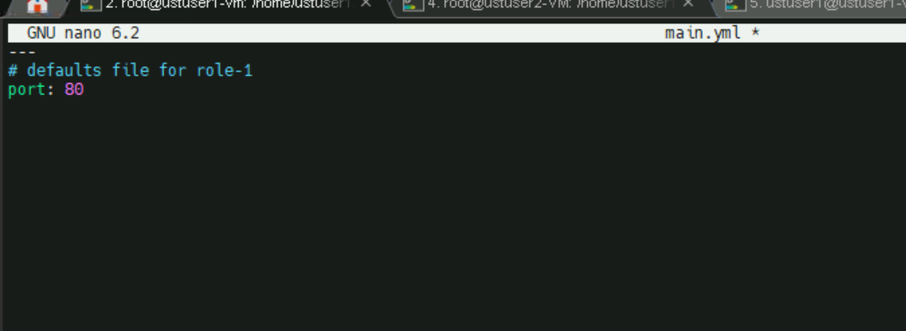

Site.yaml

