**Q1**

DEPLOYMENT and SERVICE CREATED FOR NGINX

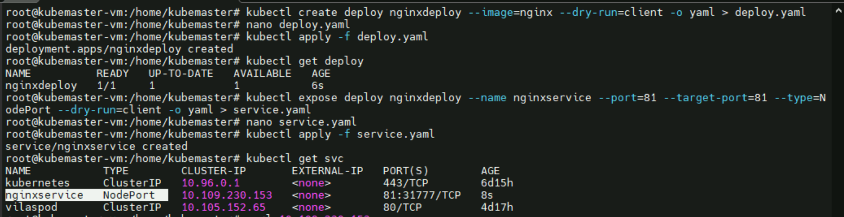

**STEP1: Deployment created**

Deployment file

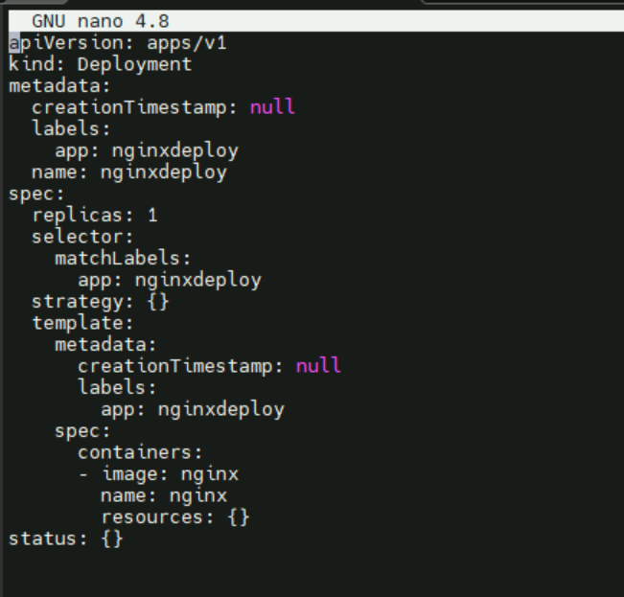

Deployment created

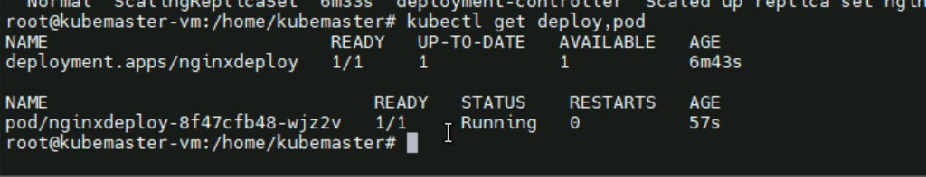

**STEP2: Service creation**

**Service file**

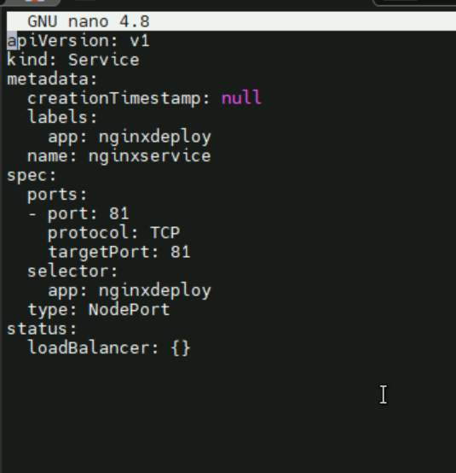

Service nodeport 🡪 nginxservice created

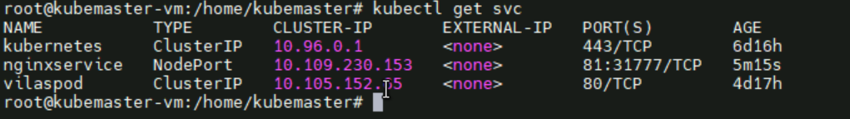

**STEP3: verification**



Curl the ip of service

Browse in the browser