**Q2**

**Jenkins image building and pushing to docker hub**

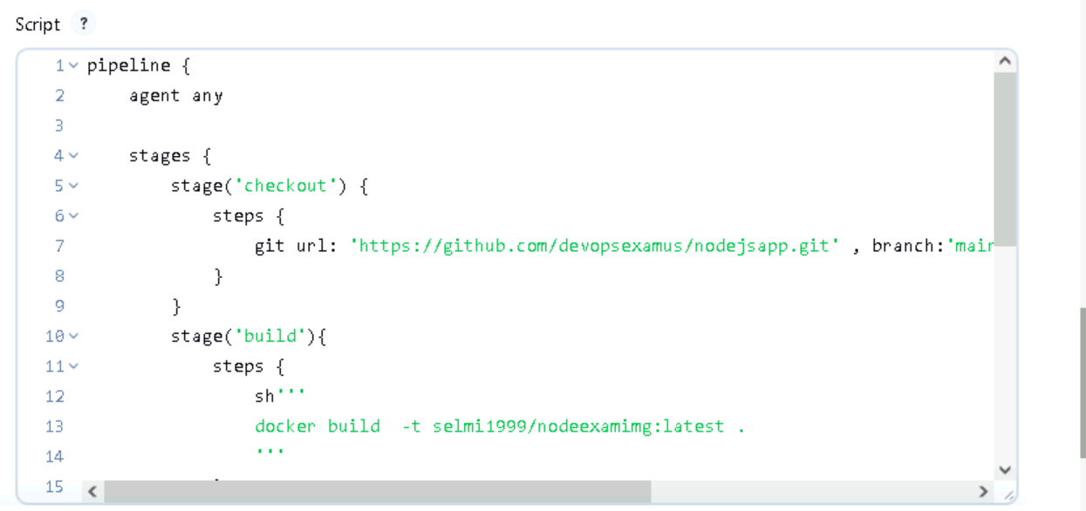

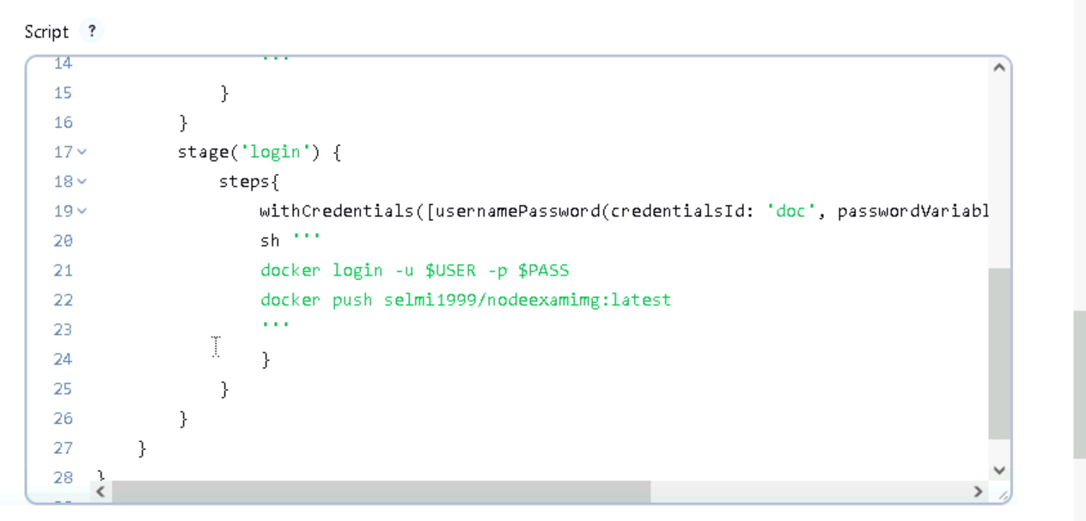

**Image push success**

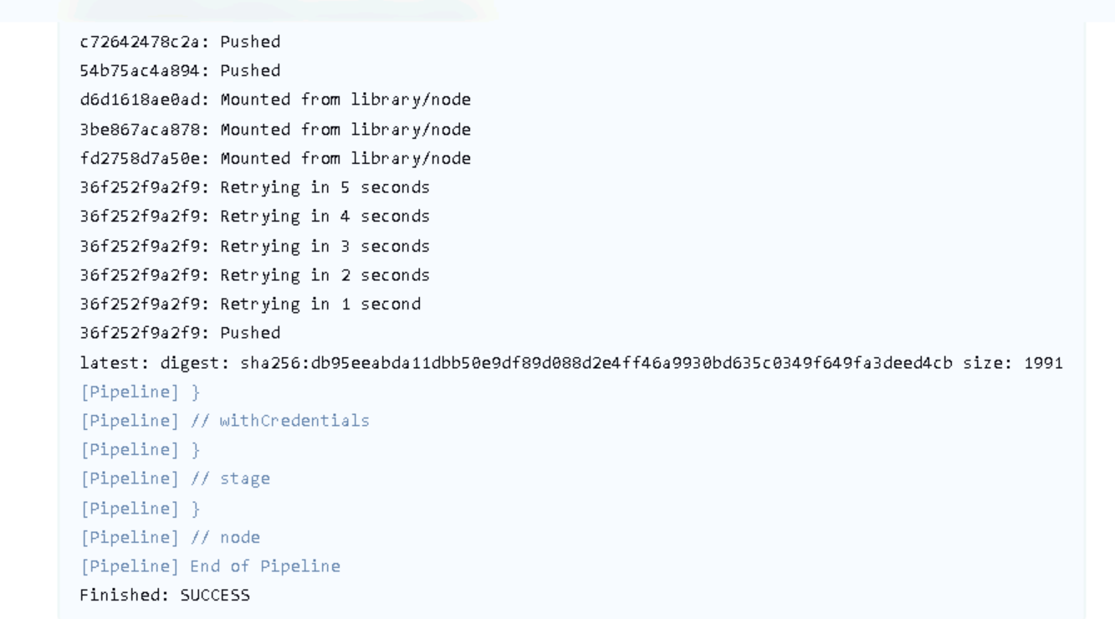

**Image pushed**



**STEP1: Deployment creation**

Creating deployment for node using pushed image



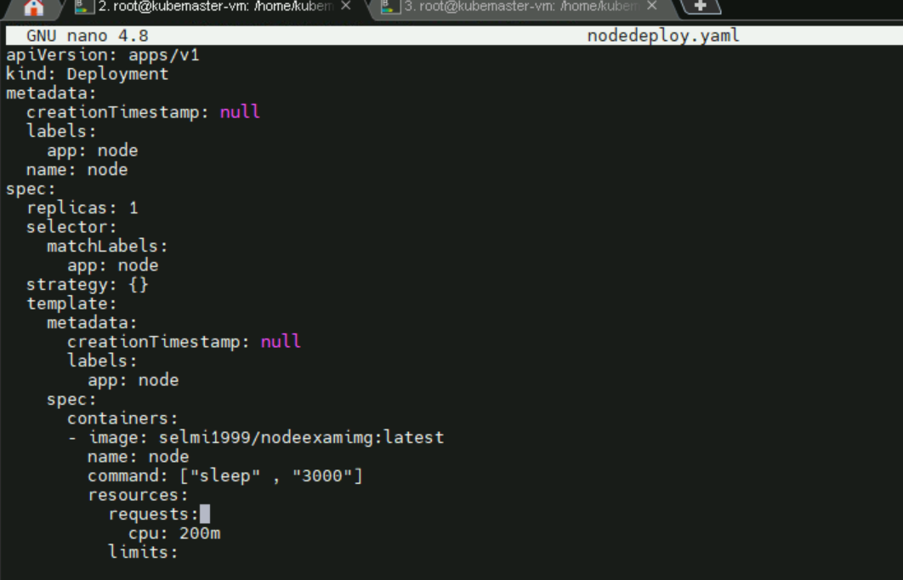

Deployment and pod created

Deployment – node

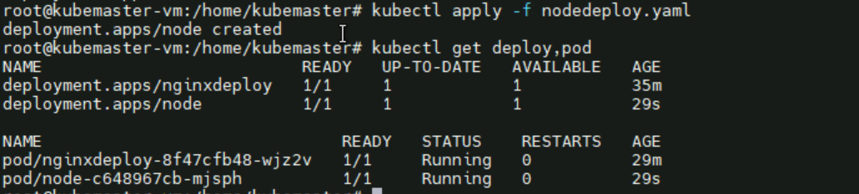

**STEP 2: HPA autoscaling**

Autoscaling the deployment (HPA)



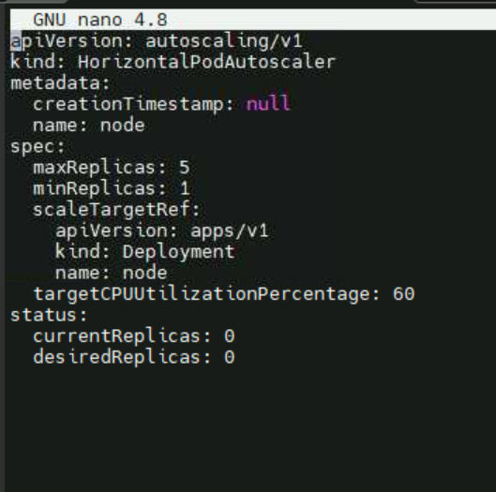



Autoscaling applied

HPA created

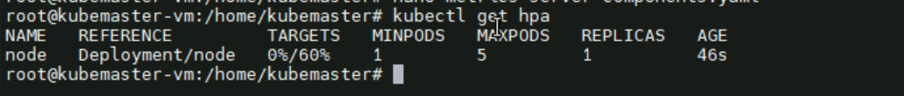

Before load



**STEP3: verification**

Applying load



New containers creating

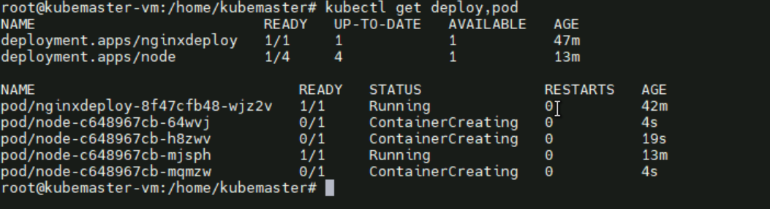

2 container/pod created

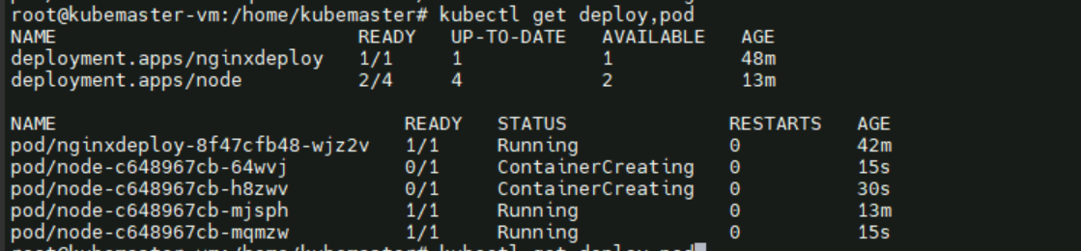

3 container/pod created

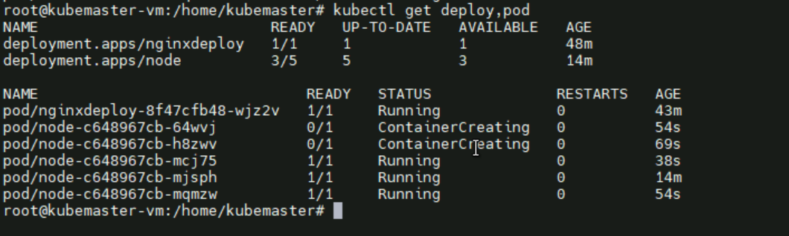

All 5 container.pod take the load and created

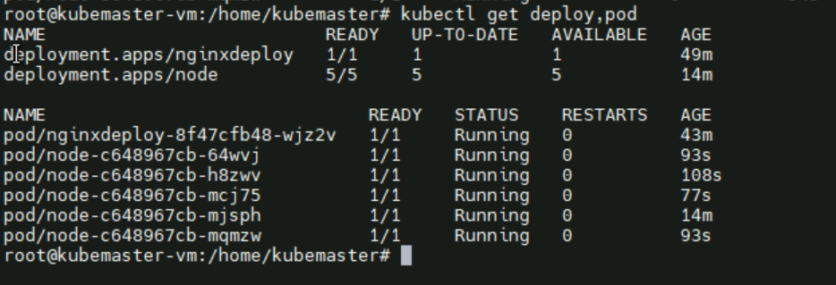

Cpu 50% used