**Q1**

Python scripting program that contains

* Displaying of source and target ip
* Identify and log packets
* Display count of packets
* Handle multiple interfaces (ICMP and TCP… IP that is reachable and not reachable where used and out shown in the document)
* Error handling added ( try, exception)
* Output write to file

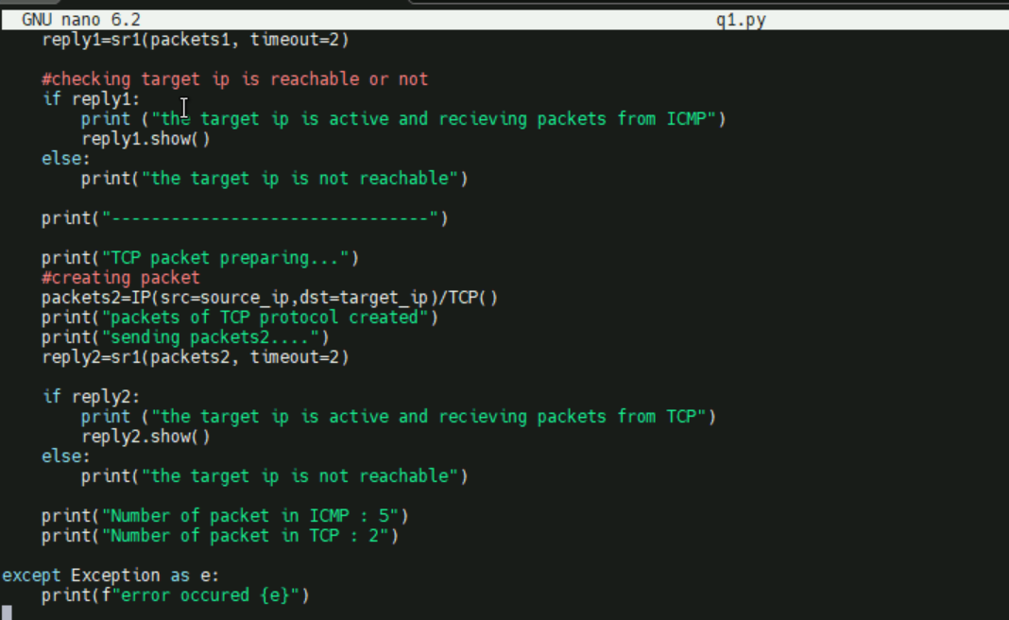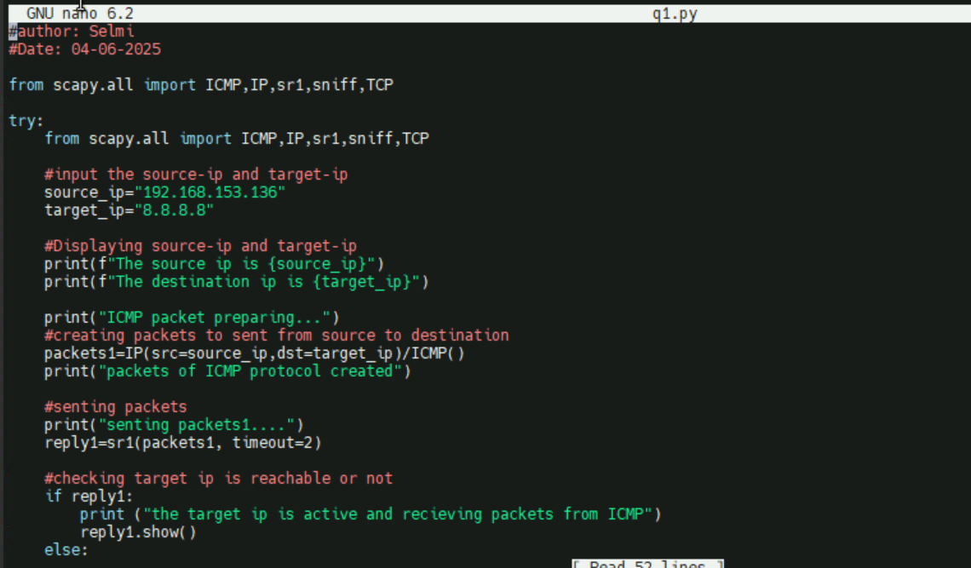

Step1: displaying source and destination ips

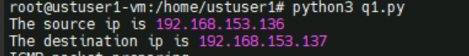

Output of ICMP and TCP ,IP

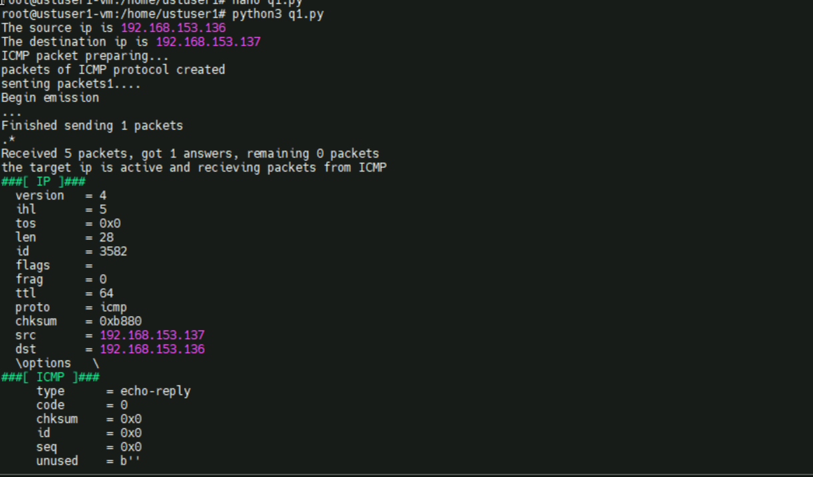

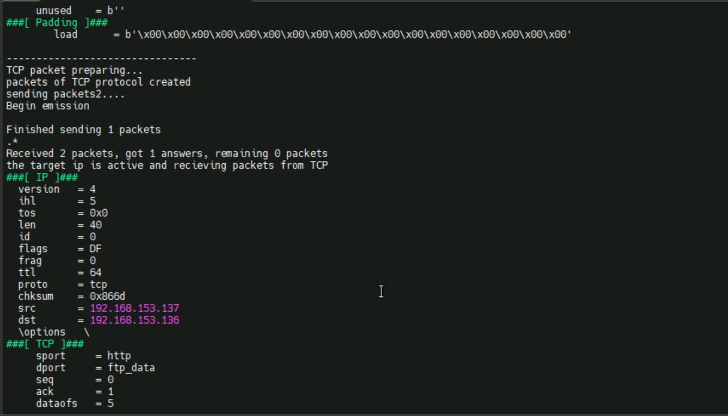

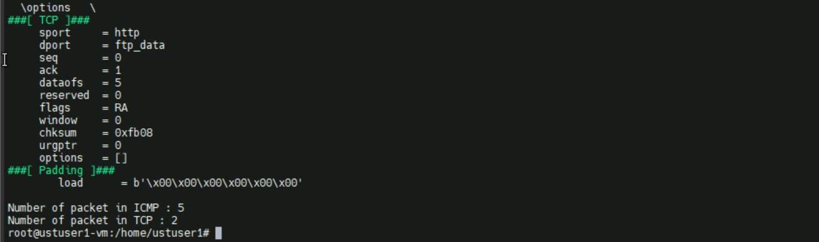

* Count of packets also shown in above screenshot

Output of ip which not reachable

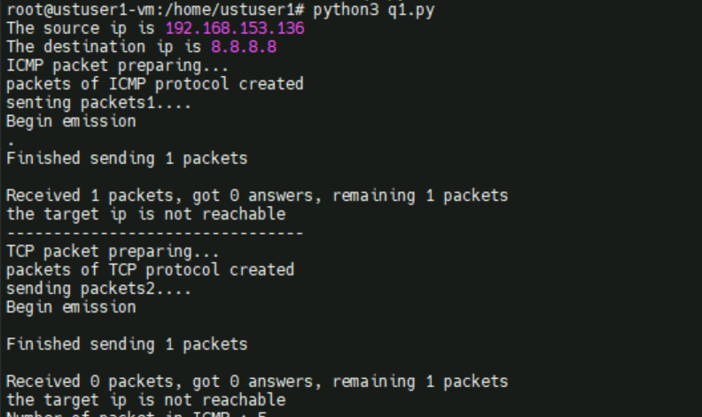

Output file code

