**Q1.Jenkins**

**### Step1: Git Repository**

https://github.com/devopsexamus/nodejsapp.git

Git repository mentioned in Jenkins pipeline

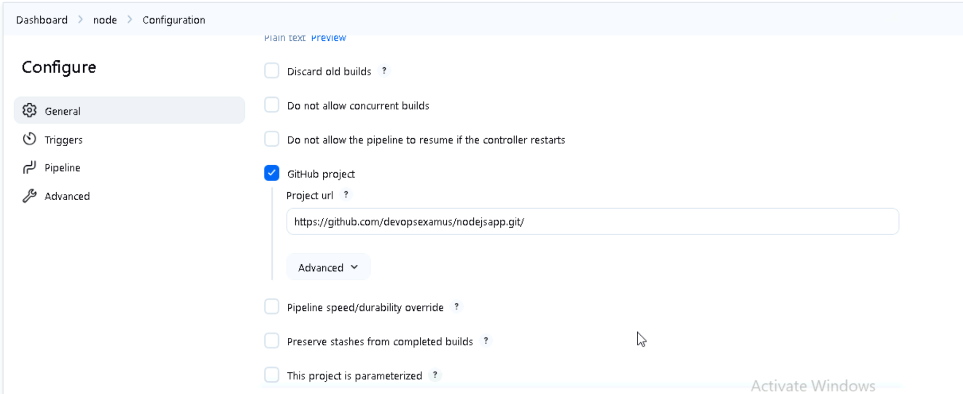

**### Step2: Pipeline script Configuration**

**Git checkout and building the image**

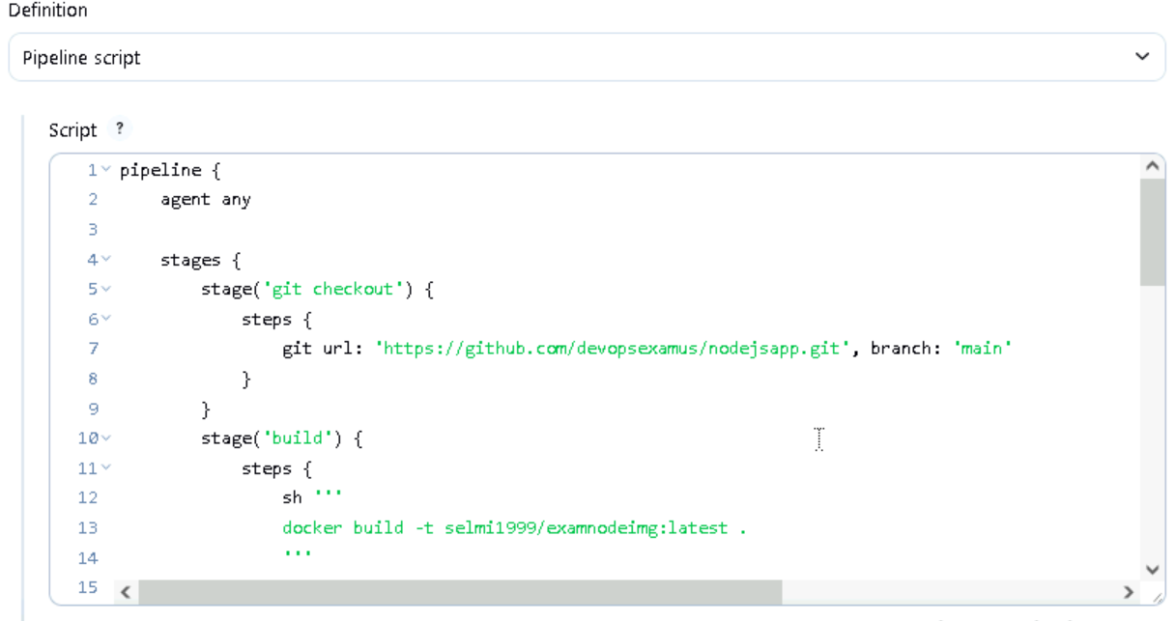

**Testing stage**

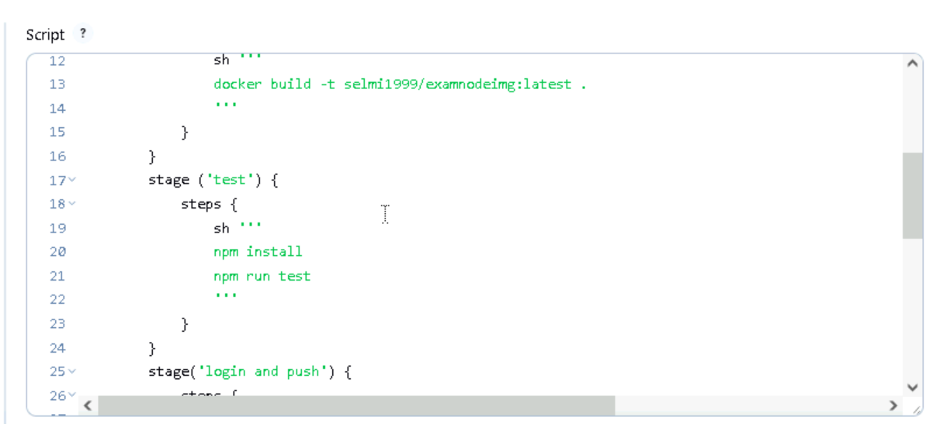

**Docker hub login and pushing image to dockerhub**

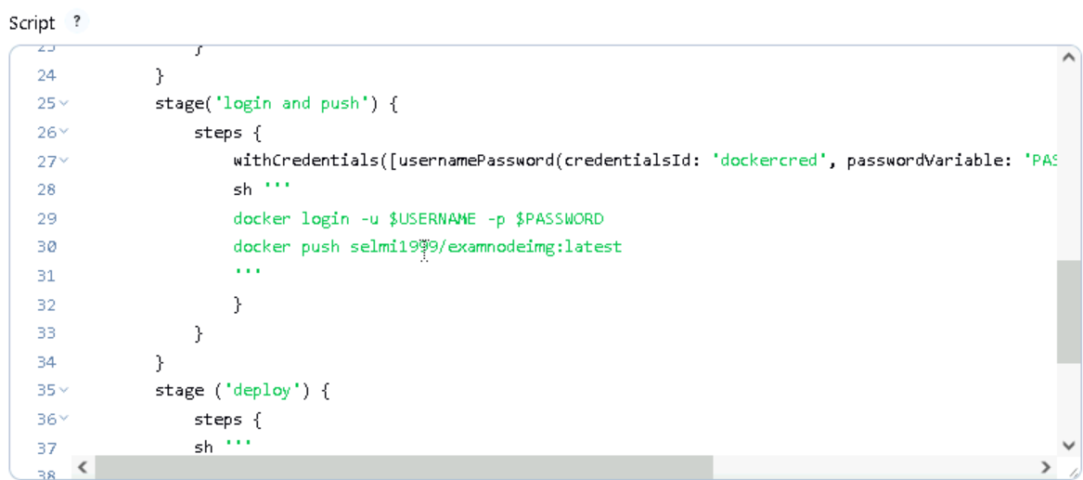

**Deployment stage**

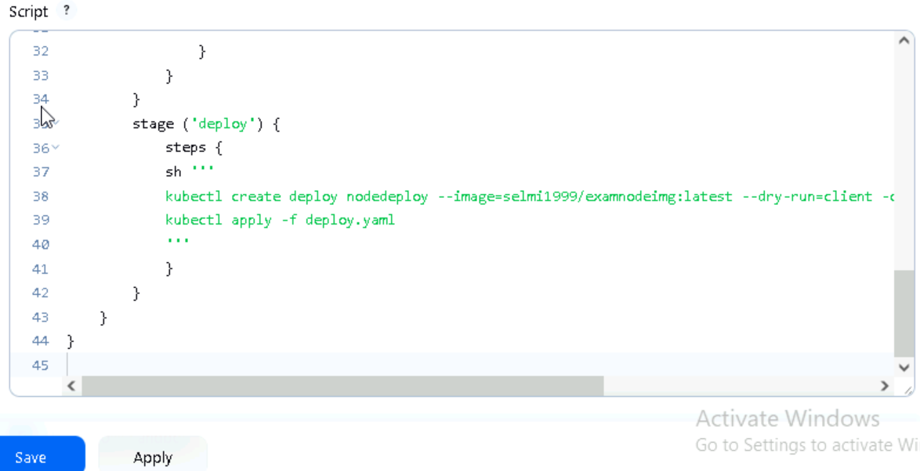

**Step3: Ensure building and testing stage is working properly**

**OUTPUT 🡪 SUCCESS**

**Stage1 🡪** git clone - success

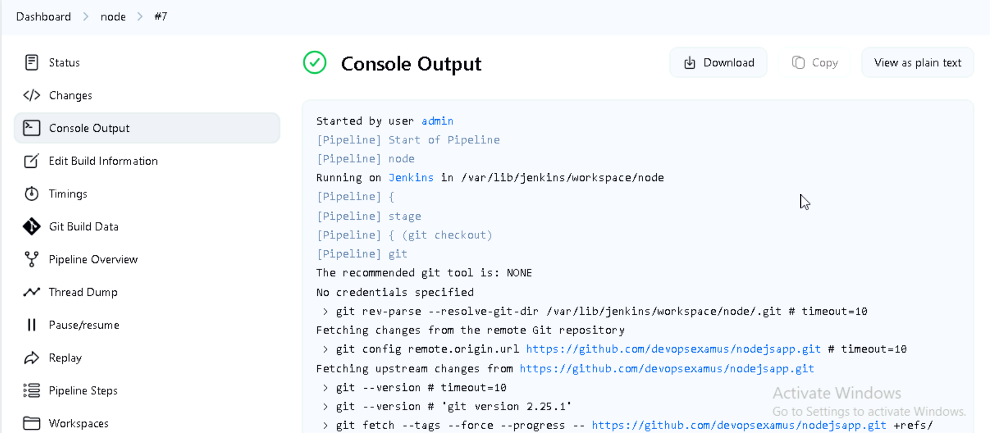

**Stage2 🡪** Build - success

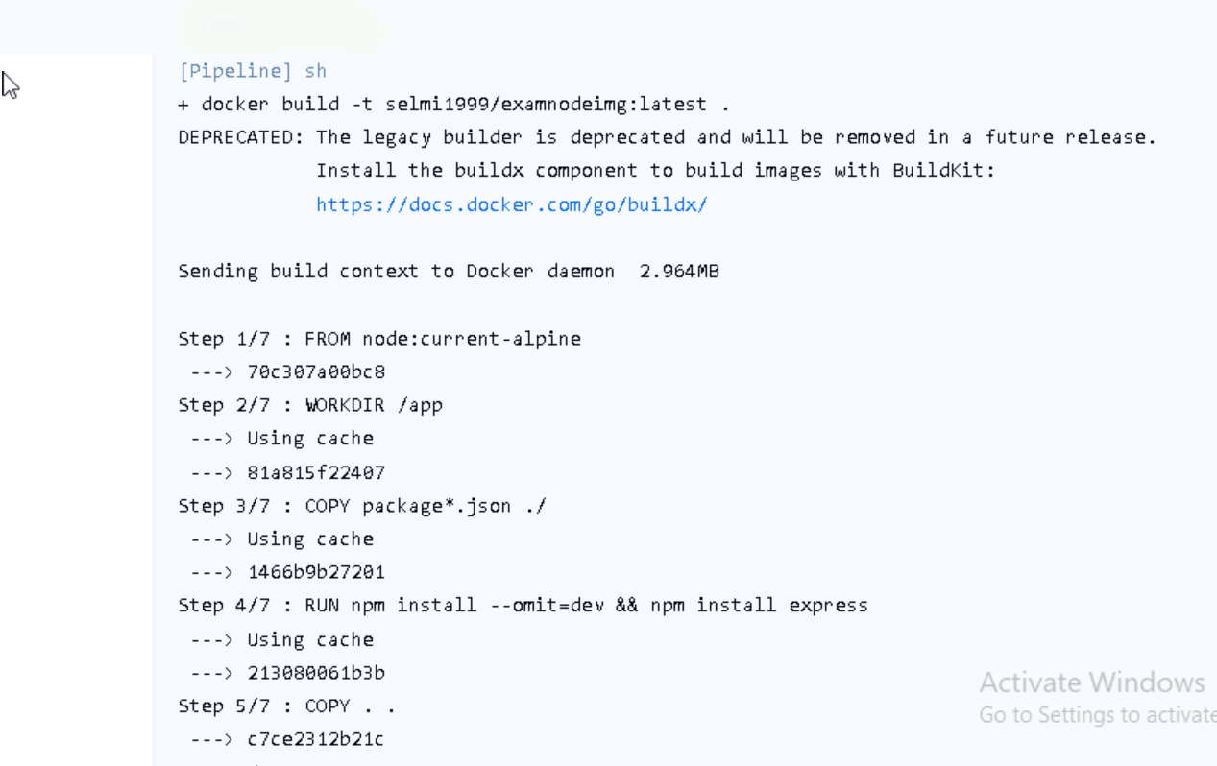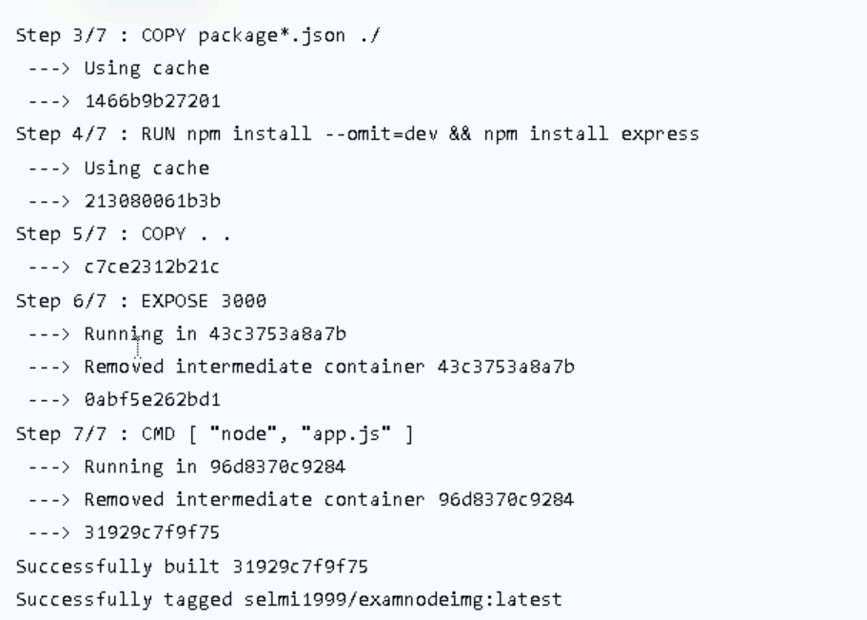

**Stage3** 🡪 test - success

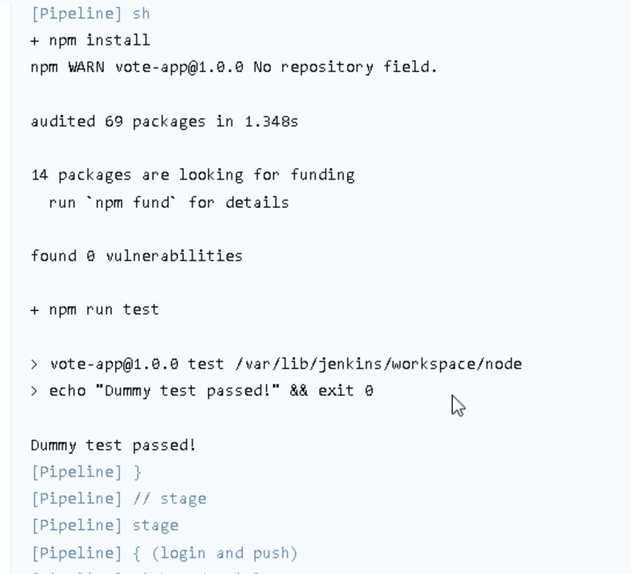

**Stage4 🡪** push - success

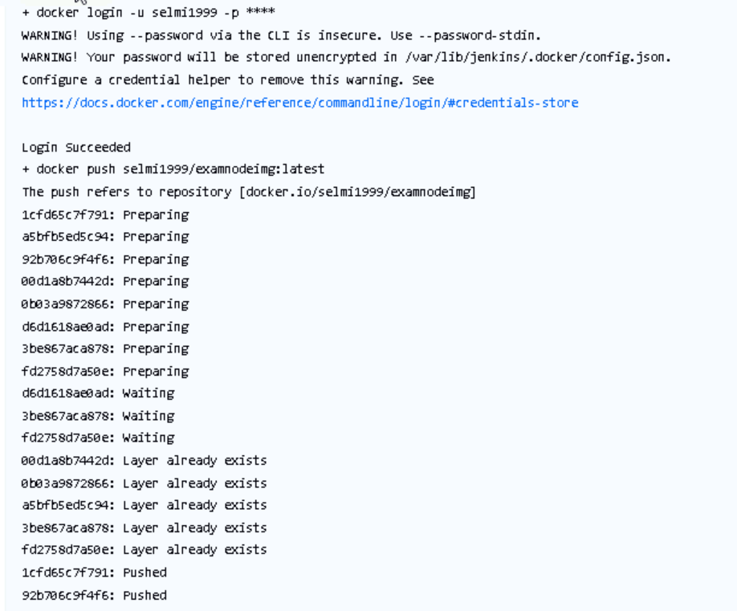

**###Step4 : Deployment working properly**

**Stage5 🡪** deployment success

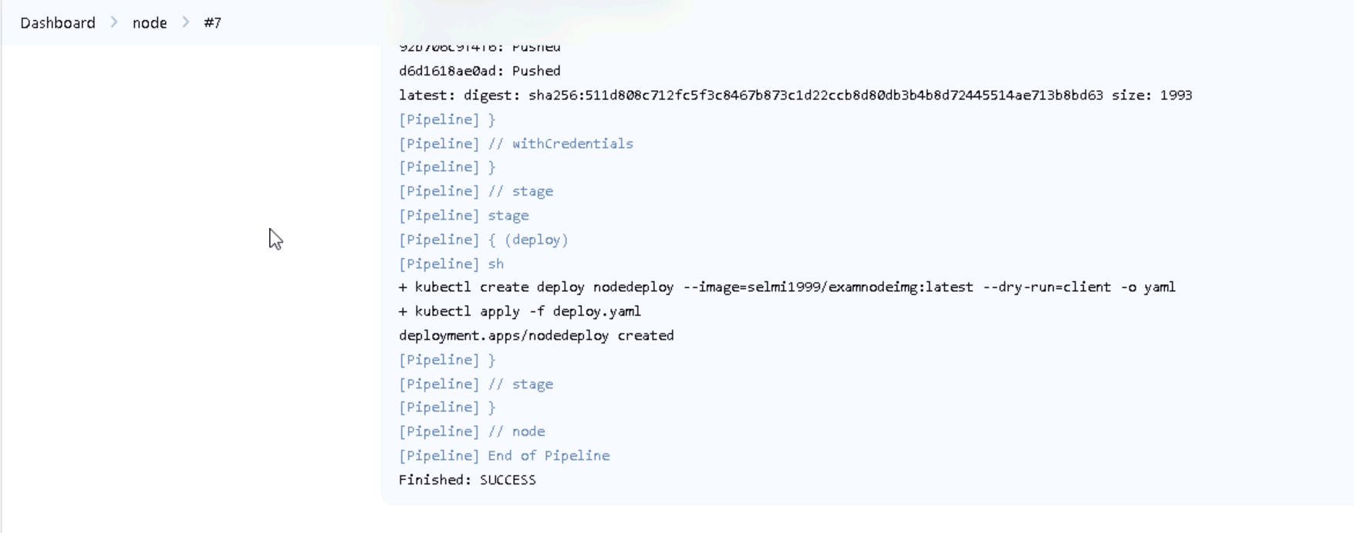

**OUTPUT 🡪 SUCCESS**

**Image pushed to docker hub**



**Yaml file of deployment created**

