**Q2**

Shell scripting program

* Take directory path as input
* Compressing it into .tar.gz file
* Creating backup file
* Proper error handling include that directory exists or not where check initially

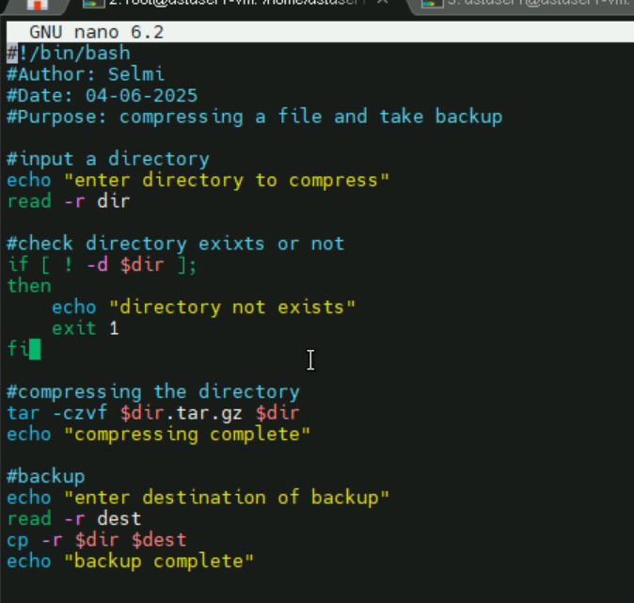

**Output**

* **File compressed**
* **Backup completed and stored in backup file**

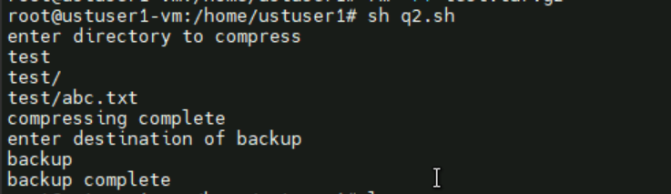

**ls (list directories)**

* test – my directory to compress
* test.tar.gz – compressed file
* backup – backup file



test directory

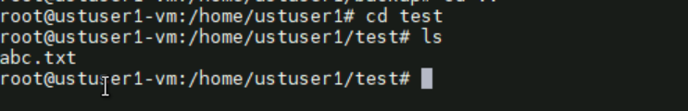

test.tar.gz



Backup

