**Q2. DOCKER**

**Step1: Pulling ubuntu docker image and ensure image is pulled**

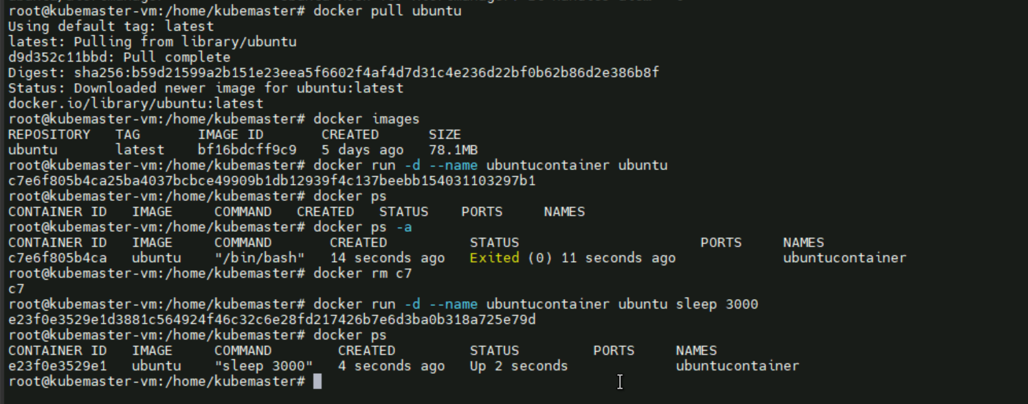

**Step2: Running the container**

Docker run -d –name ubuntucontainer ubuntu sleep 3000 (use sleep , otherwise the container go down)



**Step3: verification of container’s system resources like uptime, version , cpu, memory etc**

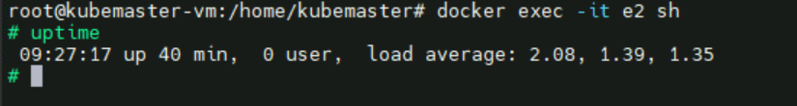



**Step4: Stopping and clean up of the container**

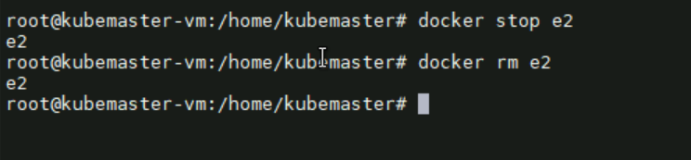

Commands

docker pull ubuntu 🡪 pull ubuntu image

docker images 🡪 list the image

docker run -d –name ubuntucontainer ubuntu sleep 3000 🡪 create container from image

docker ps 🡪 list the container

docker exec -it e2 🡪 get inside the container

docker stop e2 🡪 stop the container

docker rm e2 🡪 remove the container