**Q3**

Python scripting

* Error handling ( try, catch)
* Input directory
* Check directory exists or not
* Importing proper modules
* Print function added for alert for any modification

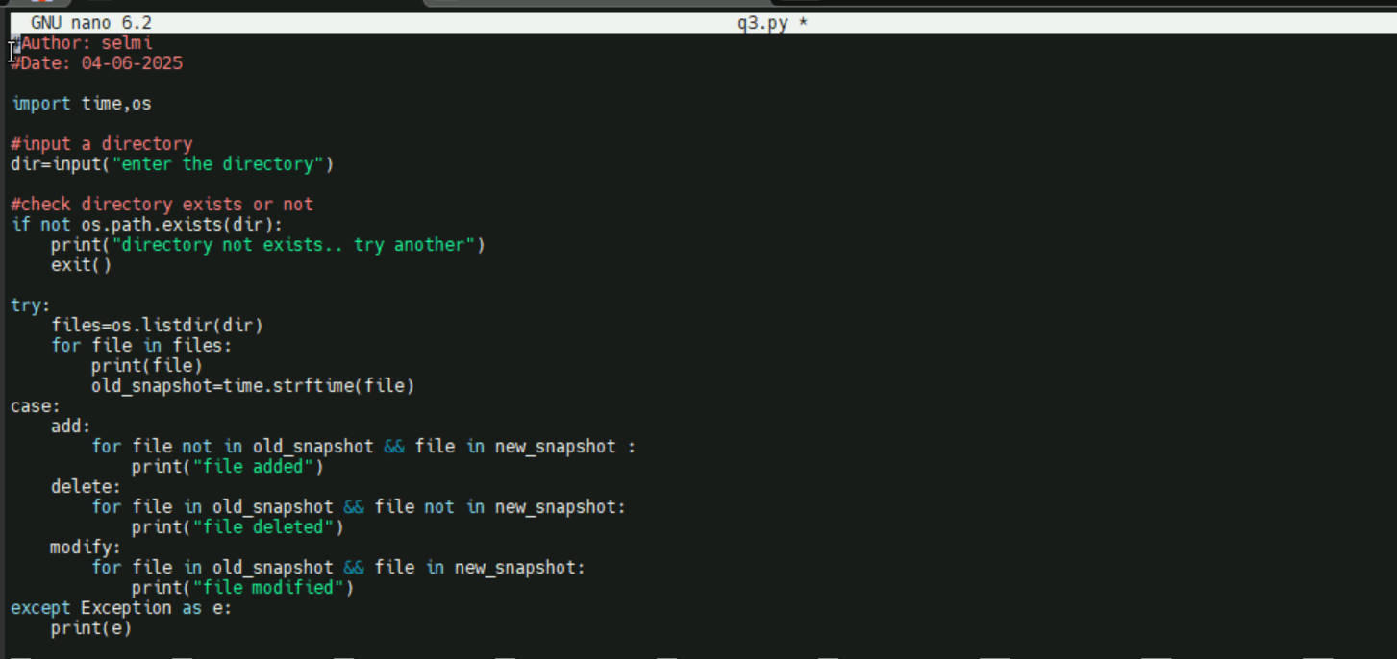

Logic of the program

* Input a directory
* Check directory exists or not
* Parsing through the directory and find all files and prints
* Taking snapshot of each file
* After each execution of program, it will check the snapshot and create a new snapshot
* If old snapshot and new snapshot are same – means file have no modification
* If old snapshot exists and new snapshot is not there – file deleted
* If old snapshot not exists and new snapshot came- file added
* If old snapshot and new snapshot are there but not same – file modified

**Output of printing file**

