**Q3. KUBERNETES**

**Step1: Pod Configuration**

Pod.yaml with volume attached

Image: nginx

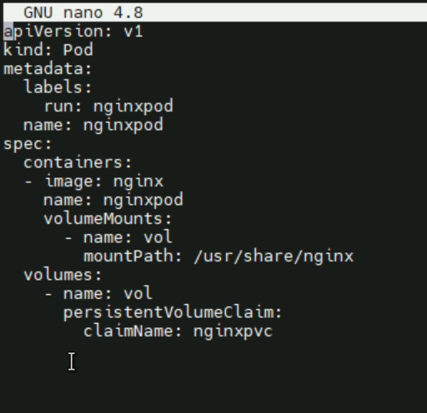

Pod is running

>> Kubectl get pod

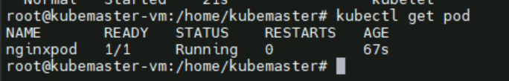



**Step2: Volume configuration**

Pvc.yaml

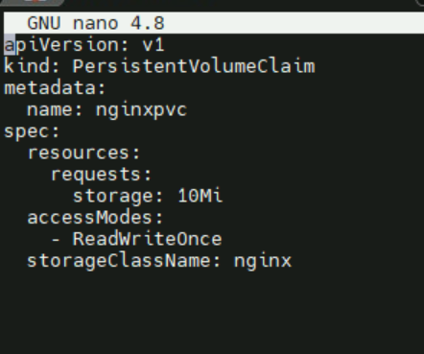

Pv.yaml

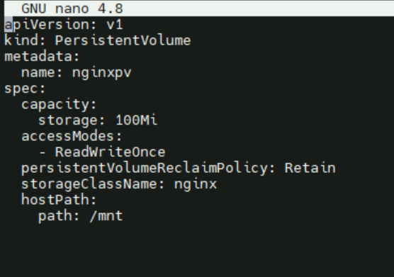

Ensuring volumes (pv and pvc are working fine)

>> kubectl get pv,pvc

Now we can see the status that pv and pvc are bounded each other

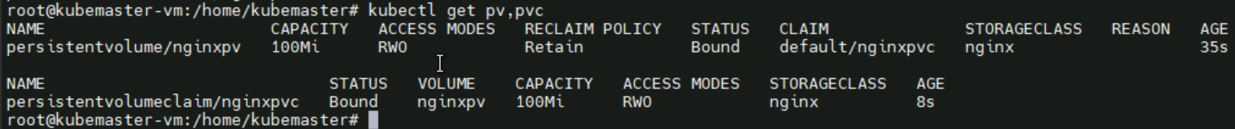

**Step3: File serving**

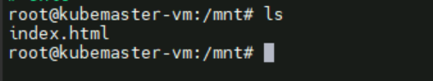

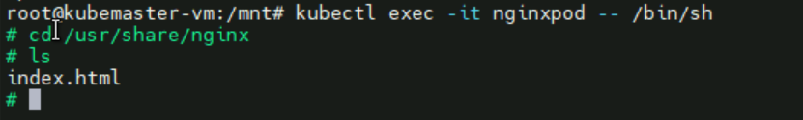

File inside the host path can see in

**Step4: Validation**

Verify the pod / container

>> kubectl exec -it nginxpod -- /bin/sh



Content served by nginx

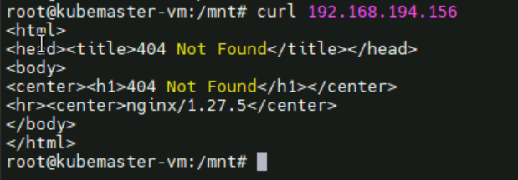

NOTE: Whatever the contents give to container mount path ( /usr/share/nginx) can be seen in host path given in pv (/mnt) and vice versa