**Q5**

Hook

* Taking msg
* Check type and give alert message

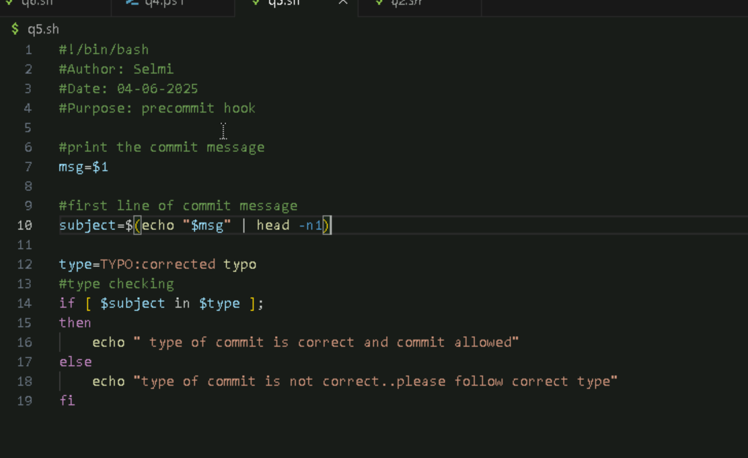

OUTPUT

