**Q6**

Shell script program contains

* Successful api connection
* Data retrieved successfully
* Data parsed and display in table
* Write output to file data_table.csv
* Proper error handling

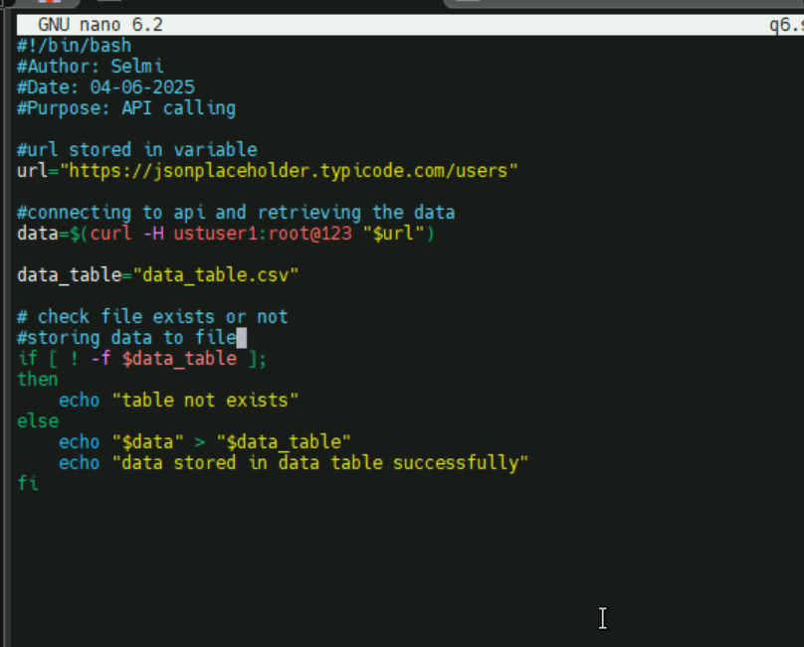

Output - SUCCESS

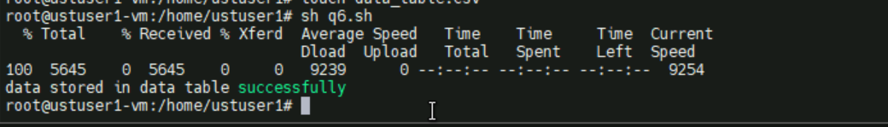

This screenshot shows successful api connection and data retrieval from the jsonplacehoder url given

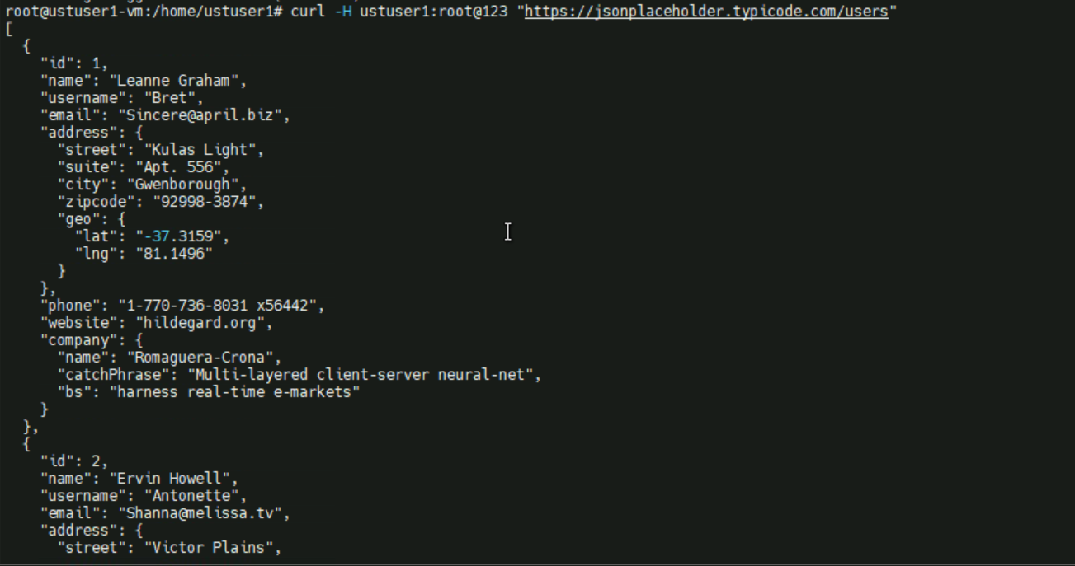

Output stored in a file data_table.csv

