**TASK**: How to do the authentication with infinity datasource api calls

Requirements:

* Infinity data source
* Type - JSON
* Parser - JSONata/UQL
* Method – **POST/GET**
* Add some url
* Use HTTP Headers for authentication to access API end point data

Solution:

EXAMPLE 1 (POST method)

* url - <https://postman-echo.com/post>
* Key: Authorization
* Value: Bearer TEST_TOKEN_EXAMPLE123
* Body content:

{

"message": "Hi, I am practising authentication with API calls"

}

* raws/root selector – data

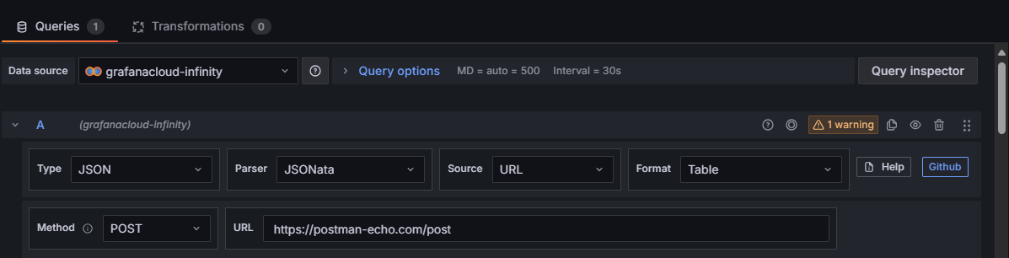

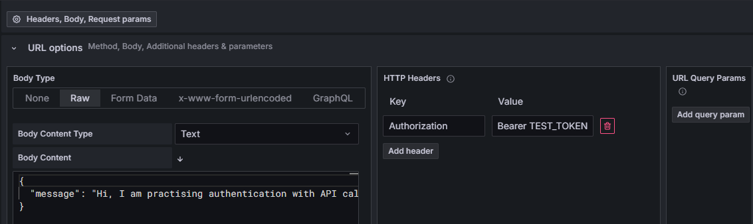

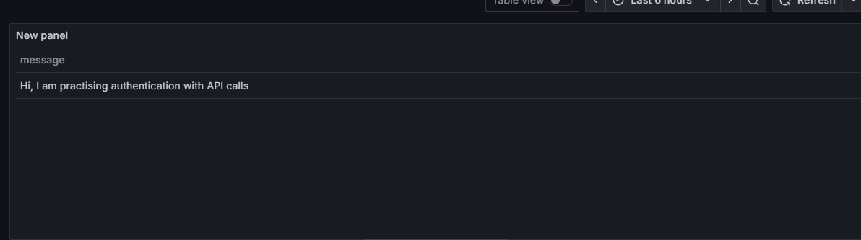

EXAMPLE 2 (POST method)

* url - <https://api.restful-api.dev/objects>
* Body content:
* {
* "name": "Apple MacBook Pro 16",
* "data": {
* "year": 2019,
* "price": 1849.99,
* "CPU model": "Intel Core i9",
* "Hard disk size": "1 TB"
* }
* }
* raws/root selector – data

OUTPUT:

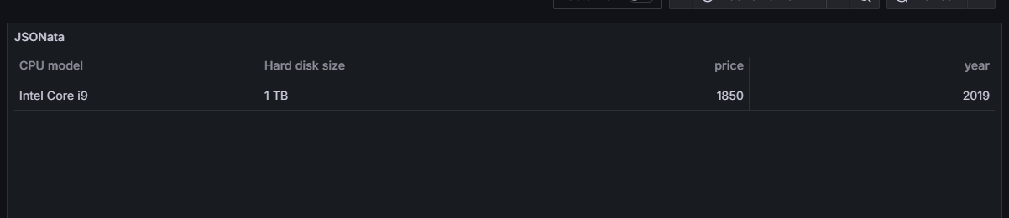

EXAMPLE 3 (GET method with UQL Query)

OUTPUT:

EXAMPLE 4 (GET method)

DASHBOARD

NOTES:

**?** Difference Between JSONata vs UQL in Infinity Datasource

JSONata

* Used for Extracting & transforming JSON fields into tabular format
* When you want to restructure JSON, handle nested fields, or rename fields.

UQL

* When you want SQL-like filtering, sorting, or aggregations.

**?** what is Rows/Root

* JSON path that tells Grafana *which array of objects to treat as table rows*
* Eg: You have columns like page, per_page, and a nested data object. With this field , Go inside data array, and treat each object as a row

**?** HTTP Headers

Headers are **extra information** you send along with an HTTP request.  
They don’t go in the URL or body → instead, they are metadata.

**?** HTTP Body Content

The **body** is the actual data you send to the server, usually in **POST/PUT** requests.  
It’s the request payload.