* **Setup the Environment**
* **Application -** [**http://localhost:8081**](https://4f40ee5236c9-10-244-5-239-8081.papa.r.killercoda.com/)
* **Grafana -** [**http://localhost:3000**](http://localhost:3000)

1. **Explore your metrics**

**Builder/Code** toggle – set Code Mode

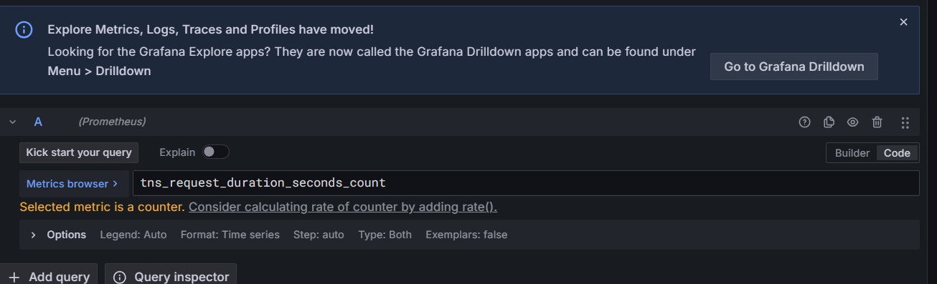

* **tns_request_duration_seconds_count**   
  The total number of requests handled by the tns service for which we recorded the duration in seconds
* **rate(tns_request_duration_seconds_count[5m])**The average number of requests per second handled by the tns service over the last 5 minutes
* **sum(rate(tns_request_duration_seconds_count[5m])) by(route)**   
  For each API route, show the average number of requests per second over the last 5 minutes, summed across all servers.
* **sum(rate(tns_request_duration_seconds_count[5m])) by(route)**   
  For each API route, show the average number of requests per second over the last 5 minutes, summed across all servers.

* **sum(rate(tns_request_duration_seconds_count[5m])) by(status_code)**

show traffic per HTTP status code

200 → OK (successful requests)

404 → Not Found

500 → Internal Server Error

click the dropdown arrow on the **Run Query** button, and then select **5s**. Grafana runs your query and updates the graph every 5 seconds.

1. **Add a logging data source (LOKI)**

Connections -> Data source -> select Loki -> Add new data source -> fill url (<http://loki:3100> ) -> save and test

1. **Explore your logs**

Explore -> data source : Loki -> Code mode

**{filename="/var/log/tns-app.log"}**

* The height of each bar in the graph encodes the number of logs that were generated at that time.

Give a new entry in application with only title, no url to see error

1. ***Build a dashboard***

Dashboard -> new -> new Dashboard -> Add visualization

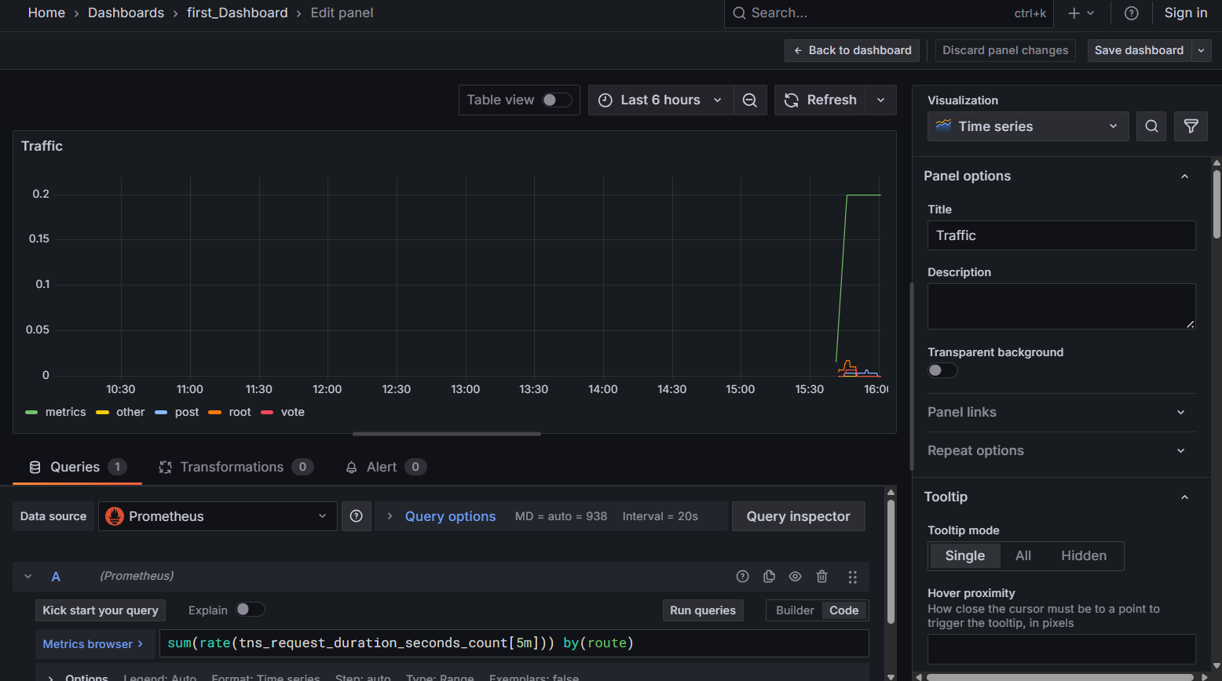

1. **Annotate events**

Right click -> Add annotation

Press ctrl -> click and drag across the graph to select an area -> add annotation

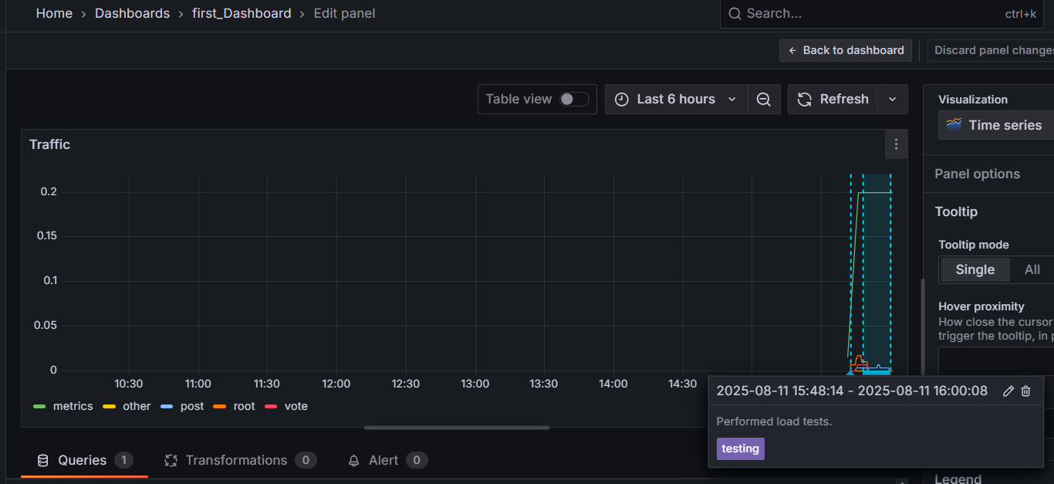

**Using annotations to correlate logs with metrics**

 create an annotation using the Loki data source

Dashboard settings -> Annotations -> Add annotation query -> Name: Errors ->Data source: Loki

{filename="/var/log/tns-app.log"} |= "error"

1. **Create a Grafana-managed alert rule**

most basic alert rule consists of two parts:

1. A **Contact point** - A Contact point defines how Grafana delivers an alert instance. When the conditions of an *alert rule* are met, Grafana notifies the contact points, or channels, configured for that alert rule.

Eg:

* [Email](https://grafana.com/docs/grafana/latest/alerting/configure-notifications/manage-contact-points/integrations/configure-email/)
* [Webhooks](https://grafana.com/docs/grafana/latest/alerting/configure-notifications/manage-contact-points/integrations/webhook-notifier/)
* [Telegram](https://grafana.com/docs/grafana/latest/alerting/configure-notifications/manage-contact-points/integrations/configure-telegram/)
* [Slack](https://grafana.com/docs/grafana/latest/alerting/configure-notifications/manage-contact-points/integrations/configure-slack/)
* [PagerDuty](https://grafana.com/docs/grafana/latest/alerting/configure-notifications/manage-contact-points/integrations/pager-duty/)

1. An **Alert rule** - An Alert rule defines one or more conditions that Grafana regularly evaluates. When these evaluations meet the rule's criteria, the alert rule is triggered.

* **Create a contact point for Grafana-managed alert rules**
* **Add an alert rule to Grafana**
* **Edit alert rule with dashboard and panel we created**

