**PART 2**

<https://grafana.com/tutorials/alerting-get-started-pt6/?pg=tutorials&plcmt=results>

githubLink - https://github.com/tonypowa/grafana-prometheus-alerting-demo.git

**Use Case: monitoring and alerting for system health with Prometheus and Grafana**

* setting up a monitoring system to watch CPU, memory, and disk usage in real time. (python script which create a fault server for creating cpu and memory use)
* Prometheus read the value
* Grafana takes the data from Prometheus and shows it on a time-series graph
* set alert rules for CPU or memory exceeds threshold, Grafana will trigger an alert
* Those alerts will also appear as annotations on the graph

Steps:

* Create a Dashboard
* Update panel name – CPU and Memory Usage
* PromQL Query

flask_app_cpu_usage{instance="flask-prod:5000"}

flask_app_memory_usage{instance="flask-prod:5000"}

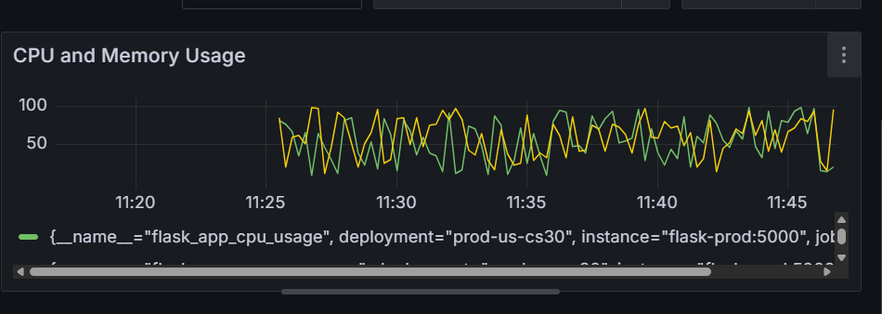

* Create a contact point - Webhook
* Create Alert rule for cpu_usage

set the threshold – 75

query - flask_app_cpu_usage{instance="flask-prod:5000"}

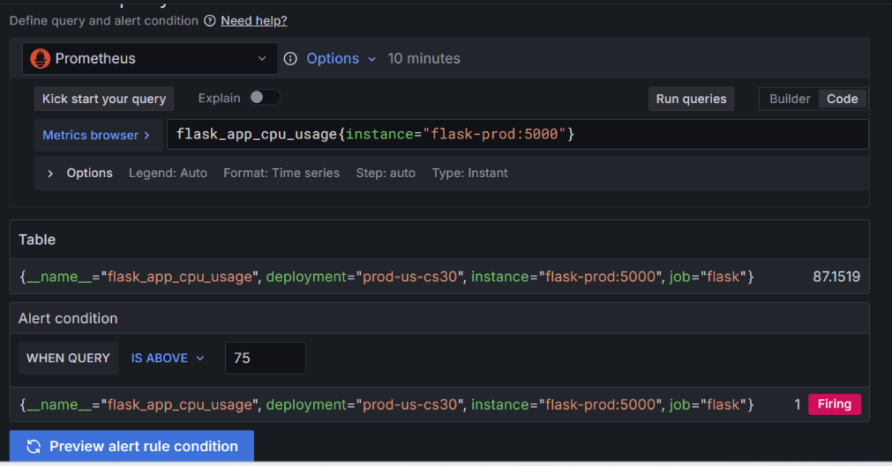

In cpu usage is 87.15% which exceeds the configured threshold of 75%

* Create new folder – system metrics
* Click + New evaluation group - system-usage .
* Choose Evaluation interval (how often the alert will be evaluated) - 1m
* Set the pending period – 0s (so the alert rule fires the moment the condition is met )
* Set Keep firing for - 0s (so the alert stops firing immediately after the condition is no longer true)
* Link Dashboard and pannel
* Create alert rule memory usage (same as cpu usage)
* Check the dashboard

 A red heart when the alert is in **Alerting** state, and a green heart when in **Normal** state. Also u can see annotation in red and green lines for cpu and memory for normal and firing state

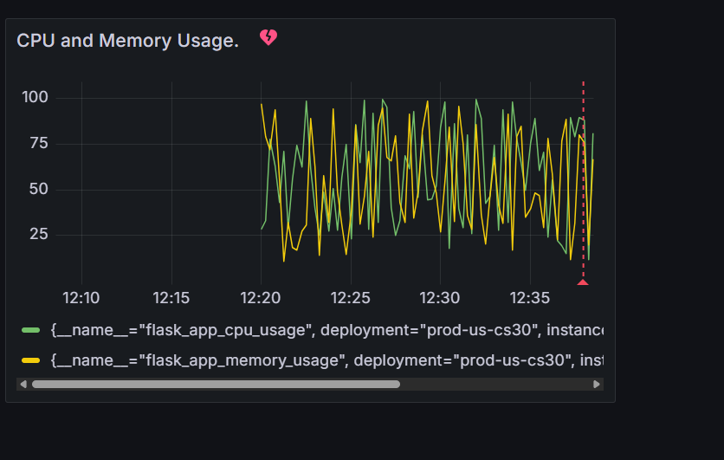

Firing message and Resolve message will come to contact point

**PART 3**

<https://grafana.com/tutorials/alerting-get-started-pt4/?pg=tutorials&plcmt=results>

GithubLink - <https://github.com/grafana/tutorial-environment.git>

