**TASK 1: CREATE A DASHBOARD**

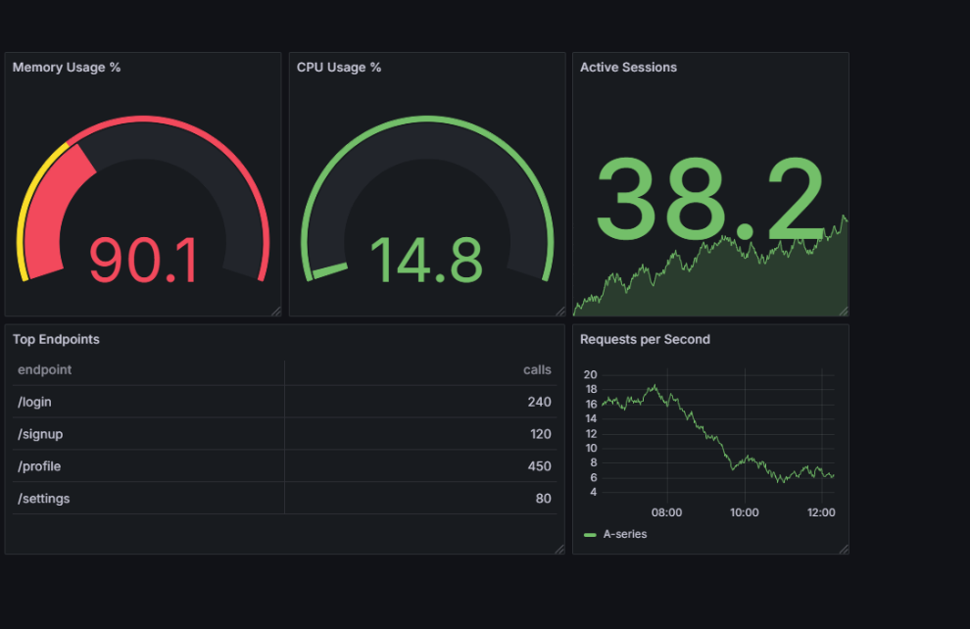

**TASK 2: SETTING UP EMAIL AS CONTACT POINT**

* Create a contact point: Email
* Create Alert rule
* Create notification policy

**TASK 3: SETTING UP TEAMS AS CONTACT POINT**

* Create a channel in teams
* Take webhook url of teams to add in contact point (refer below url)

(<https://learn.microsoft.com/en-us/microsoftteams/platform/webhooks-and-connectors/how-to/add-incoming-webhook?tabs=newteams%2Cdotnet>)

* Create a contact point: Teams
* Create Alert rule - for CPU %
* Create notification Policy



