**IS2545 - DELIVERABLE 2: Unit Testing**

Name: Xin Wen

URL: <https://github.com/Seloen/Test1111>

**Issues I faced when writing this code and test:**

The most severe issue I have met is that since I wrote the code without considering how to test, the code is very difficult to test. At first, I did not have the visit(Visitor v, String location)method, just depends on likeOrNot() method to deal with logic of going to a location and like it or not. Then I thought I should have a new method of going to a location. Although I have visit() now, it is still not a good method. And now it is very confusing when I want to test visit() in CitiSim9002 class and likeOrNot() method in Visitor class.

Another problem is that I mocked the class that I was testing. This is a mistake need to be avoid, and now I am conscious of only calling the class that the current tested class depends on.

Finally, I do not know how to write the testGenerate() test case which is supposed to the generateVisitor() method in CitySim9002 class could return correct visitor according to type it received. The point is that I have not found an assertion to compare two objects’ type. For example, testing a student object is from student class but the reference I will use to compare with it is not the same object.

Executed result of program itself:

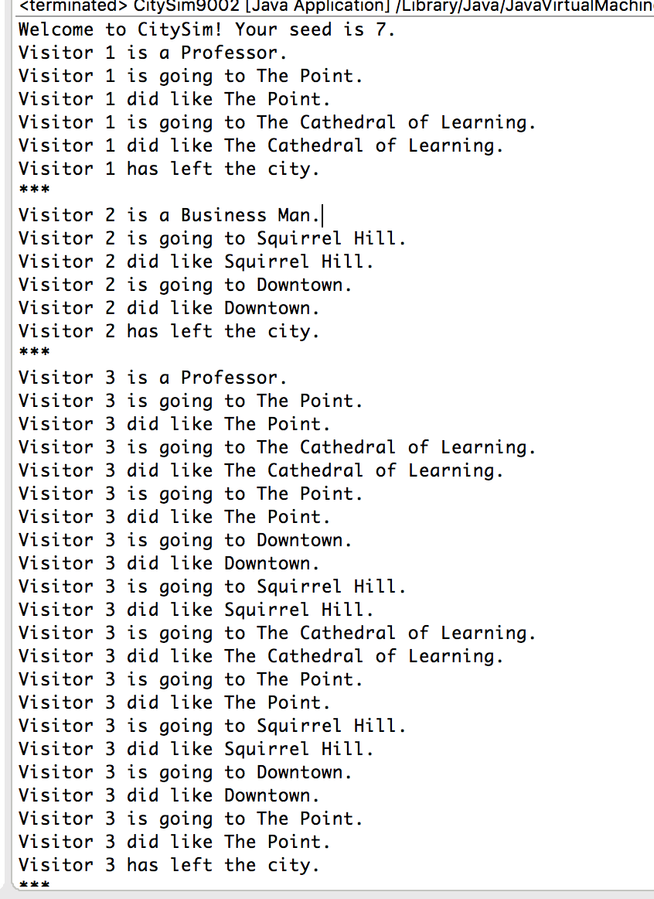

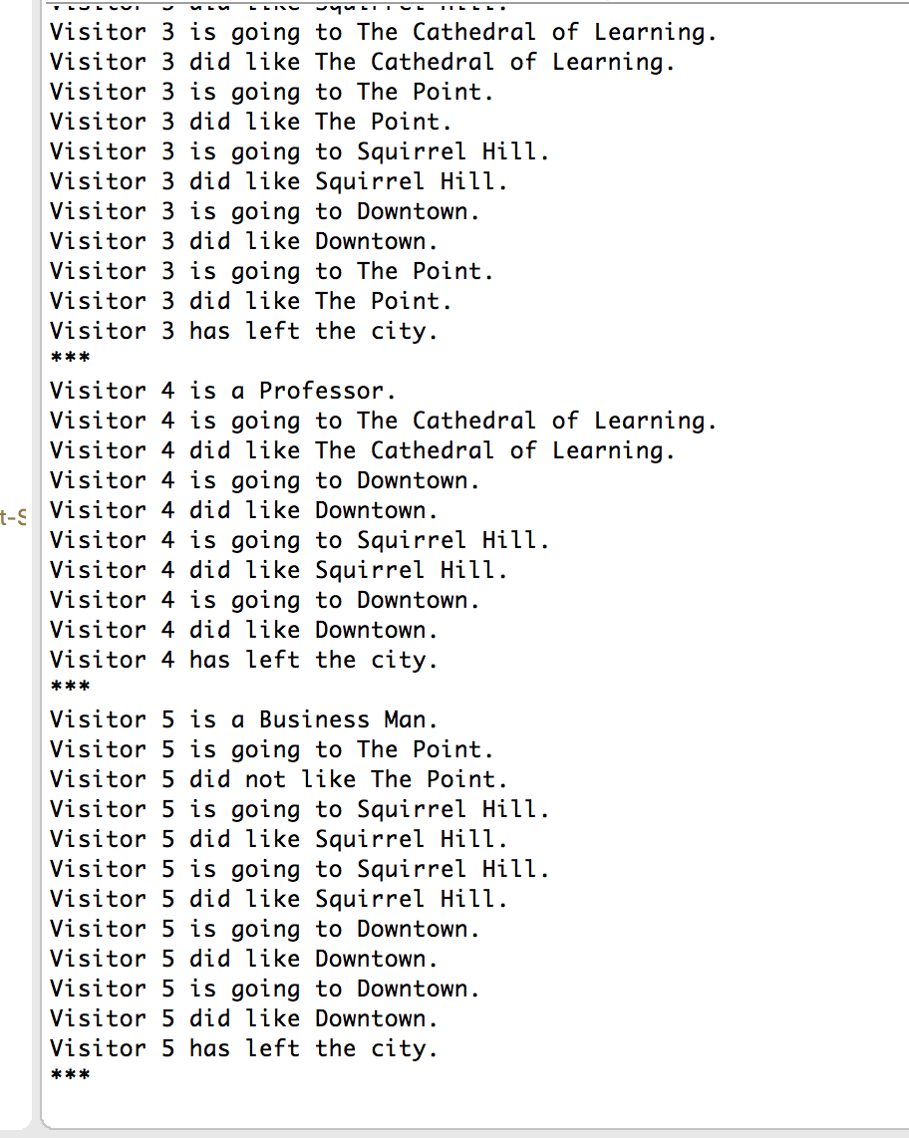

Unit Test for CitySim9002.java

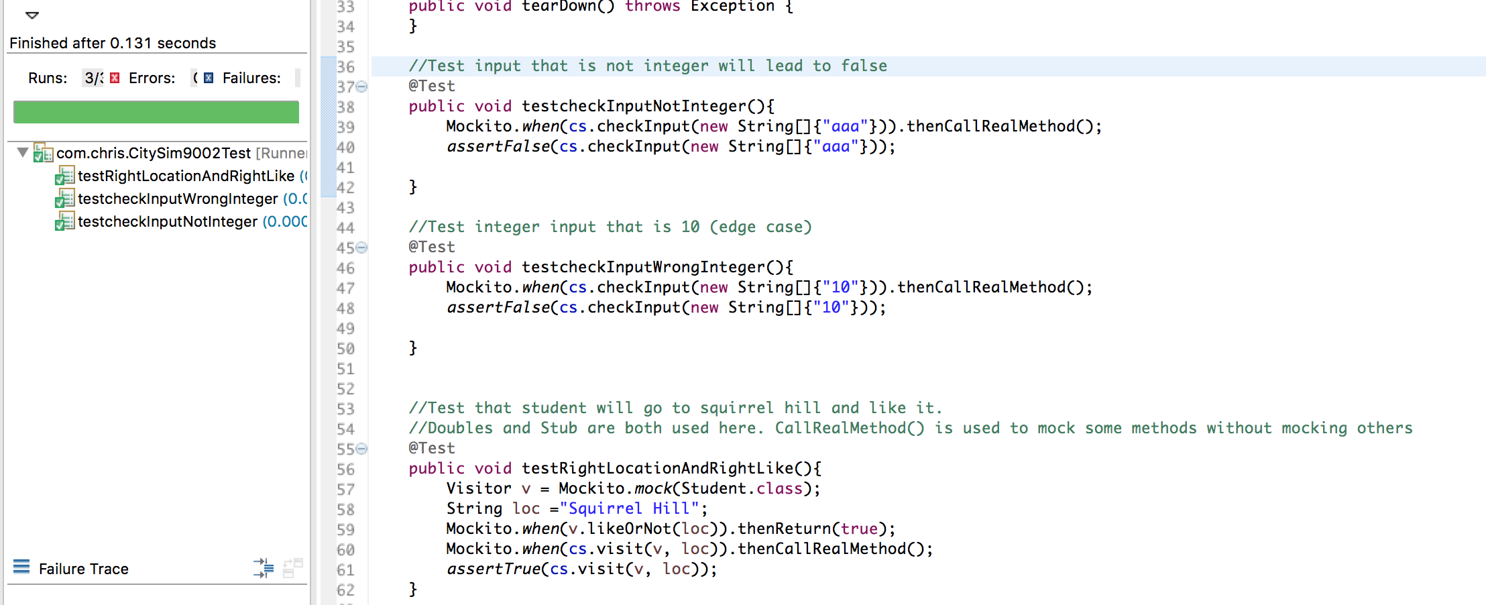

Unit Test for Student.java

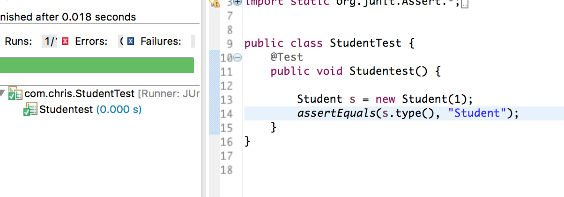

Unit Test for Blogger.java

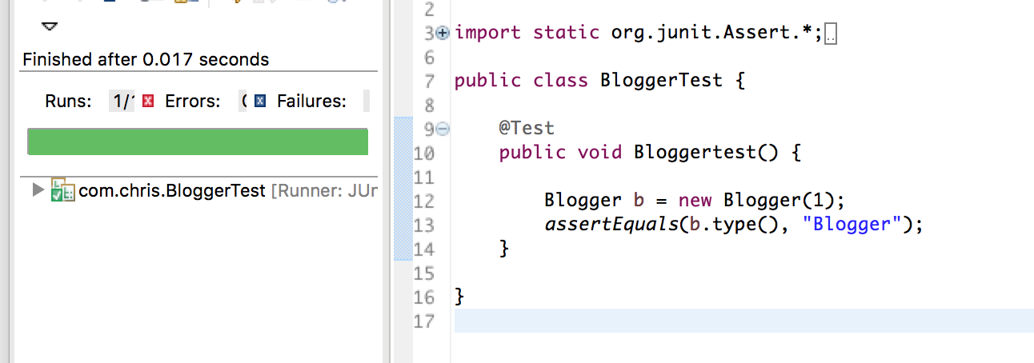

Unit Test for Visitor.java

