ACCRA TECHNICAL UNIVERSITY

Department of Computer Science

BCS 404: Introduction to Data Science with Python

PROJECT WORK REPORT

Exploratory Data Analysis, Statistical Analysis and Machine Learning using the Titanic Dataset

Name: Selorm Kobla Attipoe
Index Number: 01256419B

Academic Year: 2025/2026 Second Semester

Table of Contents
Table of Contents 1
1. Introduction 1
2. Dataset Description 1
3. Methodology 1
3.1 Tools and Libraries 1
3.2 Data Cleaning Approach 1
3.3 Machine Learning Approach 1
4. Results 1
4.1 Data Visualisation 1
4.2 Statistical Analysis 1
4.3 Machine Learning Model 1
5. Discussion 1
5.1 Major Findings 1
5.2 Statistical Insights 1
5.3 Machine Learning Results 1
5.4 Limitations of the Study 1
5.5 Recommendations 1
6. Conclusion 1
7. References 1
8. Appendix: Python Code and Notebook Output 1

1. Introduction
This report presents a data science project carried out as part of the BCS 404: Introduction to Data Science with Python course. The purpose of the project is to demonstrate practical competence in applying Python libraries for data visualisation, statistical analysis, and introductory machine learning on a real-world dataset. The dataset used is the well-known Titanic dataset, which records information about the passengers aboard the RMS Titanic and whether each passenger survived the disaster. The project follows a structured, beginner-friendly workflow covering data acquisition, data cleaning, data visualisation, statistical analysis, and the development of a simple machine learning classification model to predict passenger survival.

2. Dataset Description
The dataset used is the Titanic dataset, sourced from Kaggle (https://www.kaggle.com/competitions/titanic/data). It contains 891 passenger records and 12 columns describing each passenger's demographic details, ticket information, and survival outcome. The table below summarises the columns present in the dataset.
Column | Description
PassengerId | Unique identifier for each passenger
Survived | Survival indicator (0 = No, 1 = Yes) - target variable
Pclass | Ticket / passenger class (1 = 1st, 2 = 2nd, 3 = 3rd)
Name | Passenger's full name
Sex | Passenger's sex (male / female)
Age | Passenger's age in years
SibSp | Number of siblings / spouses aboard
Parch | Number of parents / children aboard
Ticket | Ticket number
Fare | Passenger fare paid
Cabin | Cabin number (largely missing)
Embarked | Port of embarkation (C, Q, S)

Dataset dimensions: 891 rows x 12 columns.
3. Methodology
3.1 Tools and Libraries
The project was implemented in Python using Jupyter Notebook, with the following libraries: Pandas and NumPy for data manipulation, Matplotlib and Seaborn for visualisation, and Scikit-Learn for machine learning.

3.2 Data Cleaning Approach
- Age (about 19.9% missing): filled using the median age, since the median is robust to outliers.
- Embarked (2 missing values): filled using the mode (most frequent port).
- Cabin (about 77.1% missing): dropped entirely, as imputing such a large proportion of missing values would introduce excessive bias.
- Duplicate rows: checked for using df.duplicated(); none were found in this dataset.

3.3 Machine Learning Approach
A Logistic Regression classifier was trained to predict the 'Survived' target variable using the following predictor variables: Pclass, Sex, Age, SibSp, Parch, Fare, and Embarked (one-hot encoded). The categorical variable 'Sex' was label-encoded (male = 0, female = 1). The dataset was split into a 70% training set and a 30% testing set using a fixed random state (random_state = 42) for reproducibility.

4. Results

4.1 Data Visualisation

Figure 1: Histogram of Passenger Ages
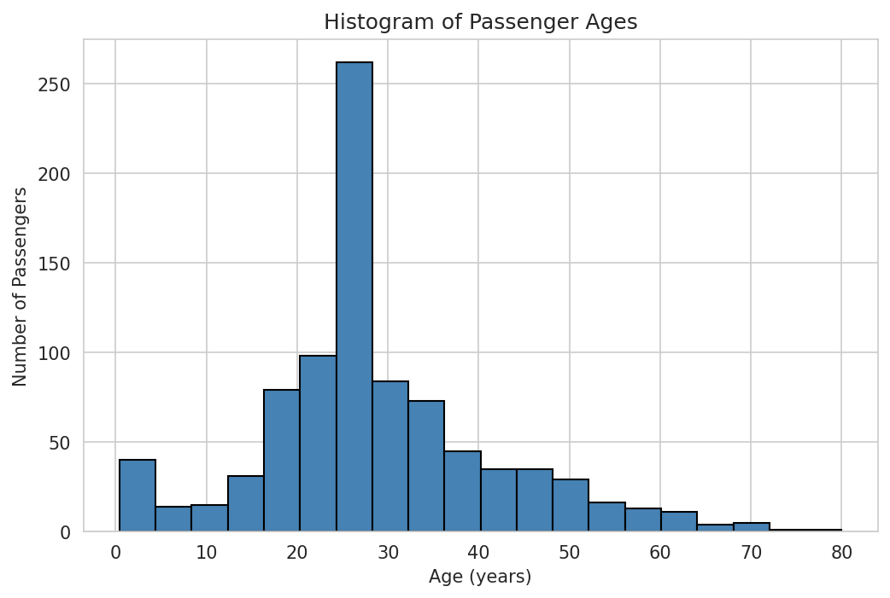
Figure 1: Histogram of Passenger Ages
Interpretation: Most passengers were young adults between roughly 20 and 35 years old. The distribution is right-skewed, with a smaller number of older passengers and a small spike around childhood ages (0-10), reflecting families travelling together.

Figure 2: Bar Chart of Passenger Class Distribution
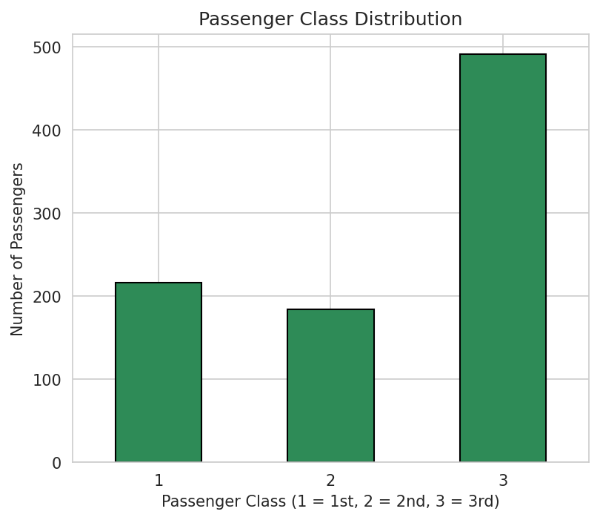
Figure 2: Passenger Class Distribution
Interpretation: The majority of passengers travelled in 3rd class, followed by 1st class, with 2nd class having the fewest passengers, suggesting the Titanic carried a large number of lower-income or emigrant passengers.

Figure 3: Boxplot of Age by Passenger Class
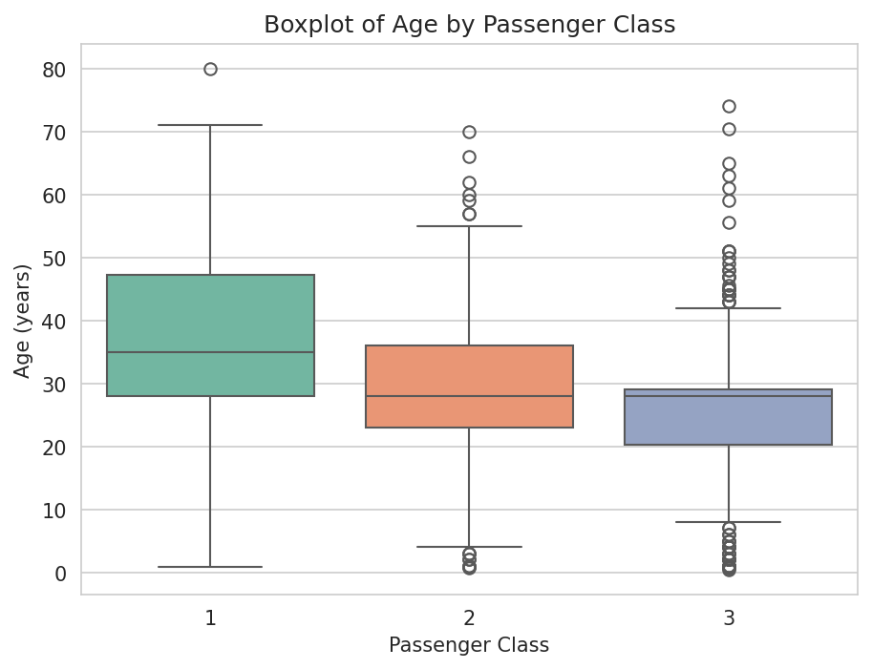
Figure 3: Age by Passenger Class
Interpretation: Passengers in 1st class tend to be older on average than those in 2nd and 3rd class. 3rd class has the youngest median age and the widest spread, reflecting a more mixed group of younger travellers and families.

Figure 4: Scatter Plot of Age versus Fare
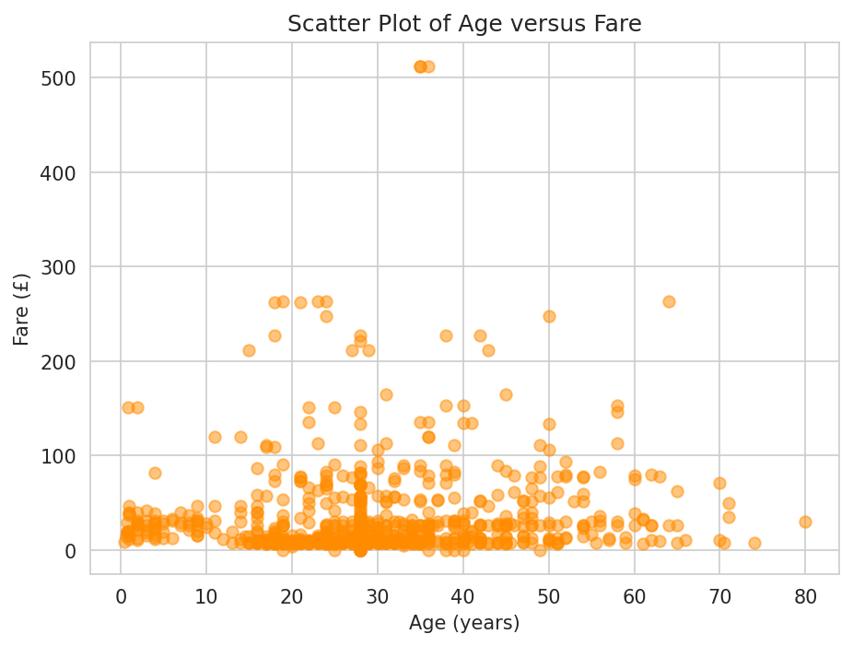
Figure 4: Age versus Fare
Interpretation: There is no strong, clear linear relationship between Age and Fare. Most fares are clustered at the lower end regardless of age, with a few older, higher-fare outliers, likely wealthier 1st class passengers.

Figure 5: Correlation Heatmap
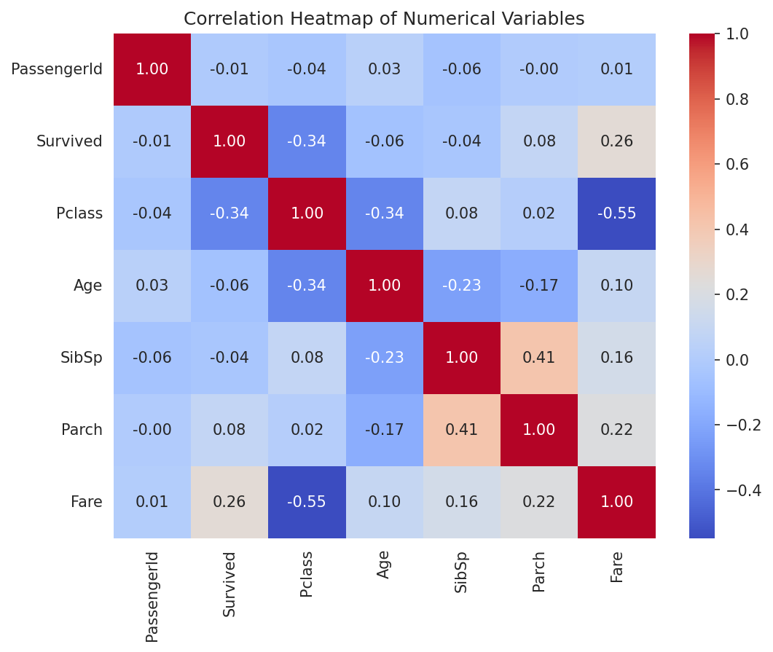
Figure 5: Correlation Heatmap of Numerical Variables
Interpretation: Survived has a moderate negative correlation with Pclass (-0.34), meaning passengers in lower classes (higher Pclass number) were less likely to survive. Fare shows a positive correlation with Survived (0.26), consistent with wealthier passengers having a higher chance of survival.

Figure 6: Pairplot of Selected Numerical Variables
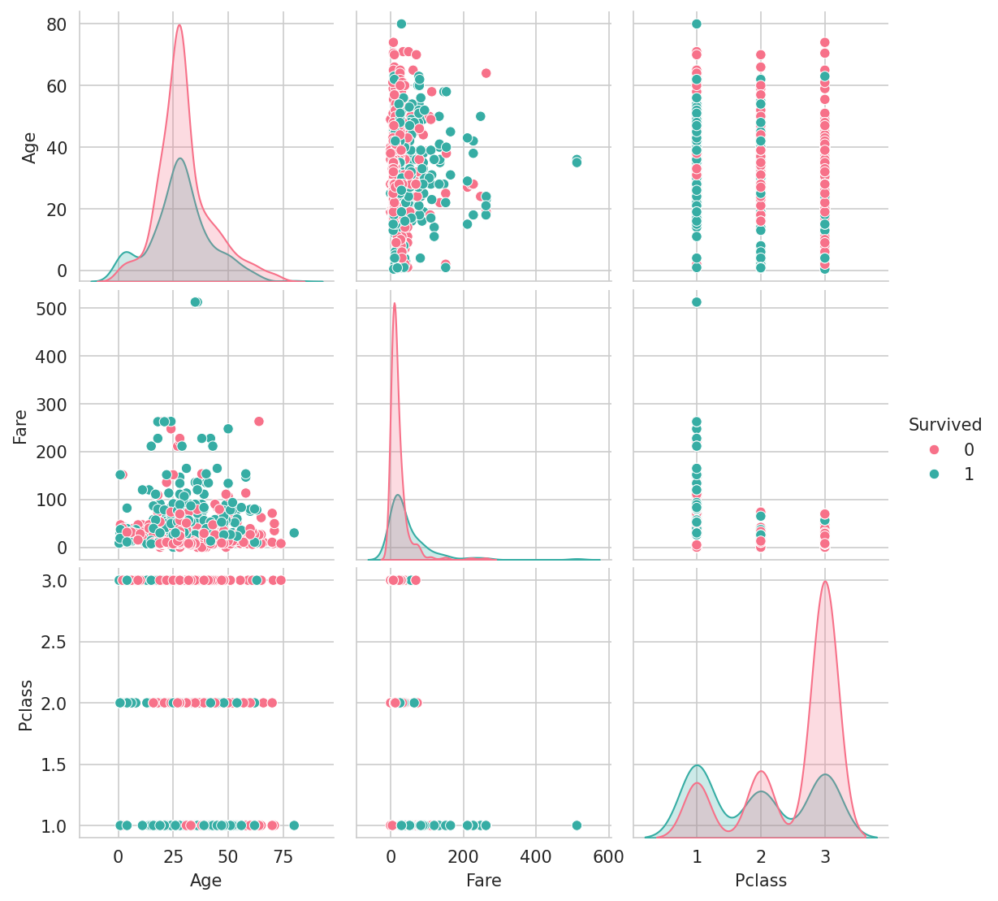
Figure 6: Pairplot (Survived, Age, Fare, Pclass)
Interpretation: Survivors are somewhat more concentrated among lower Pclass values (1st and 2nd class) and slightly higher fares, while non-survivors are spread more broadly across ages and classes.

4.2 Statistical Analysis
Descriptive statistics show the average passenger age is approximately 29.4 years (after median imputation), with an average fare of about £32.20. The frequency distribution shows 549 passengers did not survive and 342 survived; 3rd class had the most passengers (491), followed by 1st class (216) and 2nd class (184); 577 passengers were male and 314 were female.
Correlation analysis of the numerical variables found the strongest positive correlation to be between SibSp and Parch (r = 0.415), indicating passengers travelling with siblings/spouses also tended to travel with parents/children (i.e. as families). The strongest negative correlation was between Pclass and Fare (r = -0.549), which is expected since a lower Pclass number (1st class) corresponds to a higher fare.
Three important statistical findings:
- Passenger class strongly relates to survival: Pclass correlates negatively with Survived (r ≈ -0.34), confirming that 1st class passengers had a notably higher survival rate than 3rd class passengers.
- Fare and Pclass are strongly related (r = -0.549), which makes sense since 1st class tickets were the most expensive.
- Age is fairly evenly distributed but skews young: the average age is around 29-30 years, with the majority of passengers being young adults and relatively few elderly passengers on board.

4.3 Machine Learning Model
A Logistic Regression model was trained on a 70% training set (623 passengers) and evaluated on a 30% testing set (268 passengers).
Accuracy: 80.97%

Figure 7: Confusion Matrix
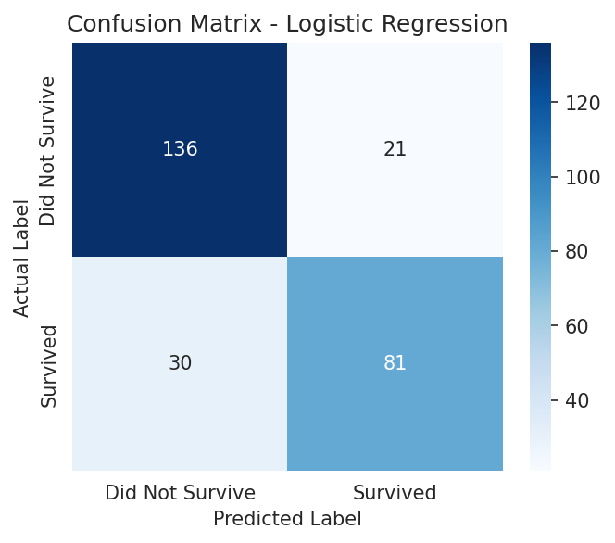
Figure 7: Confusion Matrix - Logistic Regression
The confusion matrix shows 136 true negatives (correctly predicted as not survived), 21 false positives, 30 false negatives, and 81 true positives (correctly predicted as survived).
Classification Report:
- Did Not Survive: precision = 0.82, recall = 0.87, F1-score = 0.84 (support = 157)
- Survived: precision = 0.79, recall = 0.73, F1-score = 0.76 (support = 111)
- Overall accuracy = 0.81, weighted average F1-score = 0.81

5. Discussion

5.1 Major Findings
Survival on the Titanic was strongly related to passenger class, sex, and fare paid. Passengers in 1st class, women, and those who paid higher fares had noticeably better chances of survival, consistent with the historical 'women and children first' evacuation priority and the advantage of being closer to the lifeboat deck in 1st class.

5.2 Statistical Insights
Correlation analysis confirmed that Pclass and Fare are the two numerical variables most strongly associated with survival. Descriptive statistics showed the typical passenger was a young adult in their late twenties, and the frequency distributions confirmed that 3rd class passengers made up the largest group on board.

5.3 Machine Learning Results
A simple Logistic Regression model trained on basic demographic and ticket features was able to predict survival with 80.97% accuracy on unseen (test) data, showing that even a small set of straightforward features carries meaningful predictive signal. The model performed somewhat better at identifying passengers who did not survive (recall = 0.87) than those who did survive (recall = 0.73), which is expected given the class imbalance in the training data (more non-survivors than survivors).

5.4 Limitations of the Study
- A simple median/mode imputation strategy was used for missing values, which may not fully capture the true underlying patterns.
- The Cabin column, which could have held useful information about a passenger's location on the ship, was dropped due to excessive missingness (77.1%).
- The model used is a basic Logistic Regression without extensive feature engineering, hyperparameter tuning, or comparison against other algorithms.

5.5 Recommendations
- Explore more advanced imputation techniques for missing Age and Cabin data.
- Engineer new features, such as family size (SibSp + Parch) or title extracted from the passenger's name.
- Compare Logistic Regression against other classifiers such as Random Forest or Gradient Boosting to improve predictive performance.

6. Conclusion
This project successfully applied the Python data science workflow — data acquisition, cleaning, visualisation, statistical analysis, and machine learning — to the Titanic dataset. The exploratory analysis revealed clear patterns linking passenger class, sex, and fare to survival outcomes, and a basic Logistic Regression model was able to predict survival with roughly 81% accuracy on the test data. The project demonstrates that even simple, beginner-level techniques can uncover meaningful insights and produce a reasonably effective predictive model from real-world data.

7. References
1. Kaggle. Titanic - Machine Learning from Disaster. https://www.kaggle.com/competitions/titanic/data
2. Pandas Development Team. Pandas Documentation. https://pandas.pydata.org/docs/
3. Waskom, M. Seaborn: Statistical Data Visualization. https://seaborn.pydata.org/
4. Pedregosa, F. et al. Scikit-learn: Machine Learning in Python. Journal of Machine Learning Research, 2011. https://scikit-learn.org/
5. Hunter, J. D. Matplotlib: A 2D Graphics Environment. Computing in Science & Engineering, 2007. https://matplotlib.org/

8. Appendix: Python Code and Notebook Output
The following appendix presents the full Python code from the Jupyter Notebook (titanic_eda.ipynb), together with the generated console output for each cell. Code cells are shaded in light grey, while output sections are labelled separately and shaded in light green for readability.
Code Cell 1
import pandas as pd import numpy as np import matplotlib.pyplot as plt import seaborn as sns from sklearn.model_selection import train_test_split from sklearn.linear_model import LogisticRegression from sklearn.metrics import accuracy_score, confusion_matrix, classification_report sns.set_style("whitegrid") %matplotlib inline # Load the dataset df = pd.read_csv("train.csv") print("Dataset loaded successfully.")
Output:
Dataset loaded successfully.
Code Cell 2
# Dataset dimensions print("Dataset dimensions (rows, columns):", df.shape)
Output:
Dataset dimensions (rows, columns): (891, 12)
Code Cell 3
# Column names print("Column names:") print(df.columns.tolist())
Output:
Column names: ['PassengerId', 'Survived', 'Pclass', 'Name', 'Sex', 'Age', 'SibSp', 'Parch', 'Ticket', 'Fare', 'Cabin', 'Embarked']
Code Cell 4
# First five observations df.head()
Output:
PassengerId Survived Pclass \ 0 1 0 3 1 2 1 1 2 3 1 3 3 4 1 1 4 5 0 3 Name Sex Age SibSp \ 0 Braund, Mr. Owen Harris male 22.0 1 1 Cumings, Mrs. John Bradley (Florence Briggs Th... female 38.0 1 2 Heikkinen, Miss. Laina female 26.0 0 3 Futrelle, Mrs. Jacques Heath (Lily May Peel) female 35.0 1 4 Allen, Mr. William Henry male 35.0 0 Parch Ticket Fare Cabin Embarked 0 0 A/5 21171 7.2500 NaN S 1 0 PC 17599 71.2833 C85 C 2 0 STON/O2. 3101282 7.9250 NaN S 3 0 113803 53.1000 C123 S 4 0 373450 8.0500 NaN S

Code Cell 5
# Data types df.dtypes
Output:
PassengerId int64 Survived int64 Pclass int64 Name str Sex str Age float64 SibSp int64 Parch int64 Ticket str Fare float64 Cabin str Embarked str dtype: object

Code Cell 6
# Detect missing values missing_values = df.isnull().sum() print("Missing values per column:") print(missing_values[missing_values > 0])
Output:
Missing values per column: Age 177 Cabin 687 Embarked 2 dtype: int64

Code Cell 7
# Percentage of missing values missing_percent = (df.isnull().sum() / len(df)) * 100 print("Percentage of missing values per column:") print(missing_percent[missing_percent > 0].round(2))
Output:
Percentage of missing values per column: Age 19.87 Cabin 77.10 Embarked 0.22 dtype: float64

Code Cell 8
# Detect duplicated observations duplicate_count = df.duplicated().sum() print("Number of duplicated rows:", duplicate_count)
Output:
Number of duplicated rows: 0

Code Cell 9
# Remove duplicates if any exist if duplicate_count > 0: df = df.drop_duplicates() print("Duplicates removed. New shape:", df.shape) else: print("No duplicate rows found, so no rows were removed.")
Output:
No duplicate rows found, so no rows were removed.

Code Cell 10
# Handle missing values # 1. 'Age' has missing values (numeric) -> fill with the median age. # The median is used instead of the mean because Age is slightly skewed # and the median is less affected by outliers. df['Age'] = df['Age'].fillna(df['Age'].median()) # 2. 'Embarked' has a very small number of missing values (categorical) # -> fill with the mode (most frequent port of embarkation). df['Embarked'] = df['Embarked'].fillna(df['Embarked'].mode()[0]) # 3. 'Cabin' is missing for the majority of passengers (over 75%). # Imputing this column would introduce too much bias, so instead of # filling it, we drop the column entirely since it is not useful # for our basic analysis and model. df = df.drop(columns=['Cabin']) # Confirm no more missing values remain in the columns we plan to use print("Missing values after cleaning:") print(df.isnull().sum())
Output:
Missing values after cleaning: PassengerId 0 Survived 0 Pclass 0 Name 0 Sex 0 Age 0 SibSp 0 Parch 0 Ticket 0 Fare 0 Embarked 0 dtype: int64

Code Cell 11
plt.figure(figsize=(8, 5)) plt.hist(df['Age'], bins=20, color='steelblue', edgecolor='black') plt.title("Histogram of Passenger Ages") plt.xlabel("Age (years)") plt.ylabel("Number of Passengers") plt.savefig("fig1_age_histogram.png", dpi=150, bbox_inches='tight') plt.show()

Code Cell 12
plt.figure(figsize=(6, 5)) df['Pclass'].value_counts().sort_index().plot(kind='bar', color='seagreen', edgecolor='black') plt.title("Passenger Class Distribution") plt.xlabel("Passenger Class (1 = 1st, 2 = 2nd, 3 = 3rd)") plt.ylabel("Number of Passengers") plt.xticks(rotation=0) plt.savefig("fig2_class_bar.png", dpi=150, bbox_inches='tight') plt.show()

Code Cell 13
plt.figure(figsize=(7, 5)) sns.boxplot(x='Pclass', y='Age', data=df, palette='Set2') plt.title("Boxplot of Age by Passenger Class") plt.xlabel("Passenger Class") plt.ylabel("Age (years)") plt.savefig("fig3_age_by_class_boxplot.png", dpi=150, bbox_inches='tight') plt.show()
Output:
/tmp/ipykernel_557/2933446527.py:2: FutureWarning: Passing `palette` without assigning `hue` is deprecated and will be removed in v0.14.0. Assign the `x` variable to `hue` and set `legend=False` for the same effect. sns.boxplot(x='Pclass', y='Age', data=df, palette='Set2')

Code Cell 14
plt.figure(figsize=(7, 5)) plt.scatter(df['Age'], df['Fare'], alpha=0.5, color='darkorange') plt.title("Scatter Plot of Age versus Fare") plt.xlabel("Age (years)") plt.ylabel("Fare (£)") plt.savefig("fig4_age_vs_fare_scatter.png", dpi=150, bbox_inches='tight') plt.show()

Code Cell 15
plt.figure(figsize=(8, 6)) numeric_df = df.select_dtypes(include=[np.number]) corr_matrix = numeric_df.corr() sns.heatmap(corr_matrix, annot=True, cmap='coolwarm', fmt=".2f") plt.title("Correlation Heatmap of Numerical Variables") plt.savefig("fig5_correlation_heatmap.png", dpi=150, bbox_inches='tight') plt.show()

Code Cell 16
selected_cols = ['Survived', 'Age', 'Fare', 'Pclass'] sns.pairplot(df[selected_cols], hue='Survived', palette='husl') plt.savefig("fig6_pairplot.png", dpi=150, bbox_inches='tight') plt.show()

Code Cell 17
df.describe()
Output:
PassengerId Survived Pclass Age SibSp \ count 891.000000 891.000000 891.000000 891.000000 891.000000 mean 446.000000 0.383838 2.308642 29.361582 0.523008 std 257.353842 0.486592 0.836071 13.019697 1.102743 min 1.000000 0.000000 1.000000 0.420000 0.000000 25% 223.500000 0.000000 2.000000 22.000000 0.000000 50% 446.000000 0.000000 3.000000 28.000000 0.000000 75% 668.500000 1.000000 3.000000 35.000000 1.000000 max 891.000000 1.000000 3.000000 80.000000 8.000000 Parch Fare count 891.000000 891.000000 mean 0.381594 32.204208 std 0.806057 49.693429 min 0.000000 0.000000 25% 0.000000 7.910400 50% 0.000000 14.454200 75% 0.000000 31.000000 max 6.000000 512.329200

Code Cell 18
print("Frequency distribution - Survived:") print(df['Survived'].value_counts()) print() print("Frequency distribution - Pclass:") print(df['Pclass'].value_counts()) print() print("Frequency distribution - Sex:") print(df['Sex'].value_counts()) print() print("Frequency distribution - Embarked:") print(df['Embarked'].value_counts())
Output:
Frequency distribution - Survived: Survived 0 549 1 342 Name: count, dtype: int64 Frequency distribution - Pclass: Pclass 3 491 1 216 2 184 Name: count, dtype: int64 Frequency distribution - Sex: Sex male 577 female 314 Name: count, dtype: int64 Frequency distribution - Embarked: Embarked S 646 C 168 Q 77 Name: count, dtype: int64

Code Cell 19
corr_matrix
Output:
PassengerId Survived Pclass Age SibSp Parch \ PassengerId 1.000000 -0.005007 -0.035144 0.034212 -0.057527 -0.001652 Survived -0.005007 1.000000 -0.338481 -0.064910 -0.035322 0.081629 Pclass -0.035144 -0.338481 1.000000 -0.339898 0.083081 0.018443 Age 0.034212 -0.064910 -0.339898 1.000000 -0.233296 -0.172482 SibSp -0.057527 -0.035322 0.083081 -0.233296 1.000000 0.414838 Parch -0.001652 0.081629 0.018443 -0.172482 0.414838 1.000000 Fare 0.012658 0.257307 -0.549500 0.096688 0.159651 0.216225 Fare PassengerId 0.012658 Survived 0.257307 Pclass -0.549500 Age 0.096688 SibSp 0.159651 Parch 0.216225 Fare 1.000000

Code Cell 20
# Exclude the diagonal (self-correlation = 1.0) before finding the strongest correlations corr_pairs = corr_matrix.unstack() corr_pairs = corr_pairs[corr_pairs != 1.0].drop_duplicates() strongest_positive = corr_pairs.idxmax(), corr_pairs.max() strongest_negative = corr_pairs.idxmin(), corr_pairs.min() print("Strongest positive correlation:", strongest_positive[0], "=", round(strongest_positive[1], 3)) print("Strongest negative correlation:", strongest_negative[0], "=", round(strongest_negative[1], 3))
Output:
Strongest positive correlation: ('SibSp', 'Parch') = 0.415 Strongest negative correlation: ('Pclass', 'Fare') = -0.549

Code Cell 21
# Encode categorical variables df_model = df.copy() df_model['Sex'] = df_model['Sex'].map({'male': 0, 'female': 1}) df_model = pd.get_dummies(df_model, columns=['Embarked'], drop_first=True) feature_cols = ['Pclass', 'Sex', 'Age', 'SibSp', 'Parch', 'Fare', 'Embarked_Q', 'Embarked_S'] X = df_model[feature_cols] y = df_model['Survived'] X.head()
Output:
Pclass Sex Age SibSp Parch Fare Embarked_Q Embarked_S 0 3 0 22.0 1 0 7.2500 False True 1 1 1 38.0 1 0 71.2833 False False 2 3 1 26.0 0 0 7.9250 False True 3 1 1 35.0 1 0 53.1000 False True 4 3 0 35.0 0 0 8.0500 False True

Code Cell 22
X_train, X_test, y_train, y_test = train_test_split( X, y, test_size=0.30, random_state=42 ) print("Training set size:", X_train.shape) print("Testing set size:", X_test.shape)
Output:
Training set size: (623, 8) Testing set size: (268, 8)

Code Cell 23
model = LogisticRegression(max_iter=1000) model.fit(X_train, y_train) print("Model trained successfully.")
Output:
Model trained successfully.

Code Cell 24
y_pred = model.predict(X_test) y_pred[:10]
Output:
array([0, 0, 0, 1, 1, 1, 1, 0, 1, 1])

Code Cell 25
accuracy = accuracy_score(y_test, y_pred) print("Accuracy:", round(accuracy, 4))
Output:
Accuracy: 0.8097

Code Cell 26
cm = confusion_matrix(y_test, y_pred) print("Confusion Matrix:") print(cm) plt.figure(figsize=(5, 4)) sns.heatmap(cm, annot=True, fmt='d', cmap='Blues', xticklabels=['Did Not Survive', 'Survived'], yticklabels=['Did Not Survive', 'Survived']) plt.title("Confusion Matrix - Logistic Regression") plt.xlabel("Predicted Label") plt.ylabel("Actual Label") plt.savefig("fig7_confusion_matrix.png", dpi=150, bbox_inches='tight') plt.show()
Output:
Confusion Matrix: [[136 21] [ 30 81]]

Code Cell 27
print("Classification Report:") print(classification_report(y_test, y_pred, target_names=['Did Not Survive', 'Survived']))
Output:
Classification Report: precision recall f1-score support Did Not Survive 0.82 0.87 0.84 157 Survived 0.79 0.73 0.76 111 accuracy 0.81 268 macro avg 0.81 0.80 0.80 268 weighted avg 0.81 0.81 0.81 268

