Dissertation Title:

**Creating and deploying an open standard SPI on an FPGA, involving C based test case development for emulation**

**Course No.: MELZG628T**

**Course Title: Dissertation**

**Dissertation Done by: SELVA KUMAR S**

**Student Name: SELVA KUMAR S**

**BITS ID: 2022HT80170**

**Degree Program: M.Tech. Microelectronics**

**Research Area: IP Emulation and Validation**

**Dissertation carried out at: Qualcomm Technologies Pvt. Ltd, Bengaluru**

**BIRLA INSTITUTE OF TECHNOLOGY & SCIENCE, PILANI**

**VIDYA VIHAR, PILANI, RAJASTHAN - 333031.**

**(Jan 2024)**

ABSTRACT:

IP qualification at the initial phase is the crucial part of SoC development. In the fast phased industry, Quality assurance comes with the penalty of time to market. As part of quality assurance, the newly designed or customized IP will be tested well and then integrated into SoC. This project deals with one of the methodologies that is used in the industry to Qualify the IP.

This project is based on verifying the functionality of a custom IP in an KR26 based FPGA platform. This SOM is almost equivalent to XC7A100T general purpose FPGA device in terms of LUTs, Flipflops and BRAM resources. Based on this data the resource planning is made in this dissertation. Further technical details about the SOM are discussed in the Hardware Requirement section.

First phase of the project is to bring up the eco system which is required to verify the functionality of any custom IP (i.e Custom SPI in this project). Eco system is nothing but the Processor subsystem, Memory Subsystem, Clocking and reset and other basic peripherals like Timer, UART and GPIO.

Second phase of the project will be integrating the Design Under Test with the platform, writing the C based testcase for the integrated Eco system. The development of testcases includes the understanding of different things like system specifications, system use cases, System interfaces and members. Once this understanding is done, we’ll start thinking of C based Drivers and testcase development.

The core Ideology of the project is to take a custom SPI IP and Integrate it with the small SoC like ecosystem. Emulate this ecosystem in the FPGA and writing the C based testcases to verify the functionality of the IP. SPI is a communication protocol, which is used to interface with the External non-volatile memory like serial flash. To demonstrate this use case, we are using Winbond w25q64 SPI flash, that is interfaced with the Custom IP in fast read mode.

Signature of the Student Signature of the Supervisor

Name: Selva Kumar S Name: Siva Selvamani

Date: 22/3/2024 Date:22/3/2024

Place: Bengaluru Place: Bengaluru

Contents

1. Functional Block Diagram 4

Xilinx IP used in Platform and DUT Subsystem: 4

2. Hardware and Software Requirements: 6

Hardware Requirements: 6

KR26 FPGA SOM: 6

FPGA Carrier Card 6

W25Q64 SPI Daughter card: 7

USB to UART FTDI adaptor: 7

Software Requirements: 7

Xilinx Vivado 2023.1: 7

Xilinx Vitis 2023.1: 7

3. OUTPUT (Initial Samples) 8

4. Design Considerations: 8

5. Future Plans 9

6. Abbreviations: 9

# Functional Block Diagram

The functional block diagram of FPGA based emulation environment that supports the IP validation is given below.

Figure 1Block diagram of the SoC

Entire SoC is divided into two major subsystem which are,

1. Platform Subsystem

This subsystem consists of all major components of SoC like Processor (Micro blaze), Memory (BRAM), Interrupt Controller, Clock PLL and Reset System, Debug subsystem, System tick timer, GPIO, UART, System Bus (AXI Interconnect). All these components are connected to each other via AXI Interconnect through a 32-bit AXI bus.

1. DUT Subsystem

This subsystem contains the targeted Custom IP to be qualified in Emulation Platform. In our case, it’s a AXI to QSPI IP. This is customized to interface only with Standard SPI with only one slave interface and FIFO mode.

## Xilinx IP used in Platform and DUT Subsystem:

|  |  |  |  |
| --- | --- | --- | --- |
| **Xilinx IP Used** | **Description** | **Address map** | **Size** |
| clk_wiz:6.0\ | PLL to generate different clock domain for the SoC | NA |  |
| microblaze:11.0\ | Processor system to execute the test code | NA |  |
| mdm:3.2\ | Processor debug interface for code JTAG | NA |  |
| proc_sys_reset:5.0\ | Processor and SoC reset system | NA |  |
| axi_gpio:2.0\ | GPIO module to toggle the Application alive LED | 0x40000000 | 1kB |
| axi_bram_ctrl:4.1\ | AXI BRAM controller to connect RAM to Sys Bus | NA |  |
| blk_mem_gen:8.4\ | BRAM block to have array of system memory | 0xC0000000 | 512kB |
| xlconcat:2.1\ | Multiplex to concatenate the Interrupt from different IP | NA |  |
| axi_intc:4.1\ | AXI Interrupt Controller to aggregate the IRQs | 0x41200000 | 1kB |
| axi_uartlite:2.0\ | AXI UART IP to display the debug prints in Code | 0x40600000 | 1kB |
| system_ila:1.1\ | Integrated Logic analyzer to probe the RTL signals | NA |  |
| axi_timer:2.0\ | AXI Timer to generate the general delay functions | 0x41C00000 | 1kB |
| lmb_v10:3.0\ | Processor Cache memory generator | 0x00000000 | 16kB |
| axi_quad_spi:3.2\ | Targeted Custom SPI block which is to be tested | 0x44A00000 | 4kB |

System ILA

DUT SS

PLATFORM SS

Figure 2Xilinx IP Integrator Block Design

# Hardware and Software Requirements:

The below table contains the Hardware and Software Requirements for developing an FPGA based emulation environment for Custom SPI IP.

|  |  |  |
| --- | --- | --- |
| Sl. No | Hardware Required | Software Required |
| 1. | KR26 based SOM | Xilinx Vivado 2023.1 |
| 2. | FPGA Carrier Card | Xilinx Vitis 2023.1 |
| 3. | W25Q64 SPI Daughter card | SPI Protocol Analyzer |
| 4. | USB to UART FTDI adaptor |  |
| 5. | Logic Analyzer |  |

Table 1Hardware and Software Requirements

## Hardware Requirements:

### KR26 FPGA SOM:

KR26 is a FPGA SoM which can be used with custom carrier card. This FPGA have the following specification, 189 IO’s, 117120 LUT’s, 234240 FF’s, 144 BRAM, 64 URAM, 1248 DSP slices. This FPGA part is suitable for small Microcontroller implementations.

### A green electronic board with a fan Description automatically generatedFPGA Carrier Card

Xilinx custom carrier card is used to expose the IOs of this FPGA. This carrier card has all the peripheral interfaces and its respective slave devices. It has 4 PMOD connectors to connect FDTI adaptor and SPI Flash daughter card. This also have two user LEDs which we used as Notification LED. Reset pin is default tied to high. This also have 1 SFP cage, 4 USB connectors, 4 RJ45 connectors, 1 Display port. This we can use it for expansions

### W25Q64 SPI Daughter card:

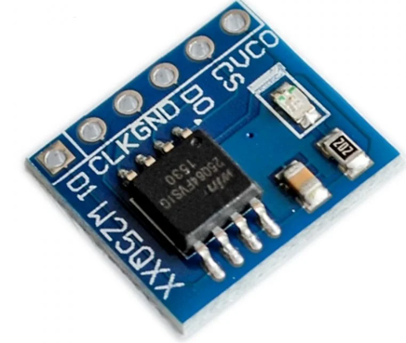

W25Q64 is a breakout board which has 64Mbits flash with Standard SPI interface. It supports up to 104MHz. It works on 2.7V to 3.5V range. Based on this we need to allocate the IO bank from the FPGA.

### USB to UART FTDI adaptor:

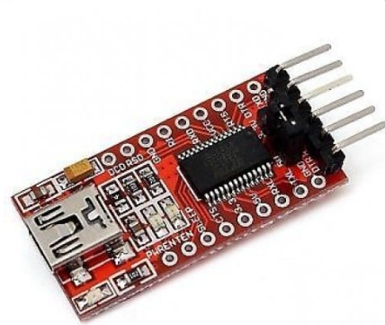

FTDI USB port is used for COM port connectivity via which debug prints in the code will be sent out. This FTDI will work in 3.3V Range and it supports up to 230Kbps UART baud rate.

## Software Requirements:

### Xilinx Vivado 2023.1:



Vivado tool is used to generate the RTL from the Block design of the SoC and handle all the SoC integration part. This tool will also handle the flow of synthesis, place and route, and bit file generation which is need for the target KR26 Family FPGA. Block design for this dissertation is shown in the section 2 of the document. This Block design is generated with the help of Xilinx IP integrator flow. This tool has Hardware manager tool which will get the debug probe date via Integrated Logic Analyzer from the real hardware.

### Xilinx Vitis 2023.1:



Vitis tool is used to generate the Embedded Application for the SoC design implemented on FPGA and handle the Application compilation and debug part. This tool will also handle the flow of compilation, debug and binary file generation which is need for the target KR26 Family FPGA. The linker script required to handle the memory map of the SoC will be generated automatically from hardware specification file (.xsa file). This tool will also provide serial terminal to monitor the debug prints in the application.

# OUTPUT (Initial Samples)

The below screenshots contain the ILA capture of Initial Platform where UART and System Timer was brought up. This Timer is used as general-purpose timer which generates microsecond Delays required in the test Application. UART is used for debug prints written on C code in the Tera Term Application.

# Design Considerations:

* UART COM port is working in 115.2KBps.
* Target DUT is Operating at 5MHz.
* Timer is configured to generate interrupt on every 30 microseconds.
* User LED will be toggled on every 500 ms to present the application alive status.
* System BUS clock frequency is 40MHz
* BRAM size is 256 kB.
* Nonvolatile memory controller (flash controller) is not part of platform design.
* Entire Application code is stored and executed from BRAM.
* FPGA is having a separate config flash to store the BIT file.

# Technologies used:

# Hardware Configurations:

# Testcase Design:

# Testcase Implementation and Use case mapping:

# Execution Results:

# Conclusion: