Business_object:
=============

A business object is a resource, such as an invoice or purchase order, similar to a database table; it has fields that hold the data for your application. Like a database table, a business object provides the structure for data. Business objects are stored in a database.

The apps in your visual application and other clients access the business objects via their REST endpoints.

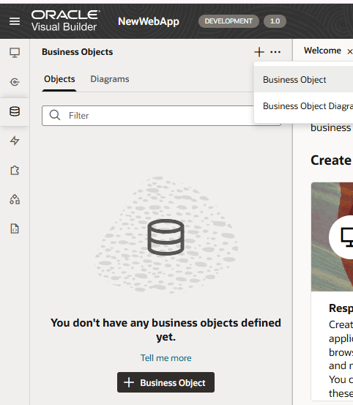

Click on + Business object– type –Department has created and by default ,those values are come.

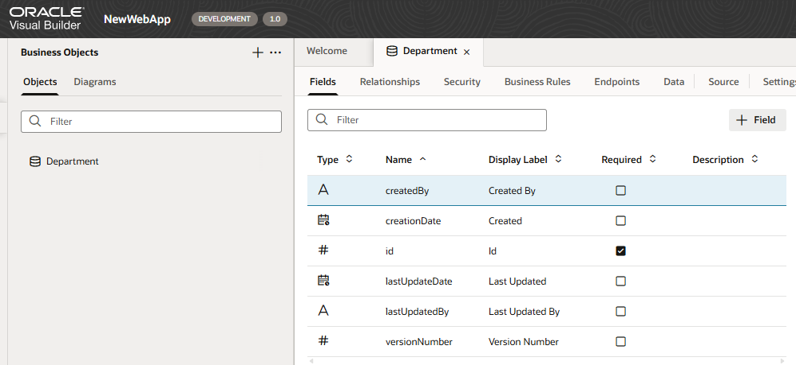

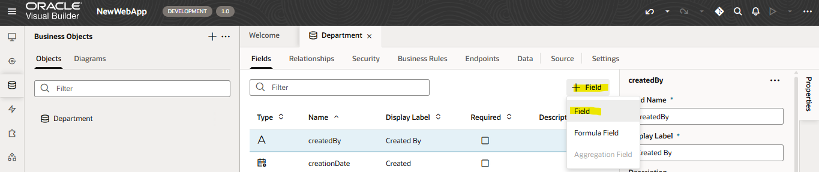

Change the created field string types
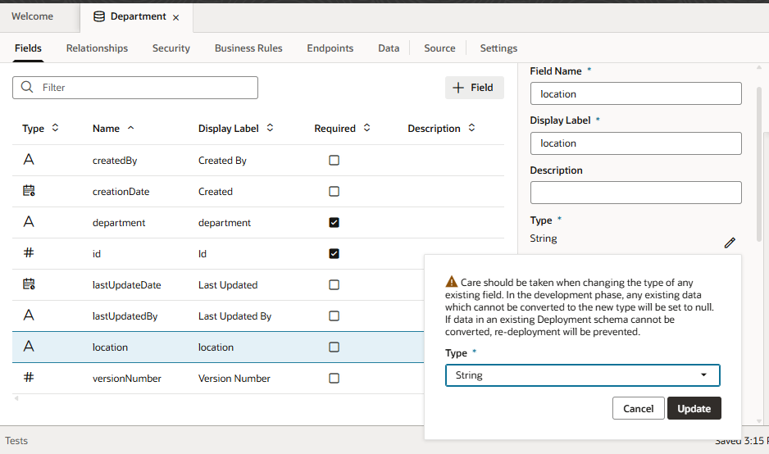

Once employee table has created ,next one is create a relation ship:
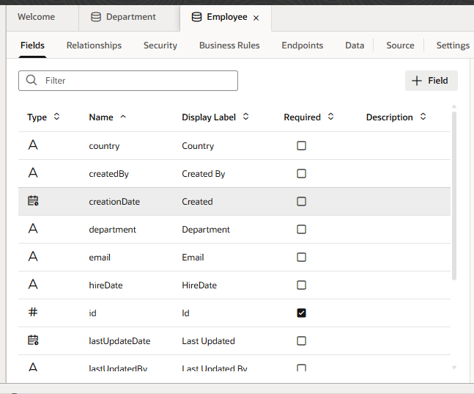

View, Create, and Edit Business Object Relationships
—-------------------------------------------------------------------------------------------------------------

Define business object relationships to more easily create pages with parent-child relationships or drop-down lists that reference another business object's values.

These relationships can be

many-to-one (and one-to-many), and
One-to-one,
many-to-many.

Create a Many-To-One or One-To-One Relationship
You can create a many-to-one or one-to-one relationship from a business object's Relationships tab. Here are examples of a many-to-one (or one-to-many) and a one-to-one relationship:
- A many-to-one relationship between the Employee and Department business objects means a department can have many employees but each employee can only work for one department.
- A one-to-one relationship between the Employee and EmployeePII objects means that each employee has one set of sensitive personally identifying information and that information belongs to only one employee.
To create a many-to-one or a one-to-one relationship:
- Open your source business object's Relationships editor.
- Click + Relationship, then select Many to One / One to One.
- In the Create Relationship dialog, select the target business object.
