**Fake news detection model using NLP**

Phase 3 –submission

**Development Part 1**

**Dataset Selection** Choose two datasets: "Fake.csv" and "True.csv" to distinguish between fake and true news articles.  
  
**Data Loading**

Load both datasets into your programming environment using Pandas.

Program for loading

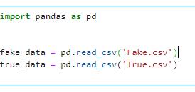

**Data Exploration**   
 Perform initial data exploration to understand the structure and content of both datasets.

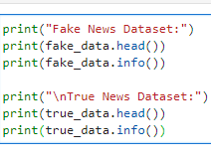

**Text Preprocessing**

Apply text preprocessing separately for both datasets. Preprocessing steps include lowercasing, tokenization, and removing stopwords and special characters. Modify the code as needed for both datasets**.** 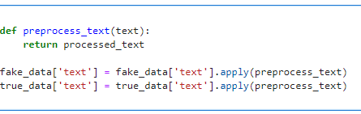

**Label Encoding**

Encode the target variable for both datasets. Use 0 for fake news and 1 for true news.

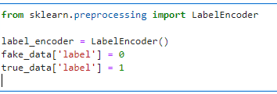

**Preprocess python code** <https://github.com/Selva73582/AI_Phase1/blob/main/preprocess.py>

**Preprocess data set** : [Dataset](https://docs.google.com/spreadsheets/d/1ALo14jb3Tb0vpLsz8DMoL31gKLAZSJGmLfQwDy-839I/edit#gid=0)