 Sri MeenakshiGovt.Arts College for Women (A),

Madurai - 625 002

 Department of Physics

Naan Mudhalvan Scheme

Domain : Sales Force Associate

Project Tile :Retail management application using salesforce

Submitted by

TEAM 1

Team I’d:NM2023TMID05133

Team Lead : Ms.RUMANA BEGAM. Y

Team Member 1 : Ms. Sangeetha.K

Team Member 2: Ms.Saranya.M

Team Member 3 : Ms. Selvalakshmi. D

Mentors : Dr. K. Vijaya Kumar & Dr. P. Indra Devi

Assistants Professors, Department of Physics, Sri Meenakshi Govt.Arts College for Women, Madurai

April, 22 - 2023

**PROJECT REPORT TEMPLATE**

**1 INTRODUCTION**

**OVERVIEW**

Retail management includes all the steps required to bring the customers into the store and fulfill their buying needs. Retail management makes shopping a pleasurable experience and ensures the customers leave the store with a smile. In simpler words, retail management helps customers shop without any difficulty.

**1.1PURPOSE**

Retail Management helps in saving time and ensures that customers easily locate their desired merchandise and return home satisfied. Effective management avoids unnecessary chaos at the store and controls shoplifting to a large extent

**2 PROBLEM DEFINITION &DESIGN THINKING**

**2.1 EMPATHY MAP**

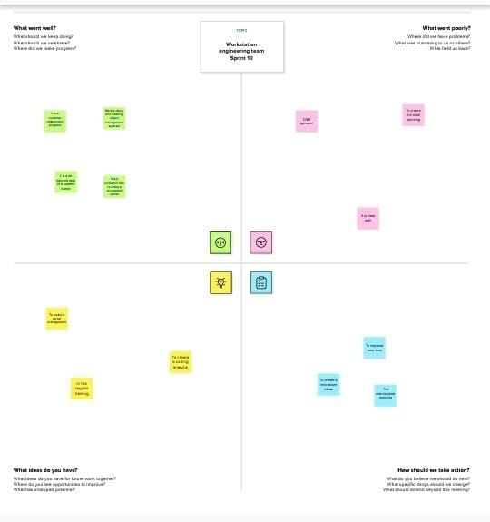

**2.2 Ideation&Brainstorming Map**

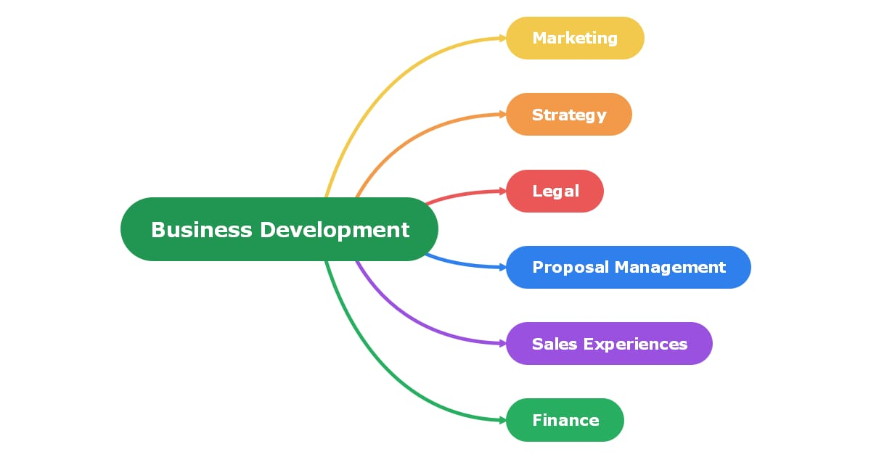  
**RESULT**

**3.1 Data Model**

|  |  |  |  |  |  |  |  |
| --- | --- | --- | --- | --- | --- | --- | --- |
| Obj 1  DISPATCH/TRACKING | |  |  | | --- | --- | | Field label | Data type | | Record | Text | | Dispatched | Checkbox | |

**3.2 Activity&Screenshot**

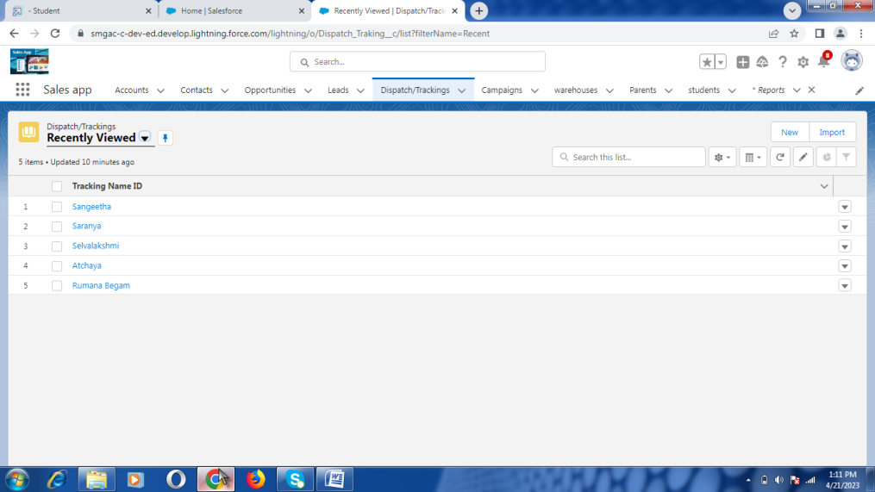

**Description**

Dispatch tracking software captures all information related to goods dispatch ,movement and delivery. This data can be accessed by stakeholders like logistics Teams via cloud –based serves and data centers to monitor the entire operations and provide clients with real-time alerts and notification

Activity 2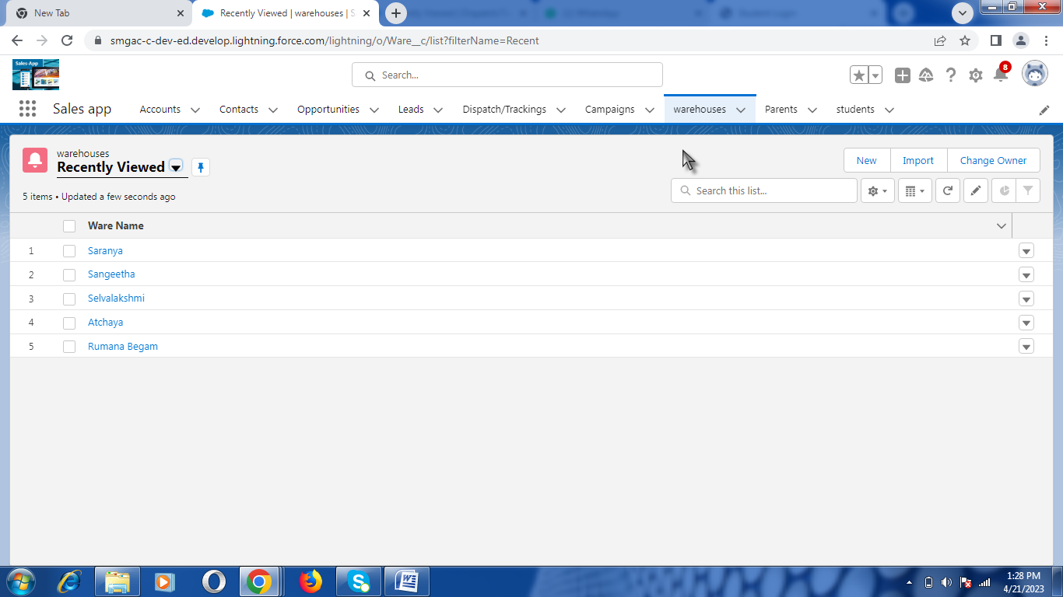

**Description**

The storage of a seller inventory and the place where online orders afulfilled

**Activity 3**

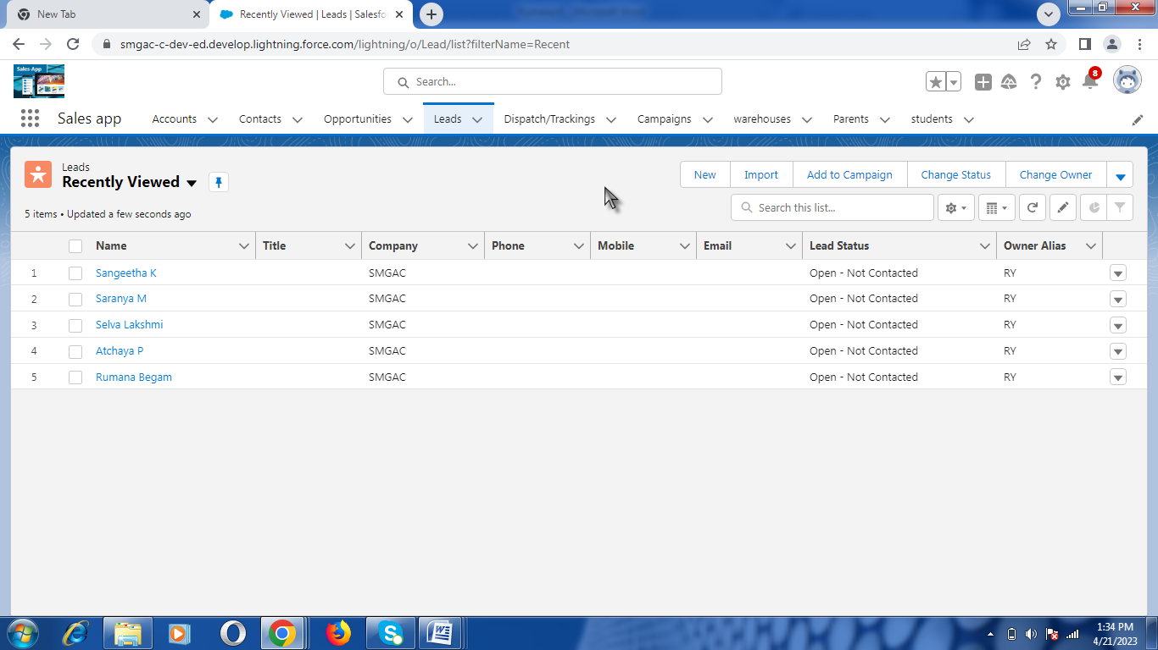

**Description**

A Retail sales lead works at stores and is responsible for managing the staff and sales

**Activity 4**

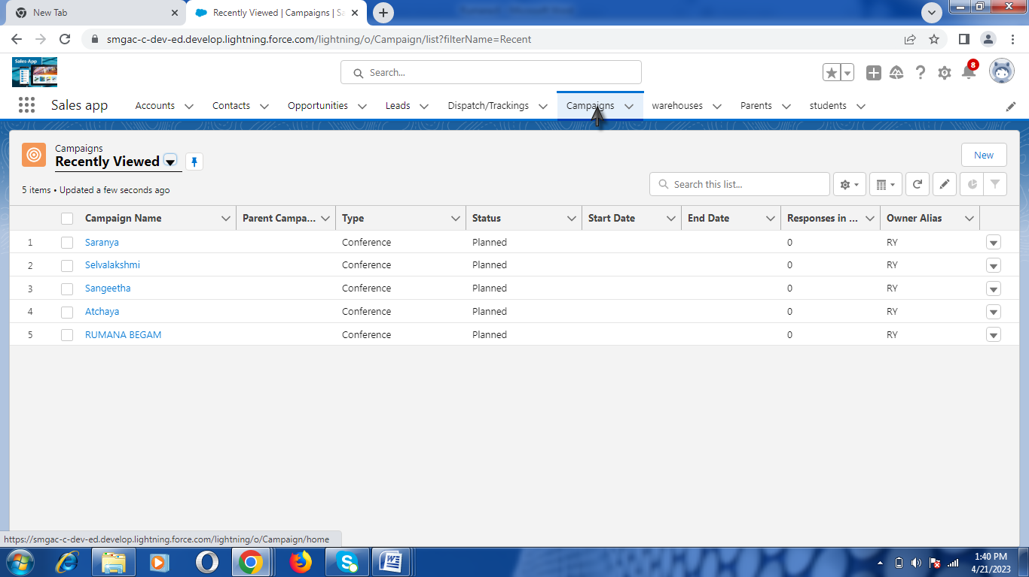

**Description**

A campaign involves multiple pushes to prospects or potential customers via email ,surveys ,socialmedia ,and other channels

**Trailhead Profile Public URL**

Team lead <https://trailblazer.me/id/rumana2403>

Team Member 1 <https://trailblazer.me/id/sangeetha1912>

Team Member 2  [https://trailblazer.me/id/saranya2201](%20%20%20https://trailblazer.me/id/saranya2201)

Team member 3 <https://trailblazer.me/id/selvalakshmi>

**5 ADVANTAGES**

1 Customer empathy

2Greater deliver options

3Greater business opportunities

4 Store retailing

5Non shop retailing

6 Company retail

**DISADVANTAGES**

1 Do not easily obtain loan

2 Inability to enjoy economics of scale

**6 APPLICATIONS**

Retail management improves overall company cohesion

Retail store management improve customer experience and boosts customer satisfication

**7 CONCLUSION**

The term retail refers to the sale of goods and service to consumers to the public for consumption

**8 FUTURE SCOPE**

A vibrant business with a wide range of sectors retailing is home to some of the biggest corporation in the world

**THANK YOU**