SIMATS ENGINEERING

C0-4-Assessment Tool 1 – Coding Challenge Task
Course Code | CSA0603
Course Title | Design and Analysis of Algorithms
Assessment | Assessment Tool 1 - Coding Challenge Task
CO Assessed | CO4 - Articulation (BL4, BL5)
Weightage | 40% of CIA
Question | Q31 - Minimum Cost Climbing Stairs
Student Name | SELVAMAGAL M
Register Number | 192472013

1. AIM
To find the minimum cost required to reach the top of a staircase using Dynamic Programming, where a person can climb either one or two steps at a time.
2. OBJECTIVE
- To understand the Minimum Cost Climbing Stairs problem.
- To apply Dynamic Programming to find the minimum cost.
- To calculate the minimum cost for each step.
- To identify the optimal path to reach TOP.
- To implement and test the solution in Python.
3. ALGORITHM
The problem is solved using Dynamic Programming. The array cost[] gives the price paid when a step is stepped on. A person can move either one step or two steps at a time, and can start the climb from Step 0 or Step 1. The DP array stores the minimum cost required to reach each step, and for each step we compare the cost of reaching it from the previous step and the step before that.
State Definition
dp[i] = minimum cost required to reach step i.
Recurrence Relation
dp[i] = cost[i] + min(dp[i-1], dp[i-2])
Base Cases
dp[0] = cost[0]
dp[1] = cost[1]
Steps
- Read n and cost[].
- Initialize dp[0] = cost[0].
- Initialize dp[1] = cost[1].
- For i = 2 to n-1, calculate dp[i] = cost[i] + min(dp[i-1], dp[i-2]).
- The top can be reached from either of the last two steps.
- Therefore, Answer = min(dp[n-1], dp[n-2]).
- Print the minimum cost.
Complexity
Time Complexity = O(n)
Space Complexity = O(n) for the DP-array implementation.
4. CODE
The following Python code implements the above Dynamic Programming approach:
def min_cost_climbing_stairs(n, cost):
dp = [0] * n
dp[0] = cost[0]
dp[1] = cost[1]
for i in range(2, n):
dp[i] = cost[i] + min(dp[i - 1], dp[i - 2])
return min(dp[n - 1], dp[n - 2])

n = 3
cost = [10, 15, 20]
result = min_cost_climbing_stairs(n, cost)
print("Min Cost =", result)

5. OUTPUT
Input
n = 3
cost = [10, 15, 20]

DP Calculation
dp[0] = 10
dp[1] = 15
dp[2] = 20 + min(10,15)
= 30

Answer = min(dp[1], dp[2])
= min(15, 30)
= 15

Output
Min Cost = 15

6. VISUALS
The main solution to this problem is the Dynamic Programming approach shown above. The figures below are an educational representation of the recursive decision structure, produced by a Python recursion-tree visualizer. Each frame reveals another part of the decision tree, from START through the TOP base cases, and finally to the minimum-cost route.
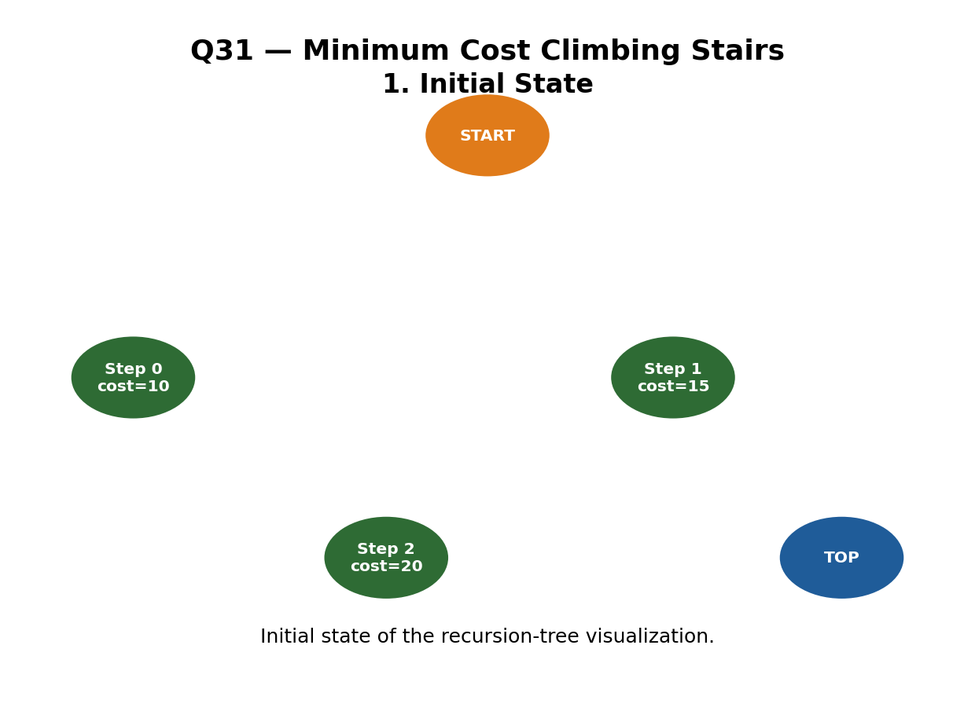
Figure 1: Initial state of the recursion-tree visualization.
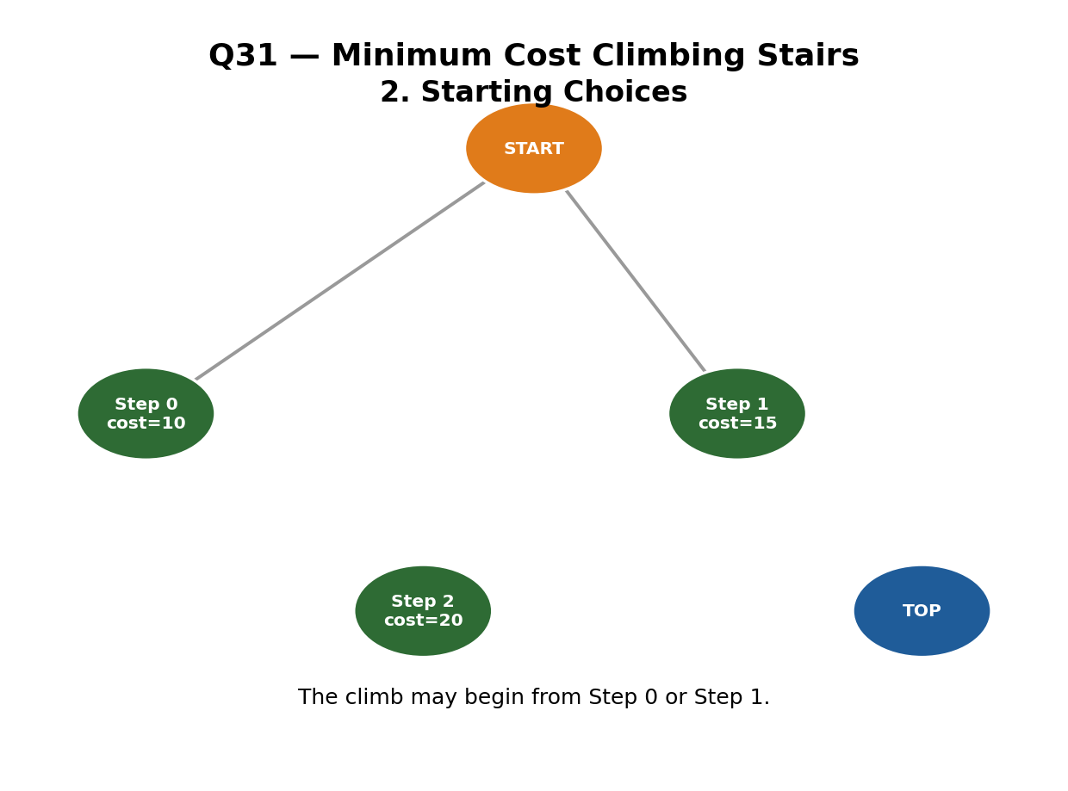
Figure 2: Two valid starting positions from START.

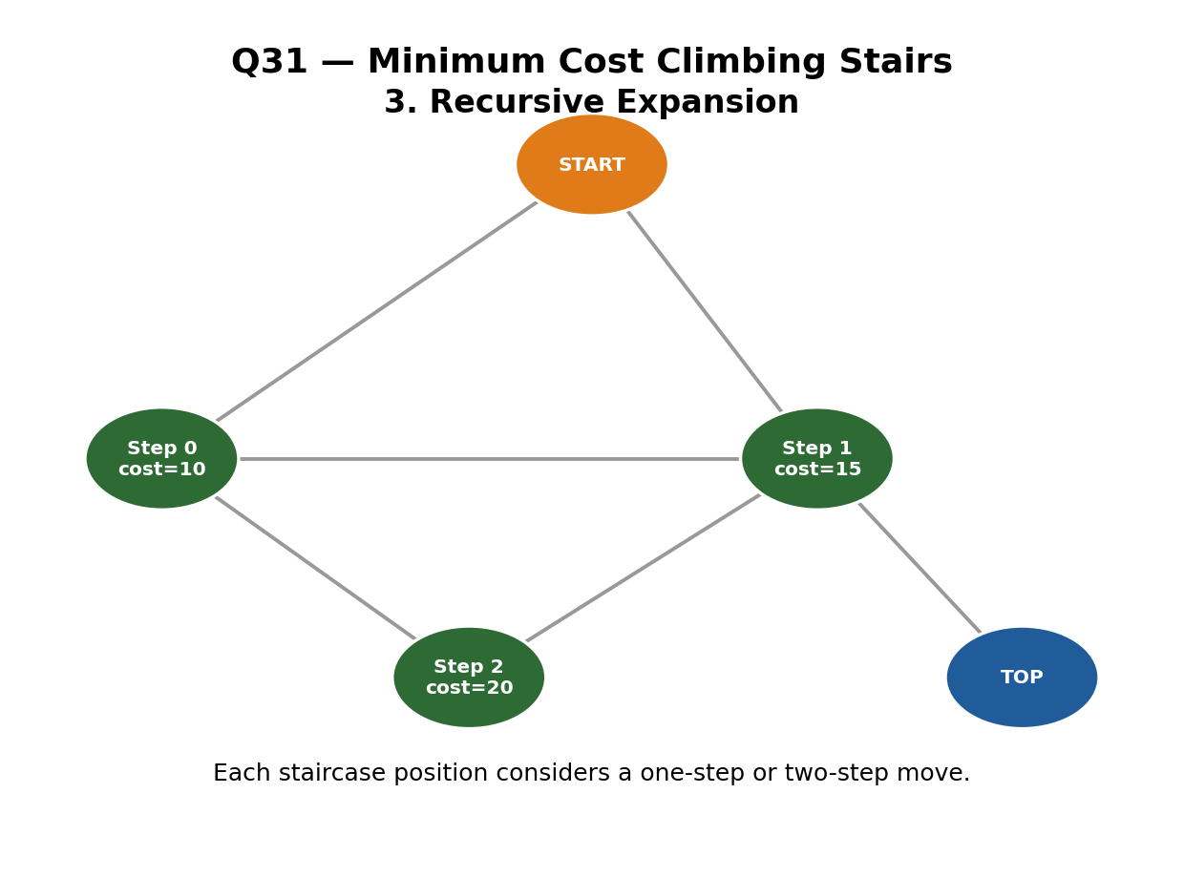
Figure 3: Recursion tree expansion using one-step and two-step moves.
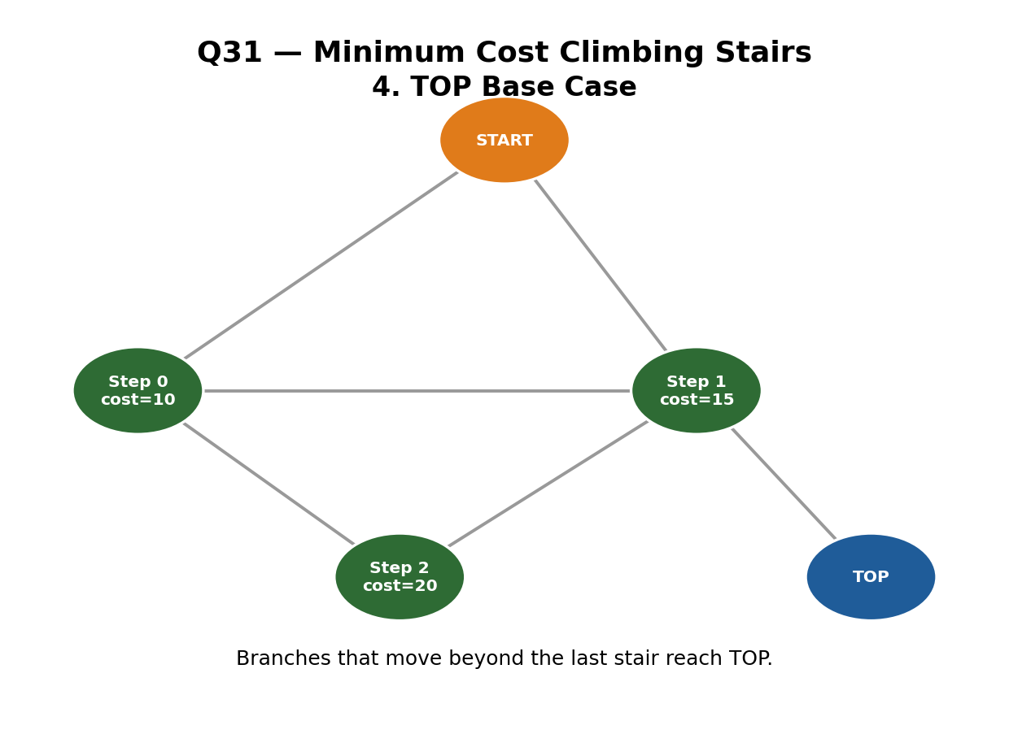
Figure 4: Recursion branches reaching the TOP base case.

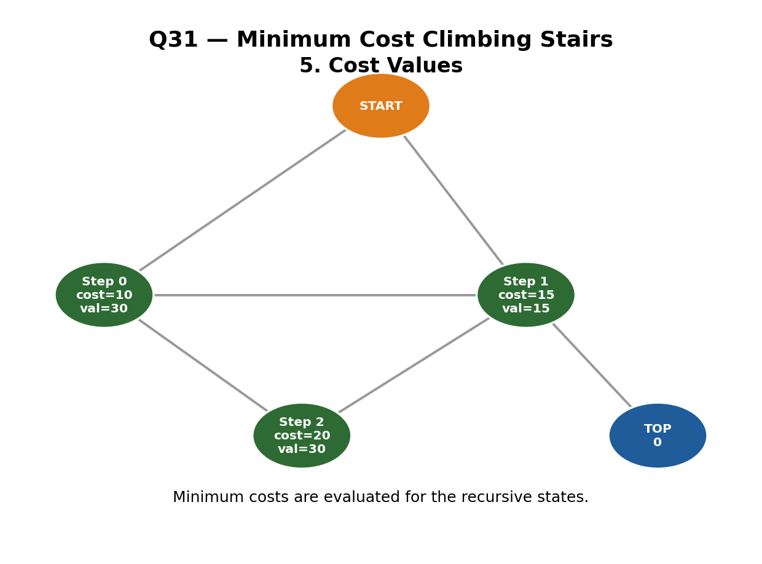
Figure 5: Minimum-cost values calculated for the recursive states.
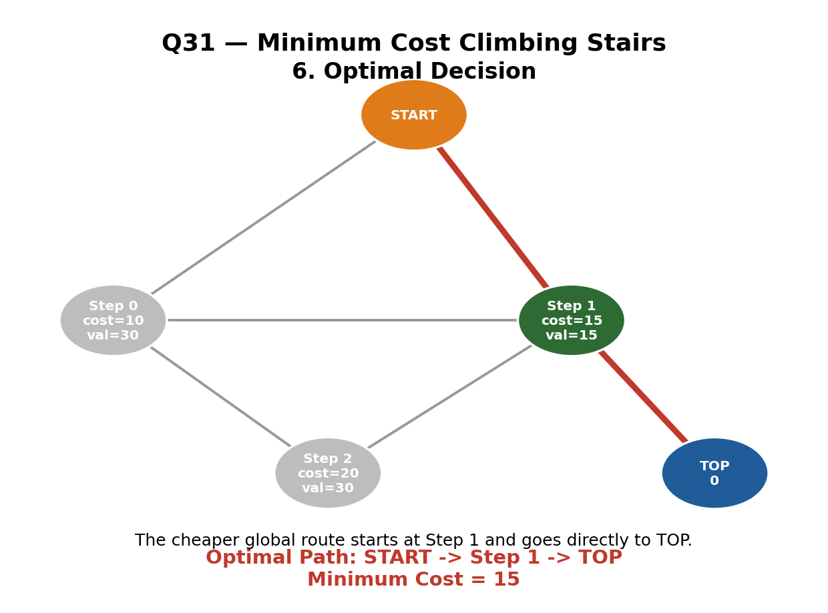
Figure 6: Optimal path identified from START through Step 1 to TOP.

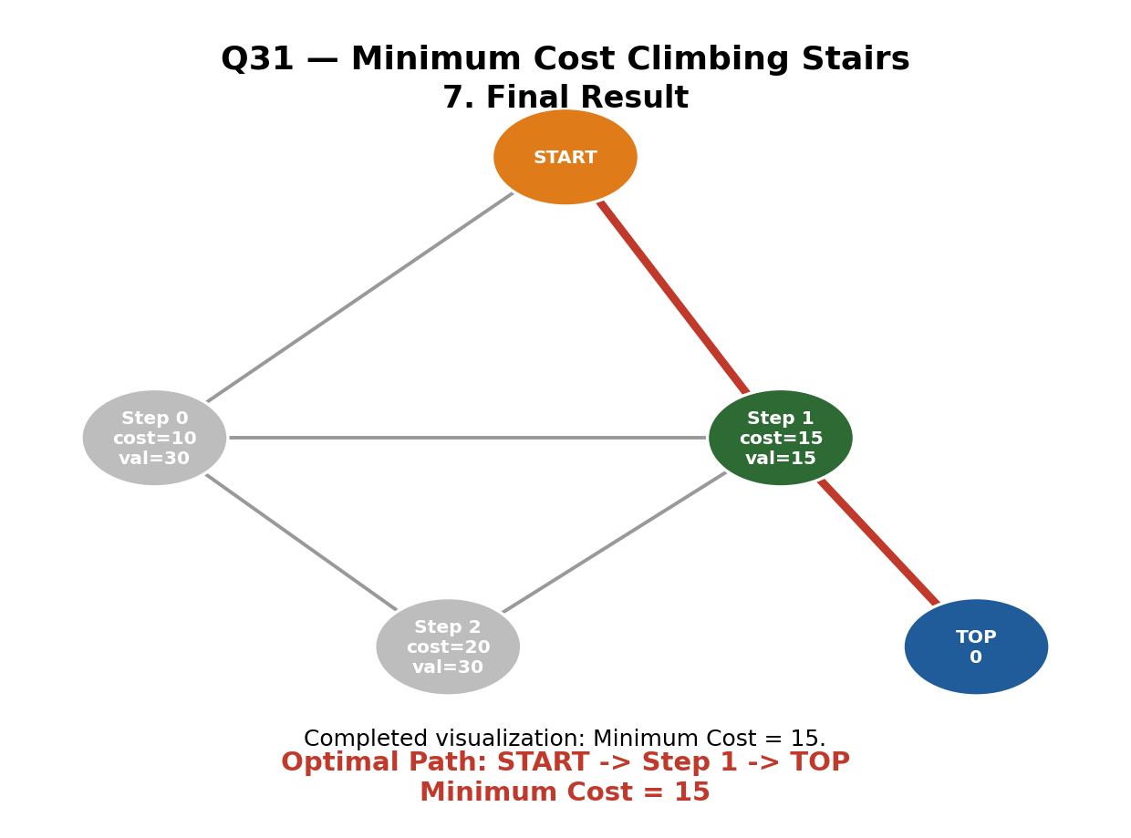
Figure 7: Completed recursion-tree visualization showing Minimum Cost = 15.
Optimal Path
Start at Step 1 (cost = 15), then jump 2 steps directly to TOP.
Total Cost = 15
7. RESULT
The Minimum Cost Climbing Stairs problem was successfully solved using Dynamic Programming. For cost = [10, 15, 20], the minimum cost required to reach TOP is 15. The optimal path is START → Step 1 → TOP.
MIN COST = 15

