SIMATS ENGINEERING
(SAVEETHA SCHOOL OF ENGINEERING)
Department of Computer Science and Engineering
Assessment Tool 1 – Coding Challenge Task
Course Code | CSA0603
Course Title | Design and Analysis of Algorithms
Assessment | Assessment Tool 1 (AT1) - Constraint-Based Problem Solving
CO Assessed | CO5 - Constraint-Based Problem Solving
Weightage | 40% of CIA
Question | Q31 - Steiner Tree Problem (NP-Hard / Constraint Optimization)
Student Name | SELVAMAGAL M
Register Number | 192472013

1. AIM
To find the minimum-cost tree that connects a given set of required terminal vertices in a weighted graph, using optional intermediate (Steiner) vertices where they reduce the total cost, and to study why this problem is NP-Hard.
2. OBJECTIVE
- To understand the Steiner Tree Problem and how it differs from a plain Minimum Spanning Tree.
- To identify the constraints: all terminal vertices must be included, and the resulting subgraph must be connected and acyclic (a tree).
- To design a backtracking approach that explores subsets of optional Steiner vertices.
- To apply pruning so that clearly non-optimal branches are not explored fully.
- To implement and test the solution in Python, and to discuss its NP-Hard complexity.
3. ALGORITHM
A Steiner Tree Problem instance is given by a weighted graph G = (V, E), a set of terminal vertices T ⊆ V that must all be connected, and a set of optional vertices (Steiner points) that may or may not be used. The goal is to find the minimum-cost connected acyclic subgraph (a tree) that contains every vertex in T. Steiner points may be included only if they help reduce the overall cost.
Constraints
- Connectivity: every terminal vertex must lie in the same connected component of the chosen subgraph.
- Inclusion of required nodes: all vertices in T must be present in the tree; Steiner vertices are optional.
- Acyclicity: the chosen subgraph must be a tree (no cycles), since a cycle can never reduce cost.
These constraints shape the search space: instead of searching over all subgraphs of G, the algorithm only needs to decide, for each optional Steiner vertex, whether to include it. Once a subset of Steiner vertices is fixed, the cheapest way to connect T together with that subset is simply the Minimum Spanning Tree (MST) of the subgraph induced by T and the chosen subset. This reduces the search space from "all subgraphs" to "all 2^k subsets of the k optional Steiner vertices", which is still exponential but far smaller and easy to explore with backtracking.
Backtracking Steps
- Read the graph, the terminal set T, and the list of optional Steiner candidates S = {s1, s2, ..., sk}.
- Set best_cost = cost of the MST using terminals only (this is a valid upper bound).
- Recursively decide, for each Steiner candidate in turn, whether to exclude it or include it in the current subset.
- Before exploring the 'include' branch for a candidate, apply the pruning rule (below); if the branch cannot possibly beat best_cost, cut it.
- When all candidates have been decided, compute the MST cost of (T ∪ chosen subset) using Kruskal's algorithm.
- If this cost is lower than best_cost, update best_cost and remember the subset and tree edges.
- After exploring every branch, best_cost and its tree edges are the minimum-cost Steiner tree.
Pruning Rule
Before branching into 'include vertex v', the algorithm checks the cheapest edge that touches v anywhere in the graph. If that single edge already costs at least as much as the best complete tree found so far, then no tree built using v can possibly beat the current best, so the entire branch under 'include v' is cut without being explored further. This is a standard branch-and-bound style lower-bound pruning rule applied inside backtracking.
Complexity
Time Complexity = O(2^k · E log V), where k is the number of optional Steiner vertices and each of the 2^k subsets needs an O(E log V) MST computation.
Space Complexity = O(V + E) for the graph and O(k) for the recursion stack.
4. CODE
The following Python code implements the backtracking search over Steiner-point subsets, with pruning, and computes the MST cost for each subset using Kruskal's algorithm:
INF = float('inf')

edges = [
('A','B',1), ('B','C',1), ('C','D',1), ('D','E',1),
('A','C',3), ('C','E',3), ('A','D',4), ('B','E',4),
('A','E',6), ('C','F',10), ('E','F',10),
]
terminals = ['A', 'C', 'E']
steiner_candidates = ['B', 'D', 'F']

def mst_cost_and_edges(node_subset, edge_list):
parent = {v: v for v in node_subset}
def find(x):
while parent[x] != x: x = parent[x]
return x
def union(x, y):
px, py = find(x), find(y)
if px == py: return False
parent[px] = py
return True
sub_edges = [e for e in edge_list
if e[0] in node_subset and e[1] in node_subset]
sub_edges.sort(key=lambda e: e[2])
total, used = 0, []
for u, v, w in sub_edges:
if union(u, v):
total += w; used.append((u, v, w))
if len(used) == len(node_subset) - 1:
return total, used
return INF, []

best_cost, best_edges = mst_cost_and_edges(set(terminals), edges)
best_subset = set()

def backtrack(index, chosen):
global best_cost, best_subset, best_edges
if index == len(steiner_candidates):
node_set = set(terminals) | chosen
cost, tree_edges = mst_cost_and_edges(node_set, edges)
if cost < best_cost:
best_cost, best_subset = cost, set(chosen)
best_edges = tree_edges
return
v = steiner_candidates[index]
backtrack(index + 1, chosen) # exclude v
chosen.add(v)
min_edge_for_v = min(w for a,b,w in edges if v in (a,b))
if min_edge_for_v < best_cost: # pruning check
backtrack(index + 1, chosen) # include v
chosen.remove(v)

backtrack(0, set())
print('Minimum Steiner Tree Cost =', best_cost)
print('Steiner points used =', best_subset)
print('Tree edges =', best_edges)

5. OUTPUT
Input
Terminals T = {A, C, E}
Steiner set S = {B, D, F}
Edges (u, v, weight):
A-B:1 B-C:1 C-D:1 D-E:1 A-C:3 C-E:3
A-D:4 B-E:4 A-E:6 C-F:10 E-F:10

Subsets Explored (backtracking, with pruning)
Subset MST Cost
{} 6 (terminals only)
{D} 5
{B} 5
{B,D} 4 <- minimum
{F}, {D,F},
{B,F}, {B,D,F} PRUNED (F's cheapest edge = 10 >= best cost)

Output
Minimum Steiner Tree Cost = 4
Steiner points used = {B, D}
Tree edges = A-B(1), B-C(1), C-D(1), D-E(1)

6. VISUALS
The main solution is the backtracking search over Steiner-point subsets shown above. The figures below show the input graph, the shape of the backtracking search tree, how pruning removes non-optimal branches, and the final optimal Steiner tree.
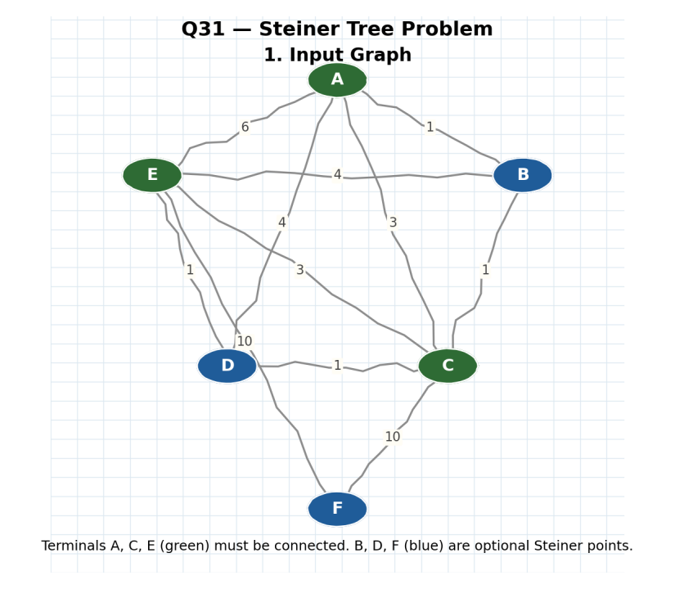
Figure 1: Input graph. Terminals A, C, E must be connected; B, D, F are optional Steiner points.

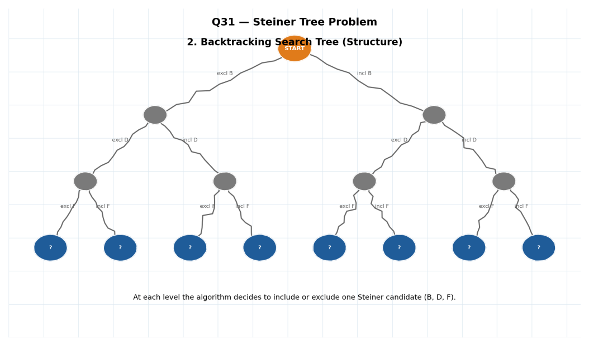
Figure 2: Structure of the backtracking search tree — one include/exclude decision per Steiner candidate.

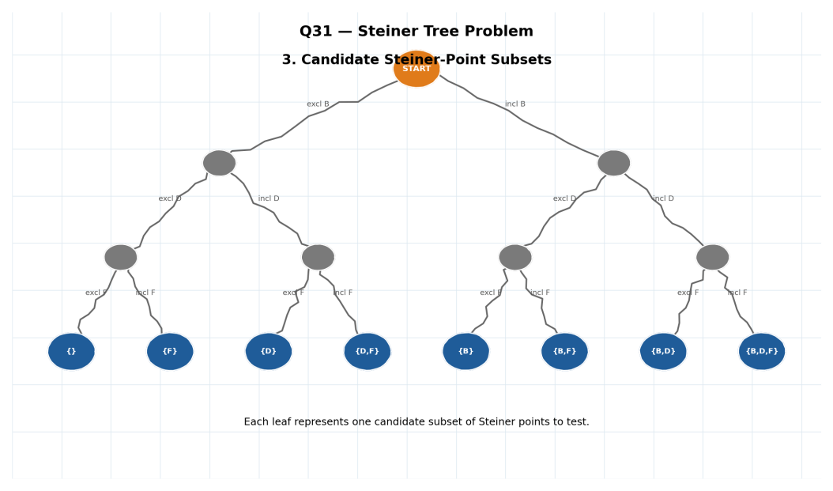
Figure 3: Each leaf of the tree corresponds to one candidate subset of Steiner points.

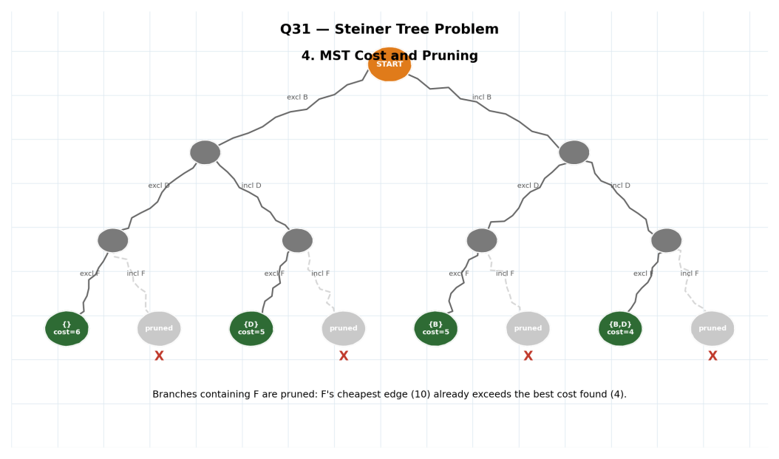
Figure 4: MST cost computed at each feasible leaf; branches containing F are pruned before evaluation.

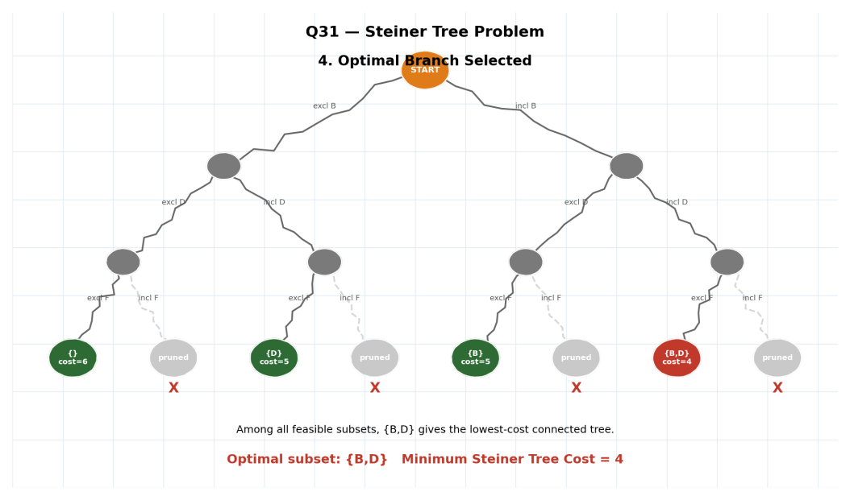
Figure 5: The optimal branch {B,D}, giving the minimum-cost tree.

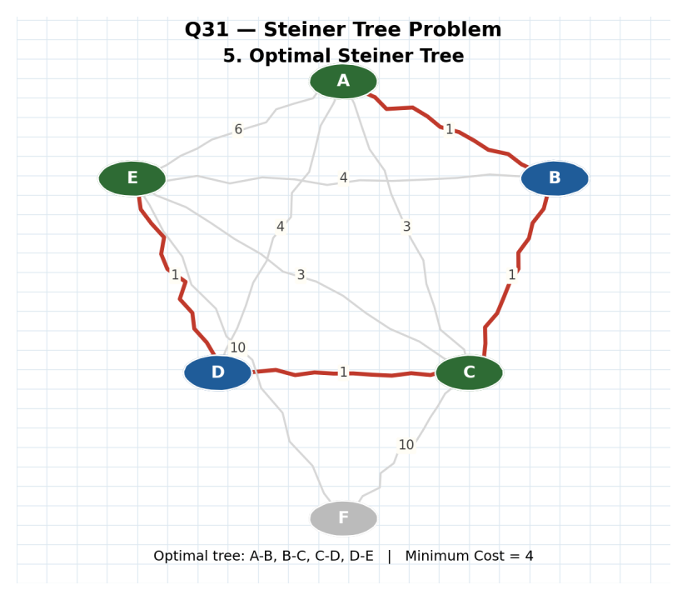
Figure 6: Final optimal Steiner tree drawn on the original graph — edges A-B, B-C, C-D, D-E, cost = 4.

How Constraints Shaped the Search
Because only the k optional Steiner vertices are decision variables (each vertex is either included or excluded), the search space is exactly 2^k subsets rather than all possible subgraphs of the input graph. The connectivity constraint is enforced automatically: any subset whose induced subgraph cannot connect all of T is rejected because its MST computation returns 'disconnected' instead of a finite cost. The pruning rule then removes whole branches — for example, every subset containing F was pruned here because F's cheapest possible edge (10) already exceeded the best tree cost already found (4), so it could never help.
7. RESULT
The Steiner Tree Problem was solved using a backtracking search over subsets of optional Steiner vertices, with each subset evaluated by its Minimum Spanning Tree cost and non-promising branches removed by pruning. For the given graph with terminals {A, C, E}, the minimum-cost tree uses Steiner points B and D, with edges A-B, B-C, C-D, D-E, giving a minimum cost of 4 — cheaper than connecting the terminals directly (cost 6).
The solution is minimal because it was chosen as the lowest-cost option among every feasible subset of Steiner points that was not eliminated by pruning, and each subset's cost is itself the true minimum (an MST) for that subset. The Steiner Tree Problem is NP-Hard because, unlike the Minimum Spanning Tree problem, the set of vertices to include is not fixed in advance — deciding which subset of Steiner points to use is equivalent to a subset-selection search, and no polynomial-time algorithm is known that always finds the optimal subset for general graphs. This is why the solution above relies on exponential backtracking (2^k subsets) rather than a single polynomial-time MST computation, and why pruning is essential to make larger instances practical.
MINIMUM STEINER TREE COST = 4

