AIRLINE ANALYTICS PROJECT
End-to-End Data Ingestion, Data Quality, PII Protection, SQLite Storage and Power BI Dashboard

Complete Project Documentation

Project Domain | Airline / Flight Analytics
Source Format | Excel workbook – UseCase - Airlines.xlsx
Processing | Python / Pandas
Storage | SQLite – airline_analytics.db
Visualization | Microsoft Power BI

1. Project Overview
This project implements an end-to-end airline analytics pipeline. The Python program reads four Excel source tables—flights, bookings, payments and passengers—then validates their schemas, performs data-quality checks, detects invalid records, removes duplicates, converts dates and flight duration, standardizes categorical fields, handles selected missing values, protects personally identifiable information (PII) through SHA-256 hashing, creates a route field, builds analytical tables, and stores the processed data in a SQLite database.
The resulting data is used for Power BI reporting. The supplied dashboard screenshots show an execution overview and a separate Duration Analysis page containing airline-level and route-level flight-duration visualizations.

2. End-to-End Architecture
The project can be understood as the following flow:
Excel Source Tables
↓
Python / Pandas Data Ingestion
↓
Schema Validation + Data Quality Checks
↓
Invalid Record Detection + Duplicate Removal
↓
Date/Time + Duration Transformation
↓
Standardization + Missing-Value Handling
↓
PII Hashing / Protection
↓
Analytical Dimensions + Booking Fact
↓
SQLite Database
↓
Power BI Dashboard
↓
Flight and Duration Insights

3. Source Data
The script loads four worksheets from the Excel workbook. The expected columns are explicitly defined in the Python code, so the pipeline can detect missing or unexpected fields before downstream processing.
Source Table | Main Purpose | Expected Columns
flights | Flight schedule, route and duration information | flight_id, airline, source, destination, departure_time, arrival_time, duration
bookings | Booking, passenger, status and seat information | booking_id, passenger_id, flight_id, booking_date, status, passport_number, seat_number, emergency_contact_name, emergency_contact_phone
payments | Payment and amount information | payment_id, booking_id, amount, payment_method
passengers | Passenger demographic and contact information | passenger_id, first_name, last_name, age, gender, email, phone, aadhaar_id, date_of_birth

4. Data Ingestion
Pandas read_excel() is used to load each worksheet. The code prints the shape of every source table so the user can verify how many rows and columns entered the pipeline. The source-loading and shape-reporting logic is implemented at the beginning of the script. fileciteturn0file0L10-L23

5. Schema Validation
An expected_schema dictionary defines the required fields for all four tables. The validate_schema() function compares expected columns with the actual DataFrame columns and reports missing or extra columns. A table is marked as PASSED when no required column is missing. fileciteturn0file0L25-L98
- Detects missing columns.
- Detects extra columns.
- Provides a table-level validation message.
- Runs validation separately for flights, bookings, payments and passengers.

6. Data Quality Checks
The data_quality_report() function reports row count, column count, duplicate-row count, missing values for each column, and data types. The report is executed for all four source tables. fileciteturn0file0L100-L122

6.1 Invalid Record Detection
Check | Rule | Action
Flight ID | flight_id is missing | Count invalid flight records
Payment amount | Numeric amount <= 0 | Count invalid payment records
Passenger age | Age < 0 or age > 120 | Count invalid passenger records
Flight duration | Duration cannot be parsed or is <= 0 | Remove invalid-duration flights
The payment amount is converted to numeric with errors coerced to missing values, while passenger-age validation checks for unrealistic values. The duration is separately validated after conversion. fileciteturn0file0L124-L143

7. Duplicate Removal
Duplicate records are removed using the business identifier of each table while retaining the first occurrence.
Table | Deduplication Key
flights | flight_id
bookings | booking_id
payments | payment_id
passengers | passenger_id
The script then prints a confirmation that duplicates were removed. fileciteturn0file0L146-L175

8. Data Transformation and Standardization
- departure_time, arrival_time, booking_date and date_of_birth are converted to datetime values using errors='coerce'.
- The original flight duration is converted into duration_minutes using pandas Timedelta conversion.
- Flights with missing or non-positive duration_minutes are removed.
- Airline, source and destination values are stripped of surrounding spaces and converted to uppercase.
- Booking status is stripped and converted to uppercase.
- Missing booking status is replaced with UNKNOWN.
- Missing airline values are replaced with UNKNOWN.
- Missing passenger last names are replaced with UNKNOWN.
- A payment amount_missing_flag is created to preserve information about missing payment amounts.
These transformations are implemented in the date/time, duration and standardization sections of the script. fileciteturn0file0L177-L276

9. PII Protection / Hashing
The pipeline protects selected personal information by applying SHA-256 hashing. The hash_value() function returns None for missing values and otherwise hashes a stripped string using UTF-8 encoding.
Source Information | Protected Field | Table
first_name | first_name_hash | passengers
last_name | last_name_hash | passengers
email | email_hash | passengers
phone | phone_hash | passengers
aadhaar_id | aadhaar_hash | passengers
passport_number | passport_hash | bookings
emergency_contact_name | emergency_contact_name_hash | bookings
emergency_contact_phone | emergency_contact_phone_hash | bookings
After the hash columns are created, the original passenger names, email, phone and Aadhaar fields are dropped, and the original passport and emergency-contact fields are dropped from bookings. This means the stored analytical tables do not retain those original PII values. fileciteturn0file0L278-L348

10. Route Creation
A derived route field is created by concatenating the standardized source and destination airport codes with an arrow. For example, the resulting pattern is SOURCE → DESTINATION. fileciteturn0file0L350-L355

11. Analytical Data Model and SQLite Storage
The cleaned data is organized into analytical tables before being written to SQLite. The database connection is created as airline_analytics.db.
SQLite Table | Role | Important Fields
dim_flight | Flight dimension | flight_id, airline, source, destination, route, departure_time, arrival_time, duration_minutes
dim_passenger | Passenger dimension | passenger_id, hashed identity/contact fields, age, gender, date_of_birth
fact_booking | Booking fact | booking_id, passenger_id, flight_id, booking_date, status, passport_hash, seat_number
dim_payment | Payment table | payment_id, booking_id, amount, payment_method, amount_missing_flag
The script writes all four tables with DataFrame.to_sql(..., if_exists='replace', index=False) and then queries sqlite_master to list the stored tables. fileciteturn0file0L358-L459

12. Power BI Dashboard – Execution Overview
The supplied Execution dashboard contains KPI-style visuals for total flights, average flight duration, total routes, total airlines, longest flight and shortest flight. It also contains a distribution of flights by airline and a horizontal bar chart for top flight routes by traffic.
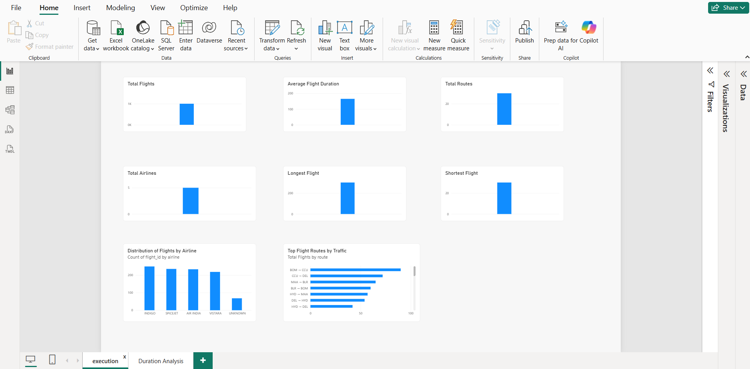
Figure 1. Power BI Execution dashboard supplied with the project.

12.1 Dashboard Metrics and Meaning
Visual | What it represents | Business use
Total Flights | Number of flight records represented | Overall flight volume
Average Flight Duration | Mean duration in minutes | Operational duration benchmark
Total Routes | Count of routes represented | Network coverage
Total Airlines | Number of airlines represented | Airline coverage
Longest Flight | Maximum flight duration | Identify longest operating duration
Shortest Flight | Minimum flight duration | Identify shortest operating duration
Distribution of Flights by Airline | Flight count by airline | Compare airline activity
Top Flight Routes by Traffic | Flight count by route | Identify high-traffic routes

13. Power BI Dashboard – Duration Analysis
The Duration Analysis page focuses on flight duration by airline and by route. The airline chart compares average flight duration across the displayed airlines, while the route chart ranks routes by average flight duration.
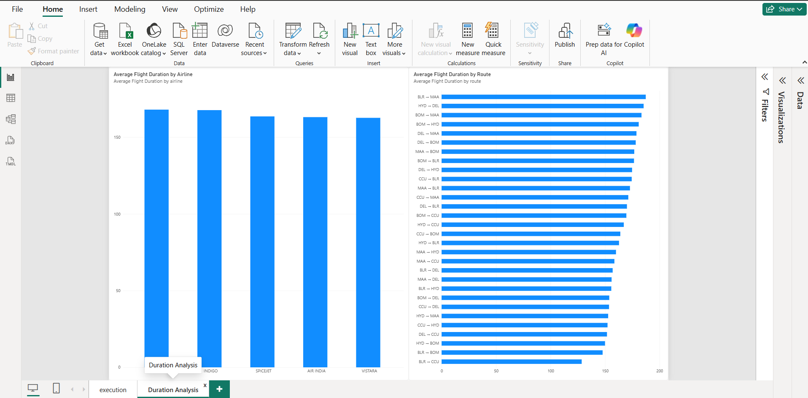
Figure 2. Power BI Duration Analysis dashboard supplied with the project.

13.1 Dashboard Observations from the Supplied Screenshot
- The displayed airline averages are relatively close to one another, with the leading bars around the high-160s/170-minute range.
- The route visual shows substantial variation in average duration, with the highest displayed route bars approaching 200 minutes.
- The route chart is sorted from higher average duration toward lower average duration.
- The exact underlying values should be taken from the Power BI model/data rather than estimated from the screenshot alone.

14. Complete Processing Sequence
- Import required Python libraries.
- Read flights, bookings, payments and passengers from Excel.
- Print source table shapes.
- Define and validate expected schemas.
- Generate data-quality reports.
- Detect missing flight IDs, invalid payment amounts and unrealistic passenger ages.
- Remove duplicates using table identifiers.
- Convert date/time columns.
- Convert flight duration to minutes.
- Remove invalid-duration flights.
- Standardize airline, airport and booking-status text.
- Handle selected missing values.
- Create payment amount-missing flag.
- Hash selected PII using SHA-256.
- Drop the corresponding original PII columns.
- Create the route field.
- Create SQLite connection.
- Build dim_flight, dim_passenger, fact_booking and dim_payment.
- Write the analytical tables to SQLite.
- Query SQLite metadata to confirm stored tables.
- Use the processed data for Power BI dashboard reporting.

15. Project Strengths
- End-to-end pipeline from raw Excel data to BI reporting.
- Explicit schema validation before analytical processing.
- Multiple data-quality checks rather than relying only on missing-value counts.
- Duplicate handling based on table identifiers.
- Standardized airport, airline and booking-status values.
- Flight duration converted into an analysis-friendly numeric measure.
- Selected PII is hashed before storage and original fields are removed.
- Analytical tables are separated into flight, passenger, booking and payment structures.
- SQLite provides a simple persistent storage layer for the cleaned data.
- Power BI provides an interactive reporting layer for operational insights.

16. Important Implementation Notes
- The supplied Python script uses if_exists='replace' when writing SQLite tables, so a rerun replaces the existing tables.
- The script identifies invalid flight IDs and invalid passenger ages but does not explicitly remove those records in the shown logic.
- Payment records with missing amounts are retained separately through amount_missing_flag, while valid_payments is created for non-missing non-negative amounts.
- The source code imports numpy, re and Path, but the shown pipeline does not use them in the visible processing steps.
- The dashboard screenshots show the final reporting layer, but the supplied files do not include the Power BI PBIX model or the exact DAX measures, so those implementation details are not documented as facts here.

17. Conclusion
This airline analytics solution establishes a complete data pipeline that moves from Excel ingestion through validation, quality control, transformation, PII protection and analytical storage into Power BI visualization. The dashboard provides a concise view of flight volume, route activity and duration behavior, while the Duration Analysis page supports comparison of average flight duration across airlines and routes.

Appendix A – Complete Python Pipeline Code
The following appendix preserves the uploaded Python implementation as a code reference. The source file contains 459 lines.
# data ingestion

import pandas as pd
import numpy as np
import sqlite3
import hashlib
import re
from pathlib import Path

# Read all source tables
flights = pd.read_excel("UseCase - Airlines.xlsx", sheet_name="flights")
bookings = pd.read_excel("UseCase - Airlines.xlsx", sheet_name="bookings")
payments = pd.read_excel("UseCase - Airlines.xlsx", sheet_name="payments")
passengers = pd.read_excel("UseCase - Airlines.xlsx", sheet_name="passengers")

print("Data Ingestion Completed")
print("-" * 50)

print("Flights :", flights.shape)
print("Bookings :", bookings.shape)
print("Payments :", payments.shape)
print("Passengers :", passengers.shape)

# Schemas Validation

expected_schema = {

"flights": [
"flight_id",
"airline",
"source",
"destination",
"departure_time",
"arrival_time",
"duration"
],

"bookings": [
"booking_id",
"passenger_id",
"flight_id",
"booking_date",
"status",
"passport_number",
"seat_number",
"emergency_contact_name",
"emergency_contact_phone"
],

"payments": [
"payment_id",
"booking_id",
"amount",
"payment_method"
],

"passengers": [
"passenger_id",
"first_name",
"last_name",
"age",
"gender",
"email",
"phone",
"aadhaar_id",
"date_of_birth"
]
}

def validate_schema(df, table_name):

expected_columns = expected_schema[table_name]

missing_columns = set(expected_columns) - set(df.columns)
extra_columns = set(df.columns) - set(expected_columns)

if missing_columns:
print(
f"{table_name}: Missing columns -> "
f"{missing_columns}"
)

if extra_columns:
print(
f"{table_name}: Extra columns -> "
f"{extra_columns}"
)

if not missing_columns:
print(f"{table_name}: Schema validation PASSED")

validate_schema(flights, "flights")
validate_schema(bookings, "bookings")
validate_schema(payments, "payments")
validate_schema(passengers, "passengers")

# Data Quality checks
def data_quality_report(df, table_name):

print("\n" + "=" * 60)
print(f"DATA QUALITY REPORT: {table_name}")
print("=" * 60)

print("Rows :", len(df))
print("Columns :", len(df.columns))

print("Duplicate rows :", df.duplicated().sum())

print("Missing values:")
print(df.isnull().sum())

print("\nData types:")
print(df.dtypes)

data_quality_report(flights, "flights")
data_quality_report(bookings, "bookings")
data_quality_report(payments, "payments")
data_quality_report(passengers, "passengers")

# Invalid record detection
invalid_flights = flights[flights["flight_id"].isna()].copy()

print("Invalid flight records:", len(invalid_flights))

payments["amount"] = pd.to_numeric(payments["amount"], errors="coerce")
invalid_payments = payments[payments["amount"].notna() & (payments["amount"] <= 0)
].copy()

print("Invalid payment records:", len(invalid_payments))

invalid_passengers = passengers[
passengers["age"].notna() &
(
(passengers["age"] < 0) |
(passengers["age"] > 120)
)
].copy()

print("Invalid passenger age records:",
len(invalid_passengers))

# Remove duplicate flight records

flights = flights.drop_duplicates(
subset=["flight_id"],
keep="first"
)

# Remove duplicate bookings

bookings = bookings.drop_duplicates(
subset=["booking_id"],
keep="first"
)

# Remove duplicate payments

payments = payments.drop_duplicates(
subset=["payment_id"],
keep="first"
)

# Remove duplicate passengers

passengers = passengers.drop_duplicates(
subset=["passenger_id"],
keep="first"
)

print("Duplicates removed.")

# convert date/time columns
flights["departure_time"] = pd.to_datetime(
flights["departure_time"],
errors="coerce"
)

flights["arrival_time"] = pd.to_datetime(
flights["arrival_time"],
errors="coerce"
)

bookings["booking_date"] = pd.to_datetime(
bookings["booking_date"],
errors="coerce"
)

passengers["date_of_birth"] = pd.to_datetime(
passengers["date_of_birth"],
errors="coerce"
)

# convert flight duration
flights["duration_minutes"] = (
pd.to_timedelta(
flights["duration"].astype(str),
errors="coerce"
).dt.total_seconds() / 60
)

# validation duration
invalid_duration = flights[
flights["duration_minutes"].isna() |
(flights["duration_minutes"] <= 0)
].copy()

print(
"Invalid duration records:",
len(invalid_duration)
)

# remove invalid duration
flights = flights[
flights["duration_minutes"].notna() &
(flights["duration_minutes"] > 0)
].copy()

# Standardize airline and airport codes
flights["airline"] = (
flights["airline"]
.astype("string")
.str.strip()
.str.upper()
)

flights["source"] = (
flights["source"]
.astype("string")
.str.strip()
.str.upper()
)

flights["destination"] = (
flights["destination"]
.astype("string")
.str.strip()
.str.upper()
)

# Standardize booking status
bookings["status"] = (
bookings["status"]
.astype("string")
.str.strip()
.str.upper()
)

# Handling missing status

bookings["status"] = bookings["status"].fillna(
"UNKNOWN"
)

flights["airline"] = flights["airline"].fillna(
"UNKNOWN"
)

passengers["last_name"] = (
passengers["last_name"]
.fillna("UNKNOWN")
)

payments["amount_missing_flag"] = (
payments["amount"].isna()
)

valid_payments = payments[
payments["amount"].notna() &
(payments["amount"] >= 0)
].copy()

# Pll masking /hashing
def hash_value(value):

if pd.isna(value):
return None

value = str(value).strip()

return hashlib.sha256(
value.encode("utf-8")
).hexdigest()

# Passenger data

passengers["first_name_hash"] = (
passengers["first_name"]
.apply(hash_value)
)

passengers["last_name_hash"] = (
passengers["last_name"]
.apply(hash_value)
)

passengers["email_hash"] = (
passengers["email"]
.apply(hash_value)
)

passengers["phone_hash"] = (
passengers["phone"]
.apply(hash_value)
)

passengers["aadhaar_hash"] = (
passengers["aadhaar_id"]
.apply(hash_value)
)
# Booking
bookings["passport_hash"] = (
bookings["passport_number"]
.apply(hash_value)
)

bookings["emergency_contact_name_hash"] = (
bookings["emergency_contact_name"]
.apply(hash_value)
)

bookings["emergency_contact_phone_hash"] = (
bookings["emergency_contact_phone"]
.apply(hash_value)
)

passengers = passengers.drop(
columns=[
"first_name",
"last_name",
"email",
"phone",
"aadhaar_id"
]
)

bookings = bookings.drop(
columns=[
"passport_number",
"emergency_contact_name",
"emergency_contact_phone"
]
)

# Create route
flights["route"] = (
flights["source"]
+ " → "
+ flights["destination"]
)

##### Data Model and storage
# connecting

connection = sqlite3.connect(
"airline_analytics.db"
)

# flight dimension
dim_flight = flights[
[
"flight_id",
"airline",
"source",
"destination",
"route",
"departure_time",
"arrival_time",
"duration_minutes"
]
].copy()

# passenger dimension
dim_passenger = passengers[
[
"passenger_id",
"first_name_hash",
"last_name_hash",
"age",
"gender",
"email_hash",
"phone_hash",
"aadhaar_hash",
"date_of_birth"
]
].copy()

# booking fact
fact_booking = bookings[
[
"booking_id",
"passenger_id",
"flight_id",
"booking_date",
"status",
"passport_hash",
"seat_number"
]
].copy()

# payment dimension

dim_payment = payments[
[
"payment_id",
"booking_id",
"amount",
"payment_method",
"amount_missing_flag"
]
].copy()

dim_flight.to_sql(
"dim_flight",
connection,
if_exists="replace",
index=False
)

dim_passenger.to_sql(
"dim_passenger",
connection,
if_exists="replace",
index=False
)

fact_booking.to_sql(
"fact_booking",
connection,
if_exists="replace",
index=False
)

dim_payment.to_sql(
"dim_payment",
connection,
if_exists="replace",
index=False
)

print("Data stored successfully in SQLite.")

tables = pd.read_sql_query(
"""
SELECT name
FROM sqlite_master
WHERE type = 'table';
""",
connection
)

print(tables)

