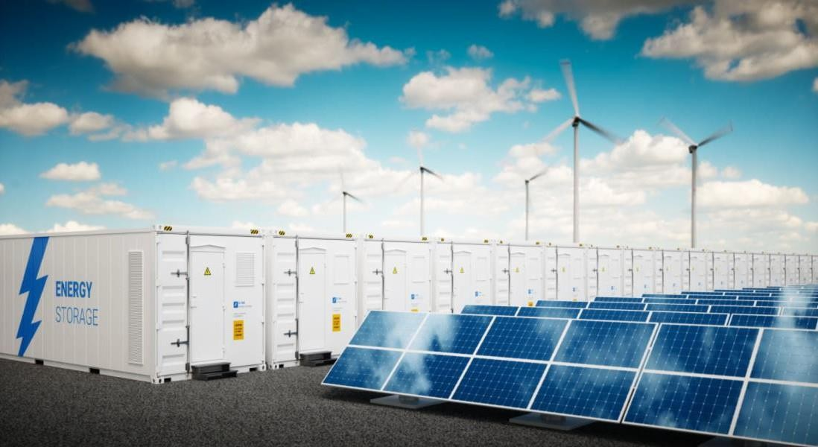

TECHNO-COMMERCIAL PROPOSAL
FOR LI-ION BATTERY BASED ENERGY STORAGE SYSTEM FOR M/S. {{Customer Caps}}

ENRICH ENERGY PVT. LTD.
ISO 9001 – 2015, ISO 14001-2015 & OHSAS 18001-2007 ORGANIZATION

Head Office: 302, Third Floor, ’The Orion’, 11/1C Koregaon Park Road, Pune – 411001, Maharashtra, India
PHONE: +91 20 26050080/84
FAX: +91 20 26050079

Web: www.Enrichenergy.com

Contents
1. COVERING LETTER 2
2. PROJECT DETAILS 3
3. SCOPE OF WORK FOR THE PROJECT: 3
4. TECHNICAL BASE CONSIDERATION: 4
5. BESS CONFIGURATION: 5
6. AUXILIARY CONSUMPTION: 6
7. TECHNICAL SPECIFICATIONS: 7
8. COMMERCIAL OFFER 8
9. GENERAL TERMS AND CONDITIONS 9
10. PAYMENT SECURITY 10
11. SCHEDULED COMPLETION DATE (SCoD) TIMELINE CONDITIONS 10
12. LIQUIDATED DAMAGES 11
13. INSURANCE 12
14. QHSE 12
15. FORCE MAJEURE 12
16. WARRANTY 12
17. DEFECT LIABILITY PERIOD 13
18. CONFIDENTIALITY 13
19. OWNERSHIP OF INFORMATION 13
20. ARBITRATION 13
21. JURISDICTION 14
22. CANCELLATION 14
23. INDEMNIFICATION 14
24. GOVERNING LAW 14
25. LIMITATION OF LIABILITY 14
26. CONSEQUENTIAL LOSSES 15
27. RESTRICTION ON EXPORT AND USE OF PRODUCT 15
28. INTELLECTUAL PROPERTY RIGHTS 15

COVERING LETTER

REF:EEPL/{{Name of Customer}}-{{Rev No}}/BESS/{{Project Capacity}}/Offer/{{Offer No}}/{{ST}}/{{FY}} Date: December 17, 2025

To,
{{Client Name}},
{{Customer Address}}

Kind Attn.: {{Kind Attn}}, {{Client Dgsn}}

Subject : Techno- Commercial offer for {{Project Capacity}} BESS Project at {{State}}.

Dear Sir,

We thank you for providing us an opportunity to submit our proposal for EPC Solution for Battery Energy Storage Solution consisting of Container, BMS, PCS (POWER CONDITIONING SYSTEM), EMS (Energy Management System) & Electrical Equipment. The details are included in the proposal for your kind perusal.

We would like to introduce our company “Enrich Energy Pvt. Ltd.” (EEPL), headquartered in Pune, as an ISO 9001:2015, ISO 14001:2015 and OHSAS 18001:2007 certified company engaged in providing EPC services for solar PV power projects, BESS projects, and a pioneer in turnkey development of solar parks. We have successfully commissioned {{Enrich AC}} ({{Enrich DC}}) in the key Solar States of India, and are currently executing projects of {{Enrich Projects}} pan India.

We trust you will find our technical offer in line with your requirement & look forward for your continued support and patronage and in the event you require any further clarifications/information, kindly treat us at your disposal.

Thanking you again, we look forward to your prestigious order. Yours faithfully,
For Enrich Energy Pvt. Ltd.

{{Enrich Contact Name}}
{{Enrich Contact Dgsn}}
Email: {{Enrich Contact Email}}
Mobile: {{Enrich Contact No}}

PROJECT DETAILS

GENERAL
 | {{Kind Attn}}
Client Contact Person | {{Client Dgsn}}
Details | Email: {{Client Email}}
 | M: {{Client Contact No}}
 | {{Enrich Contact Name}}
Enrich Contact Person | {{Enrich Contact Dgsn}}
Details | Email: {{Enrich Contact Email}}
 | Contact: {{Enrich Contact No}}
Project Details | Li-ion Battery Energy Storage System {{Project Capacity}}
Site Location | {{State}}
Scheduled Completion Date (SCoD) Timeline Conditions: | The Scheduled Completion Date (SCoD) shall be {{Completion Month}} Months from the date of release of NTP along with Advance and issuance of relevant documents (NTP Conditions) and fulfillment of SCoD Conditions by Client.
NTP CONDITIONS | - Handover of Land which is sufficient, suitable for project execution with clear boundary demarcation for BESS project and site preparation.  - Release of Advance along with LOI/PO & NTP.  - Access / Approach road to execution site, Access & Permissions/ or Permits to the site

SCOPE OF WORK FOR THE PROJECT:

EPC solution for Battery Energy Storage Solution consisting of Battery Container, PCS (Power Conditioning System), EMS (Energy Management System) & Electrical Equipment for {{Project Capacity}} as per the below mentioned Scope:
- Enrich Scope: {{Enrich Scope}}
- EEPL battery limit shall be upto {{Evacuation Level}} cable termination at MV panel of existing Solar plant.
- EEPL considered that the existing auxiliary transformer will be used for BESS auxiliary supply.
- EEPL has considered that the distance between MCR & BESS IDT is within {{Mtrs}} meters & in
existing MV panel 1 feeder is available at site for {{Evacuation Level}} cable termination.
- BESS power evacuation at {{Evacuation Level}} voltage level.
- BESS delivered energy shall be considered at {{Evacuation Level}} bus at MV panel.

TECHNICAL BASE CONSIDERATION:

Proposed System

  - The BESS shall have 3 nos. x 2.77 MW of bi-directional PCS.

  - The proposed EMS is an intelligent system for Energy Shifting.

Sr. No. | Description for Bill of Material | Make | Unit | Quantity
1 | Containerized Battery of {{Battery Pwr}} MWh each | {{Battery Make}} | Nos. | {{Battery Qty}}
2 | Power Conditioning System (PCS) {{PCS Pwr}} MW @ 25°C | {{PCS Make}} | No. | {{PCS Qty}}
3 | Energy Management System (EMS) consisting of Hardware/Software for operation of the BESS for desired applications | {{EMS Make}} | Lot | {{EMS Qty}}
4 | Inverter Duty Transformer (IDT) {{IDT Pwr}} MVA trafo ({{IDT Transformer}}) ONAN with NIFPS and Tap Changers | Wilson Power/ Shiridi Sai Electricals/ Danish | No. | {{IDT Qty}}
5 | Balance of Systems (BoS) upto {{Evacuation Level}}
6 | Civil works (BESS Foundation, IDT foundation, cable trenches etc.) and Installation & Commissioning

- Only 33kV cable termination will be done at MV panel by EEPL.
- EEPL considered that the existing auxiliary transformer will be used for BESS auxiliary supply.
- EEPL has considered that the distance between MCR & BESS IDT is within {{Mtrs}} meters &
in existing MV panel 1 feeder is available at site for {{Evacuation Level}} cable termination.
- BESS power evacuation at {{Evacuation Level}} voltage level.
- BESS delivered energy shall be considered at {{Evacuation Level}} bus at MV panel.

BESS CONFIGURATION:

Year | Cycles | Estimated State of Health percentage (Approximate) | Available Capacity after degradation | Max usable Energy available at battery  terminals | Available energy at 33 KV interconnection in MWh (after one way effncy) | BESS Aux consumption for 2 Hrs of discharge | Delivered energy at plant end metering After Aux
 |  | % | MWh / day | MWh / day | 0.961 | MWh / day | MWh / day

AUXILIARY CONSUMPTION:

S.No. | Item | Description | Time Slot | Activity | Total Energy |  | Remarks
1 | BESS during Discharge (35 deg C) | Chillers and fans, all together | Night | Discharging, Night |  |  | From 6 PM and from 8 PM evening hours
2 | BESS during Standby (30 deg C) | Chillers and fans, all together | Night | Standby |  |  | From 8 PM to 6 AM night
3 | BESS during Charge (35 deg C) | Liquid cooling for each BESS 40KW | Day | Charging, Day |  |  | BESS Charging during day time say 12 Noon to 2 30 PM
4 | BESS during Standby (35 deg C) | Chillers and fans, all together | Day | Standby |  |  | Remaining part of the day
5 | Container Aux power | Power Socket for maintenance | Used only when BESS opened for maintenance, hence not considered for energy needs
6 | PCS power needs | Dyna CPS 2304 | Night | Standby
7 | PCS power needs | Dyna CPS 2304 | Night | Discharge
8 | PCS power needs | Dyna CPS 2304 | Day | Standby
9 | PCS power needs | Dyna CPS 2304 | Day | Charge
Total Aux. (kWh)

Aux consumption during BESS Discharge - drawn from BESS
Aux consumption during BESS Night Standby - drawn from Grid
Aux consumption during BESS Charge - drawn from Solar
Aux consumption during BESS Day Standby - drawn from Solar
Total Aux power per 24 hrs from BESS system
Aux from Solar plant

TECHNICAL SPECIFICATIONS:

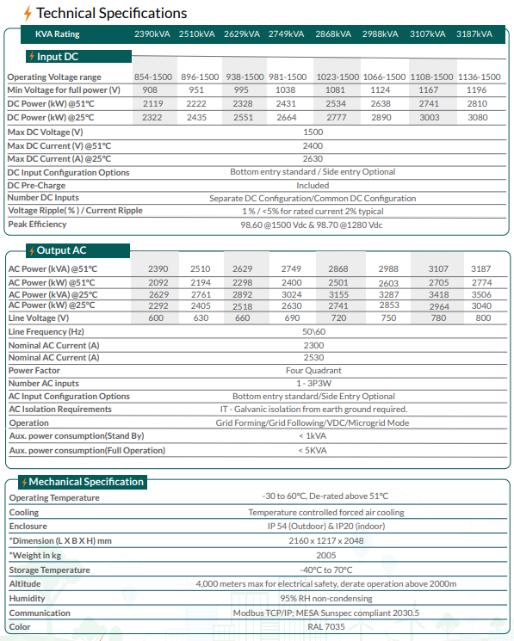

Note: To meet power requirement of {{AC MW}} from the BESS, we are selecting Newen {{PCS Pwr}} MW PCS from above specification list.

COMMERCIAL OFFER

PRICE SCHEDULE

S.No. | Battery Energy Storage Solution | Price (INR)
1 | Supply of Containerized Battery with BMS, PCS, EMD, IDT, Balance of System including required Electrical Equipment’s | {{Price}}
2 | Civil Works, Installation & Commissioning Services | {{Price}}
TOTAL | In Words: {{Price in Words}} | {{Price}}

PRICE BASIS

- The applicable taxes viz. GST (Goods & Service Tax) shall be payable extra as applicable.
- Standard packaging is included in the price. Any additional requirements will be charged extra.
- The Purchase Price includes the standard warranty provisions as set forth in Clause 16 (Warranty). Any extended warranty requested by the Client shall be subject to additional charges, calculated based on actual costs incurred.
- If the finished product is not shipped due to reasons attributable to client, warehousing charges shall be 1% per week of the manufactured goods cost.
- All warranties are on an ex-works basis. Any taxes, import duties, transportation shall be paid extra at actuals.
- All additional cost/s due to statutory variation and/ or any increase of taxes and duties and in the event of introduction of any new taxes, duties, cess and levies in the future and applicability of any anti-dumping duty, surcharge, safe-guard duty any special duties shall be applicable & payable extra at actuals to Enrich by the client as per change in law clause. Currently BCD is considered at {{BCD}} plus cess of {{BCD}}.
- We have considered 1 USD = {{USD Rate}} INR for the quoted price of supplies (Imported material). In case USD to INR exchange rate increase over and above INR 87/- either at the time of settlement of LC on maturity date or down payment to BESS manufacturer, then additional difference on account of settlement amount of LC towards remittance value/down payment value based on actual basis of exchange rate considered by paying bank, shall be payable extra by client over and above INR {{USD Rate}}/-. Exchange rate will be taken from RBI reference rate at 11 AM on the date of payment by Client. (in case of holiday the rate of previous day)
- Any financing cost or Bank Guarantee charges are not included in our offer.

GENERAL TERMS AND CONDITIONS

PAYMENT TERMS

SECTION A: PAYMENT TERMS FOR Supply of Containerized Battery Energy Storage System consisting of Lithium Battery Racks including HVAC, FSS.

Sr.no. | Milestones | Amount to be paid
1 | Interest free Advance payment along with the LOI | 30% Advance payment along with LOI
2 | 70% of Price through an irrevocable and transferable LC at sight against intimation of readiness of BESS one week before Dispatch | 70% of the Total Price + Applicable taxes

- 100% of payment towards GST shall be payable extra immediately against submission of tax Invoice/ Debit Note /Advance receipt vouchers along with relevant document if any.

SECTION B: PAYMENT TERMS FOR BOS

Sr.no. | Milestones | Amount to be paid
1 | Interest free Advance payment along with the LOI | 20% of the BoS Price + Applicable taxes
2 | 80% of BoS Price through an irrevocable and transferable LC at site:
I | Drawing submission | 10 % of the BoS Price + Applicable taxes
II | Supply/Service of BOS components on pro-rata basis | 65 % of the BoS Price + Applicable taxes
Iii | On intimation of commissioning of BESS project | 5 % of the BoS Price

- All payments shall be done within 10 working days from submission of invoices duly certified with milestone completion.

- GST will be charged in accordance with the applicable rate based on the HSN/ SAC classification.

- Any delay in payment may result in delay in execution of supplies under the order accordingly. Further, an interest @ 15% p.a. with monthly rests will be payable in case of delayed payments from the date of milestones as stated above till the date of actual payment.

Note: RA bill shall be allowed in case of payments for lump sum contracts such as civil, mechanical, electrical erection works, etc.

PAYMENT SECURITY

- As payment security, Client shall open an irrevocable, unconditional and transferable LC at site of value as per clause 7 within 15 days from issuance of LOA/NTP. LC if required will be transferred to the respective equipment suppliers/ Sub-contractor. LC shall be valid up to full and final realization of contractual payment and also proportionate payment against supply & works contract shall be withdrawn from the LC from time to time.
- In case of delay in opening of LC by client and any delay in acceptance of BoE against LC and its payment beyond 5 working days, in such each case, Enrich shall be entitled for an equitable extension of Schedule Completion Date on day to day basis. Further an interest @ 15% p.a. with monthly rests will be payable in case of delayed payments from the date of milestones as stated above till the date of actual payment. This shall be in addition to other remedies prescribed in this Offer elsewhere.
- All additional cost/s due to statutory variation and/ or any increase of taxes and duties and in the event of introduction of any new taxes such as duties, cess and levies in the future, these will be payable extra to Enrich by the client.

SCHEDULED COMPLETION DATE (SCoD) TIMELINE CONDITIONS

Installation & Commissioning Schedule

- Access & Permissions/ or Permits to the site to be provided by customer.
- The activity of Commissioning shall be completed in a period of {{SCoD Civil}} months including civil works.
- Based on OEM guidelines, Battery commissioning to be completed within {{SCoD OEM}} months from date of dispatch / shipment (OEM Ex-factory).
- Beyond {{SCoD Delay Battery}} months, the battery needs to be maintained at ambient temperature of 25°C to avoid any degradation.
- Site acceptance test (Capacity test and RTE (Round Trip Efficiency) test) schedule is included in above commissioning schedule.

Delivery Terms
- The delivery of the products shall be completed within a period of {{Completion Month}} months to the site, subject to the receipt of the purchase order and advance payment.
- The delivery of products in installments, partial shipments, or ahead of the agreed delivery schedule is permissible, provided a prior delivery plan is shared with CLIENT.
- ENRICH shall retain ownership of the products until the Purchaser has fulfilled the following obligations concerning said products:
    - Fully settled all outstanding amounts owed to ENRICH under the terms of the Contract or Purchase Order.
- In the event that the products cannot be delivered or received by the Purchaser when ready due to circumstances attributable to the CLIENT, Enrich will notify the Purchaser and may ship the products to a storage facility, including a location within the manufacturing site or to an agreed freight forwarder. If ENRICH puts Products in storage, the following conditions shall apply:
    - All risk of loss or damage shall immediately transfer to the Purchaser if it has not already;
    - Any sums payable to ENRICH upon delivery, or any charges incurred such as those for preparation, handling, inspection, preservation, insurance, storage, demurrage, removal, and applicable taxes, shall be payable by the Purchaser upon submission of invoices by Enrich;
    - when conditions permit and upon payment of all amounts due hereunder, ENRICH shall resume delivery of Products to the originally agreed point of delivery.
- Unless claims for shortages, damage, or other discrepancies in the products are submitted in writing by the Purchaser to Enrich within fifteen (15) calendar days of delivery, the Purchaser shall be deemed to have accepted the quantity and quality of the products as being in compliance with the Contract or Purchase Order.
- If the Customer defaults, for reasons not attributable to Enrich, fail to take delivery of the materials according to the agreed schedule, despite Enrich’s intimation regarding the readiness of materials, the material shall be deemed to be delivered to the Customer and the Customer will then be liable to pay the portion of the purchase price due at the time of delivery, as though the delivery had taken place. Enrich will arrange for the storage of the materials at the risk and expense of the buyer, and if required, insurance will be arranged at the buyer’s cost.
- If any delay, including the delay in lifting materials by the Customer, due to reasons directly or indirectly attributable to the Customer, exceeds a period of ninety (90) days, Enrich shall be entitled to additional charges for idle time, mobilization-demobilization costs, warehousing fees, and interest on the outstanding amount at a rate of 24% per annum until full payment is received.
- In the event that Enrich’s performance under the contract or purchase order is delayed due to reasons directly or indirectly attributable to the Customer, Enrich shall be entitled to an extension of time and compensation for any additional costs incurred as a result of the delay.

(SCoD) TIMELINE EXTENSION

Enrich shall be entitled for an equitable extension of Schedule Completion Date on day to day basis for any delay in any of the below mentioned SCoD timeline conditions.
- Approval of all drawings and project documents within 03 working days from its submission.
- Delivery of any free issue items at site from client / Works which are in client’s scope s per scheduled date.
- In case of delay in opening LC by client and in acceptance in BoE against LC and its payment beyond 5 working days,
- Release of Change Order on mutually agreed terms within 7 (Seven) working Days in case there is a change in scope or schedule.
- Torrential rains hampering site works

LIQUIDATED DAMAGES

- Delay LD: Liquidated damages on account of delay from the Scheduled Completion Date In case the project is not commissioned as per agreed timeframe, we agree to pay liquidated damages to the Client for such delay in commissioning @ the rate of 0.25% of the total contract price per week for such delay on pro-rata basis (calculated for the non-completed work (unbilled portion) at site), up to a maximum of 3% of the total contract price.
- The LD shall not be applicable for delay in case the project is delayed on account of any reason attributable beyond Enrich scope of work and its control or due to occurrence of any event of Force Majeure condition as stated in this Offer and in such case, we shall be entitled to extension of time (“EOT”) along with price escalation for carrying out the execution of project without levy of liquidated damages.

INSURANCE

- Enrich will take suitable Transit Insurance Policy for transportation of goods as defined in the Enrich scope from our factory/ vendor’s ex-works to project site.
- Enrich shall take necessary insurance pertaining its scope from mobilization till the project commissioning, After Commissioning of project Client shall take necessary insurance for BESS system to cover various risks including, but not limited to, Fire & Allied Perils, Earthquake, Theft, Burglary, Damages, Third Party Risks, Terrorism, Riots, etc. as soon as the goods are commissioned at your Project site. Short settlement of insurance claim, if any, would be on client’s account.

QHSE

Enrich will follow Environment, Health and Safety as per our internal EHS policy.

FORCE MAJEURE

The following clauses which substantially affect the performance of the Contract shall only be considered as Force Majeure conditions.
- Natural phenomena, including but not limited to act of god, floods, torrential rain, lightning, earthquakes, tornados, typhoons, hurricanes, landslides, volcanic eruptions, and objects striking the earth from space (such as meteorites), quarantine restrictions, epidemics, pandemic;
- Acts of any Government, domestic or foreign, including but not limited to war (whether or not war is declared), hostilities, invasion, revolution, rebellion, insurrection against any authorities, military or usurped power, terrorism or foreign embargoes;
- Munitions of war, explosive materials, ionizing radiation or contamination by radio-activity, except as may be attributable to the use of such munitions, explosives, radiation or radio-activity;
- Any changes in country laws, trade restrictions, imposition of penal duties and levies adversely affecting continuation of contractual commitments;
- In case the completion of project delayed due to clearances, clearances from statutory authorities, or any reasons which can be attributed to such issues, this shall be deemed to be a Force Majeure Condition.
- Forced Shutdown, Forced Back down of Power Plant due to reasons not attributable to us.

WARRANTY

We shall offer you a standard warranty as follows from date of supply:

- For EMS, Transformer shall be 12 months (1 year) from the date of commissioning or 18 months (1 and a half years) from the date of supply, whichever is earlier. For PCS it shall be 60 months (5 years) from the date of commissioning or 66 months (5 and a half years) from the date of supply, whichever is earlier.
- Warranty is applicable for the above products provided all equipment and complete system is maintained and operated as per warranty terms of individual OEM equipment manufacturer. Warranty on Consumables items (HVAC, FSS) is one Year.
- The above warranty shall be limited to any manufacturing defects commencing from the date of dispatch. All normal wear and tear during operation shall be treated as exclusion. If any manufacturing defects are found attributable to us during operations, it shall be either repaired or replaced in parts at the sole discretion of Enrich / OEM.
- Any improper use, abuse, infringement, or repairs/ replacement by unauthorized personnel to existing product shall render warranty terms as null and void.
- Any extended warranty requested by the Client, beyond the standard warranties specified above, will be provided in accordance with the OEM recommendations, subject to additional charges.
- All free issue supplies by client, warranty shall be client’s responsibility.

DEFECT LIABILITY PERIOD

Defect Liability for BESS plant (excluding client’s scope of supply & works) shall be for one year from the date of commissioning which includes workmanship and product warranties as provided by OEM.
NOTE: Our Warranties shall stand invalid for any mishandling, sabotage/force majeure conditions or outside OEM warranty terms.

CONFIDENTIALITY

Client shall acknowledge that certain Confidential Information including the information pertaining to the BESS projects and working of our company may be disclosed to Client and therefore, Client shall hereby agree to keep all such information strictly confidential and shall not use the same for any purpose other than for evaluation of the Projects.

OWNERSHIP OF INFORMATION

- Client shall agree and acknowledge that our company is the sole and exclusive owner of all the rights, title and interest in any and all intellectual property and/or proprietary rights, in the information/ details provided by us pursuant to this Offer and Client shall not have or claim any right, title or interest in the same in any manner howsoever and shall not use the said information for any purpose other than for evaluation of the proposal.
- Client shall acknowledge that certain Confidential Information including the information pertaining to the Battery Cell, Pack, Battery Management System (BMS), Charging Cabinet, Power Cabinet, Operating Software and working of our company may be disclosed to Client and therefore, Client shall hereby agree to keep all such information strictly confidential and shall not use the same for any purpose other than for evaluation of the Product.
- Any public/ media statement concerning this Offer or any information/ details provided therein or details of Order pursuant to this Offer shall be released with our prior consent and approval.

ARBITRATION

- If at any time any question, any dispute and/or differences whatsoever shall arise between the parties due to any conditions and failing amicable settlement the same shall be referred to an arbitrator under the Indian Arbitration & Conciliation Act 1996 or any statutory modifications of the same prevalent at the time. The venue of such arbitration will be Pune.

JURISDICTION

- Any dispute arising out of the Order against this Offer shall be subject to the jurisdiction of the court in the city of Pune.

CANCELLATION

- The order once placed will not be cancelled unless default by Enrich, with prior notice of 30 days & Enrich’ written consent and after compensating for material delivered & services rendered at site till date of cancellation.
- Raw material procurement & material readiness at the vendor’s location on date of cancellation shall also be included as part of compensation.
- Any other cost incurred by Enrich for this cancellation shall also become part of above compensation

INDEMNIFICATION

- Both Parties shall indemnify, defend and hold harmless the other Party against any and all proceedings, actions, third party claim for loss, damage and expenses of whatever kind and nature arising out of any act or omission caused by the gross negligence or willful misconduct or fraudulent behavior of the defaulting party or non-performance of its obligations under this proposal, including for any breach of Applicable Laws.
- Neither party shall be liable to each other for any consequential loss, nor other incidental loss except as expressly set out in the Proposal unless such loss or damages are solely caused by the fraud & mis-representation of the defaulting party.
- In case the project lands are being arranged / organized by the contractor, shall have no effect of this clause after valid title transfer in pursuance to the conveyance deed except for the instances of fraud or mis-representation however, in any case the overall liability on the contractor shall not exceed limits provided in the clause no 2. LIQUIDATED DAMAGES.

GOVERNING LAW
Technical proposal shall be governed by and construed in accordance with the laws applicable to Republic of India.

LIMITATION OF LIABILITY

Our maximum aggregate liability arising out of or in connection with the Order with reference to this Offer shall not exceed 3 % of the order value in any case.

CONSEQUENTIAL LOSSES

Enrich shall in no event be liable for loss of profit, loss of revenues, loss of use, loss of production, costs of capital or costs connected with interruption of operation, loss of anticipated savings or for any special, indirect, or consequential damage or loss of any nature whatsoever.

RESTRICTION ON EXPORT AND USE OF PRODUCT

        - Purchaser acknowledges and agrees that any supply of Products shall be subject to all applicable domestic and/or foreign laws and regulations regarding export control, which shall be applicable to the Contract/ Purchase according to the wording valid at the time. Purchaser shall neither directly nor indirectly export, re-export or import, any supply from or provided by Enrich to any jurisdiction for which an import or export license or any other license, permit, consent, or approval is required without first obtaining such Approval. Purchaser shall undertake that all third parties receiving such supply from Purchaser comply with this requirement.
        - The Products are provided on strict condition that:
- The Products are solely for civil use.
- The Products are not to be supplied to any jurisdiction, whether directly or indirectly, or for any application where such supply or application is prohibited by any applicable law or regulation; and
- The Products will not in any way be installed, used, or applied in or in connection with the planning, construction, maintenance, operation, or use of
        - any nuclear facilities, including, but not limited to, nuclear power plants, nuclear fuel manufacturing plants, uranium Enrichment plants, spent nuclear fuel stores or research reactors.
        - any missile technology or chemical or biological weapons or applications, flight, navigation or communication of aircraft or aircraft ground support equipment.
        - Purchaser must not re-sell nor otherwise supply in whatsoever way Products to any third party of which Purchaser knows or is supposed to know that it intends to use the Products in any way violating Clauses above.

INTELLECTUAL PROPERTY RIGHTS

Any patent, software, design, copyright, trademark, or other intellectual property right (“IPR”) being part of the Products and/or Services, whether owned or held by limited right, registered or not, is and shall remain the sole and exclusive property of Enrich or its Affiliates. The purchaser will not acquire any ownership right or ownership title in such IPR. Purchaser is hereby granted with a non-exclusive, non-transferable, limited license to use the IPR subject to the following: (i) The IPR may be used only in conjunction with equipment specified by Enrich; (ii) the IPR shall be kept strictly confidential; (iii) the IPR shall not be copied, reverse engineered, or modified; and (iv) Purchaser’s right to use the IPR shall terminate immediately when the specified equipment is no longer used by Purchaser or when otherwise terminated.

DISCLAIMER

The present business proposal contains technical & commercial information that must be considered as confidential and therefore cannot be transmitted nor made available to any person other than its recipient and the staff members directly involved, without the previous consent of M/s. Enrich Energy Pvt. Ltd.

