**E-Commerce Application on IBM Cloud Foundry**

**Phase 3: Development Part 1** 

**Problem Statement**:

Begin building the artisanal e-commerce platform on IBM Cloud Foundry.

Design the platform layout and create a database to store product information.

**Problem Description:**

You are tasked with designing and developing an artisanal e-commerce platform that connects artisanal producers and crafters with consumers who appreciate unique, handmade products. The platform aims to provide a user-friendly and secure online marketplace where artisans can showcase and sell their creations, and customers can browse, purchase, and review these products.

**Creating A Login Home Page:**

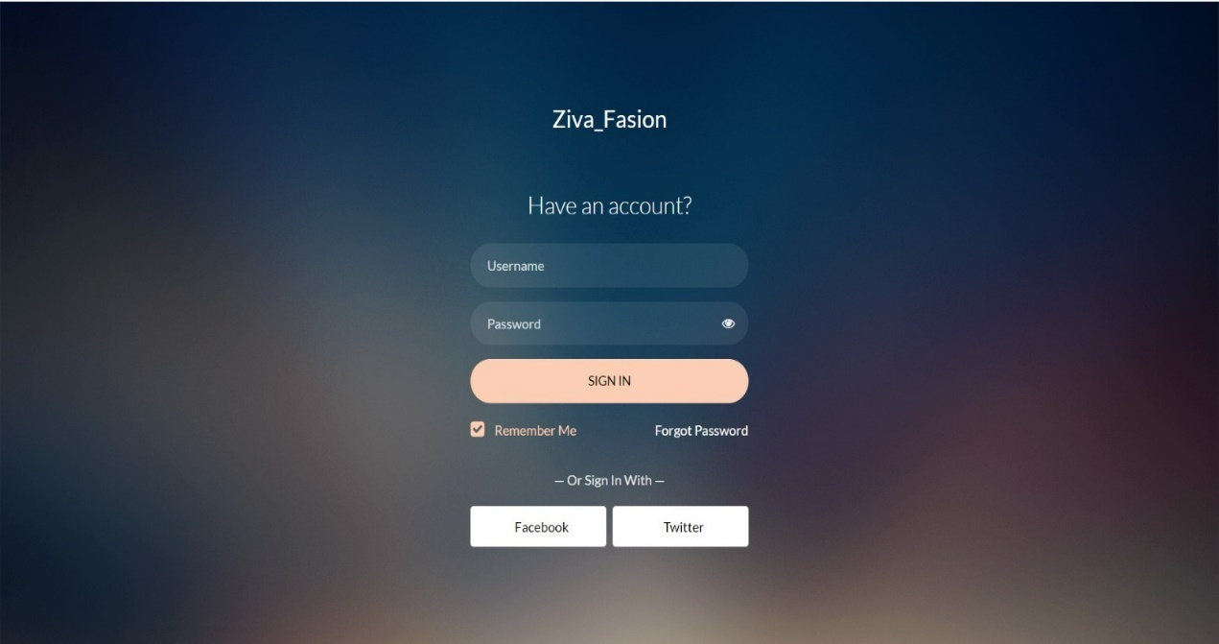

**HTML Code:**

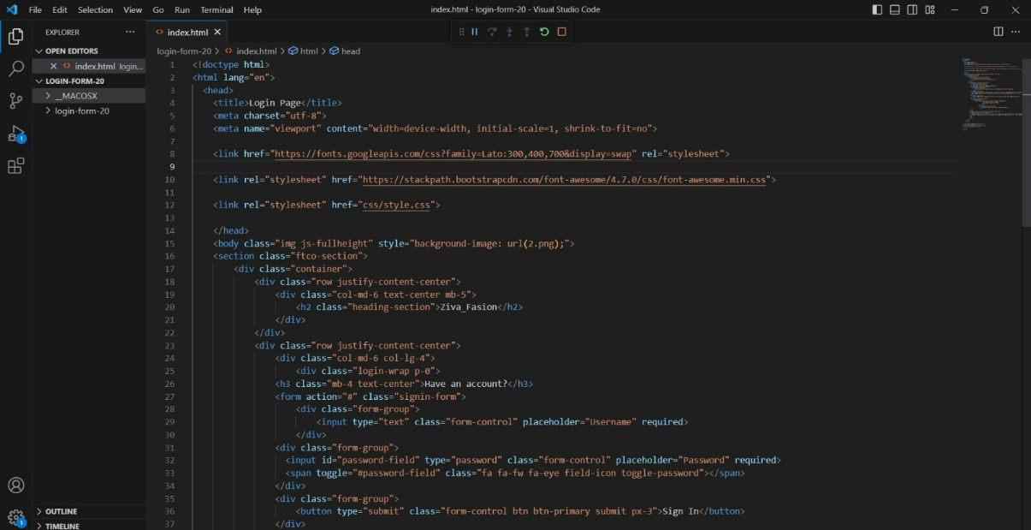

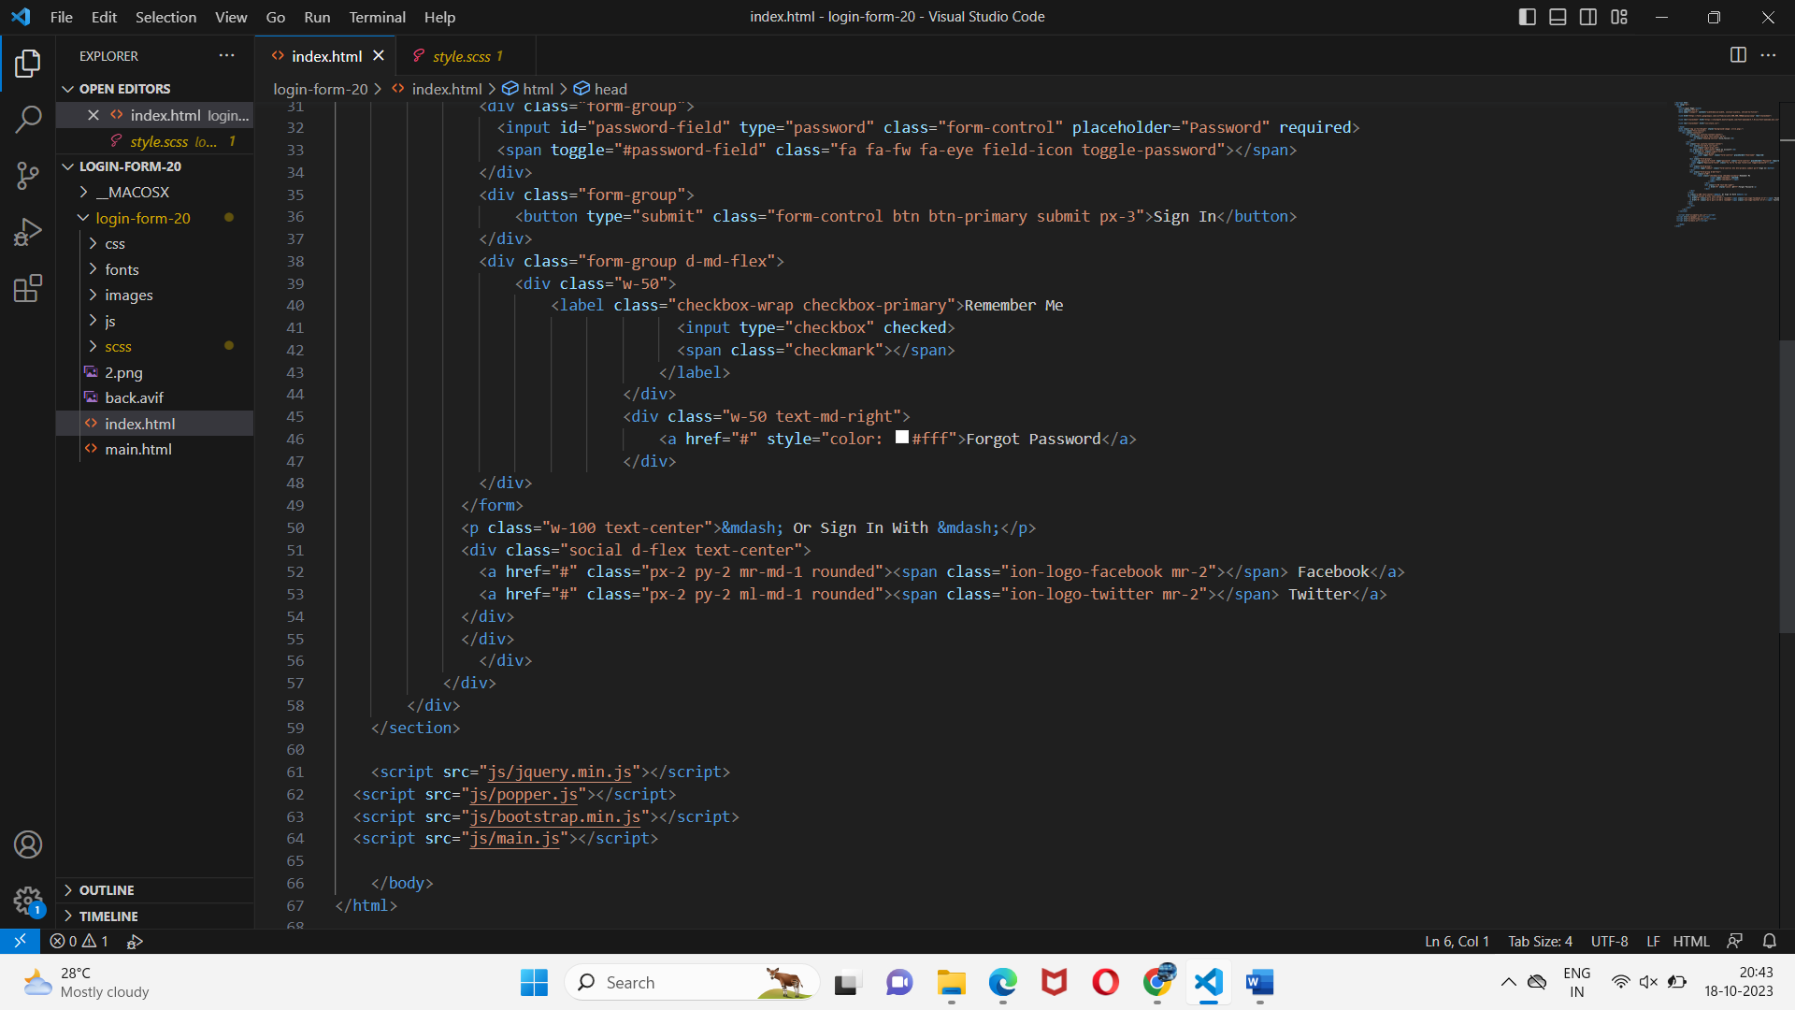

**CSS Code:**

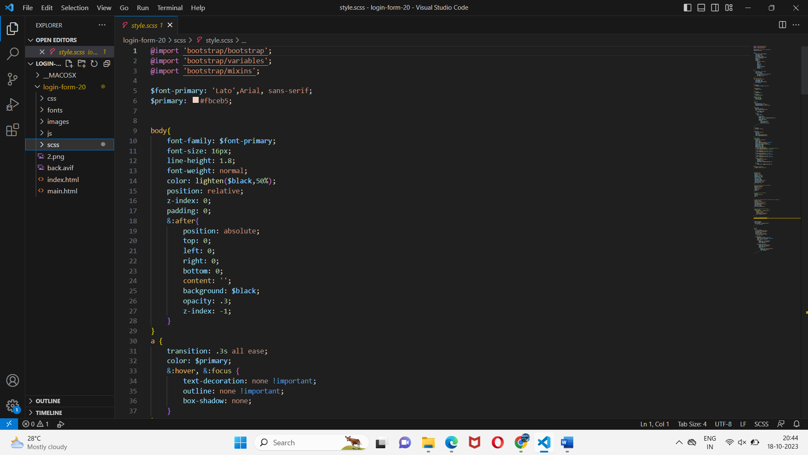

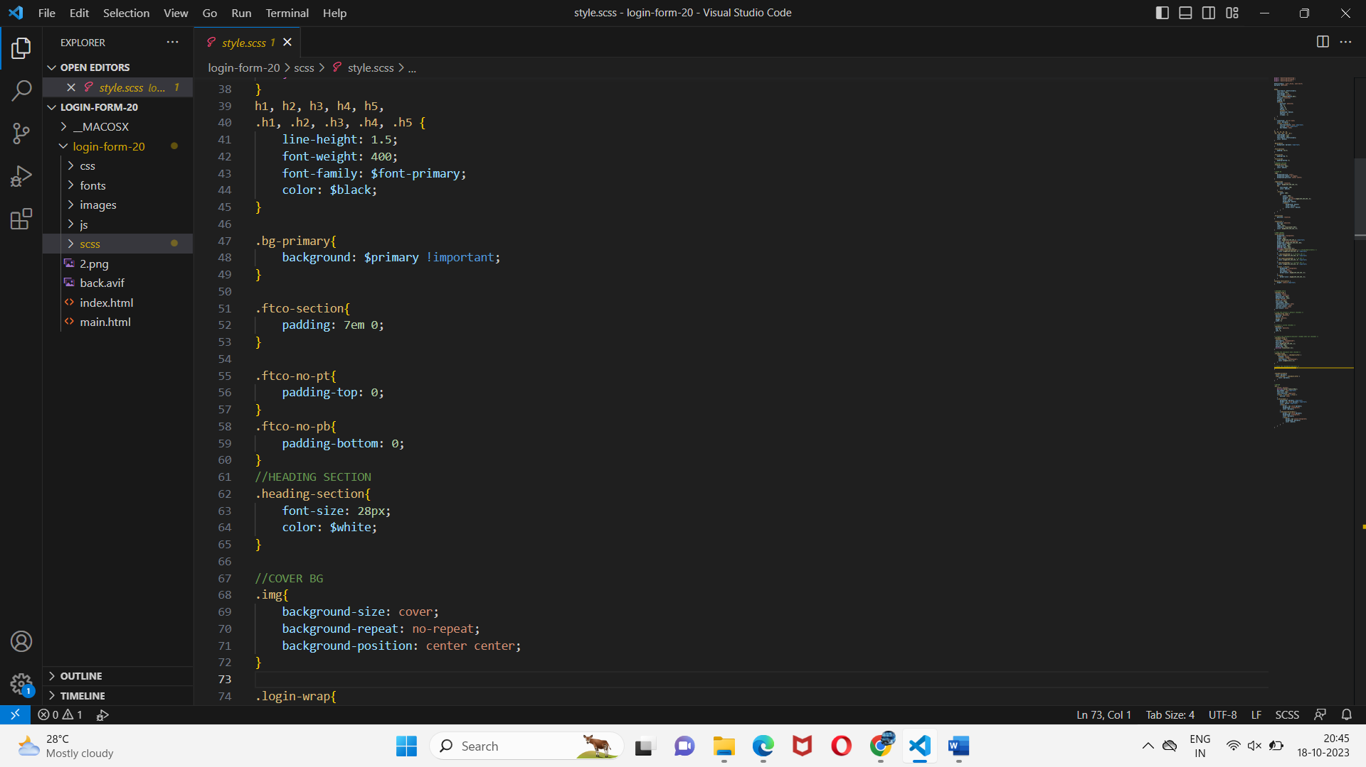

**JS Code :**

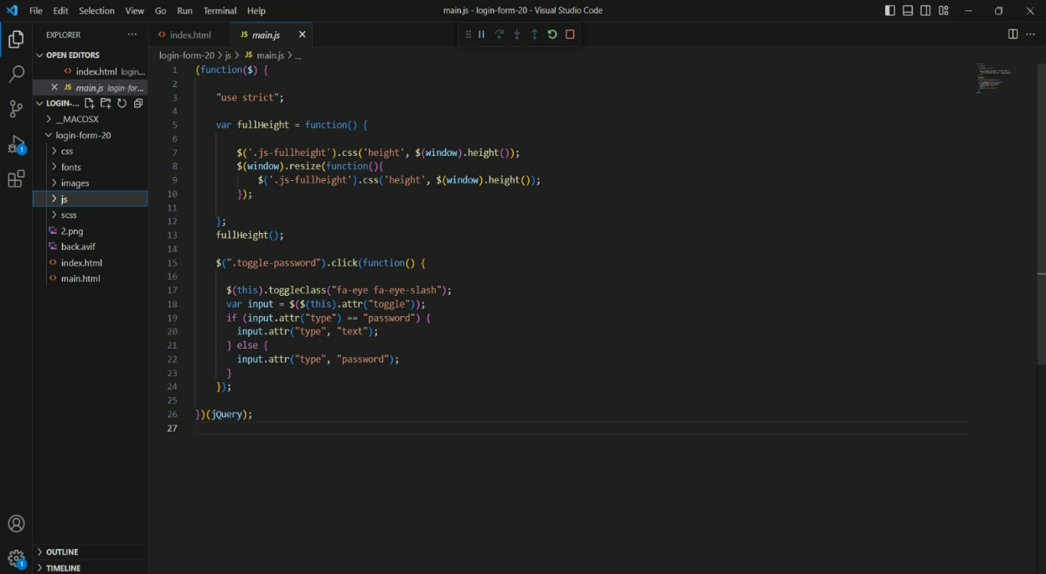

**IMPLEMENTED IN IBM CLOUD USING DB2 AND CLOUD STORAGE:**

**Step1:**

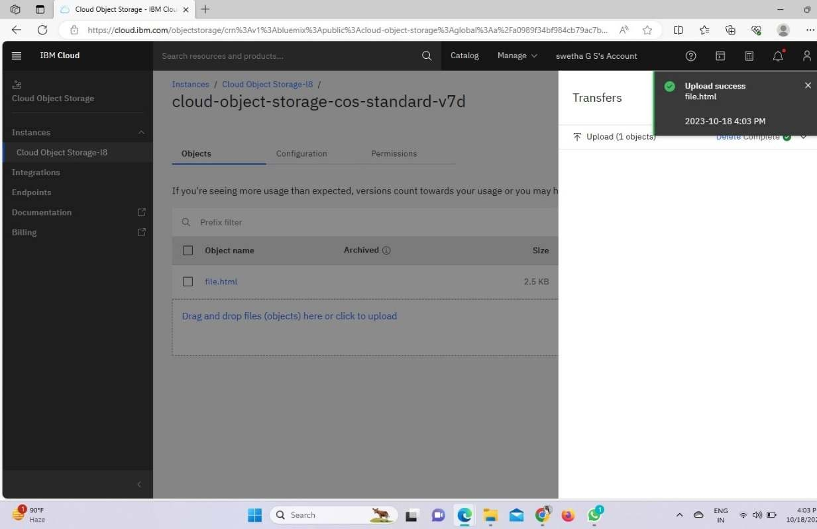

**Step 2:**

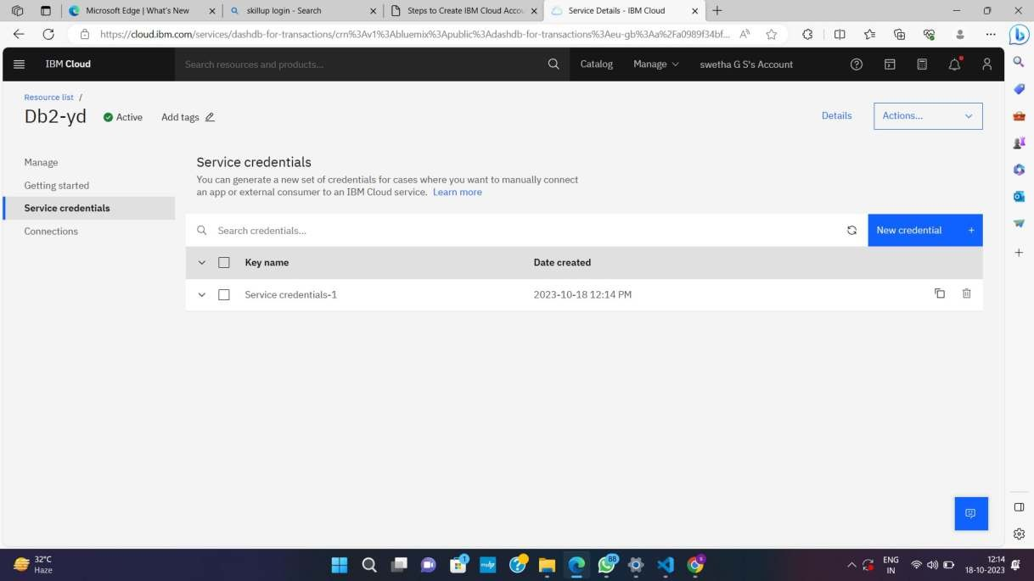

**Step 3:**

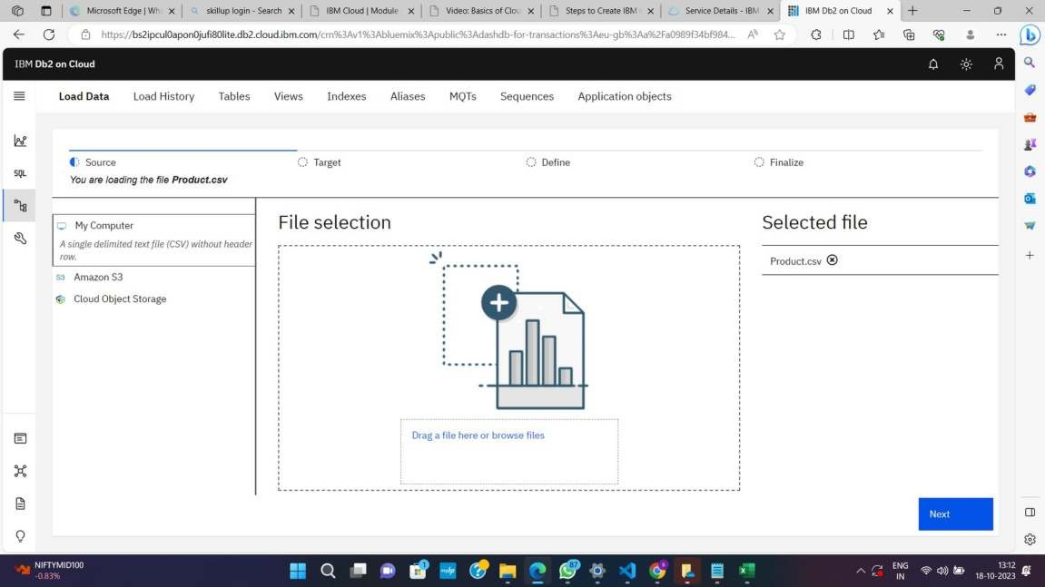

**Step 4:**

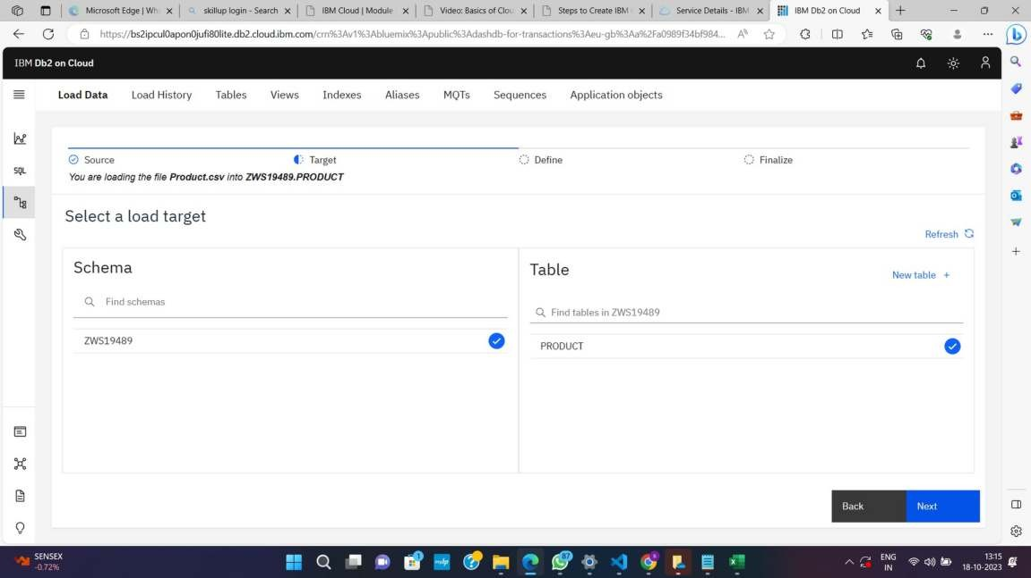

**Step 5:**

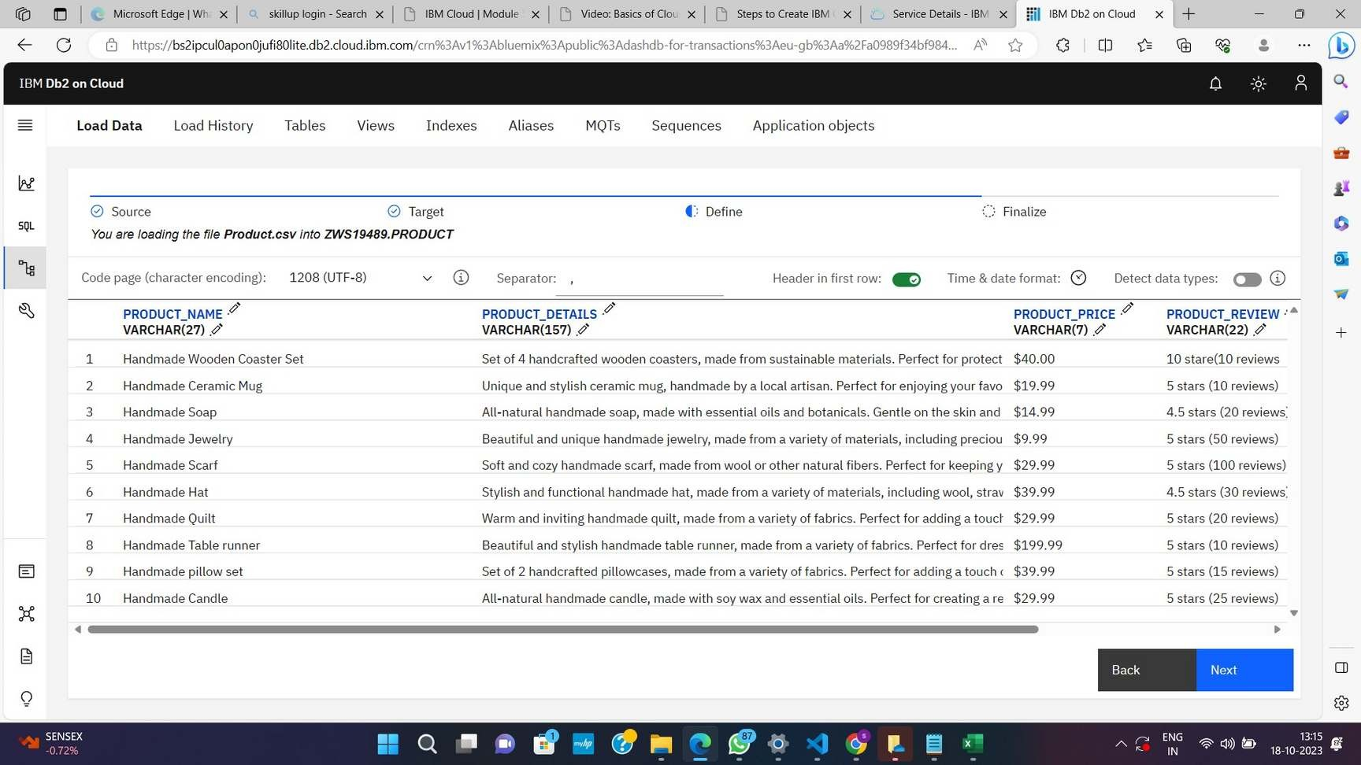

**Step 6:**

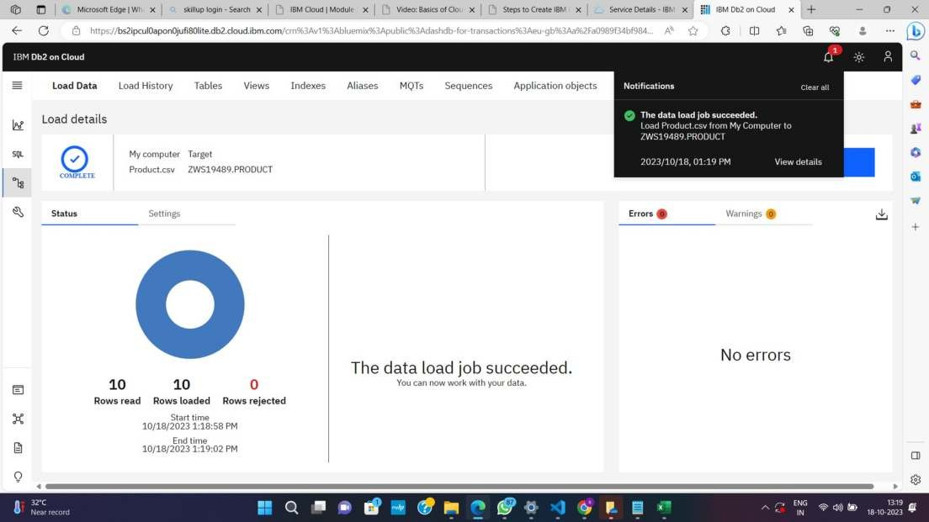

**Step 7:**

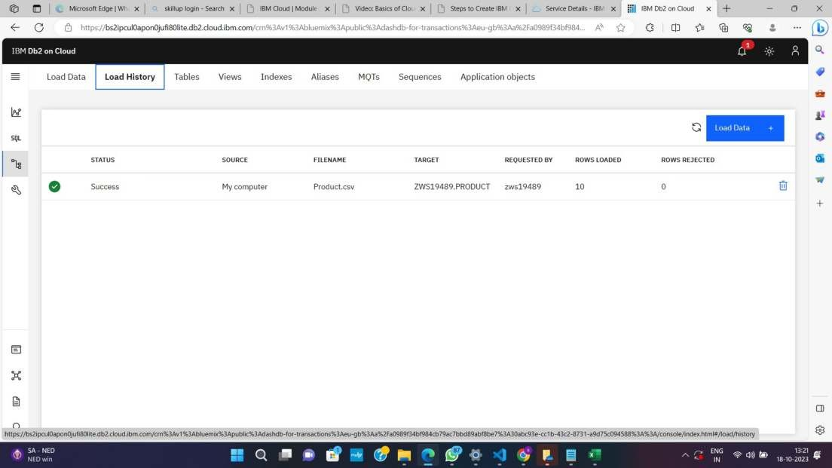

**Step 8:**

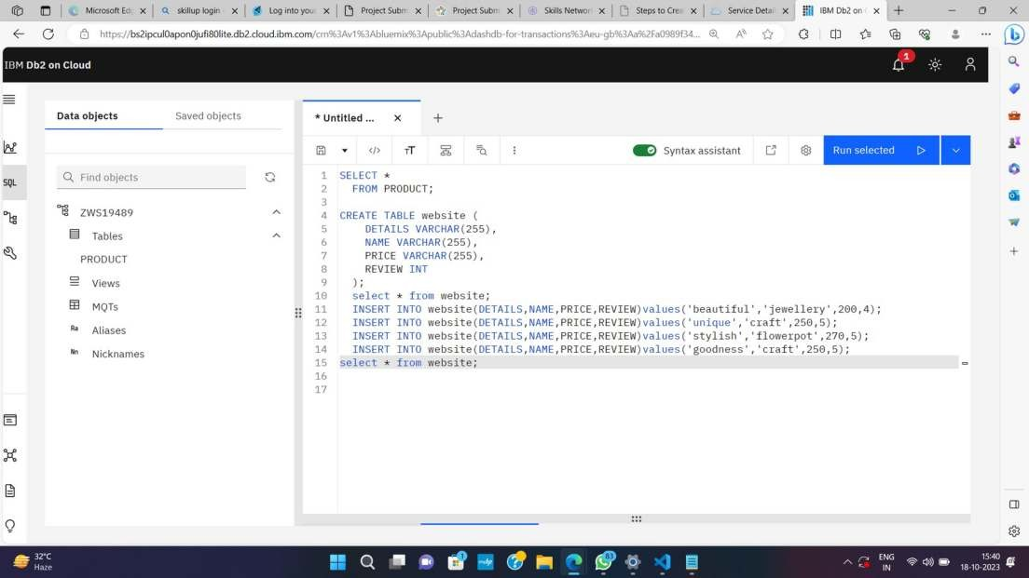

**Step 9:**

