1. **Slide Menu**

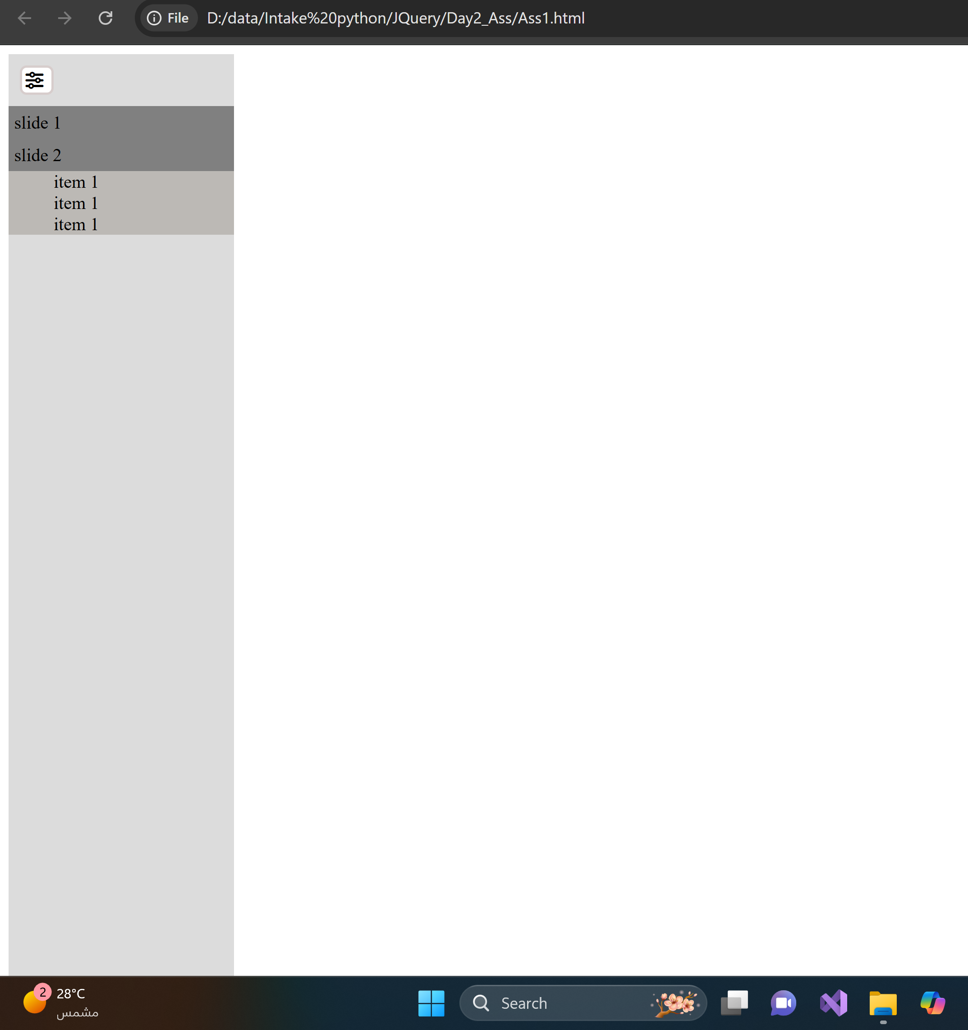

1. **Ajax**

Make your own interface to display post title and body by requesting posts from this API: https://jsonplaceholder.typicode.com/posts