HiLCoE School of Computer Science
AI-POWERED AMHARIC DOCUMENT DIGITIZATION AND SEMANTIC RETRIEVAL SYSTEM
ANNEXES B, C AND D
B: Entity-Relationship Diagram and Data Dictionary · C: Use-Case, Sequence and Class Diagrams · D: UI Wireframes and Design Specification
Tasks 2 (shared) and 3 · Prepared by Yassin Bedru
Annex A (corpus catalog) is delivered by Kibreab Dawit with Task 1.
October 2026

Contents
Annex B: Entity-Relationship Diagram and Data Dictionary 3
B.1 Data dictionary 4
Annex C: Use-Case, Sequence and Class Diagrams 5
C.1 Use-case diagram 5
C.2 Use-case descriptions 7
C.3 Sequence diagram: document ingestion 8
C.4 Sequence diagram: search and result viewing 9
C.5 Class diagram 10
Annex D: UI Wireframes and Design Specification 10
D.1 Screen inventory and navigation 11
D.2 Wireframe 1: search results with document viewer (desktop) 11
D.3 Wireframe 2: home / empty state 12
D.4 Wireframes 3 and 4: mobile list and viewer 13
D.5 Wireframe 5: administrator sign-in 14
D.6 Wireframe 6: document administration 14
D.7 Interface states 15
D.8 Design tokens 15
D.9 Component inventory 16
D.10 Design rationale 16

Annex B: Entity-Relationship Diagram and Data Dictionary
The relational database stores document metadata, page images and chunk positions. The dense vectors are stored separately in ChromaDB, keyed by the same chunk_id, so that a search hit from ChromaDB can be joined to its page and bounding box. The schema is in third normal form: every non-key attribute depends on the key, the whole key and nothing but the key (for example, the document title is stored once in DOCUMENTS and not repeated in every chunk).
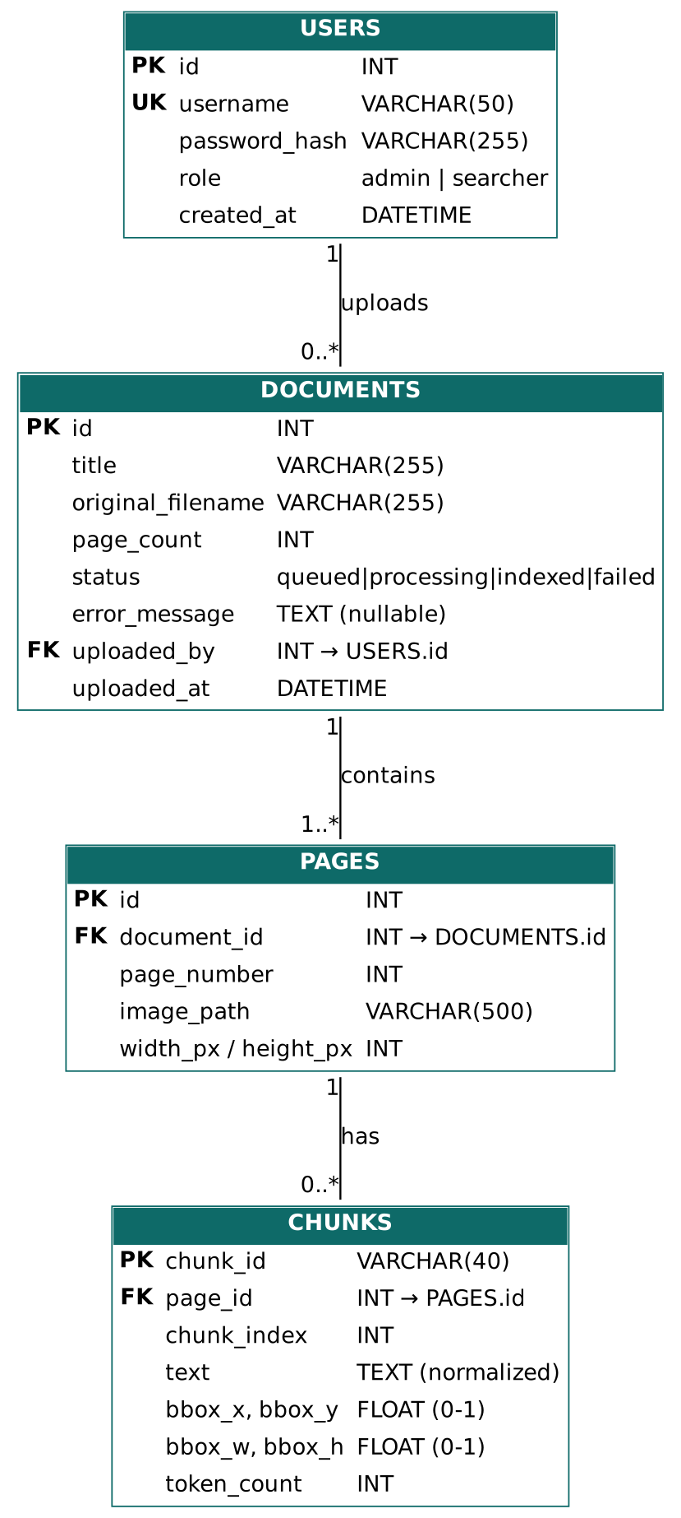
Figure B.1: Entity-relationship diagram

B.1 Data dictionary
Table.column | Type | Constraint | Description
USERS.id | INT | PK, auto | Unique identifier of a user.
USERS.username | VARCHAR(50) | UNIQUE, NOT NULL | Login name.
USERS.password_hash | VARCHAR(255) | NOT NULL | Salted hash (bcrypt); passwords are never stored in clear text.
USERS.role | VARCHAR(10) | CHECK admin or searcher | Determines access to administrator functions.
USERS.created_at | DATETIME | default now | Account creation time.
DOCUMENTS.id | INT | PK, auto | Unique identifier of an uploaded document.
DOCUMENTS.title | VARCHAR(255) | NOT NULL | Display title (defaults to the file name without extension).
DOCUMENTS.original_filename | VARCHAR(255) | NOT NULL | Name of the uploaded file.
DOCUMENTS.page_count | INT | >= 0 | Number of pages, set after the PDF is split into images.
DOCUMENTS.status | VARCHAR(12) | CHECK queued, processing, indexed, failed | Processing state shown as a badge in the administration page.
DOCUMENTS.error_message | TEXT | NULL allowed | Reason when status is failed.
DOCUMENTS.uploaded_by | INT | FK to USERS.id | Administrator who uploaded the document.
DOCUMENTS.uploaded_at | DATETIME | default now | Upload time.
PAGES.id | INT | PK, auto | Unique identifier of a page.
PAGES.document_id | INT | FK to DOCUMENTS.id, ON DELETE CASCADE | Owning document. Deleting a document removes its pages and chunks.
PAGES.page_number | INT | >= 1, UNIQUE with document_id | Position of the page in the document.
PAGES.image_path | VARCHAR(500) | NOT NULL | Location of the preprocessed page image (the image the OCR read) served to the viewer.
PAGES.width_px / height_px | INT | NOT NULL | Size of the preprocessed page image; used to normalize OCR boxes.
CHUNKS.chunk_id | VARCHAR(40) | PK | Identifier shared with the ChromaDB entry.
CHUNKS.page_id | INT | FK to PAGES.id, ON DELETE CASCADE | Page that contains the chunk.
CHUNKS.chunk_index | INT | >= 0 | Order of the chunk in the page.
CHUNKS.raw_text | TEXT | NOT NULL | Chunk text exactly as recognized by the OCR, before normalization (what the page shows; used for result snippets).
CHUNKS.norm_text | TEXT | NOT NULL | Chunk text after Amharic normalization (homophones unified, punctuation cleaned), 200 to 400 tokens; used for BM25 and for the embedding.
CHUNKS.normalizer_version | VARCHAR(20) | NOT NULL | Version of the normalization rules that produced norm_text (for example 1.0), so that chunks can be re-normalized and re-indexed when the rules change.
CHUNKS.bbox_x, bbox_y, bbox_w, bbox_h | FLOAT | between 0 and 1 | Normalized bounding box (fractions of page width and height; origin top-left).
CHUNKS.token_count | INT | > 0 | Number of tokens, for checking the chunk window.

Status of this annex. The columns raw_text, norm_text and normalizer_version replace the earlier single text column. The final column list is to be confirmed with the backend owner (Semir Sultan) before the entity-relationship diagram in Figure B.1 is redrawn, so the diagram still shows the earlier single text column. The same check should settle how several bounding boxes per chunk (the bboxes array returned by the API) are stored, because bbox_x to bbox_h hold only one box.

Annex C: Use-Case, Sequence and Class Diagrams

C.1 Use-case diagram

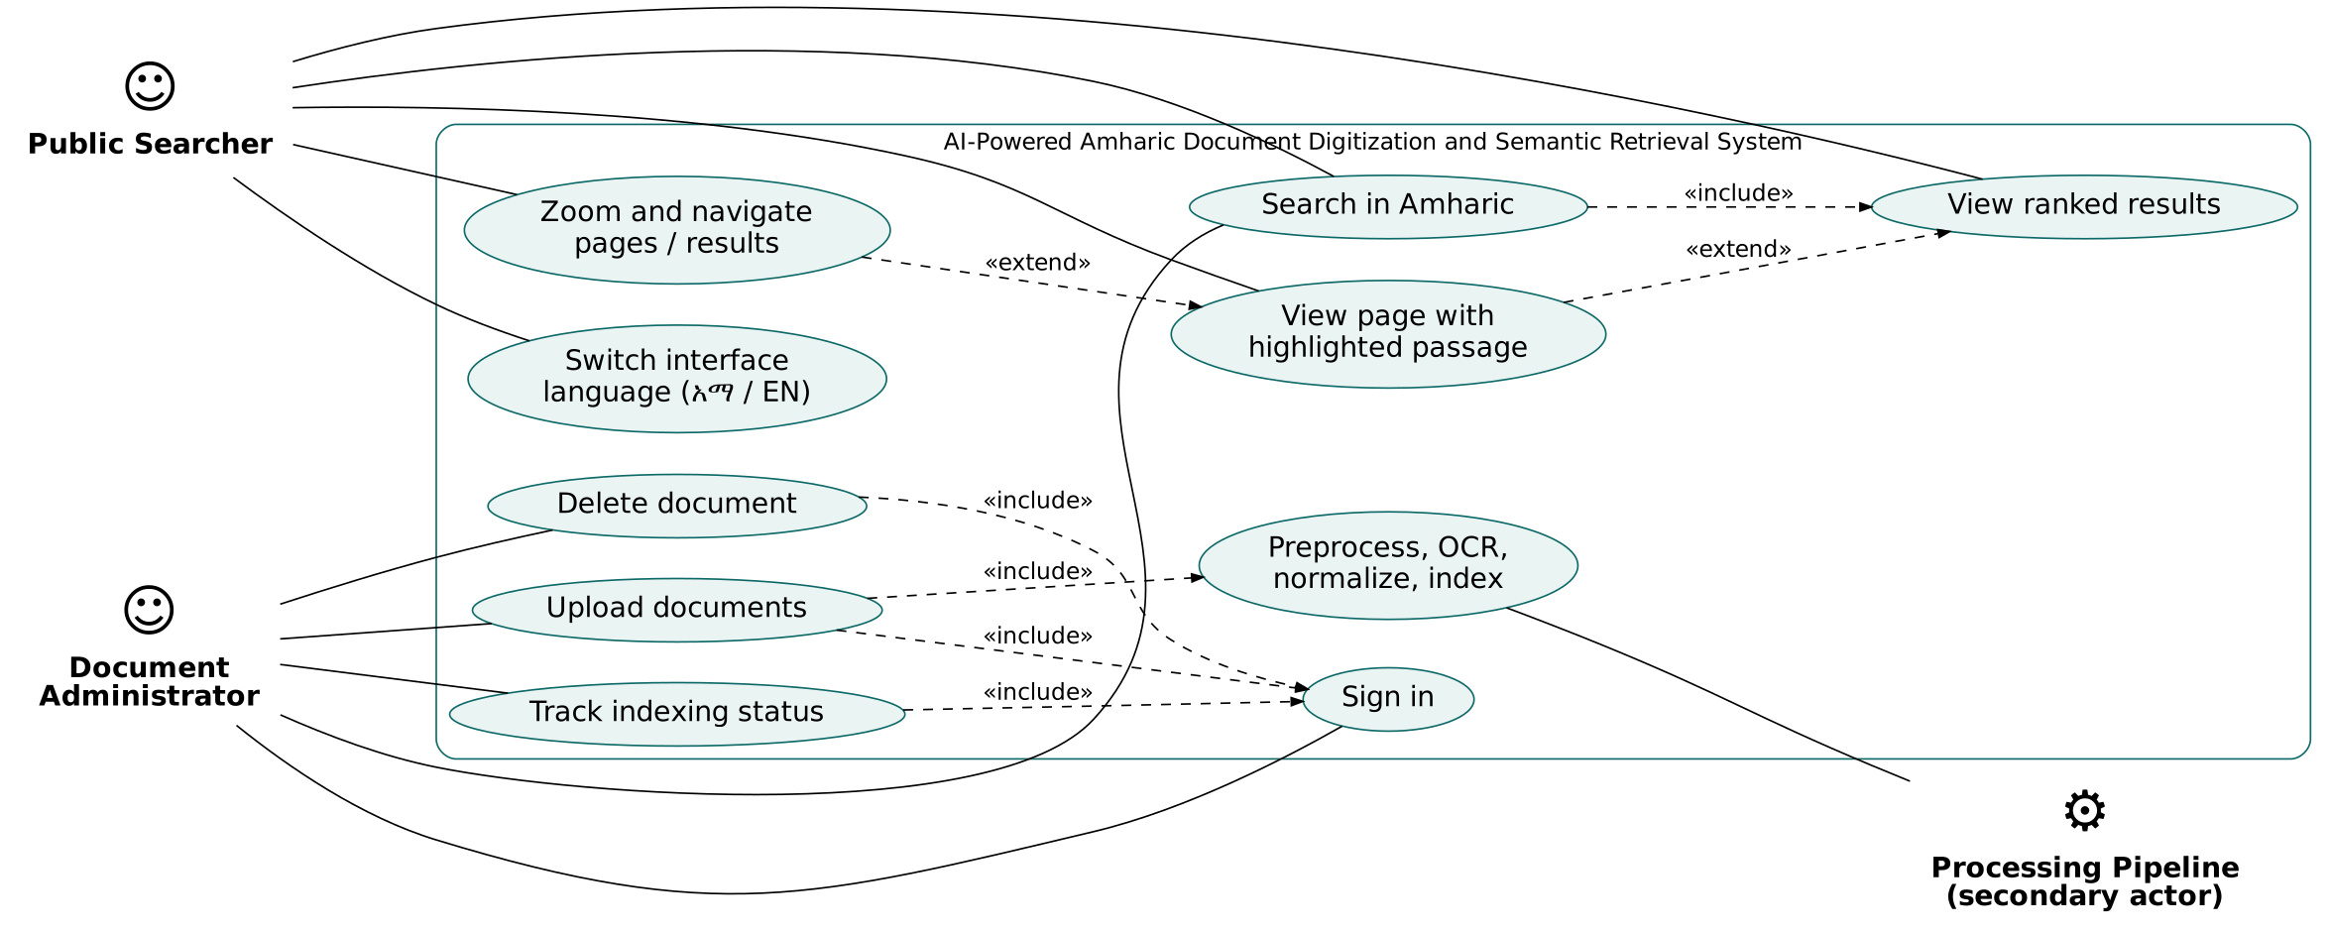
Figure C.1: System use-case diagram

C.2 Use-case descriptions
Item | UC-1 Search in Amharic | UC-3 View page with highlighted passage
Actors | Public Searcher, Document Administrator | Public Searcher, Document Administrator
Pre-condition | At least one document is indexed. | A result list is displayed.
Main flow | 1. User types a query.  2. User presses Search or Enter.  3. System normalizes the query and runs hybrid retrieval.  4. System displays ranked results with title, page, snippet and score. | 1. User selects a result.  2. System loads the page image.  3. System draws a highlight at each of the result's bounding boxes and scrolls the first one into view.  4. User may zoom, change page or move to another result.
Alternative flows | 2a. Query is empty: the Search button is disabled.  4a. No matches: “No passages found” message with advice.  4b. Backend error: error message and the query remains. | 2a. Image fails to load: error with Retry button.  4a. Other results on the page are shown with a lighter highlight.
Post-condition | Result list is displayed; first result is selected. | The matched passage is visible on the page image.

Item | UC-7 Upload documents | UC-9 Delete document
Actors | Document Administrator; processing pipeline (secondary) | Document Administrator
Pre-condition | Administrator is signed in (UC-6). | Administrator is signed in; document exists.
Main flow | 1. Administrator chooses or drops files.  2. System validates type (PDF, PNG, JPG) and size (50 MB).  3. System uploads with a progress bar; document is stored with status “queued”.  4. Pipeline processes the file; the status changes to “processing”, then “indexed”.  5. The list refreshes automatically. | 1. Administrator clicks Delete.  2. System asks for confirmation naming the document.  3. On confirmation the document, pages, chunks and vectors are removed.  4. The list is refreshed.
Alternative flows | 2a. Unsupported type or too large: file is rejected with a message.  4a. Processing fails: status “failed” with the reason.  4b. Upload fails: the error message sent by the backend is shown in the file’s row. | 2a. Administrator cancels: nothing changes.  3a. Deletion fails (for example, the document is still being indexed): the reason is shown and the document stays listed.
Post-condition | The document is searchable when its status is “indexed”. | The document no longer appears in search results.

C.3 Sequence diagram: document ingestion
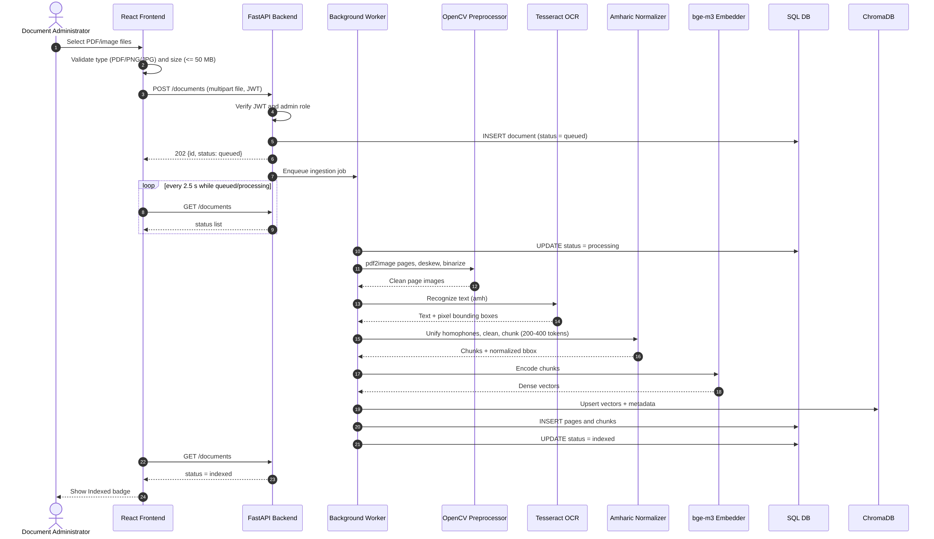
Figure C.2: Sequence diagram of document ingestion

C.4 Sequence diagram: search and result viewing
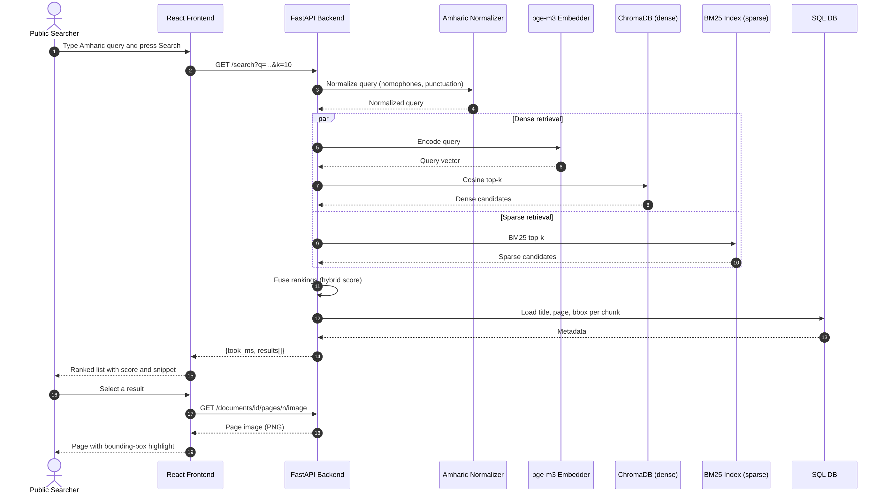
Figure C.3: Sequence diagram of semantic search and result viewing

C.5 Class diagram
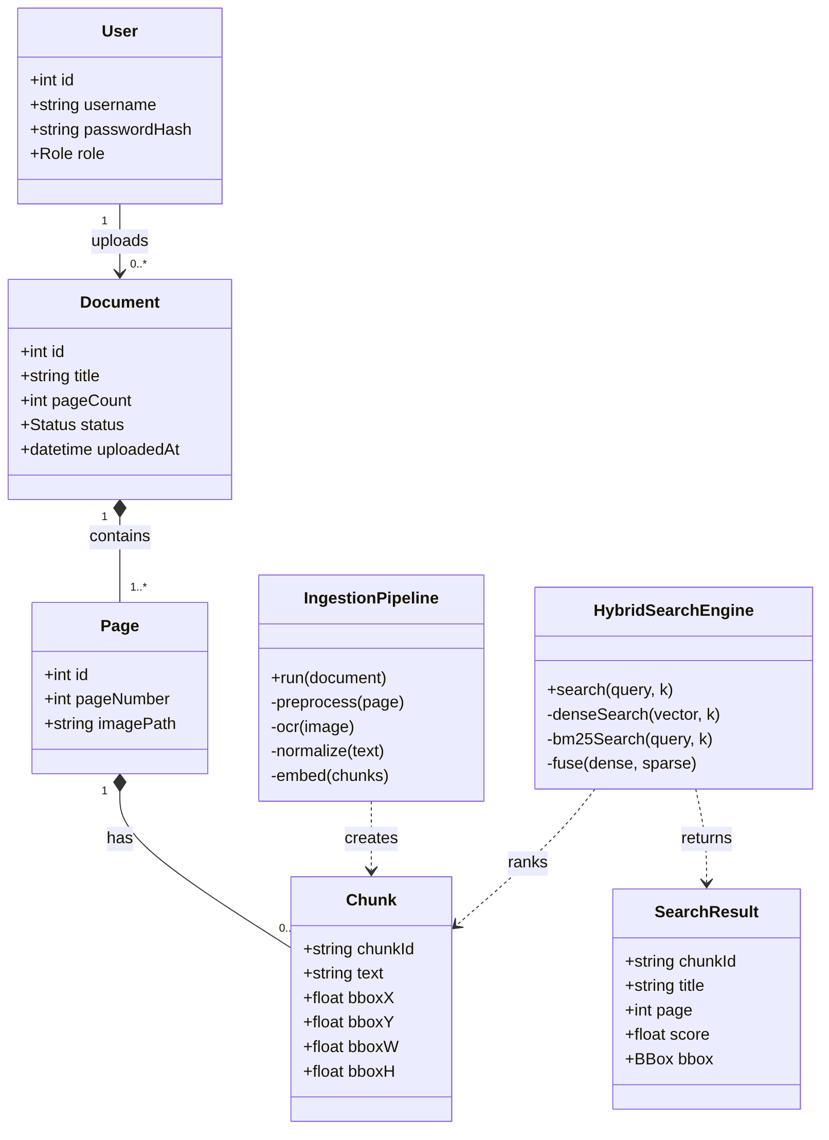
Figure C.4: Class diagram of the main domain, pipeline and search classes

Annex D: UI Wireframes and Design Specification
This annex records the interface design produced for Task 3. The wireframes are low-fidelity (grayscale boxes and labels) so that layout, content and interaction can be agreed before colour and typography. Numbered markers in each wireframe are explained in the legend below it. The wireframes were translated into the implemented screens shown in the project report (Section 6). The wireframe images are supplied as separate 2x PNG files; they can be placed in Figma as reference images, and the component and token tables in D.8 and D.9 contain what is needed to rebuild them as editable frames in Figma.

D.1 Screen inventory and navigation
Screen | Route | Access | Purpose
Search home (empty state) | / | Public | Introduce the search and offer an example query.
Search results with viewer | / | Public | List ranked passages and show the page image with the highlighted passage.
Mobile results / mobile viewer | / | Public | Same functions in separate full-screen views.
Administrator sign-in | /login | Public | Authenticate an administrator.
Document administration | /admin | Administrator | Upload, monitor and delete documents.

D.2 Wireframe 1: search results with document viewer (desktop)
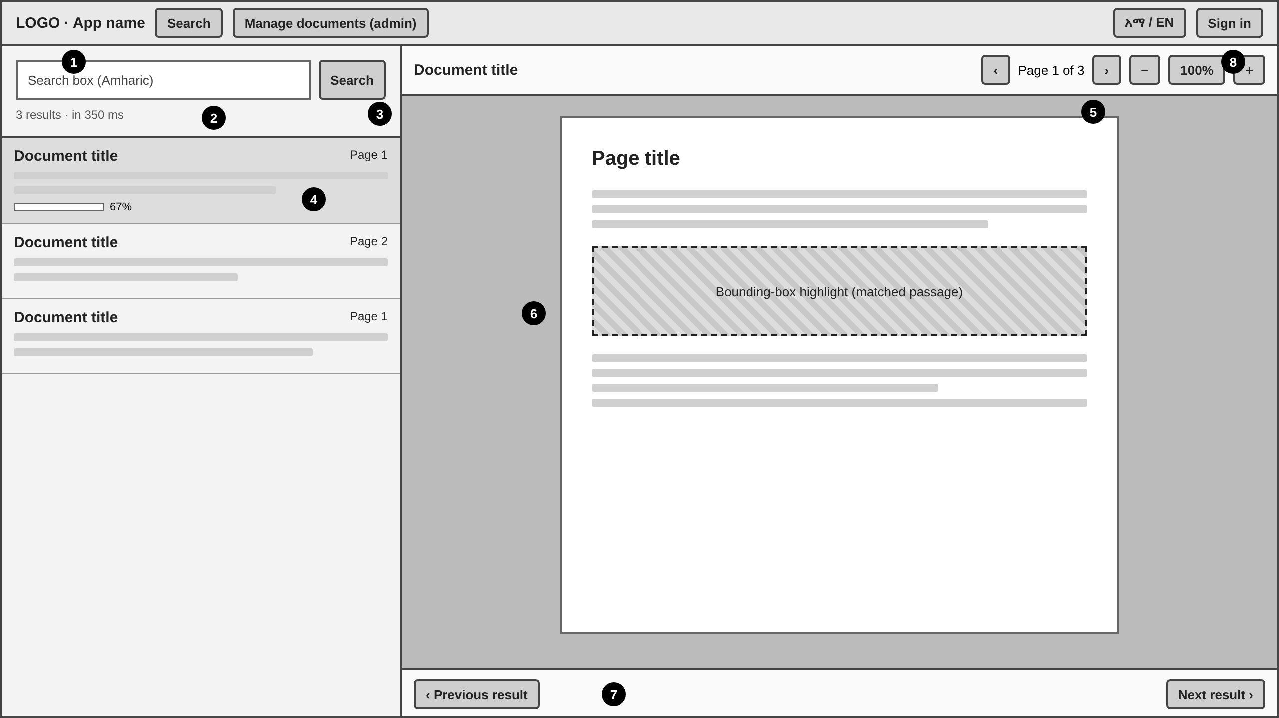
Figure D.1: Desktop search results and viewer
# | Element | Behaviour
1 | Logo and application name | Links to the home screen.
2 | Search box | Amharic input (lang=am); Enter submits; remains filled after searching.
3 | Search button | Disabled when the box is empty or a search is running; label changes to “Searching…”.
4 | Result card | Title, page number, three-line snippet and score bar; the selected card is shaded; click selects it.
5 | Viewer toolbar | Previous/next page (disabled at ends), zoom out, zoom level (click resets to 100%), zoom in.
6 | Page image with highlight | Dashed hatched region(s) show the matched passage (one per line when the API sends several boxes); the first scrolls into view and all scale with zoom.
7 | Result navigation | Previous/next result (disabled at ends) without returning to the list.
8 | Language and account | Language toggle (አማርኛ / English); Sign in or Sign out; “Manage documents” appears only for administrators.

D.3 Wireframe 2: home / empty state
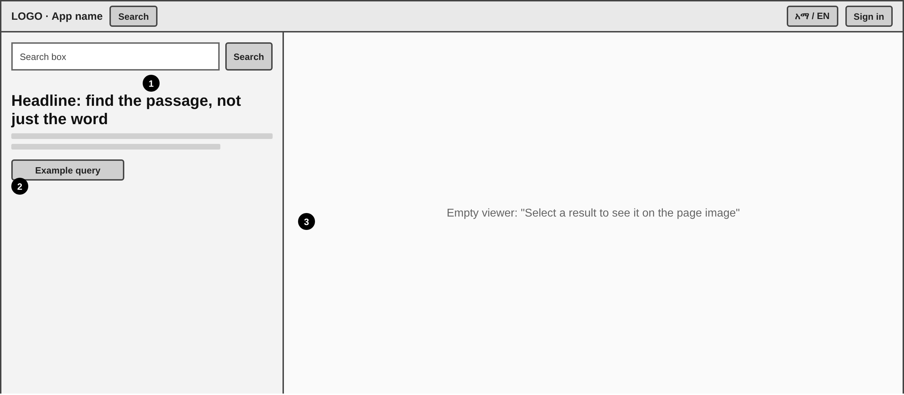
Figure D.2: Initial screen
# | Element | Behaviour
1 | Search box and button | As in D.2.
2 | Headline, one-line explanation, example query button | Clicking the example fills the search box with a sample Amharic query.
3 | Empty viewer message | Tells the user that selecting a result shows the page image.

D.4 Wireframes 3 and 4: mobile list and viewer
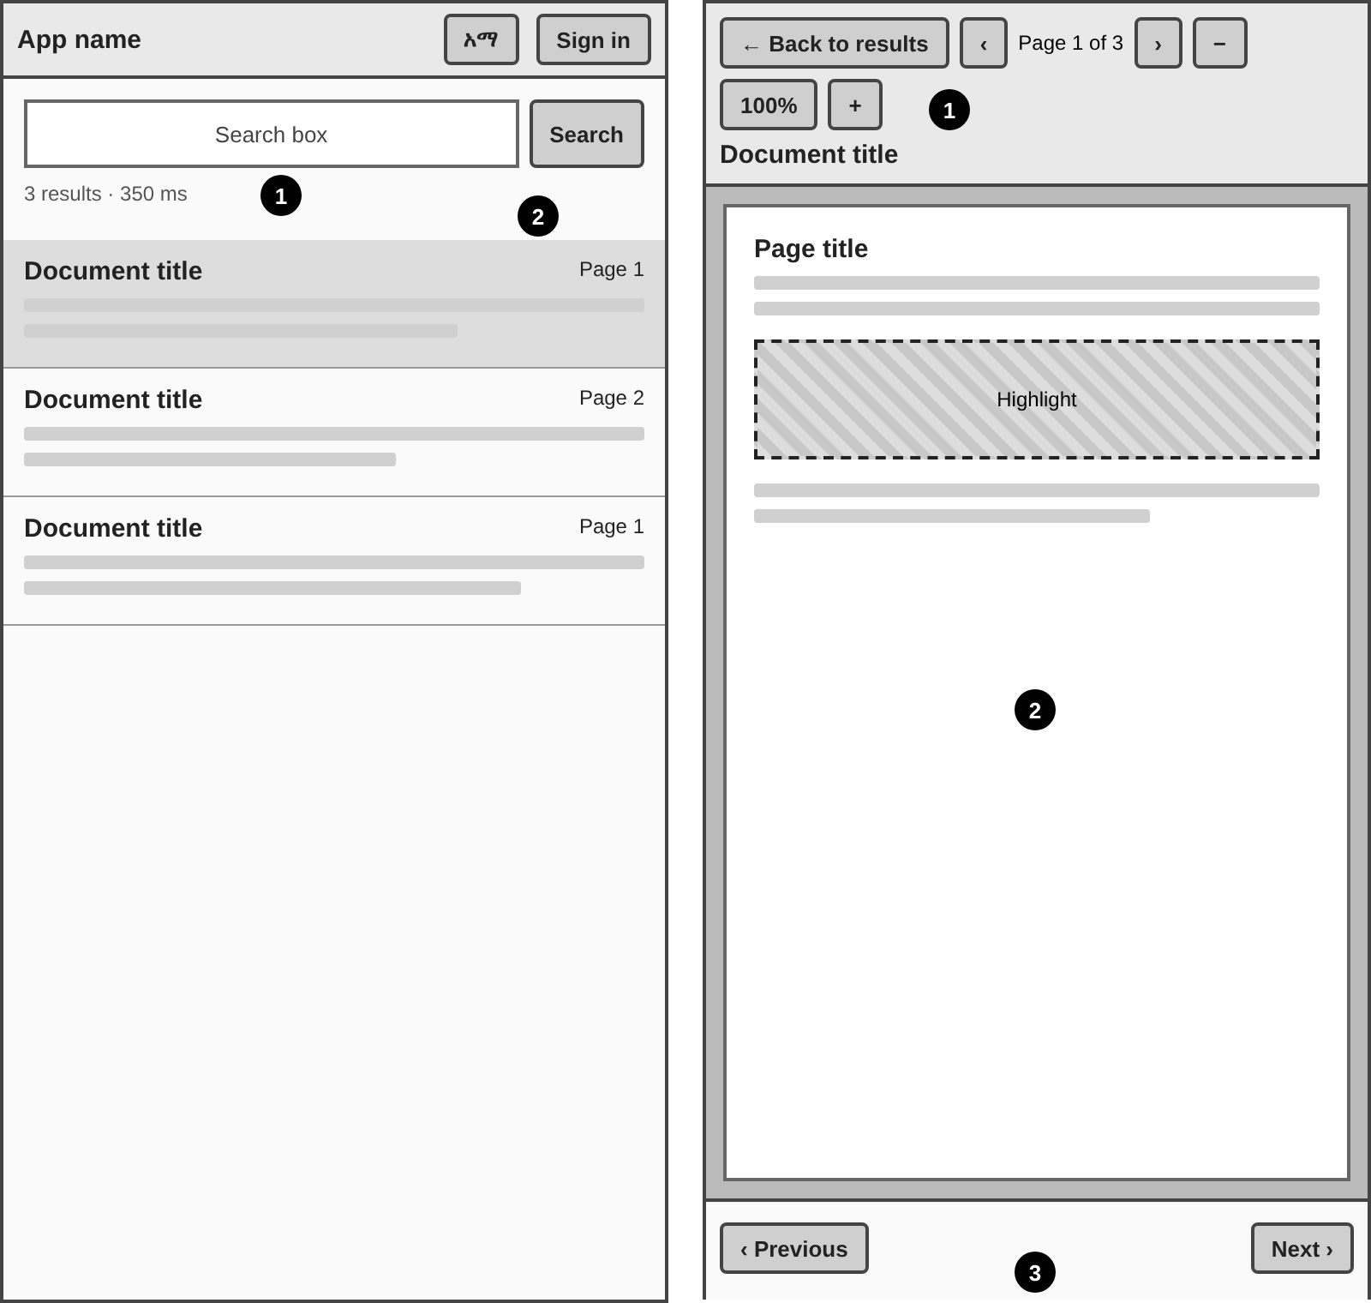
Figure D.3: Mobile result list (left) and mobile viewer (right)
Screen / # | Element | Behaviour
List 1 | Search field and button | Full width; result count and response time below.
List 2 | Result card | Tapping opens the viewer as a full-screen view.
Viewer 1 | Toolbar | Back to results, previous/next page, zoom controls; the document title has its own row.
Viewer 2 | Page with highlight | Scrolls and pinches within its container; highlight is scaled with the image.
Viewer 3 | Result navigation | Previous/next result at the bottom, within thumb reach.

D.5 Wireframe 5: administrator sign-in
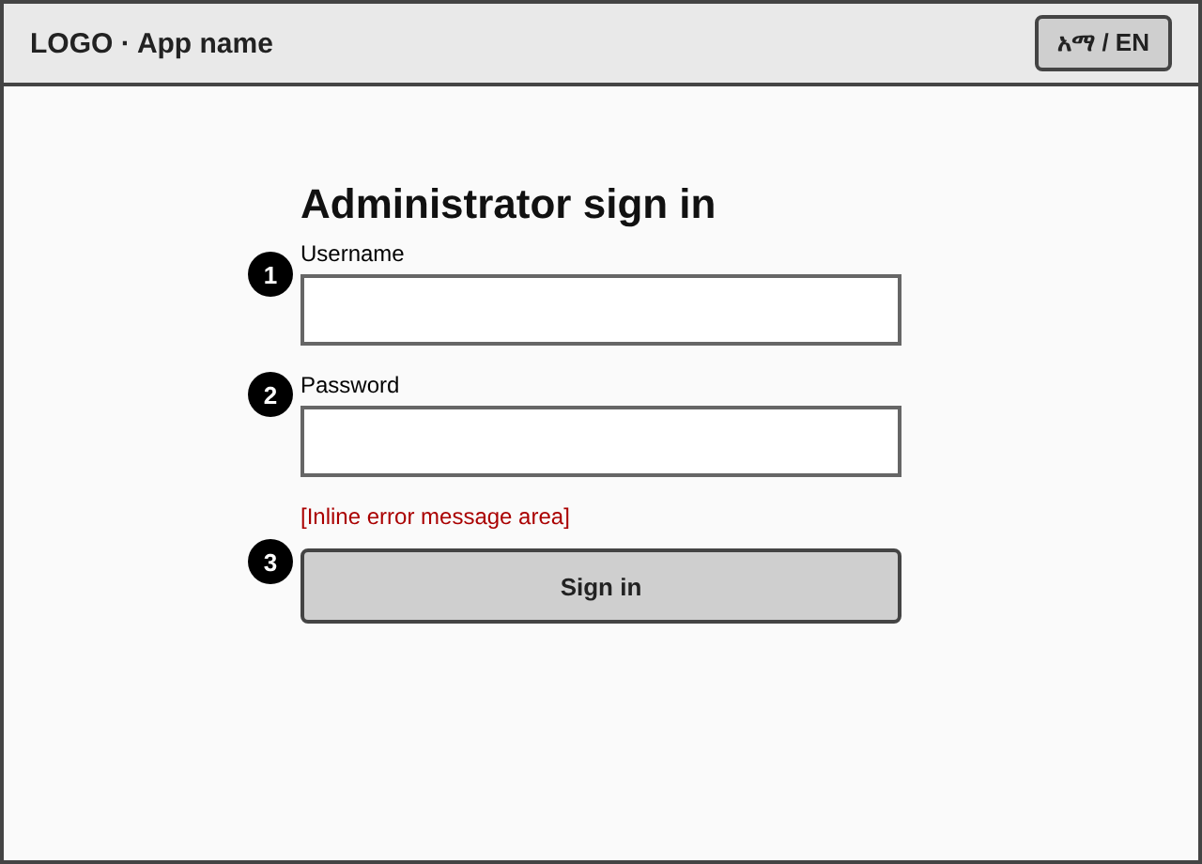
Figure D.4: Sign-in
# | Element | Behaviour
1 | Username field | Label above field; autocomplete=username.
2 | Password field | Masked; autocomplete=current-password.
3 | Error line and Sign in button | Error appears above the button with role=alert and says what is wrong; button disabled while waiting.

D.6 Wireframe 6: document administration
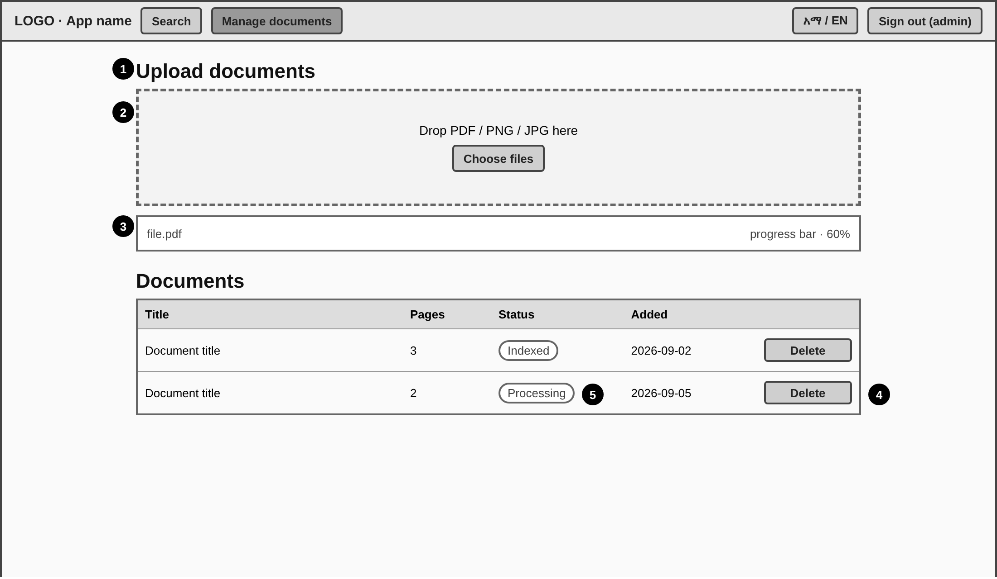
Figure D.5: Upload and document list
# | Element | Behaviour
1 | Section heading | Upload documents.
2 | Drop area and Choose files button | Accepts PDF, PNG, JPG up to 50 MB by drop or chooser; highlights when a file is dragged over.
3 | Upload progress rows | One row per file with progress bar; an error replaces the bar for rejected files.
4 | Delete action | Opens a confirmation naming the document.
5 | Status badge | Queued, Processing, Indexed or Failed; the list refreshes every 2.5 s while any is queued or processing.

D.7 Interface states
Screen | Empty | Loading | Error | Success
Search | Headline and example query | Button shows “Searching…” | Message “Search failed. Check your connection and try again.” | Count, time, ranked list
Viewer | “Select a result …” message | “Loading page…” | “The page image could not be loaded.” and Retry | Page with highlight
Upload | Drop area only | Progress bar per file | Per-file message (type, size, network, or the backend’s own message) | 100% bar and row in the list
Document list | “No documents yet. Upload a scan to start indexing.” | Status badge Processing | Message “The document list could not be loaded” with Retry; a failed delete shows the reason; status badge Failed | Status badge Indexed
Admin session | — | — | Token expired or invalid (401/403): signed out and sent to the sign-in page with the notice “Your session has expired or is not valid. Sign in again.” | Admin page after signing in again

D.8 Design tokens
Token | Value | Use
archive (primary) | #0E6A68 | Buttons, active navigation, links; contrast with white text 6.4:1.
archive-dark | #0A4F4D | Button hover.
archive-soft | #D6EBE9 | Selected result, hover backgrounds, indexed badge.
marker (amber) | #F5B700 | Used only for highlights of retrieved passages, so that amber always means “found text”.
ink | #18262B | Body text; contrast 13.4:1 on the page background.
mute | #5B6B70 | Secondary text; contrast 5.2:1.
paper / panel / rule | #EAEFEA / #F7F9F6 / #CBD5CD | Page background, panels, borders.
danger | #B3261E | Errors and delete actions; contrast 6.2:1.
Typeface | Noto Sans Ethiopic (interface), Noto Serif Ethiopic (titles and headings) | Full Ethiopic coverage; bundled with the application.
Type scale | 12, 14, 16 (body), 18, 20, 24 px | Minimum body size 16 px for Amharic readability.
Radius / spacing | 6 px radius; 4 px spacing grid | Consistent controls.
Focus | 3 px solid primary, 2 px offset | Visible keyboard focus.

D.9 Component inventory
Component | Variants / states | Used on
Button | Primary, ghost, danger; default, hover, disabled, focus | All screens
Text input | Default, focus, error | Search, sign-in
Result card | Default, selected, hover | Search
Score bar | 0 to 100% | Result card
Viewer toolbar | Default, disabled controls | Viewer
Highlight box | Active (strong), other (light) | Viewer
Drop area | Default, drag-over | Administration
Progress row | Uploading, error, done | Administration
Status badge | Queued, processing, indexed, failed | Administration
Data table | Header, row, empty | Administration
Header bar | Anonymous, administrator | All screens

D.10 Design rationale
- Two panes on desktop. The list stays visible while the user inspects the page, supporting quick comparison of results (recognition rather than recall).
- Amber means found text. The only warm colour in an otherwise cool interface is the highlight, so the eye goes to the answer.
- Errors say what to do. Every message names the problem and the next action, without blaming the user.
- One visible name per action. The upload button, the toast and the status all use the same words in the same language.
- Mobile is its own layout. Instead of shrinking the two panes, the viewer becomes a full-screen view with thumb-reachable controls.

