HiLCoE School of Computer Science
AI-POWERED AMHARIC DOCUMENT DIGITIZATION AND SEMANTIC RETRIEVAL SYSTEM
Senior Project Report
Individual Chapter: Frontend Development, System Integration and User Acceptance Testing
Prepared by: Yassin Bedru (EV9609, DRB2202)
Team: Kibreab Dawit · Ferid Hamza · Semir Sultan · Yassin Bedru
Responsibilities: Tasks 3, 9 (co-owner), 10, 11 (UAT) and 12 (final deck)
October 2026

Table of Contents
1. Introduction and Scope of This Chapter 3
1.1 Objectives of the frontend module 3
1.2 Relationship to the project proposal 3
2. Requirement Analysis for the Frontend 4
2.1 Functional requirements 4
2.2 Non-functional requirements 5
3. System Analysis and Design Artifacts 5
3.1 Use-case model 5
3.2 Sequence diagrams 6
3.3 Class and data models 9
4. Frontend Architecture and Implementation 11
4.1 Technology choices 11
4.2 Project structure 11
4.3 Main components 11
4.4 Authentication and access control 12
4.5 Internationalization 12
4.6 Accessibility and responsiveness 12
5. The Bounding-Box Highlight: Design and Algorithm 13
5.1 Why normalized coordinates 13
5.2 Drawing the overlay 13
5.3 Limitations of the highlight 13
6. User Interface Design and Screens 14
6.1 Design process and wireframes (Task 3) 14
6.2 Search and viewer 14
6.3 Administration 16
6.4 Mobile layout 17
6.5 Language switching 19
7. Backend Integration (Task 9, Frontend Side) 20
7.1 API contract 20
7.2 Integration agreements and checklist 20
7.3 Demo mode 20
7.4 Integration status 21
8. Testing and Evaluation 21
8.1 Test strategy 21
8.2 Unit test results 21
8.3 End-to-end test results 21
8.4 User Acceptance Testing (Task 11) 22
8.5 Traceability 23
9. Deployment and Reproducibility 23
10. Limitations and Future Work 24
11. Conclusion 24
References 24

1. Introduction and Scope of This Chapter
This chapter documents the part of the project delivered by Yassin Bedru: the user-facing web application, its integration with the backend services, and the evaluation of the system with real users. In the team work breakdown it covers Task 3 (UI/UX wireframes), Task 10 (React application, document viewer and bounding-box overlay), the frontend half of Task 9 (API integration, co-owned with Semir Sultan), the usability part of Task 11 (User Acceptance Testing), and the compilation of the final defense presentation (Task 12). The requirement analysis and UML modelling of Task 2 were shared by the whole team; the diagrams produced for that task are included here and in Annexes B to D.
The system accepts scanned Amharic documents, converts them to searchable text through preprocessing, OCR, normalization and vector indexing, and lets users find passages by meaning. The frontend is the only part of this pipeline that users see. Its job is therefore to make two things easy: (1) administrators can load documents and see when they are ready, and (2) searchers can type a question in Amharic and immediately see where in the original page the answer sits. The second point is the main difference between this system and an ordinary text search box, and it is the reason a bounding-box overlay was treated as a core feature, not a decoration.

1.1 Objectives of the frontend module
- Provide an Amharic-first search interface that accepts natural-language queries and displays ranked passages with a relevance score.
- Render the original document page and draw a highlight over the exact region from which each retrieved passage was extracted.
- Provide a role-based administration area for uploading, monitoring and deleting documents, protected by JWT authentication.
- Define and document a clean REST contract with the FastAPI backend, and keep all network access in a single module so that the interface can be developed and demonstrated even when the backend is unavailable.
- Meet accessibility and responsiveness expectations (keyboard use, readable contrast, phone-sized screens), because the stated beneficiaries include students and public-office staff on ordinary devices.
- Evaluate the interface through automated tests and through a structured User Acceptance Test using the System Usability Scale (SUS).

1.2 Relationship to the project proposal
Proposal item | How this chapter satisfies it
Specific objective 7: responsive web UI in React and FastAPI that accepts Amharic queries, shows ranked results and overlays highlights on page images | Sections 4 to 6 (React app, result list, document viewer with bounding-box overlay)
Scope 5.1: role-based access (Document Administrators and Public Searchers) | Section 4.4 (routing guard, JWT) and Section 6.3 (admin area)
Scope 5.1: document viewer and passage highlighting | Section 5 (overlay algorithm) and Section 6.2
Methodology 7.4: UML and ER diagrams, Figma wireframes | Section 3 and Annexes B, C, D
Methodology 7.6: unit, integration, system testing and UAT with 5 to 8 users using SUS | Section 8 and the separate UAT Kit (protocol, scripts, SUS forms, scoring workbook)
Non-functional: query latency below 1.5 s, UI scannability, zero licensing cost | Section 2.2 (requirements) and Section 7 (results); all libraries are open source

2. Requirement Analysis for the Frontend
Requirements were derived from the proposal, from the document-archive and user-interview approach described in Section 7.2 of the proposal, and from the constraints of the other modules (for example, the OCR module returns pixel coordinates, while the interface needs coordinates that stay valid at any zoom level). Each requirement has an identifier so that it can be traced to a design element and to a test case in Section 8.

2.1 Functional requirements
ID | Requirement | Priority | Test
FR-1 | A searcher can enter an Amharic query and submit it with the Search button or the Enter key. | Must | TC-03
FR-2 | The system lists results ranked by score, showing document title, page number, snippet and score; the number of results and the response time are shown. | Must | TC-03, TC-04
FR-3 | Selecting a result displays the original page image in a viewer. | Must | TC-06
FR-4 | The viewer draws a highlight over the passage using the bounding box returned by the API; other results on the same page are shown with a lighter highlight. | Must | TC-05
FR-5 | The user can zoom, move between pages of the document, and move to the previous or next result without returning to the list. | Must | TC-07 to TC-10
FR-6 | A clear message is shown when there are no results or when the search fails; failed page images can be retried. | Must | TC-12
FR-7 | The interface can be switched between Amharic and English. | Should | TC-13
FR-8 | An administrator can sign in with a username and password; invalid credentials produce an inline error. | Must | TC-14 to TC-16
FR-9 | Administrator pages are inaccessible to anonymous users; searching is public. | Must | TC-14, TC-21
FR-10 | An administrator can upload one or more PDF, PNG or JPG files (up to 50 MB each), seeing upload progress; other file types and oversize files are rejected before upload. | Must | TC-17, TC-19
FR-11 | The document list shows title, page count, status (queued, processing, indexed, failed) and date, and refreshes automatically while any document is being processed. | Must | TC-17, TC-18
FR-12 | An administrator can delete a document after confirming the action. | Must | TC-20

2.2 Non-functional requirements
ID | Requirement | How it is met / verified
NFR-1 Performance | Search results must appear within 1.5 s (proposal 7.3). The frontend must not add noticeable delay. | Production bundle is 189 kB (62.8 kB gzipped). Backend latency is reported to the user (“in N ms”). End-to-end latency is measured with the real backend (Section 7).
NFR-2 Usability | Non-technical users must succeed without training; target SUS score of at least 68 (industry average). | Search-engine style layout; UAT with SUS (Section 8.4).
NFR-3 Accessibility | Keyboard operable, visible focus, readable contrast, screen-reader labels. | Visible focus ring, labelled controls, aria-live regions; text contrast ratios between 5.2:1 and 13.4:1 (WCAG AA requires 4.5:1).
NFR-4 Responsiveness | Usable on phones and desktops without horizontal scrolling. | Two-pane layout on desktop, full-screen viewer on phones; verified at 390 px (TC-22 to TC-24).
NFR-5 Localization | Amharic text must render correctly without relying on fonts installed on the user's machine. | Noto Sans/Serif Ethiopic fonts are bundled with the application and do not depend on an external font service.
NFR-6 Security | Admin functions require authentication; tokens must not persist indefinitely. | JWT in sessionStorage (cleared when the tab closes), route guard on the client, and mandatory server-side role checks in the API.
NFR-7 Cost | Zero licensing cost. | React, Vite, Tailwind CSS and the fonts are open source; hosting target is a free tier (Vercel).
NFR-8 Maintainability | Modular code that other team members can extend. | Single API module, small components, documented contract, automated tests.

3. System Analysis and Design Artifacts
The whole team contributed to the requirement analysis and UML modelling (Task 2). The diagrams below were drawn to describe the complete system, and they fix the vocabulary shared by all modules: the same names (document, page, chunk, bounding box, status) appear in the database schema, the API and the user interface.

3.1 Use-case model
There are two human actors. The Public Searcher searches, reads results and views highlighted pages without signing in. The Document Administrator must sign in, uploads and deletes documents and monitors indexing; the administrator can also search. The processing pipeline (preprocessing, OCR, normalization, embedding and indexing) is modelled as a secondary actor that is triggered by every upload.

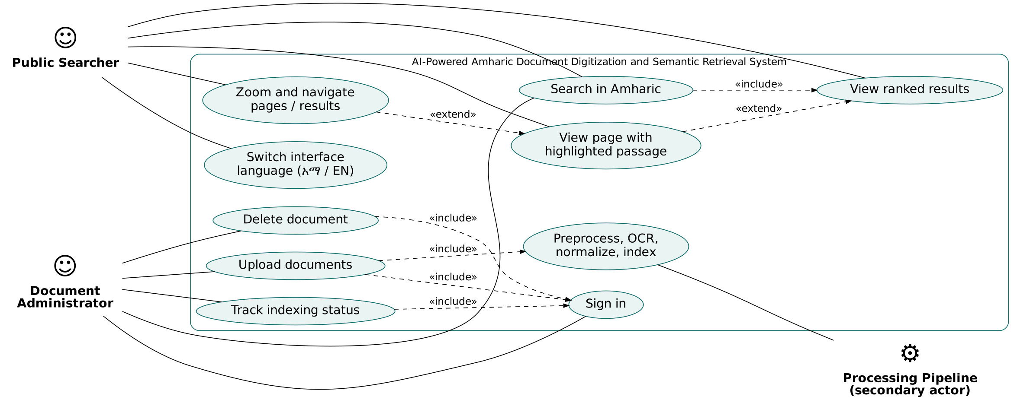
Figure 3.1: System use-case diagram

3.2 Sequence diagrams
Figure 3.2 shows the ingestion flow. The important design decision for the frontend is that an upload returns immediately with the status “queued”, and the heavy work runs in a background worker. The interface therefore polls the document list every 2.5 seconds while any document is queued or processing, and stops polling when all are finished.
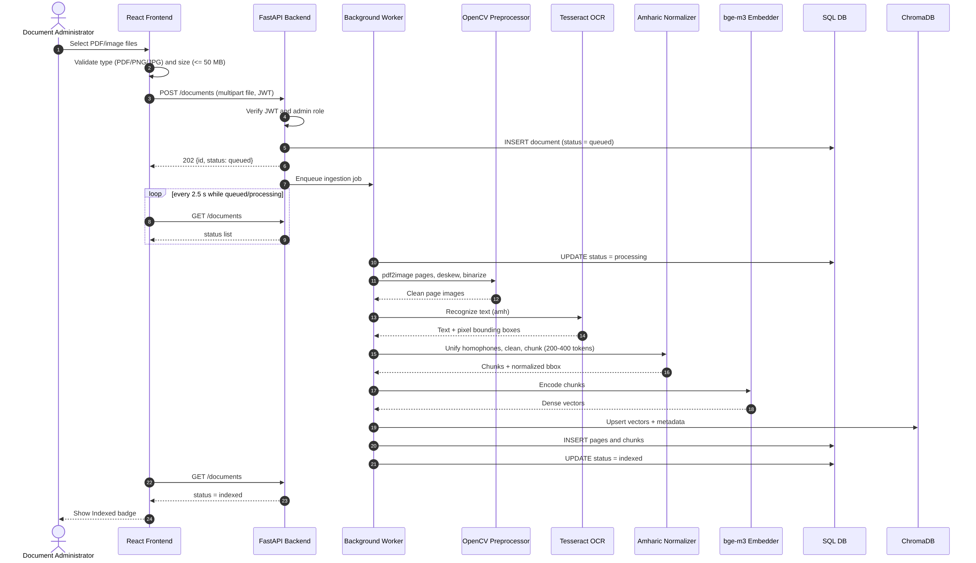
Figure 3.2: Sequence diagram of document ingestion
Figure 3.3 shows a search. The query is normalized in the same way as the indexed text (homophone unification), the dense and sparse retrievers run in parallel, and their rankings are fused. The response already contains the title, page and bounding box of every hit, so the interface does not need extra calls to draw the list; it requests the page image only when the user selects a result.
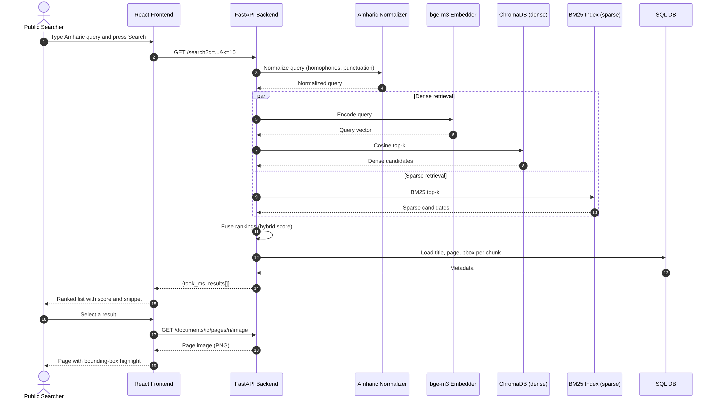
Figure 3.3: Sequence diagram of semantic search and result viewing

3.3 Class and data models
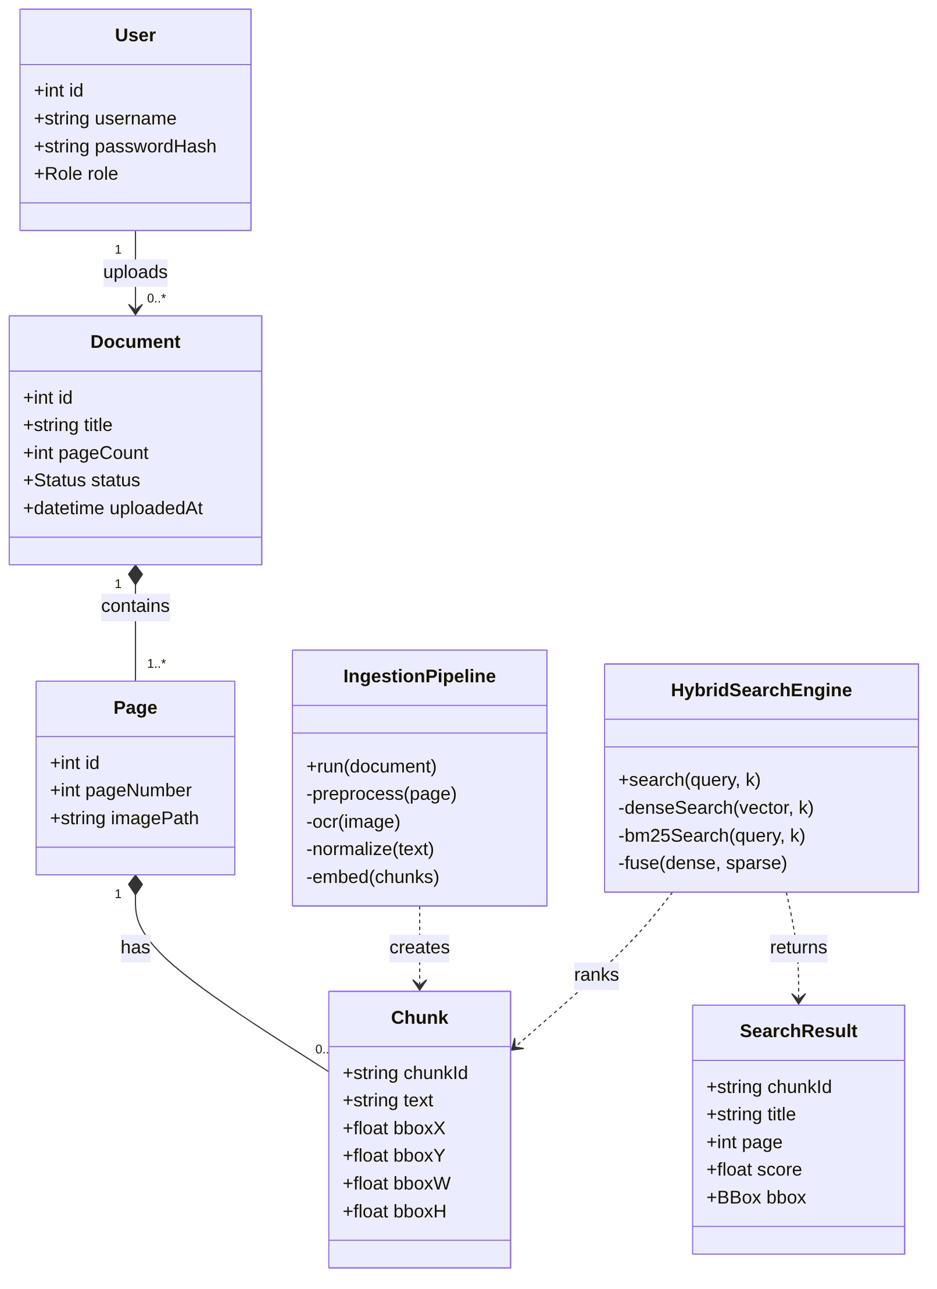
Figure 3.4: Class diagram of the main domain, pipeline and search classes
The relational schema (Figure 3.5) is in third normal form. The chunk table stores the bounding box as four normalized numbers between 0 and 1. This is the single most important integration decision of the project and is explained in Section 5.1.
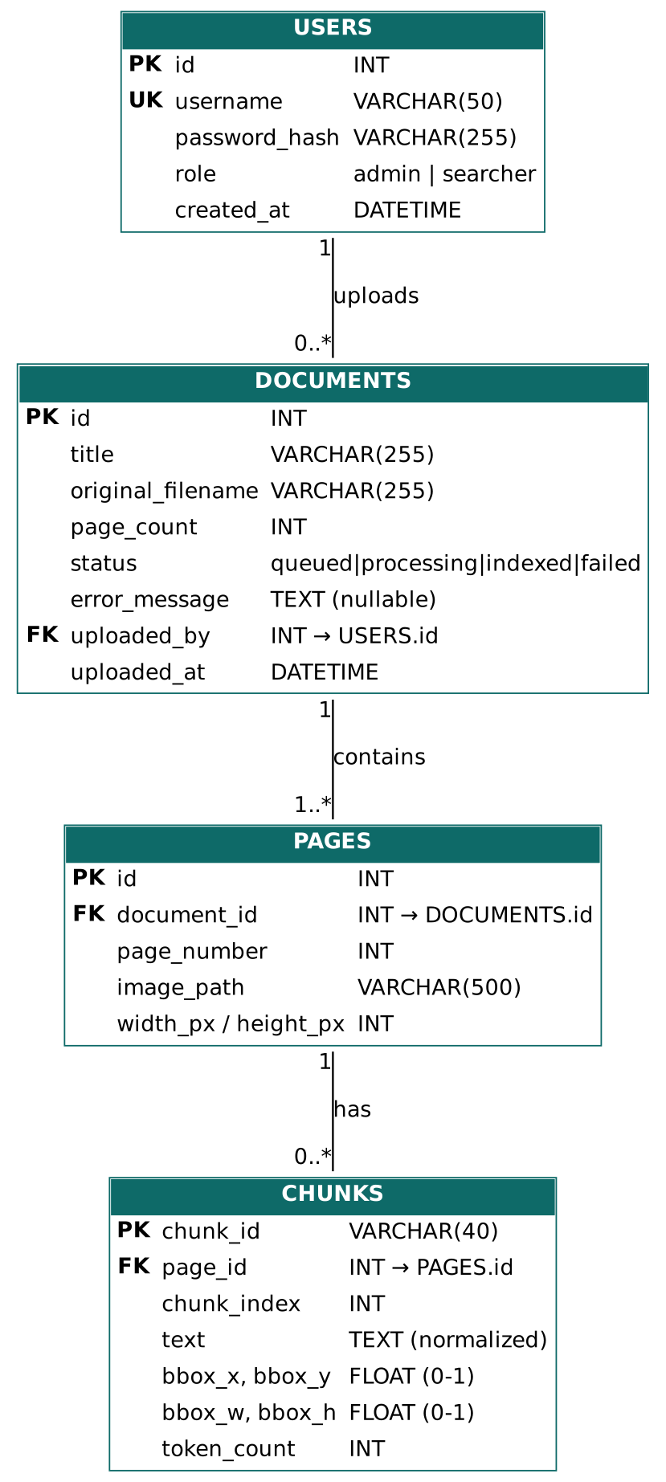
Figure 3.5: Entity-relationship diagram

4. Frontend Architecture and Implementation

4.1 Technology choices
Technology | Role | Reason for choice
React 18 | Component-based UI | Named in the proposal; a mature ecosystem; the document viewer, result list and upload area are naturally independent components.
Vite 5 | Development server and bundler | Very fast rebuilds; produces a static bundle that can be hosted free on Vercel.
Tailwind CSS 3 | Styling | Named in the proposal; a small design-token set (colours, spacing) keeps the interface consistent.
React Router 6 | Client-side routing | Three routes (search, login, admin) with a guard for the admin route.
Noto Sans / Serif Ethiopic (Fontsource) | Amharic typography | Complete Ethiopic coverage; bundled with the app so that the interface looks identical on every machine.
Vitest and Playwright | Unit and end-to-end tests | Fast unit tests for logic; Playwright drives a real browser for end-to-end checks.
Streamlit, which the proposal lists as an alternative for fast prototyping, was not used, because a Streamlit page cannot place a precisely positioned, zoomable highlight over an image or provide a responsive full-screen mobile viewer.

4.2 Project structure
Path | Responsibility
src/lib/api.js | The only place that talks to the backend: login, search, list/upload/delete documents, fetch page images. Adds the JWT header, converts HTTP errors into exceptions, reports upload progress.
src/lib/mockApi.js | In-browser stand-in for the backend used when no API address is configured. It returns data in the same shape as the real API and draws page images so that the highlight can be checked visually.
src/lib/bbox.js | Pure functions for bounding boxes: clamping, conversion to CSS percentages, conversion of OCR pixel boxes to normalized boxes.
src/lib/auth.jsx | Authentication context: stores the user and token for the browser session; exposes login, logout and isAdmin.
src/lib/i18n.jsx | Amharic/English dictionary and language toggle.
src/components/ | DocumentViewer, ResultList, UploadDropzone, Header.
src/pages/ | SearchPage, LoginPage, AdminPage (one per route).
tests/ | Vitest unit tests and the Playwright end-to-end suite.

4.3 Main components

SearchPage
Holds the query, the request status (idle, loading, done, error) and the list of results. After a successful search the first result is selected automatically so that, on a desktop, the user sees a highlighted page immediately. On a phone the viewer stays hidden until a result is tapped, because there is not enough room to show both panes.

ResultList
Renders each result as a button containing the title, page number, a three-line snippet and a score bar. The active result is marked with aria-current so that it is announced by screen readers.

DocumentViewer
Loads the page image through the API module, shows loading and error states (with a Retry button), supports seven zoom levels from 60% to 250%, page navigation, and previous/next result navigation. When the image has loaded it scrolls the active highlight into the centre of the view. Object URLs created for page images are released when the page changes to avoid memory growth in long sessions.

UploadDropzone
Accepts files by drag-and-drop or the file chooser. Each file is validated before it is sent (type PDF, PNG or JPG; size at most 50 MB) so that mistakes are reported immediately and do not waste bandwidth. Every file has its own progress bar and error line.

AdminPage
Lists documents with coloured status badges and starts polling every 2.5 seconds only while at least one document is queued or processing. Deleting requires a confirmation dialog that names the document.

4.4 Authentication and access control
The login form posts the credentials to the API, which returns a JSON Web Token and the user's role. The token is kept in sessionStorage, so it disappears when the browser tab is closed; this limits exposure on shared computers such as library or office machines. A route guard redirects anonymous visitors from /admin to /login and then returns them to the page they asked for. The administrator link is only displayed to administrators. It must be understood that client-side checks are a convenience, not a security boundary: the FastAPI endpoints must verify the token and the role on every protected request (Section 7.2), and the interface was written on that assumption.

4.5 Internationalization
All visible strings are held in one dictionary with an Amharic and an English version, and Amharic is the default. The language choice is remembered between visits. The document language attribute and the search field carry lang="am" so that browsers and screen readers choose suitable fonts and pronunciation.

4.6 Accessibility and responsiveness
- Every input and icon button has a text label or aria-label; the search field has a hidden label.
- Focus is always visible (3 px outline); the interface can be used entirely from the keyboard.
- Status messages (result count, upload progress, errors) are in aria-live or role=alert regions.
- Text and control colours meet WCAG AA contrast: white on the primary teal 6.4:1, body text on the page background 13.4:1, secondary text 5.2:1, error text 6.2:1.
- Animations are reduced to near zero when the operating system requests reduced motion.
- At widths below 1024 px the two-pane layout becomes a list with a full-screen viewer; no horizontal scrolling occurs at 390 px width.

5. The Bounding-Box Highlight: Design and Algorithm

5.1 Why normalized coordinates
Tesseract and EasyOCR report positions in pixels of the image that was analysed. A page image can be shown at many sizes: the preprocessed scan may be 2480 px wide, the browser may show it 886 px wide, and the user may then zoom to 250%. If the interface used pixel values, the highlight would be wrong as soon as the display size differed from the analysed size. The project therefore stores and transmits every bounding box as four numbers between 0 and 1 (x, y, width and height as fractions of the page width and height, with the origin at the top-left corner). The conversion is done once, in the backend, when chunks are created:
x = left / page_width, y = top / page_height, w = width / page_width, h = height / page_height
The frontend function pixelsToBBox in src/lib/bbox.js implements exactly this formula and is covered by a unit test; the backend developers can reuse it as a reference.

5.2 Drawing the overlay
The page image and the highlights are placed in a container whose width is set by the zoom level, with the image at 100% width and each highlight absolutely positioned using CSS percentages (left = x × 100%, top = y × 100%, and so on). Because both the image and the boxes scale with the container, no recalculation is needed when the user zooms or the window is resized, and the highlight stays correct. The active result is drawn with a darker amber fill and border and a multiply blend so that the printed text underneath remains readable; other results on the same page are drawn lighter. Any box that extends past the page edge is clamped to the page by clampBBox, which protects against rounding errors or an OCR box that slightly overflows.
End-to-end test TC-05 checks that for a result with x = 0.10, y = 0.18, w = 0.80 and h = 0.13 the overlay element receives left = 10%, top = 18%, width = 80% and height = 13%.

5.3 Limitations of the highlight
The highlight is as accurate as the OCR bounding boxes. A chunk of 200 to 400 tokens may span several columns or pages; in this version the backend returns one rectangle per chunk, so a chunk that crosses a column break will be drawn as one larger rectangle. A natural extension is for the API to return a list of line-level boxes per chunk, which the interface could draw individually without any other change to the design.

6. User Interface Design and Screens

6.1 Design process and wireframes (Task 3)
The interface was designed in three steps: (1) low-fidelity grayscale wireframes for six screens, in which every element has a number that is explained in Annex D, so that layout could be discussed before any colour or typography was chosen; (2) a visual design with a restrained palette (deep teal as the single brand colour, a pale grey-green page background, and amber used only for highlights so that it always means “this is the passage”); and (3) implementation in React. The teal and amber pair was chosen to evoke an archive and a highlighter pen without resembling a generic dashboard.
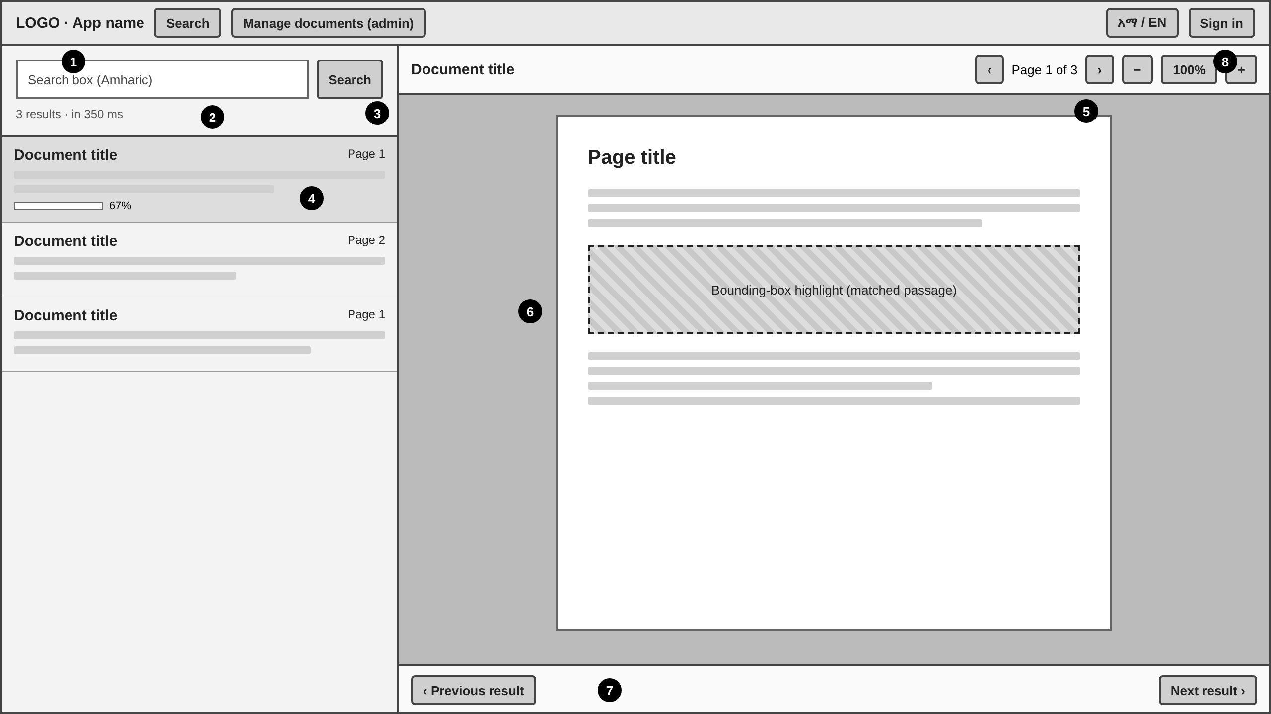
Figure 6.1: Wireframe of the desktop search screen with result list and document viewer (annotations explained in Annex D)

6.2 Search and viewer
The screen is a two-pane layout, as in a mail client: results on the left, the page on the right. This keeps the context (the list) visible while the user inspects the original page, and it makes the first result visible immediately after the search.
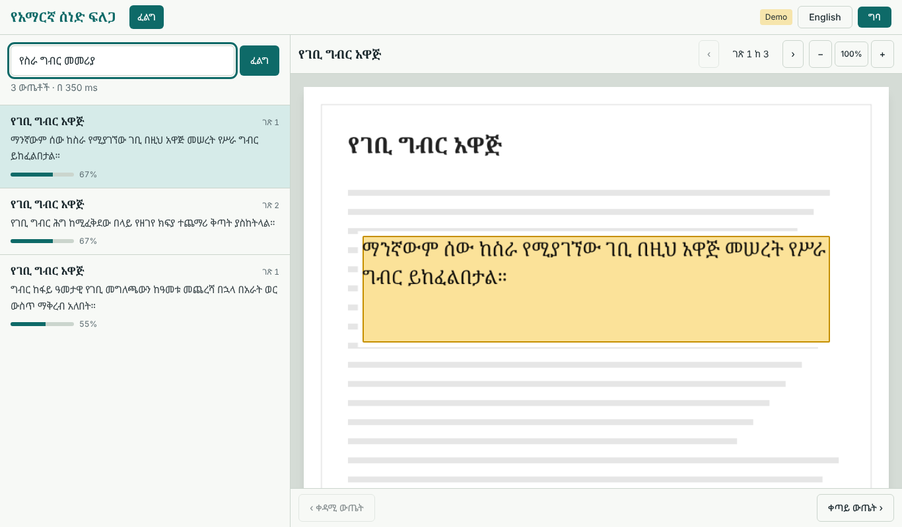
Figure 6.2: Search results and highlighted passage on the original page (demo data)
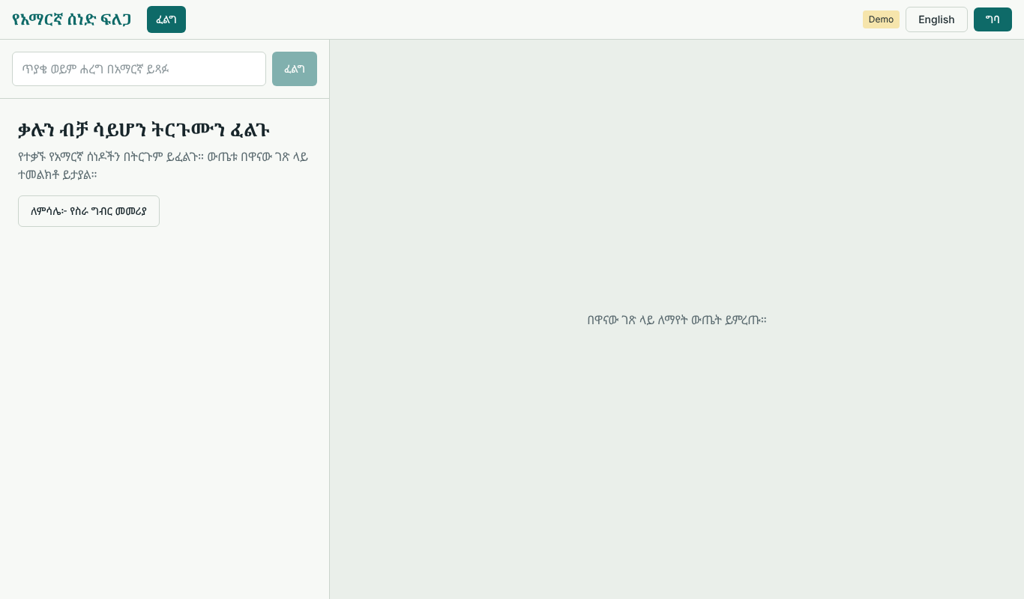
Figure 6.3: Initial screen with an example query the user can click
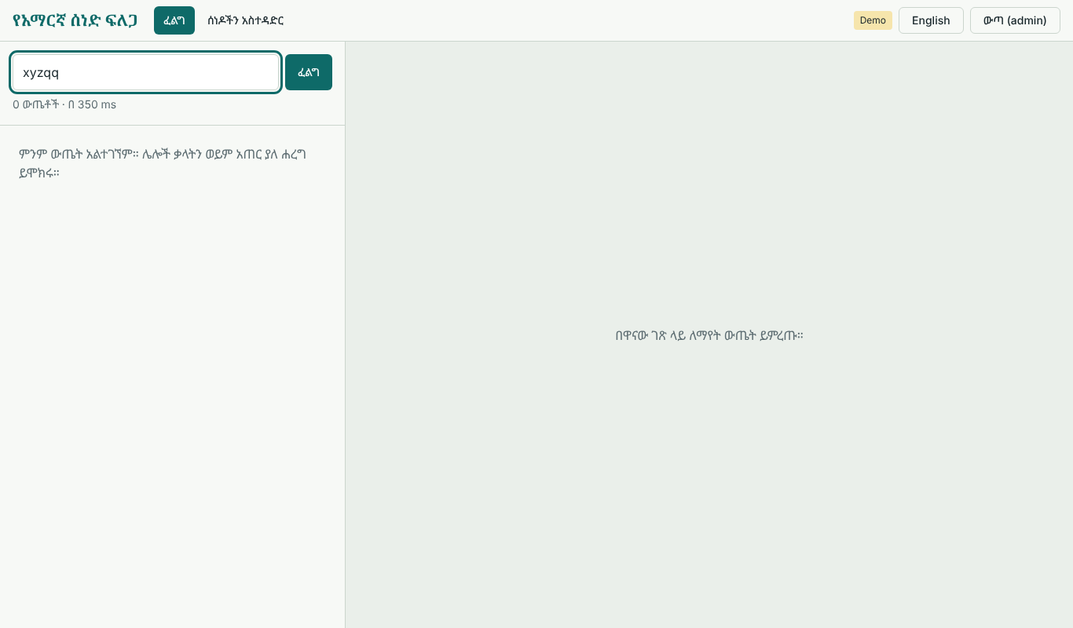
Figure 6.4: Empty state: the message explains what to do next

6.3 Administration
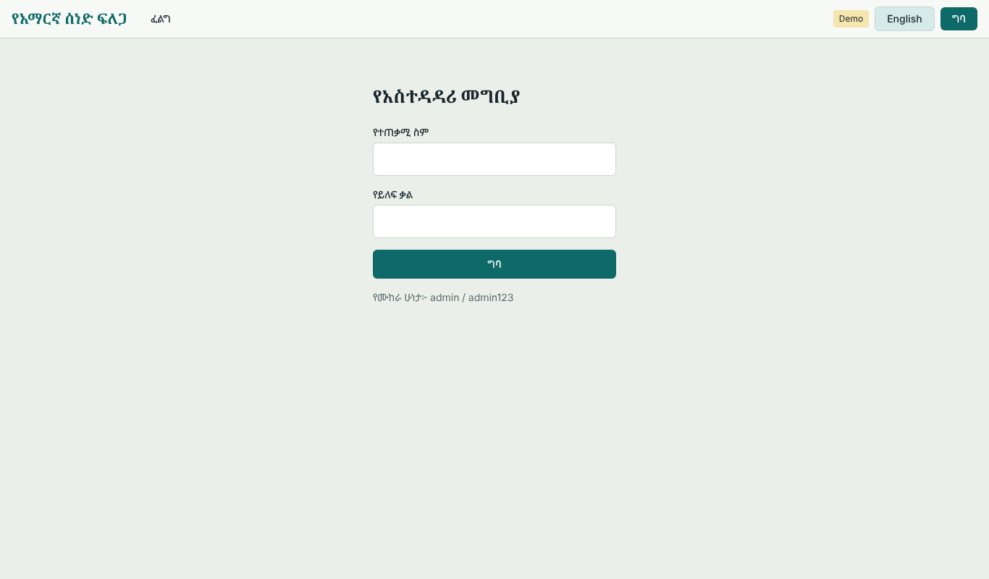
Figure 6.5: Administrator sign-in
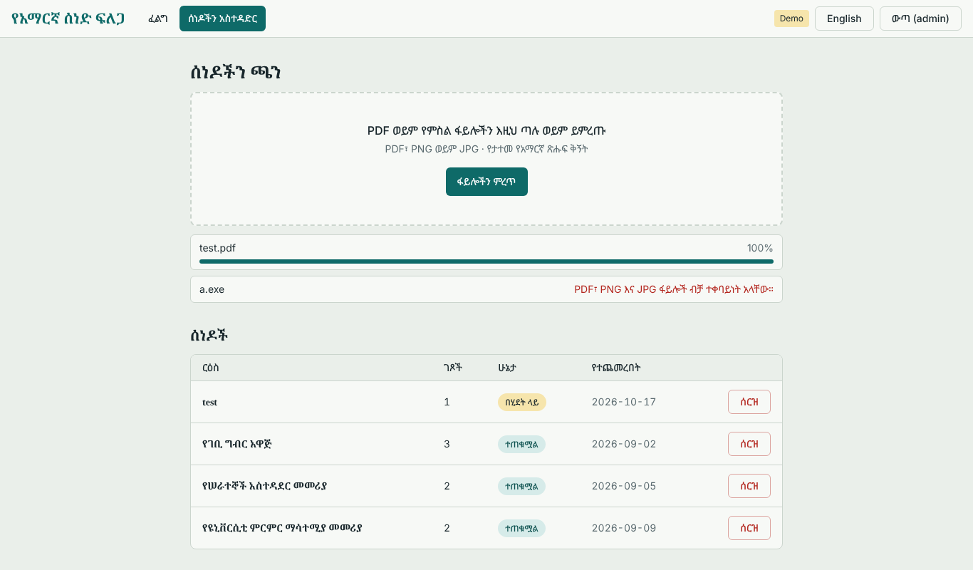
Figure 6.6: Upload area with a successful upload, a rejected file type, and the document list with status badges

6.4 Mobile layout
On a phone the list and the viewer are separate full-screen views. The viewer has its own toolbar (back, page, zoom) at the top and result navigation at the bottom so that the thumb can reach every control.
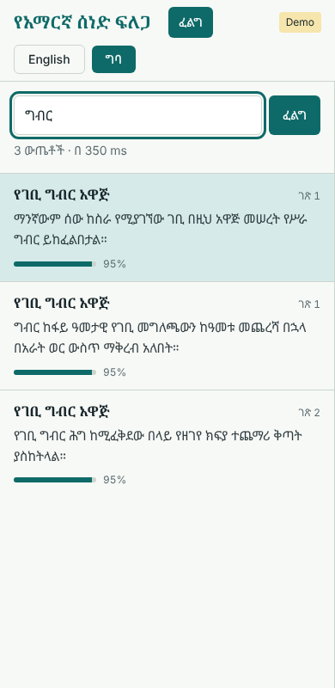
Figure 6.7: Mobile result list (390 px wide)
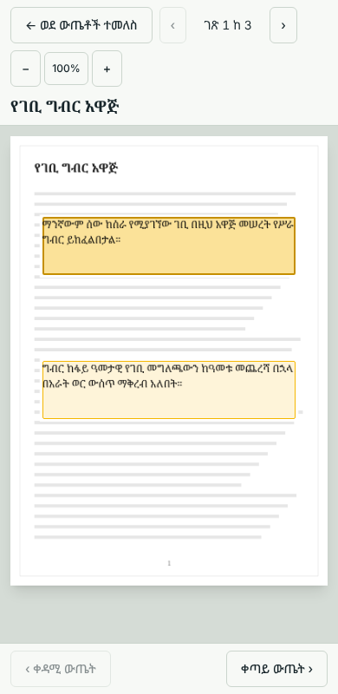
Figure 6.8: Mobile viewer with highlights

6.5 Language switching
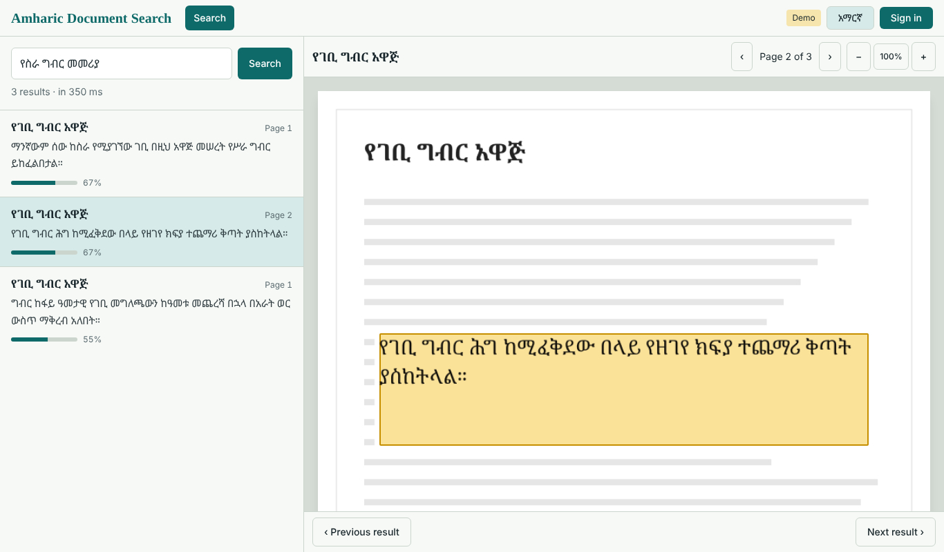
Figure 6.9: The same screen in English

7. Backend Integration (Task 9, Frontend Side)

7.1 API contract
The following contract was written by the frontend and is proposed to the backend owner (Semir Sultan) as the shared interface. It is implemented by the real client in src/lib/api.js and by the mock in src/lib/mockApi.js, so the two are always checked against each other by the tests.
Method and path | Request | Response
POST /auth/login | { username, password } | 200 { access_token, token_type, role: “admin” | “searcher”, username }; 401 on wrong credentials
GET /search | q (text), k (default 10) | 200 { query, took_ms, results: [ { chunk_id, doc_id, title, page, pages_total, score (0 to 1), snippet, bbox: { x, y, w, h } } ] }
GET /documents | Bearer token (admin) | 200 [ { id, title, pages, status, uploaded_at } ]
POST /documents | multipart field “file”; Bearer token (admin) | 202 { id, status: “queued” }
DELETE /documents/{id} | Bearer token (admin) | 204 No content
GET /documents/{id}/pages/{n}/image | none (or Bearer token) | 200 image/png of the rendered page

7.2 Integration agreements and checklist
- Bounding boxes are normalized 0 to 1 (Section 5.1). The backend converts OCR pixels once when chunks are created.
- Scores are returned between 0 and 1; the interface shows them as percentages. The hybrid score after fusion must be rescaled to this range.
- CORS: the FastAPI application must allow the frontend origin (the Vercel domain and http://localhost:5173 during development) and the Authorization header.
- Authorization is enforced in the API: POST/GET/DELETE /documents must return 401 without a token and 403 for a non-admin role. Search must remain public.
- Page images are produced by pdf2image at a consistent resolution (about 150 to 200 DPI) and cached on disk, so that repeated viewing is quick. The same image must be the one the OCR boxes were measured on, otherwise the highlight will be offset.
- Status values are exactly queued, processing, indexed and failed. If a document fails, the interface shows the failed badge; an optional error_message field can be added without any breaking change.
- Switching from mock to real backend requires only one setting: VITE_API_URL=http://localhost:8000 (or the deployed API address).

7.3 Demo mode
Because the OCR, embedding and backend modules were being developed in parallel, the interface contains a mock backend that returns three sample documents, performs a small keyword-plus-synonym search to imitate hybrid retrieval, and draws sample pages on a canvas so that the highlight lines up with the text. The mock is only active when no API address is configured and a “Demo” badge is shown in the header. It allowed every interface feature to be built, tested and demonstrated before the real pipeline existed, and it provides the team with a working reference of the contract.

7.4 Integration status
At the time of writing, the interface has been fully tested against the mock. Verification against the real FastAPI service (Task 9 integration testing) is performed by running the same Playwright suite with VITE_API_URL set and with the seeded document collection; any failing test then points at a contract mismatch. The measured end-to-end latency (NFR-1) and the retrieval metrics are reported in the chapters of the module owners and in the integrated test report.

8. Testing and Evaluation

8.1 Test strategy
Level | Tool | What is checked
Unit | Vitest | Pure functions: normalized bounding-box conversion and clamping, percentage formatting, and the shape of search results (contract check).
System (end-to-end) | Playwright (Chromium) | 25 scripted scenarios across search, viewer, administration, language, protection of admin pages and mobile layout.
Integration | Same suite with a real API address | Contract conformity between frontend and FastAPI (Section 7.4).
Usability | UAT with SUS | Whether target users can complete the main tasks and how they rate the interface.

8.2 Unit test results
The seven unit tests in tests/frontend.test.js pass: four for the bounding-box utilities (percentage CSS conversion, clamping of boxes that leave the page, conversion of OCR pixel boxes, score formatting) and three for the search contract (result shape, semantic matching of related words, empty query).

8.3 End-to-end test results
All 25 scenarios passed in the final run (25 of 25), including a check that no JavaScript or console errors occurred during the whole session. The scenarios, the required behaviour and the observed values are listed below.
ID | Scenario | Result
TC-01 | Home page loads in Amharic with search box and headline | Pass
TC-02 | Empty query keeps the Search button disabled | Pass
TC-03 | Amharic query returns ranked results with count and latency (observed: 3 results) | Pass
TC-04 | Results are sorted by descending match score (observed: [67, 67, 55]) | Pass
TC-05 | Bounding-box highlight overlay is drawn at the normalized coordinates (x=10%, y=18%, w=80%, h=13%) (observed: left: 10%; top: 18%; width: 80%; height: 13%;) | Pass
TC-06 | Selecting another result jumps the viewer to that result's page (observed: ገጽ 2 ከ 3) | Pass
TC-07 | Previous-result button is disabled on the first result | Pass
TC-08 | Next-result button is disabled on the last result | Pass
TC-09 | Zoom in enlarges and zoom out shrinks the page image (observed: 709 < 886 < 1108px) | Pass
TC-10 | Page navigation stops at the last page (button disabled) | Pass
TC-11 | A synonym query (ታክስ) still finds tax passages (semantic match demo) (observed: 3 results) | Pass
TC-12 | A query with no match shows the empty-state message | Pass
TC-13 | Language toggle switches the interface to English | Pass
TC-14 | Unauthenticated visit to /admin redirects to the login page | Pass
TC-15 | Wrong password shows an inline error and stays on login | Pass
TC-16 | Correct credentials open the admin page and show the document list | Pass
TC-17 | Uploaded PDF appears in the table with status Processing | Pass
TC-18 | Status polling updates the document to Indexed without a page reload | Pass
TC-19 | Unsupported file type is rejected with a message | Pass
TC-20 | Deleting a document (after confirmation) removes it from the list | Pass
TC-21 | After sign-out, admin pages are protected again | Pass
TC-22 | On a phone, opening a result shows the viewer full-screen (observed: 390x800) | Pass
TC-23 | On a phone, the Back button returns to the result list | Pass
TC-24 | No horizontal page scrolling at 390 px width | Pass
TC-25 | No JavaScript or console errors during the whole session | Pass

Defects found and fixed during testing. Three issues were found while preparing the screenshots and tests and were corrected before the final run: (1) Amharic characters displayed as empty boxes on machines without an Ethiopic font, which led to bundling the fonts with the application; (2) on phones the document title was squeezed into a few characters in the viewer toolbar, which was fixed by giving the title its own row; (3) a browser console error for the missing site icon, fixed by adding an icon. Test TC-25 now guards against console errors.

8.4 User Acceptance Testing (Task 11)
UAT will answer the question that automated tests cannot: whether real users can find what they need. The full protocol is in the separate UAT Kit; this section summarizes it.

Participants
Five to eight people drawn from the beneficiary groups named in the proposal: students, university library or administrative staff, and at least one legal or records professional. At least two participants should be people who do not usually use search tools extensively. Each session is individual and lasts about 25 minutes.

Tasks
Task | Scenario given to the participant | Success criterion
T1 | Search for “የስራ ግብር መመሪያ” and name the document at the top of the list. | Correct title stated without help
T2 | Open the first result and point to the highlighted passage on the page. | Highlight located within 30 seconds
T3 | Find the same topic using a different word (for example “ታክስ”) and compare the results. | Results opened; participant notes similarity
T4 | Go to the next page of the document, zoom in, then go back to the results. | All three actions without help
T5 | Switch the interface to English and back. | Completed without help
T6 | Sign in as administrator, upload a document and tell when it is ready. | Uploaded; status “indexed” identified
T7 | Delete the test document. | Deleted after confirming

Measures
For each task the observer records success (yes, with help, or no), time in seconds, errors and comments. After the tasks, each participant completes the ten-item System Usability Scale. SUS answers are converted to a score from 0 to 100: for odd-numbered items the score is the answer minus 1, for even-numbered items it is 5 minus the answer, the ten values are added and the sum is multiplied by 2.5. A mean score of 68 is the commonly used benchmark for average usability; 80 or above is considered good. The scoring workbook included in the kit calculates these values automatically.

Results
The sessions with participants are carried out with the final integrated system, and the table below is completed from the UAT scoring workbook. No results are reported in this draft, because inventing usability data would be dishonest; the table must be filled with the real figures before submission.
Measure | Target | Result
Number of participants | 5 to 8 | [to be filled from the workbook]
Mean task success (without help) | ≥ 80% | [to be filled]
Mean SUS score | ≥ 68 | [to be filled]
Median time for task T1 (first search) | ≤ 60 s | [to be filled]
Most frequent usability problem | none critical | [to be filled]

8.5 Traceability
Each functional requirement in Section 2.1 lists the test cases that verify it, and every one of the 25 scenarios maps to at least one requirement, so no feature of the interface is untested and no test exists without a requirement.

9. Deployment and Reproducibility
The application is a static bundle. To run it locally: install Node.js, run “npm install”, then “npm run dev” (demo mode) or set VITE_API_URL and start the backend. “npm run build” creates the dist folder, which can be deployed to Vercel as a static site, and the only environment variable required is the API address. “npm test” runs the unit tests, and the end-to-end suite is run with the Python script in tests/e2e after building and previewing the app. A README in the project describes each step and the API contract.

10. Limitations and Future Work
- Highlights are one rectangle per chunk; line-level boxes would be more precise for chunks that span columns (Section 5.3).
- The viewer displays page images; selecting and copying recognized text, or showing the OCR text next to the image, would help users check recognition quality.
- Search filters (by document, date range) and result pagination are not included; the proposal scoped the system to simple natural-language search.
- The token is kept in the browser session; refresh tokens and token expiry handling could be added for long administrator sessions.
- Only printed text is supported, as in the proposal scope; handwritten text and mobile camera capture are out of scope.
- The amount of usability evidence is limited by the small UAT sample (5 to 8 users), which is adequate for finding major problems but not for statistical claims.

11. Conclusion
The frontend turns the pipeline of preprocessing, OCR, normalization and vector retrieval into a tool that a non-technical person can use: type a question in Amharic, see the best passages, and see exactly where each one sits on the original scanned page. Its design rests on a few decisions that make integration with the rest of the system predictable: a single API module, a documented contract, normalized bounding boxes, and a mock backend that lets the interface be developed in parallel. The implementation meets all twelve functional requirements and is covered by seven unit tests and twenty-five end-to-end scenarios, all passing. The remaining work for this module is to complete the integration run against the real backend and to carry out and report the User Acceptance Test with the final system.

References
- Brooke, J. (1996). SUS: A “quick and dirty” usability scale. In P. W. Jordan et al. (Eds.), Usability Evaluation in Industry. Taylor & Francis.
- Sauro, J., & Lewis, J. R. (2016). Quantifying the User Experience: Practical Statistics for User Research (2nd ed.). Morgan Kaufmann.
- W3C. (2018). Web Content Accessibility Guidelines (WCAG) 2.1. https://www.w3.org/TR/WCAG21/
- Nielsen, J. (1994). Usability Engineering. Morgan Kaufmann (ten usability heuristics).
- Meta Platforms. React documentation. https://react.dev
- Smith, R. (2007). An Overview of the Tesseract OCR Engine. Proceedings of ICDAR, 2, 629 to 633.
- BAAI. (2024). BGE-M3: Multi-Functionality, Multi-Linguality, and Multi-Granularity Embedding Model. Hugging Face.
- Pressman, R. S., & Maxim, B. R. (2020). Software Engineering: A Practitioner's Approach (9th ed.). McGraw-Hill.
- Sommerville, I. (2021). Software Engineering (10th ed.). Pearson.

