|  |  |  |
| --- | --- | --- |
|  | **NAME** | **POSITION** |
| **AUTHOR** | <NAME First name> | Functional owner (for <APPLICATION>) |
| <NAME First name> | Middleware Architect |
| BLONDEZ Olivier | Middleware Business Analyst |
| **VERIFICATION** | <NAME First name> | Middleware Architect |
| <NAME First name> | Middleware Business Analyst |
|  |  |
| **APPROVAL** | <NAME First name> | Middleware Architect |
| <NAME First name> | Functional owner (for <APPLICATION>) |

| **Version** | **Author** | **Subject of the revision** |
| --- | --- | --- |
| 0.1 | BLONDEZ Olivier  <NAME First name> | Draft Version |
| 1.0 | <NAME First name> | CREATION |

|  |
| --- |
| **ASSOCIATED DOCUMENTS** |
|  |

Table of Contents

1 General Information 3

2 Issues 3

3 Interface Tracking 4

3.1 Interface Classification 4

4 Interface Functionality Requirements 6

4.1 Business Justification and Requirement 6

4.2 Process Flow / Data Flow and Business and Date Rules 6

4.3 Assumptions 7

4.4 Constraints 7

4.5 Out of Scope 7

5 Interface Data Requirements 8

5.1 Source Interface Data Layout 8

5.2 Sample Data 8

5.3 Data Retention 8

6 M/W solution (if applicable) 9

6.1 Middleware Solution 9

6.2 Mapping Rules & Conversion criteria 9

7 Configuration and Dependencies 9

7.1 Conversion / Cutover / Other Project Tasks 9

7.2 Other Dependencies 9

8 Interface Controls 9

8.1 Completeness Control 9

8.2 Accuracy Control 10

8.3 Duplicate Records Control 10

8.4 Error Detection and Communication Control 10

8.5 Integrity of Data Transformation Control 11

8.6 Standard File Format Control 11

8.7 Interface Data Security 12

9 Compliance 12

9.1 Compliance Team Classification 12

9.2 Relevant Regulations 12

9.3 Other Regulatory Requirements 12

10 Miscellaneous Data Capture 12

10.1 Interface Referring Report Definition Document(s) 12

10.2 Other Pertinent Details 13

11 Recovery and Restart 13

12 Testing Scenarios 13

# General Information

|  |  |
| --- | --- |
| Description | EDICOM to ITESOFT Invoices (EDI Files) flow |
| Source | EDICOM  Internal |
| Middleware | TALEND |
| Target | ITESOFT  Internal (Cloud Azure) |
| Data type | Invoices (EDI Files) |
| Priority | |  |  |  |  | | --- | --- | --- | --- | | X | High | Interface is required for go-live | | |  | Medium | Either not needed day one or a workaround is possible | | |  | Low | Supports “nice to have” functionality | | |  | Other | Specify: |  | |  | | | |
| Complexity | |  |  |  |  | | --- | --- | --- | --- | |  | Very High | Refer to complexity estimator | | |  | High | Refer to complexity estimator | | | X | Medium | Refer to complexity estimator | | |  | Low | Refer to complexity estimator | | |  | Very Low | Refer to complexity estimator | | |  | Other | Specify: |  | |  | | | |
|  |  |
|  |  |

# Issues

**N/A**

| **Issue #** | **Issue**  **owner** | **Date Raised** | **Issue Description** | **Issue Resolution** | **Resolved By & Date** |
| --- | --- | --- | --- | --- | --- |
|  |  |  |  |  |  |

# Interface Tracking

## Interface Classification

|  |  |
| --- | --- |
| Flow Code | TLDXXXX |
| Flow Name | DEMAT_POST_INVOICES_EDICOM_TO_ITESOFT |
| Direction  *(Only for half flows ?)* | |  |  |  |  | | --- | --- | --- | --- | | X | Inbound | Interface data flows inbound to Middleware | | | X | Outbound | Interface data flows outbound from Middleware | | |  | Other | Specify: |  | |  | | | |
| Interface  Type | |  |  |  |  | | --- | --- | --- | --- | | X | Batch (ETL) | One-way transfer of “accumulated” data set; Usually done by scheduled file transfer. | | |  | Near Real-Time (ESB-ETL) | One-way message-based transfer of data; Usually triggered by event. | | |  | Real-Time (ESB) | Immediate transfer of small data set; Usually triggered by event. | | |  | API | Invoked from Application. | | |  | Other | Specify: |  | |  | | | |
| Interface  Frequency | |  |  |  |  | | --- | --- | --- | --- | |  | Hourly | Details: |  | | X | Daily | Details: | Once a day at 7 a.m. Every day from Monday to Friday | |  | Weekly | Details: |  | |  | Monthly | Details: |  | |  | Quarterly | Details: |  | |  | Yearly | Details: |  | |  | On-Demand | How often: |  | |  | Other | Specify: |  | |  | | | |
| Type of  Records  Sent | |  |  |  |  | | --- | --- | --- | --- | |  | Full record load | Send all records every time interface is executed | | |  | Delta full records | Only send records where one or more fields have changed since previous execution | | | X | Delta records | Only send fields (and keys) that changed since previous interface execution | | |  | Other | Specify: |  | |  | | | |
| Flow type | |  |  |  |  | | --- | --- | --- | --- | | X | File transfers | Send one or more files | | |  | Data consultations | Service for consulting data | | |  | Data search | Service for searching data | | |  | Creating or updating data | Service for creating or updating data | | |  | Other | Specify: |  | |  | | | |
| Volume  *(per single*  *execution)* | |  |  | | --- | --- | | Average Volume: |  | | Average number of calls per day:1 |  | |

# Interface Functionality Requirements

## Business Justification and Requirement

This automatic and direct integration between EDICOM (shared TALEND directory) and ITESOFT (SFTP) will be enabled via TALEND middleware and One Automation.

Network traffic to be opened between EDICOM environment and ITESOFT :

* The files will be sent to us by EDICOM on a shared TALEND directory.
* The Middleware IPs must be communicated to ITESOFT so that access to the SFTP is authorized (Withelist).

## Process Flow / Data Flow and Business and Date Rules

* **Step 1**: **Download itesoft files :** Retrieve all itesoft files (EDI file in XML format) for the company "1011 - ROQUETTE ITALY" made available by EDICOM (Use a "CompanyCode" context variable to store the value 1011.)

The flow of sending itesoft files is done by One Automation (RoboCopy from the EDICOM share to the TALEND share).

* **Step 2:** **Archive itesoft files :** Archiving will be done on a Sharepoint location accessible to the business.

Archiving must work with timestamp and deletion of old files beyond 60 days.

More precisely, copy the files into a directory corresponding to the current month (Example: “03-2024” directory for the month of March 2024) and delete the entire directory when it is more than 2 months old.

* **Step 3:** **Upload itesoft files :** The flow will have to transfer all the itesoft files (EDI files in XML format) to the ITESOFT SFTP.

Diagram :

EDICOM Middleware ITESOFT

ITESOFT (SFTP)

Trigger event

No file transformation

One automation

SFTP

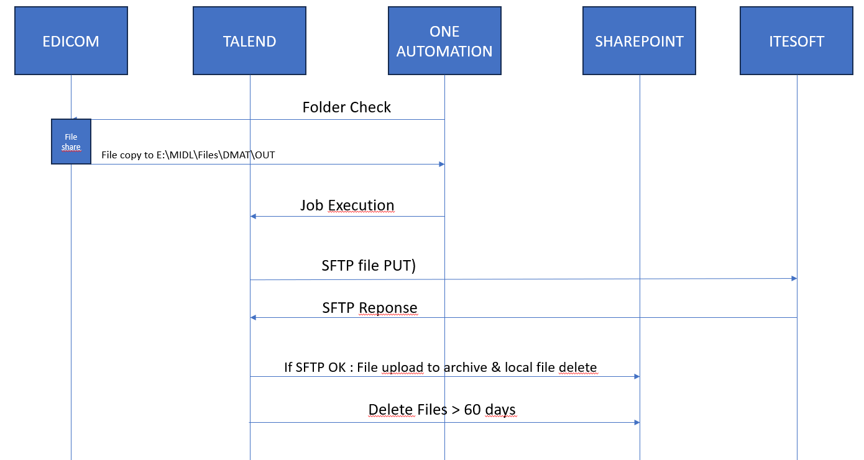

## Assumptions

**N/A**

## Constraints

**N/A**

| Description of  Constraint | Constraint Reported By | Constraint Type  (Data or Business) | Comment |
| --- | --- | --- | --- |
|  |  |  |  |
|  |  |  |  |

## Out of Scope

**N/A**

| Description of  Out-of-Scope Item | Item  Reported By | Type  (Data or Business) | Comments |
| --- | --- | --- | --- |
|  |  |  |  |

# Interface Data Requirements

## Source Interface Data Layout

Source data is available as (Type “X” for ***all*** that apply):

|  |  |  |  |
| --- | --- | --- | --- |
|  | Database | Table Name(s): |  |
| X | File | Type: | EDI File (Invoices) |
|  | Procedure | Name: |  |
|  | API | Name |  |
|  | Other | Method: |  |

Mapping rules are detailed in the attached document

## Sample Data

**Source Sample Data**:

To be updated when source idoc data is available

**Target Sample Data**:



## Data Retention

|  |  |  |  |
| --- | --- | --- | --- |
|  | None | Data retention is not necessary for this interface | |
|  | 7 days | | |
|  | 15 days | (default) | |
|  | 30 days | | |
| X | Other | Specify: | Governed by <Source> standard configuration. No specific requirement for data retention |
|  | | |

# M/W solution (if applicable)

## Middleware Solution

**N/A**

## Mapping Rules & Conversion criteria

| Source | Rules | Target |
| --- | --- | --- |
|  |  |  |
|  |  |  |
|  |  |  |

# Configuration and Dependencies

## Other Dependencies

**N/A**

| Dependency | Predecessor or Successor | Description |
| --- | --- | --- |
| FEX_XXX |  | Scheduling, folder check, file transfert, etc… |
|  |  |  |
|  |  |  |

# Interface Controls

## Completeness & accuracy Control

N/A

| Control | Control Addressed |
| --- | --- |
|  |  |
|  |  |
|  |  |

## Duplicate Records Control

**N/A**

| Control | Control Addressed |
| --- | --- |
|  |  |
|  |  |
|  |  |

## Error Detection and Communication Control

### Data Error (Non-Execution) Notification

Notification Mechanism:

|  |  |  |  |
| --- | --- | --- | --- |
| X | Email Notification | Send To: | <Middleware> monitoring team will notify L2 Support |
|  | Other | Specify: |  |
|  | | |

Urgency:

|  |  |  |  |
| --- | --- | --- | --- |
|  | Immediate |  | |
| x | Next Business Day |  | |
|  | Before Specific Event | Specify: |  |
|  | | |

Impact to business in the event of this error:

|  |
| --- |
|  |

### Non-Fatal Execution Error Notification

|  |  |  |  |
| --- | --- | --- | --- |
| X | Email Notification | Send To: | <Middleware> monitoring team will notify L2 Support |
|  | Write to Error Log | Elements: |  |
|  | Other | Specify: |  |
|  | | |

Urgency:

|  |  |  |  |
| --- | --- | --- | --- |
|  | Immediate |  | |
| x | Next Business Day |  | |
|  | Before Specific Event | Specify: |  |
|  | | |

Impact to business in the event of this error:

|  |
| --- |
|  |

### Fatal Execution Error Notification

|  |  |  |  |
| --- | --- | --- | --- |
| X | Email Notification | Send To: | <Middleware> monitoring team will notify L2 Support |
|  | Write to Error Log | Elements: | Log of all the process |
|  | Other | Specify: |  |
|  | | |

Urgency:

|  |  |  |  |
| --- | --- | --- | --- |
|  | Immediate |  | |
| X | Next Business Day |  | |
|  | Before Specific Event | Specify: |  |
|  | | |

Impact to business in the event of this error:

|  |
| --- |
|  |

### Fatal Execution Error Progress Handling:

|  |  |  |  |
| --- | --- | --- | --- |
|  | Commit Progress | Records that were successfully processed before the error are committed to target before the append | |
|  | Back Out Progress | All records from this interface execution are removed from target system even if they were successful | |
| x | Other | Specify: | IDocs can be retriggered from source SAP EWM for error cases |
|  | | |

## Standard File Format Control

**N/A**

| Control | Control Addressed |
| --- | --- |
|  |  |
|  |  |
|  |  |

# Recovery and Restart

**N/A**

# Testing Scenarios

**General description:**

|  |  |
| --- | --- |
| Normal Functionality - test cases that ensure the enhancement functions as it should. | |
| ID | Description |
| 1 |  |
| 2 |  |
| 3 |  |
| 4 |  |
| Exception - special logic or exceptions (e.g. report should exclude certain specific condition) | |
| 5 |  |
| *6* |  |
| Error Handling - functionality in case of errors (e.g. Error Message or Error Log ) | |
| 7 |  |
| 8 |  |

**Prerequisites:**

* *Master data creation (To explain which master data to create and explanation how to create to reproduce test data – with screen shot)*

**Step Details & Expected result:**

|  |  |  |  |  |  |
| --- | --- | --- | --- | --- | --- |
| Normal Functionality - test cases that ensure the enhancement functions as it should. | | | | | |
| ID | Step N° | | Description | Test data | Expected result |
| 1 | 1 | |  |  |  |
| 2 | |  |  |  |
| 3 | |  |  |  |
| 4 | |  |  |  |
| 2 |  | |  |  |  |
|  | |  |  |  |
|  | |  |  |  |
|  | |  |  |  |
| 3 |  | |  |  |  |
|  | |  |  |  |
|  | |  |  |  |
|  | |  |  |  |
| 4 |  | |  |  |  |
|  | |  |  |  |
|  | |  |  |  |
|  | |  |  |  |
| Exception - special logic or exceptions (e.g. report shold exclude certain specific condition) | | | | | |
| 5 |  |  | |  |  |
| *6* |  |  | |  |  |
| Error Handling - functionality in case of errors (e.g. Error Message or Error Log ) | | | | | |
| 7 |  |  | |  |  |
| *8* |  |  | |  |  |