# Interface Functionality Requirements

## Business Justification and Requirement

This automatic and direct integration between EDICOM (shared TALEND directory) and ITESOFT (SFTP) will be enabled via TALEND middleware and One Automation.

Network traffic to be opened between EDICOM environment and ITESOFT :

* The files will be sent to us by EDICOM on a shared TALEND directory.
* The Middleware IPs must be communicated to ITESOFT so that access to the SFTP is authorized (Withelist).

## Process Flow / Data Flow and Business and Date Rules

* **Step 1**: **Download itesoft files :** Retrieve all itesoft files (EDI file in XML format) for the company "1011 - ROQUETTE ITALY" made available by EDICOM (Use a "CompanyCode" context variable to store the value 1011.)

The flow of sending itesoft files is done by One Automation (RoboCopy from the EDICOM share to the TALEND share).

* **Step 2:** **Archive itesoft files :** Archiving will be done on a Sharepoint location accessible to the business.

Archiving must work with timestamp and deletion of old files beyond 60 days.

More precisely, copy the files into a directory corresponding to the current month (Example: “03-2024” directory for the month of March 2024) and delete the entire directory when it is more than 2 months old.

* **Step 3:** **Upload itesoft files :** The flow will have to transfer all the itesoft files (EDI files in XML format) to the ITESOFT SFTP.

Diagram :

EDICOM Middleware ITESOFT

ITESOFT (SFTP)

Trigger event

No file transformation

One automation

SFTP

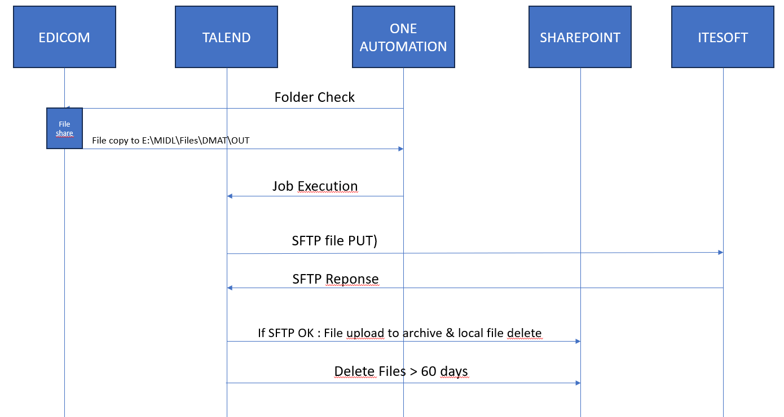

|  |  |
| --- | --- |
| Normal Functionality - test cases that ensure the enhancement functions as it should. | |
| ID | Description |
| 1 | Test abcd |
| 2 | Test egdj |
| 3 | Test1zefsv |
| 4 |  |
| Exception - special logic or exceptions (e.g. report should exclude certain specific condition) | |
| 5 |  |
| *6* |  |
| Error Handling - functionality in case of errors (e.g. Error Message or Error Log ) | |
| 7 |  |
| 8 |  |

**Prerequisites:**

* *Master data creation (To explain which master data to create and explanation how to create to reproduce test data – with screen shot)*

**Step Details & Expected result:**

|  |  |  |  |  |  |
| --- | --- | --- | --- | --- | --- |
| Normal Functionality - test cases that ensure the enhancement functions as it should. | | | | | |
| ID | Step N° | | Description | Test data | Expected result |
| 1 | 1 | |  |  |  |
| 2 | |  |  |  |
| 3 | |  |  |  |
| 4 | |  |  |  |
| 2 |  | |  |  |  |
|  | |  |  |  |
|  | |  |  |  |
|  | |  |  |  |
| 3 |  | |  |  |  |
|  | |  |  |  |
|  | |  |  |  |
|  | |  |  |  |
| 4 |  | |  |  |  |
|  | |  |  |  |
|  | |  |  |  |
|  | |  |  |  |
| Exception - special logic or exceptions (e.g. report shold exclude certain specific condition) | | | | | |
| 5 |  |  | |  |  |
| *6* |  |  | |  |  |
| Error Handling - functionality in case of errors (e.g. Error Message or Error Log ) | | | | | |
| 7 |  |  | |  |  |
| *8* |  |  | |  |  |