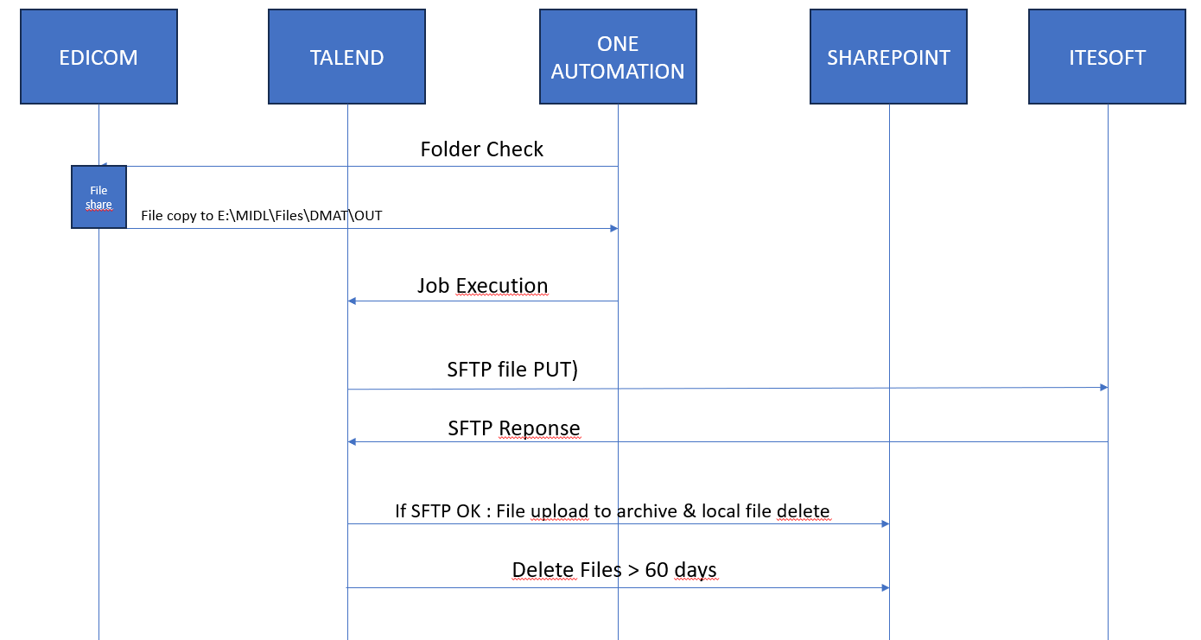

**Document 1: Functional Specification for a Mobile App for Task Management**

* **Purpose:** To outline the features and functionalities of a mobile application for managing tasks and projects.
* **Scope:** Define the app's target users, platforms, and integration with other tools or services.
* **Features:**
  + Task creation and management: Detailed description of task creation, editing, categorization, prioritization, assignment, and completion tracking.
  + Project management: Organization of tasks into projects, project creation and editing, progress tracking, and dependency management.
  + Collaboration: Features for team collaboration, including task assignment, commenting, notifications, and file sharing.
  + Reminders and alerts: Implementation of reminders, push notifications, and due date alerts for tasks and projects.
  + Search and filtering: Robust search functionality to find tasks and projects based on various criteria, including keywords, tags, and assignees.
  + Customization: Options for personalizing the app's interface, notification preferences, and task organization methods.
* **Non-Functional Requirements:**
  + Performance: Define performance expectations, such as loading times, responsiveness, and offline functionality.
  + Security: Specify security measures for user authentication, data encryption, and access control.
  + Usability: Outline usability principles for intuitive navigation, clear UI elements, and accessibility considerations.

**Document 2: Functional Specification for a Customer Relationship Management (CRM) System**

* **Purpose:** To document the features and functionalities of a CRM system for managing customer interactions and data.
* **Scope:** Define the CRM's target users, supported businesses, and integration with other systems.
* **Features:**
  + Contact management: Creation, storage, and organization of customer contact information, including personal details, communication preferences, and purchase history.
  + Sales pipeline management: Tracking leads, opportunities, and deals throughout the sales process, with customizable stages and status tracking.
  + Marketing automation: Automated marketing campaigns, email marketing tools, lead nurturing, and campaign performance tracking.
  + Customer support: Ticketing system for managing customer inquiries, issue resolution, and feedback collection.
  + Reporting and analytics: Generation of reports on customer data, sales performance, marketing campaign effectiveness, and customer support metrics.
* **Non-Functional Requirements:**
  + Scalability: Define the system's ability to handle growing data volumes and user traffic.
  + Data security: Specify security measures for protecting sensitive customer data, including compliance with data privacy regulations.
  + Integrations: Outline the ability to integrate with other business systems, such as accounting, marketing automation, and e-commerce platforms.

**Document 3: Functional Specification for an E-commerce Website**

* **Purpose:** To outline the features and functionalities of an e-commerce website for selling products online.
* **Scope:** Define the website's target audience, product categories, and payment processing integrations.
* **Features:**
  + Product catalog: Creation, management, and display of product information, including descriptions, images, pricing, and variations.
  + Shopping cart and checkout: Secure shopping cart functionality, seamless checkout process, support for multiple payment methods, and order confirmation.
  + User accounts: User registration, login, and account management, including order history, saved addresses, and payment information.
  + Search and filtering: Robust search functionality to find products based on keywords, categories, price range, and other attributes.
  + Product recommendations: Personalized product recommendations based on browsing history, purchase history, and user preferences.
* **Non-Functional Requirements:**
  + Performance: Define performance expectations, such as page loading times, product image optimization, and search responsiveness.
  + Security: Specify security measures for user authentication, payment processing, and data protection.
  + SEO (Search Engine Optimization): Implementation of SEO best practices to improve website visibility in search engine results.
  + Accessibility: Ensure the website is accessible to users with disabilities, following WCAG guidelines.

**Remember:** These are just outlines, and each document should be tailored to your specific requirements and project scope. Use clear headings, subheadings, and bullet points to organize the information effectively.