In the Netherlands alone more than 300.000 <https://oogfonds.nl/onze-ogen/feiten-en-cijfers/> Dutch people have a visual disability. This doesn’t account for the near 9 million other people who need to wear glasses to get even a semblance of 20/20 vision. Or the estimated 100 to 200 thousand people <https://www.nji.nl/cijfers/autisme> on the autism spectrum, these people exist yet we refuse to take them into account when designing our websites. I want to explore what solutions exist to help these people and whether the websites I visit often are designed with the thought that every single human on earth should be able to access them.

So, for ***what*** do we design our websites? <https://exsite.ie/history-of-responsive-web-design/> In the early days of the internet there weren’t enough different types of monitors to necessitate a fluid and responsive design. Developers made websites for a select amount of pixel counts. This changed in the in 2000s with the market going open and different companies making different sizes of screens for desktop use. With this change the early versions of responsive design started showing up. With new units developed to scale with screen size and percentage-based scaling where a table, picture or column would take up 25% of a screen. 2010 came around and everything changed, mobile first design was already rising with iPhone being released 3 years earlier, but mobile access to webpages started skyrocketing and we haven’t looked back since.

But all these changes are done because the hardware changing around them. These changes weren’t made with the people in mind but with the thought of getting more clicks and keeping retention on your website as high as possible. So, for ***who*** we design our websites? <https://uxdesign.cc/how-to-design-digital-interfaces-with-every-disabilities-in-mind-19572579d7ef#d9c6> There are roughly 5 groups which need more attention to their needs in our digital age:

* Vision Impairment
* Deaf or hard of hearing.
* Autism spectrum disorder
* Physical disabilities
* Learning disabilities

For all these a wide range of solutions exists which we will go over and most of them might overlap, furthermore other less severe disabilities like near sightedness are not named here but should find improvements in accessibility if all or any of the accommodations are provided.

## Visual Impaired

<https://uxdesign.cc/tips-on-designing-inclusively-for-visual-disabilities-d42f17cc0dcd>

Vision impairments comes in different types which makes it a difficult challenge to overcome in web design. Examples are blindness both partial and complete, colour blindless, lack of contrast sensitivity and poor acuity a lack in vision sharpness.

There are multiple different techniques to help people with these disabilities to use the websites full functionality, and these can be divided into three categories:

1. Composition
2. Colour and size
3. Audio

Composition is easy, put important things front and centre and slowly branch out to less and less. Reduce clutter if possible and hide as little off-screen. A great example of readability in combination with functionality is Apple’s buy pages.

Front and centre is the product that you will be buying with the only other element being the buy menu. All options under a header are laid out and if clicked will bring you to the next section of buy process (Type -> Colour -> storage -> insurance) further when a new option is selected the big picture of the product changes to mimic the selected options. The buyer is never confused and will be guided through the process, this known as a step-through tunnel or a step-by-step tunnel.

Colour and size are the most common debated topics in the development process. But they rarely involve the needs of the visitor but more whether the design follows the company house style. Easy fixes are changeable fonts and zoom/enlarge buttons for text, but with the rise of AI and simulations developers can check if their page is safe to use for the colour blind and will not cause overstimulation. Both Firefox and chromium browsers have their built in the developer console with accessibility tab and chrome lighthouse respectively. But <https://www.w3.org/WAI/ER/tools/> lists over 167 different tools to help developers with this process.

Audio is last part and is easy to use if advertised correctly, text-to-speech is simple solution just let a voice read out what is on the page, yet companies might hide this feature behind a small button with a small icon which defeats the part of it becoming more accessible to visual impaired.

## Deaf / Hard of hearing

Sound and audio in web design space is a difficult topic, the days where a page would instantly give you an audio quip are luckily over, but when used audio is the best and most straightforward way to convey importance of an object. A classic example is receiving a new notification of message in combination with a simple bell sound and shaking bell icon over the messenger, both the vision impaired and deaf will now know that a message is pending to be read. So, what else can we do besides combine audio and visual.

There are two instances where lots of companies and institutes still fail on audio communications, the first is only providing service in audio. With the coming of support bots this has slowly been phased out, but some companies will still only provide support through phone calls. Extending this to video calls or simply giving the option to only use chat will help this group.

Second instance is videos, if your institute relies on videos on either YouTube or Local provide subtitles, translating and transcribing should be a standard and there are companies out there willing to do it for less than a euro per video.

## Autism spectrum disorder

Consistency and simplicity. Two words that mean a lot and can get you far in arguably the biggest range of groups mentioned. Like mentioned earlier composition of your page with the most important parts of your page front and centre with as little clutter around it as possible, keep it simple. Consistency can come in many different forms, using icons which are near synonyms with actions is important, the magnifying glass icon is synonyms with searching, the hourglass icon is better known as the loading icon, don’t try to change their meanings. Further if a large blue button always brings you out of the current page, don’t make a large blue button that now is used as a dropdown.

## Physical disabilities

Enlarge, enlarge, enlarge! If possible, make all your call-to-action has easy as possible to click but more importantly make them reachable using the tab key on a keyboard. A cool way to test if your website is tab friendly is putting all your developers on a keyboard only restriction and see how much they can reach without using a mouse.

On the topic of mouse avoid scrolling as much possible large swiping motions can be difficult to perform both dexterity wise but also, they will become tiring if needed to be used in small steps multiple times in a row.

Lastly automate as much as possible, retrieve information from the browser, former website visits, login information to fill in as much information as possible. Calendars shouldn’t force me scroll to the correct day, my phone already knows my exact location and if you cannot retrieve that try to get as much information as possible using as little possible. Using my postcode you can find in which city, street, and house number I live. So, why would I need to fill in those three before I fill in my postcode. <https://www.youtube.com/watch?v=hcYAHix-riY>

## Learning disorders

Analysing big texts is hard, but sometimes it is near impossible to reduce the size of these texts to a more condense version, besides completely translating these to a video format where a person can follow it along. You can try to implement a font changer, <https://www.dyslexiefont.com/en/typeface/> provides a font which is proven to help people with dyslexia to learn easier. Focus sans is another great font for people with ADHD.

# Canvas

Canvas LMS (Learning Management System) is a platform used by Fontys developed by Drieam where students can find all their courses including all content related to those courses. Student can login into the platform using their student account and if they are linked to a course, they will receive notification through email and on the platform itself. It supports a mobile app and a mobile version of the webapp.

Canvas tested at Fontys ICT (FHICT) before it branched out to other courses within Fontys. <https://www.portfoliofontysict.nl/en/portfolio-2020/november-2020/fhict-assists-fontys-in-canvas-implementation/> And was chosen over 18 other LMS software solutions for its flexibility and its integration with both 3rd party tools like YouTube, Dropbox, and MS teams but also other software solutions from Drieam such as FeedPulse and Studycoach. The reason why FHICT was willing to test out this new system was as Eric Slaats from FHICT put it.

*For an average school, this subject is often complicated. We not only understand education, but also ICT. We are happy to put this extra knowledge to work for the whole of Fontys.*

So as a student with both access to FHICT Canvas and Fontys Canvas what are the current differences, what are the current problems with either version, how was Canvas communicated to the rest of Fontys.

A quick google search gives us that Fontys wanted to implement Canvas in 2021 which was likely delayed a bit due to the ongoing pandemic <https://www.fontys.nl/actueel/fontys-kiest-voor-canvas/> but this page isn’t meant for students as the 2 mentioned extra sources are guides for teachers, one a 7 year old video made by the company and the second an hour long guide on how to do everything. So, teachers are most likely informed but what about students. A useful guide made by the IT department is a 24 page pdf <https://fontys.edu/Nieuws-tonen-op-3/IT-guide-students-english-PDF.htm> with every single IT tool lined out for students, sadly as far as I know this document has not been directly shared through email or mentioned to students and is just passively sitting in a google search. Furthermore, the Canvas section of this document tells the user to ‘***’Go to canvas.fontys.nl and see what learning resources are available to you.’’*** Lastly the education on how to use Canvas has been tasked on the courses and section of Fontys themselves instead of Fontys as a whole or FHICT. With small, short educational videos provided by Fontys Kunsten and Fontys Hogeschool Theologie Levensbeschouwing for their courses. But enough of the communication and let’s compare them to what we have learned about how we can use UX/UI to make webapps accessible to everyone.

# Redesign

To make it easier on myself I have chosen 3 elements from canvas that I will try to rate, these are the login page, sidebar, and a module page more on the last one later. These are chosen based on frequency of use, if I want to know what was said in the last class, I need to go through all these steps to find out.

## Login Page.

Canvas’ login page is straight forward to the right we have all information we need to login. Login pages have 1 function logging you in.

This login page is simple but has some small things that make it harder to use no reason. The first thing is the use of placeholders. Placeholders are not Labels if they want to keep the example email make it a label or when clicking on the input box move the placeholder above the input box instead of deleting it.

The “Sign in” button is a bright button with a thin white font placed inside of it, furthermore on both the full screen as mobile version it only takes up 25%. Increasing the size of the button to fill up the space and either changing the pink hue or bolding the type face should give the button more readability.

Then we have the link to “Signing in requires a [Fontys account](https://www.fontys.edu/pcninfo/).” Which as it stands brings you to a Fontys 404 page with no information on how to login into canvas. I recommend moving the guide that placed inside of canvas’ Help button to this page.

Last, we have the “Privacy” and “Help” links in the footer. The privacy link does not give you any information regarding how cookies will be used or how your privacy is protected. Rather it brings you to the “Rules & regulations” page of Fontys. The “Help” link brings you service desk number which is useful.

With these changes the page has become slightly more readable, links have been made consistent with an underline and the sign in button has become more pronounced. With the font size increase of the page header and the addition of a label the page has been given more structure.

Another change that could be made is the input itself. As it stands you need to input your student number + @student.fontys.nl or @fontys.nl. The addition of this could be automized in the form making it so the student only needs to enter his student number. But this would need a trial with new students. Lastly, the login page might as well make use of the empty space and add an announcement / news feed to the right allowing Fontys to communicate outside of just using emails.

## Sidebar

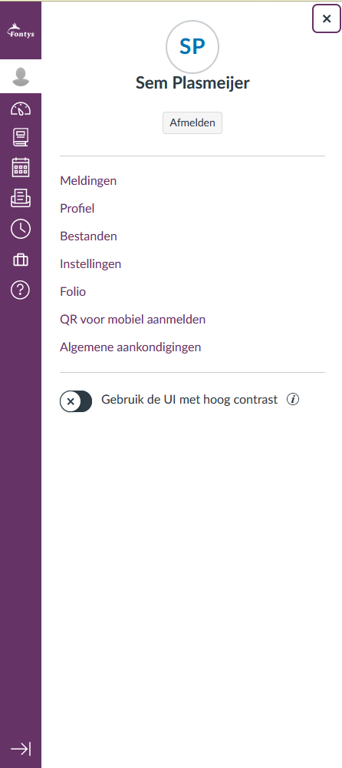

The sidebar has 2 versions and a second sidebar that sometimes opens. Version 1 adds text labels to the icons while Version 2 removes the text labels and only displays the icons.

When clicking on some of the navigation items an extra sidebar gets opened with navigation links on the new page. This feature allows the user to navigate the page without preloading it.

The sidebar has a few problems, not restricted to only visual but also technical problems. Opening the extra sidebar navigation in for example “Account” and then changing the sidebar version from one with labels to one without closes the extra sidebar. Opening the second version decreases the size of the Fontys Logo and as it stands if you click the “Afmelden” or “Logout” button and then refreshing the page will not log you out. If you simply refresh the page or even open a new Canvas window you will be automatically logged in.

Navigation links don’t have an underline something only when hovering they receive one with a near invisible change in font colour.

Then we have the “Help” button I recommend changing this to a clearer and more universal button. For example, we could make this a Fontys tool button which brings the user to a page with all Fontys help tools.

Lastly for the sake of consistency we could make it so every single button on the sidebar opens an extra sidebar instead of randomly changing page. As it stands “Help” only has external links in its sidebar, Portfolio, Inbox, Dashboard and Kalendar all directly bring you to the page and Account, Geschiedenis and Cursussen open an extra sidebar.

A great feature in the sidebar is high contrast mode. This changes all the colours on the website to a green blueish which allows fonts to be clear in both black and whites. The problem is in the finished product, when selecting this option all A tags in html receive an underline unlike the regular UI which removed all of them. This results in sidebar looking incredibly messy and unfinished. Further it straight up removed the home button from the page.

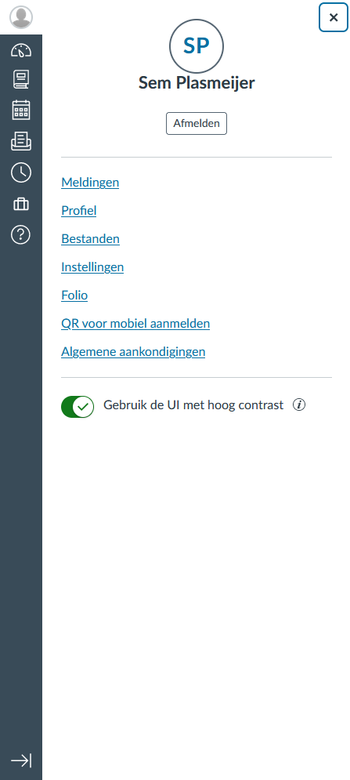

In the redesigned we will keep the none label version the same, but the labelled version we will move out the labels to the right. This way the icons don’t have to move slightly downward and won’t create the illusion that the icons increased in size. If we can’t add an extra sidebar to all navigation links than indicate which ones will create the extra sidebar. We will also increase the contrast on hovering of links.

# Modules

Arguably the most important page in all of canvas are the module pages. These pages contain information regarding tests, courses, links to information and anything a teacher wants to post. These pages are contained within the overall course pages which is why an extra sidebar has been added to quickly navigate through it. An addition to this would be to add an extra compartment within modules so we can also navigate to the modules we want reducing clicking. The next and previous buttons are great for structured courses which want to layout everything in chapters. Besides changing the header, the next button could show the title of the next page and whether you will be entering a new chapter next.

But the single best feature and add the same time the worst feature is the page reader. This takes the content of the module and puts on a separate page. It allows for font changes, highlighting, focus modes and different themes. The problem is that it takes you completely out of the page removing any other visual clues you might get like table formatting and images. Furthermore, it does not allow for any documents to be read.

Redesigning the technical part to able to read docx and pdf parts might be too difficult, that’s why I recommended course leaders to reduce these files as much as possible and use the module page for its intended purpose.

